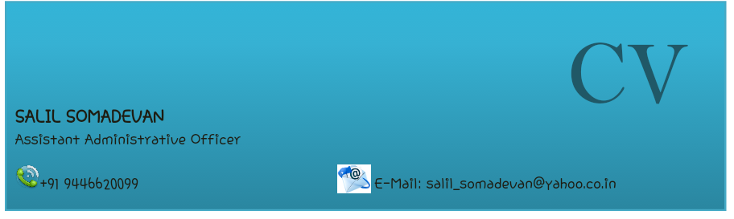

 **PROFILE**

* 8 Years of Experience in Administration & HR
* 3 Years of experience in Accounts
* Meeting deadlines.
* Good working knowledge in MS Office.
* Able to work independently and self-motivated.
* Multitasking
* Team Management

**EXPERTISE**





 **PROFESSIONAL BACKGROUND**

1. **Current Organization:** M/s. Tecpro Infra-Projects Ltd.

**Role:** Assistant Administrative Officer

**Period:** From December 2011 to till date

**Responsibilities:**

* Assistant to Manager (HR).
* Preparation of Payroll.
* Handling PF, ESI, PT, & WC Policy.
* Power Point Presentation.
* Vehicle Management, Housekeeping, Travel Desk.
* Maintaining Attendance & Leave Register of all sites.
* Preparing Rental Agreement of site offices & Vehicles.
* Mess Management, Guest House arrangements.
* Knowledge of Systems Administration.
* Agenda tracking , follow ups and delegation
* Appointments &calendars schedule of MD – track & remind
* Travel assistance: - Visa processing, flight ticket, hotels search, foreign exchange purchase etc.
* Personal & company vehicles – service & insurance renewals
* Credit card and Club membership – payments
* Proper upkeep of personal documents, files & records

1. **Organization:** M/s. Reprographics Pvt. Ltd. Hyderabad

**Role:** Accountant

**Work Experience:** June 2011 - September 2011

**Responsibilities:**

* Maintaining sales & Purchases in Tally & Excise Udyog Software.
* Follow up of payments.
* Prepared company accounts and tax returns for audit.
* Arrange Dispatch of materials.
* Handling Petty cash.
* Performed general office duties and administrative tasks like maintaining company guest house.
* Prepared monthly sales reports.
* Updating Insurance & Road Tax.
* Bill Preparations.
* System Administration.

1. **Organization:** M/s. Reprographics Pvt. Ltd., Mumbai

**Role:** Accountant

**Work Experience**: February 2007 - September 2009

**Responsibilities**

* Handling accounts.
* Prepared costing of Import Shipment.
* Maintaining sales & Purchases in Tally & Excise Udyog Software.
* Arrange for Dispatch of materials to all over India.
* Handing petty cash.
* Prepared monthly salary statement.
* Performed general office duties and administrative tasks like maintaining office documents.
* Prepared monthly sales reports & expenses.
* Updating vehicle services, Insurance, & Road Tax.
* System Administration.

 **EDUCATIONAL QUALIFICATIONS**

* Bachelors in commerce from Mahatma Gandhi University.
* Pre - Degree from Mahatma Gandhi University.
* Matriculated from Kendriya Vidhyalaya, Kochi.

**OTHER QUALIFICATIONS**

* Diploma in Fire & Safety Engineering

 **LANGUAGES KNOWN**

English, Malayalam, Hindi

 **Personal Details**

|  |  |
| --- | --- |
| Name | Salil Somadevan |
| Gender | Male |
| Marital Status | Bachelor |
| DOB | 23-07-1983 |
| Phone No | Mobile +91 9446620099 |
| **Permanent**  **Address** | VRA 161A Makam,Near Girls High School,  Attingal, Trivandrum ,Kerala,India-695101 |
| **Driving License** | M/C with gear, LMV, HPMV, HGMV |

 **DECLARATION**

I hereby declare that the above statements are correct and true to the best of my knowledge and belief.

Place: Ernakulam

Date: