**Prajitha Prasannan** 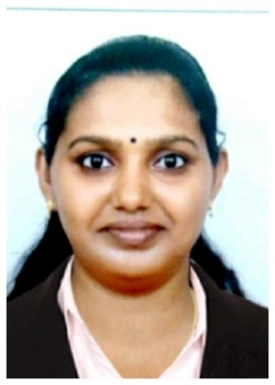

**Arattupuzha, Alappuzha**

**Cell Phone: +919656486183**

**E-Mail:** [**prajitha.galeena@gmail.com**](mailto:prajitha.galeena@gmail.com)

# objective

*Seeking a career oriented position in a progressive organization where my professional experiences and academic knowledge will enable me to make significant contributions and where I will have an opportunity for personal development*.

# functional skills

|  |
| --- |
| * Comprehensive problem solving ability & decision making. * Excellent communication skills. * Good presentation skill. * Ability to deal with people diplomatically. * Customer service and orientation. |

# PROFFECIAN SUMMERY

* **ACCOUNTANT at M/S SIVAPRASAD & ASSOCIATES CHARTERED ACCOUNTANT, ALAPPUZHA** **(From 1st May 2015 to 31st August 2018** )

**Job summary.**

The position is highly specialized and the successful candidate will be responsible for all accounting related tasks in the company and routine reconciliations to ensure accuracy in the internal system. Also the candidate will be responsible for preparation of reports to management and the annual financial statements for the Company.

**Duties and Responsibilities**

* Creat financial reports, analize, examine and interprete records, reconcile report and financial data.
* Process journal entries and perform correction to ensure accureate records.
* Handiling day to day financial closing.
* Prepare company accounts and GST returns.
* Manage accounts payables, account receivables and payroll dipartments.

# education and achievement

|  |  |  |  |
| --- | --- | --- | --- |
| **Course** | **School / College** | **Board / University** | **Year of Pass out** |
| M.com(Accounting and Finance) | Distance Education | Annamalai University | 2015 |
| B.com(Computer Application) | University Institute of Technology, Alappuzha | Kerala University | 2012 |
| HSE – Commerce | SNMHSS,Alappuzha | State Board | 2009 |
| SSLC | SNMHSS, Alappuzha | State Board | 2007 |

# computer skills

**Operating Systems:** Windows 2000, Windows XP

**Office Package:** Microsoft Word, Excel, PowerPoint, Tally.

# languages KNOWN

Malayalam, English, Hindi

# personal details

Date of Birth : 17/05/1991

Nationality : Indian

Passport No : S8952080

# DECLARATION

I do hereby declare that the particulars of information and facts stated herein above are true, correct and complete to the best of my knowledge and belief.

Place:

Date: Yours Sincerely

Prajitha Prasannan