**ASIF.I.S**

Contact No.: 8129575915

E-mail: asifasif640@gmail.com

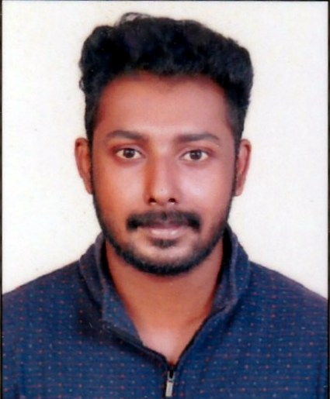

**CARRIER OBJECTIVE**

To work in a firm with a professional work driven environment where I can utilize and apply my knowledge, skills which would enable me as a fresh graduate to grow while fulfilling organizational goals.

**BASIC ACADEMIC CREDENTIALS**

|  |  |  |  |
| --- | --- | --- | --- |
| **Qualification** | **Board/University** | **Year** | **Percentage** |
| M.com | ANNAMALAI UNIVERSITY | 2019 | 56% |
| B.com with computer application | MARTHOMA COLLEGE OF SCIENCE AND TECHNOLOGY, AYOOR  (KERALA UNIVERSITY) | 2016 | 62% |
| Higher Secondary | S.V.B.H.S.S  Pothencode | 2013 | 73% |
| High School | N.B.H.S.S  Attingal | 2011 | 75% |

**PROJECTS REPORT**

* **Company Name:** EMMANUEL CASHEW INDUSTRIES
* **TOPIC:** Cost Volume Profit Analysis

**Professional Summary “Total Experience of 3 years”**

Result driven professional having rich experience in management of Accounting and finance operations in computerized environment, Preparation of Financial Reports, Cash Management. Rich exposure of performing assigned job with minimum supervision. Main Areas of skills are: Financial Analysis, Cash Flow, Inventory Control, payroll, Tax Analysis.

**Work Experience**

**Finance Executive May/2017 - Nov/2018**

**Nakshatra Associates (Tax, Audit & Accounts Consultants) Trivandrum, Kerala**

* Financial Statements disclosure requirements as per relevant laws, and International Accounting Standards.
* Financial Statements Analysis, Income tax matters including determination of taxable income and calculation of tax liability of companies.
* GST matters specifically from viewpoint of Financial Statements.
* Worked in Projected Accounting.
* Handled Account Reconciliation.
* Assisted in Internal Audit related Matters.
* Conducted Statutory Audits of Several Trading Companies**.**

**Accountant April /2016 - April/2017**

**Accountants Service Society Thrissur, Kerala**

* General Ledger Accounting.
* Account Analysis and Reconciliation of G/L accounts.
* Month, Quarter & Year end close.
* Expenses Reporting and Analysis.
* Accounts Receivable/Accounts Payable.
* Bank Reconciliation.
* Financial Statement Preparation & Analysis.
* Billing.

**IT PROFICIENCY**

* Sap FICO, Sap Business one, Microsoft Office Word, Microsoft Office Excel, Microsoft Office Power Point, Tally, Typing skill 35 words per minute.

**ACHIEVEMENTS**

* Won prizes in various co/extra-curricular in schools and colleges.
* Actively participated in various sports activities for school
* Take part in many Social work

**INTERPERSONAL SKILL**

* Ability to rapidly build relationship and set up trust.
* Confident and Determined
* Ability to cope up with different situations.

**PERSONAL DETAILS**

**Name Father’s :-** Ismail. M

**Name Mother’s :-** Safeela Mani. A

**Permanent Address :-** A.K.Manzil (V.T.E.R.A, B-2 Lane - 04)

Kannancode, Venjaramoodu (P.O),

Thiruvananthapuram, Kerala

**Pin Code :-** 695607

**Date of Birth :-** 27/10/1994

**Language Known :-** English, Tamil, Malayalam, Hindi

**Marital Status :-** Single

**Nationality/Religion :-** Indian /Islam

**Interest & Hobbies :-** Internet browsing, Reading, Playing football& cricket, Social

Activities, Driving, Riding, Travelling, Listening Music

**DECLARATION**

I do hereby declare that the above information is true to the best of my knowledge**.**

**Place: Venjaramoodu Asif.I.S**

**Date: 16/04/2020**

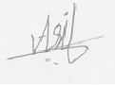

**(Signature)**