**VARSHA BABU VM**

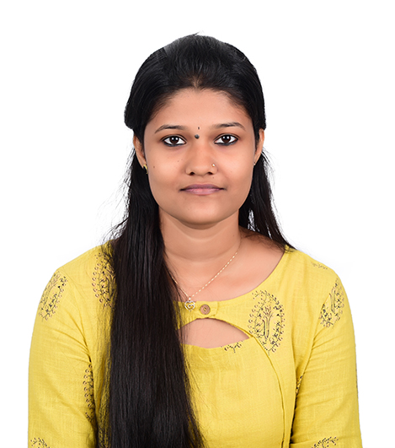

**B.Com Commerce with Computer Application**

**“Harshom”, Thannimoodu**

**Puliyarakonam PO**

**Trivandrum -695573 E-mail :** [**varsha.vm6@gmail.com**](mailto:vandanabvm3@gmail.com)

**Kerala, India Phone no : +91- 6235127052**

**OBJECTIVE:**

**Seeking a challenging opportunity in an organization to excel and grow along with the organization by utilizing my knowledge and acquired skills towards fulfillment of organizational vision.**

**EDUCATIONAL QUALIFICATIONS:**

|  |  |  |  |
| --- | --- | --- | --- |
| **Qualification** | **Board/ University** | **Year of**  **Passing** | **Percentage**  **(%)** |
| **BCOM – CA** | **Kerala University** | **2020** | **Result awaiting** |
| **PLUS TWO** | **HSE** | **2016** | **65** |
| **10th** | **ICSE** | **2014** | **60** |

**SOFTWARE PROFICIENCY:**

* **Programming languages : Html**
* **Operating systems : Windows XP**
* **Software used : MS Word, MS PowerPoint**
* **Others : Internet Surfing for latest technologies**

**MY SKILLS:**

* **Good Communication skill**
* **Presentation skill**
* **Quick learner**
* **Good Team Player**
* **Hardworking**

**INTER PERSONAL SKILL:**

* **Can lead an organisation in the best and positive way.**
* **Punctual and disciplined.**
* **Ability to cope with different situations.**
* **Confident and determined**
* **Hardworking towards the achieving goals.**

**PERSONAL PROFILE:**

**Name : Varsha Babu. VM**

**Father’s Name : G. Mahendra Babu**

**Date of Birth : 03/12/1997**

**Gender : Female**

**Marital status : Single**

**Nationality : Indian**

**Languages Known : Malayalam, English and Tamil**

**Address : “Harshom”, Thannimoodu**

**Puliyarakonam PO**

**Tvm-695573**

**DECLARATION:**

**I hereby declare that the information furnished above is true to the best of my knowledge and subject to verification.**

**Date :**

**Place : Trivandrum VARSHA BABU VM**