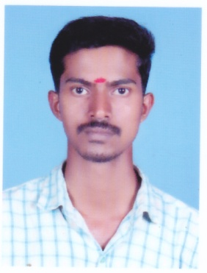**MAHESH.P**

**E-mail:-**

Maheshpkannan1995@gmail.com

**Address for Communication:-**

MANNANVILAKATHU VEEDU

PULLAYIL(PO)

Kilimanoor

Thiruvananthapuram

Kerala, India- Pin 695601

**Mobile: 9947254320**

**Personal Data**

Date of Birth : 31/05/1995

Sex : Male

Nationality : Indian

Marital status : Single

**Languages Known**

English, Hindi and Malayalam

**Education**

**➢ BA political science**

**(Kerala University 2013-2016)**

**➢ Plus Two (Humanities)**

**Second Class**

**(Kerala higher Secondary Education 2013)**

**➢ SSLC**

**(Board of Public Examination, Kerala 2011)**

**Additional Qualification**

**➢ Computer Basic**

**EXPERIENCE**

Two year exposure as accountant and business executive in moneymuttathu nidhi limited (presently working) Trivandrum dist

**Personal Details**

Nationality : Indian

Date of Birth : 31/05/1995

Gender : Male

Marital Status : Single

**Declaration**

I hereby declare that the above particulars are true to the best of my knowledge and belief.

Place: Thiruvananthapuram Mahesh.P