**CURRICULAM –VITAE**

**ANURAJ K R**

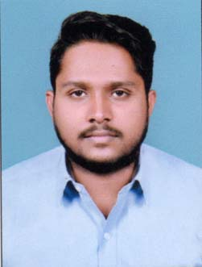

A B BHAVANAM

VENGARA THODIYOOR NORTH PO

KARUNAGAPALLY

KOLLAM KERALA

MOB:7902908823, 9745508668

MAIL ID: [anuraj9745@gmail.com](mailto:anuraj9745@gmail.com)

**CARRER OBJECTIVE**

To be part of growing and reputed organization , which provide sample opportunities for me to utilize my knowledge and skill thereby , contribution to this success of the organization and thus leads to my personal growth.

**EDUCATIONAL QUALIFICATION**

* SSLC (Kerala Board)
* PLUS TWO COMMERCE ( Kerala Higher Secondary Board)
* Degree –BBA( Kerala University)
* Doing MBA( Kerala University )

**PROJECT**

* Project held in SOUTHERN RAILWAY , kollam section

TOPIC:  **CUSTOMER SATISFACTION**

**LANGUAGES KNOWN**

* ENGLISH
* MALAYALAM
* HINDI
* TAMIL

**PERSONAL PROFILE**

Name : **ANURAJ K R**

Father’s Name : Rajagopala Pillai

Mother’s Name : Usha Kumari.P

Date of Birth : 03/10/1995

Gender : Male

Nationality : Indian

Marital Status : Single

Religion : Hindu

Permanent Address : A B Bhavanam

Vengara, Thodiyoor North.P.O

Karunagapally

Kollam, Kerala-690523

**EXPERIENCE**

1. **ISON BPO** : ONE YEAR AS CUSTOMER RELATION QUALITY
2. **MUTHOOT HONDAKOLLAM** :TWO YEAR AS CUSTOMER RELATION OFFICER (CRO)

**PASSPORT DETAILS**

Passport No : S 5170816

Date of Issue : 22/10/2018

Date of Expiry : 21/10/2028

Place of Issue : Trivandrum

**REFERENCE**

Ranjith Mohan

Mob:+971503994503

Email :ranjithmohanpr@gmail.com

**DECLARATION**

I hereby declare that above mentioned information is correct at my knowledge & belief. I bear the responsibility correctness of the above mentioned particulars.

Place : Karunagapally SD/-

Date : ANURAJ K R