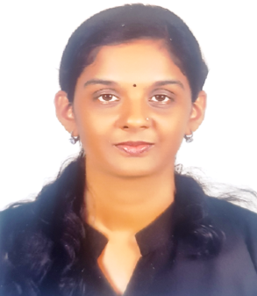**Curriculum Vitae**

**PARVATHY S**

Sujikrithy, Kurumandal B

Paravur P.O, Kollam

India

Mob: +91-6235453676

Email: [sreeparu311290@gmail.com](mailto:sreeparu311290@gmail.com)

**OBJECTIVE**

To seek a challenging and successful career and development in order to expand my horizon. To excel in assigned responsibilities and thereby ensure career growth.

**EDUCATIONAL QUALIFICATION**

* M.Com ( IGNOU University )
* B.Com ( Kerala University in the year 2014)
* HSC
* SSLC

**COMPUTER SKILLS**

**Operating system:**

Windows 2000, Windows XP, Windows 7 – 10, LINUX, Ms-Dos

**Office Package:**

Microsoft Word, Excel, Power point

**Accounting Package**:

Tally

**WORK EXPERIENCE**

Two year accounting experience in CET SKILL EXCELLENCE from January 2015 to February 2017

**HOBBIES**

**Music, Reading books and Newspapers**

**SKILLS**

* **Customer Service skills**
* **Time Management Skills**
* **Problem Solving skills**

**PERSONAL STRENGTH**

* **Good, Analytical Communication Skills**
* **Willingness to learn**
* **Patient and strong work ethics**

**PERSONAL PROFILE**

**NAME**  : PARVATHY. S

**FATHER ‘S NAME**  : SURESHBABU ASAN M

**MOTHER'S NAME** : AJITHA SURESH

**DATE OF BIRTH**  : 18/10/1989

**GENDER** : FEMALE

**MARITAL STATUS** : MARRIED

**PASSPORT NO** : J9903245

**PASSPORT EXPIRY** : 10-10-2021

**DRIVING LICENSE** : YES (INDIAN)

**NATIONALITY** : INDIAN

**LANGUAGES KNOWN** : ENGLISH, HINDI, TAMIL, MALAYALAM

**DECLARATION**

I hereby declare that the above mentioned information is correct to the best of my knowledge and belief.

**Place: Kollam** **PARVATHY. S**

**Date: 27-02-2020**