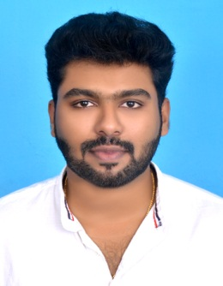**RESUME**

**VIPIN. V.P**

PPI/793

Sivashakthi

Chattumukku, Idavanthode,

Edacode, Nemom.P.O.

Thiruvananthapuram

Mob : 0091 - 9656113334

Email : vipinvp379@gmail.com

# OBJECTIVE

To obtain a position in my carrier that will enable me to use my strong organizational skills, educational background and ability to work well with leaders on accomplishing the organization task.

# EDUCATIONAL QUALIFICATION

* BCOM (Taxation Law & Accounts)
* Plus Two
* S.S.L.C

# AREA OF SPECIALISATION

* Commerce, Finance & Accounts

# TECHNICAL QUALIFICATION

* Computerized Accounting (Tally)
* Well versed with MS Office & Internet Applications

# WORKING EXPERIENCE

* Working as Accountant in charge from Oct 2010 to 2014, Inevite Technologies, Marapalam, Pattom, Trivandrum, Kerala
* Working as Accounts Assistant in charge since Sep.2014, ‘Somatheeram Ayurveda’ Group, Trivandrum, Kerala
* Working as Music Teacher from May 2014 to 2016, Holy Family English Medium High School, Pachalloor, Trivandrum
* Working as Music Teacher since June 2016, Govt. Regional Technical Fisheries High School, Valiathura, Trivandrum

# QUASI ACADEMIC QUALIFICATION

* First prize in light Music & Recitation at State Level Competition
* Won CCRT Scholarship (New Delhi) in Carnatic Music Vocal
* “Kalaprathibha” in Sub District Level
* Won scholarships at school level
* Won prizes in cultural competitions at school level.

# AREAS OF INTEREST

* Finalization of Accounts
* Auditing of Accounts
* Singing
* Teaching Music

# PERSONALSTRENGTH

* Sincerity towards job and punctuality.
* Ambitious, hardworking and well disciplined.
* Positive thinking self-motivated.

# PERSONAL PROFILE

Date of Birth : 22-12-1988

Father’s Name : K.Vijaya kumar

Marital Status : Married

Nationality : Indian

Languages known as : Malayalam, English, Hindi & Tamil

Driving Licence No. : 1/1083/2008 (Date of Expiry - 30.01.2028)

Passport No. : K3754161 (Date of Expiry - 15.04.2022)

**DECLARATION**

I declare that the above furnished details are true and correct to the best of my knowledge and belief.

**VIPIN. V.P**

Place : Thiruvananthapuram

Date :