**SAMEEM KALLAR MANGALAM**

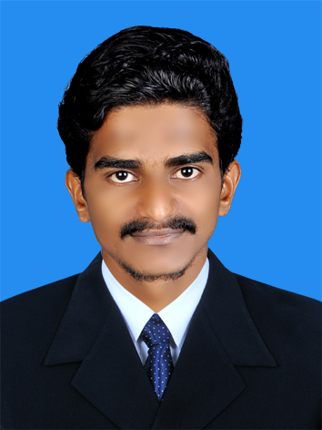

Mob: +91 9526752801

E-mail: sameemkunju@gmail.com

_____________________________________________________________________________________

**Objectives**

To obtain a challenging position in forward looking companies for utilizing my skills and abilities that offers professional growth while being resourceful, innovative and flexible. I want to be creative , learning and contributing towards the success of the company.

**Work Exposure**

Good work exposure in handling accounts of any type of business organization from vouching to preparation of final accounts. Experience in handling Tax Affairs and working knowledge in preparation & e-Filing of Tax returns. Work experience in modern computer accounting software.

**Educational Qualifications**

|  |  |  |  |  |  |
| --- | --- | --- | --- | --- | --- |
| **Sl.No** | **Course** | **Name of Institution** | **Board/University** | **Percentage Of Marks** | **Year Of passing** |
| **1.**  **2.**  3. | **B COM**  **+2**  **SSLC** | **PARAPPANAGADI CO-OPERATIVE COLLEGE**  **KHMHSS VALAKKULAM**  **KHMHSS VALAKKULAM** | **CALICUT UNIVERSITY**  **HSE**  **KERALA STATE** | **59%**  **66%**  **72%** | **2019**  **2016**  **2014** |

**Computer Knowledge**

* PG Diploma in Business Accounting & Management ( PGDBAM ) from IPA Kerala ( 2015 ).
* Knowledge in SAP - Business One : Global Certificate Holder ( 2015 ).
* Knowledge in MS Office- Microsoft Excel Global Certificate Holder ( 2015 ).
* Specialized in Tally ERP 9.0,Peachtree & Quick Books Accounting Software.
* Knowledge in Computer Fundamentals, Windows XP, Windows 7,Linux.

**Language Competency**

* English --- Speak , Write , Read.
* Malayalam ---Speak , Write , Read.
* Hindi ---Speak , Write , Read.

**Abilities and Area of Strength**

* Ability to work efficiently & effectively in a confidential work environment and to rapidly acquire knowledge.

**Personal Details**

* Nationality : Indian
* Date Of Birth : 12/08/1997
* Marital Status : Single
* Gender : Male
* Father's Name : Mr.HAMZA
* Driving License : LMV/HMV No:65/3387/2016 ( INDIA )
* Address : KALLAR MANGALAM ( House )

VALAKKULAM(P/O)

VALAKKULAM

MALAPPURAM

________________________________________________________________________

**Declaration**

I hereby declare that the details furnished above are true and correct to the best of my knowledge and belief.

Place:9526752801

Date : **Name:SAMEEM**

_________________________________________________________________________