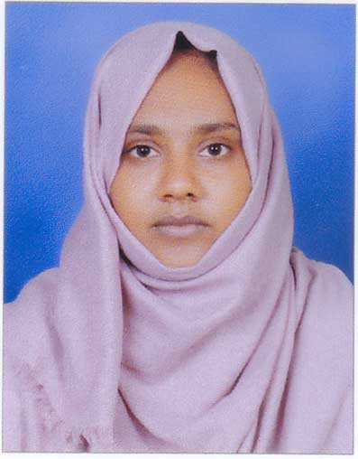

**ANSI N**

**(M COM, Finance)**

KAIPALLY HOUSE,

CHITTATTUMUKKU P.O

KANIYAPURAM

Contact No : 9567032234

ansy1992j@gmail.com

**CAREER OBJECTIVE**

To convert opportunity into success and achieve excellences through hard work and do my best to contribute in achieving organisation goals.

**SKILLLSETS**

* In depth knowledge of Accounting & Taxation.
* Good communication skill.
* Self confidence.
* Optimistic.
* Knowledge seeker.
* Patience.

**ACADEMIC QUALIFICATIONS**

* M Com (Finance)

(2015) University of Kerala

* B Com (computer Application)

(2012) University of Kerala

* Higher Secondary

(2009) Board of Higher secondary examination Kerala

* SSLC

(2007) Kerala State Board

**RELAVENT TRAININGS & CERTIFICATIONS**

* 2015 SAP FICO ERP (Module in ECC 6.0)
* 2014 Diploma in Computer Application
* 2012 Tally ERP 9
* 2007 MS Office

**PERSONAL DETAILS**

Date of Birth : 6th may 1992

Father’s Name : Abdul Karim

Sex : Female

Religion & Caste : Islam Muslim

Nationality : Indian

Marital Status : Married

Languages Known : English, Malayalam,Hindi, Arabic

**PASSPORT DETAILS**

Passport No :

Date of Issue :

Date of Expiry :

.

**DECLARATION**

I hereby declare that the particulars of information and facts stated above are true, correct and complete to the best of my knowledge.

Place : Trivandrum

Date : **ANSI N**