**CURRICULUM VITAE**

ARUN.S.R 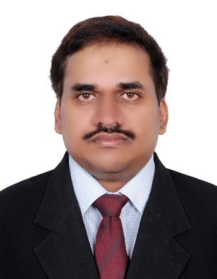

T.C.11/435,”ROHINI”,

NANTHANCODE,

THIRUVANANTHAPURAM-695003

PHONE:0471-2316543

EMAIL:arunsomasekharan4@gmail.com

---------------------------------------------------------------------------------------------------Objective:To become established in life through a stable and progressive company offering career growth through proven performance.

Educational Qualification

*B.Com passed(University of Kerala)

*Pre-Degree (Fourth Group(Commerce) University of Kerala

*S.S.L.C (Kerala Board of Examination)

Technical Qualification

*Tally from CGI.

*Graduate Diploma In Information Technology(GDIT).

*Typewriting English Lower under KGTE.

Passport Details

Passport No : P 1392681

Date of passport : 08/11/2016

Expiry date of passport : 17/11/2026

Place of issue : India

**Languages Known**

Malayalam, English and Hindi.

**Work Experience**

*Worked as Accountant in M.K.S.Egg Merchant,Attakulangara ,Trivandrum from November 2017 to 15th February 2020.

*Worked as Accounts Assistant cum Computer Operator in a Sales Tax Consultant.(Roby Associates,Kesavadasapuram,Thiruvananthapuram.(August 2014 to January 31st 2017).

*Worked since November 2008 to November 2013 as Data Entry Operator Cum Accounts Assistant in Almaya Group Of Company, Dubai,UAE

*August 2007 to January 2008 worked as Accounts Assistant in Soorya Enterprises (Sanitary ware shop),Trivandrum.

*February 2002 to July 2006-Worked as Audit Clerk at Lalji&Co.Chartered Accountants,KTUC Building,Nanthencode, Trivandrum-695003.Phone:2310592

**Job Description:**

# Preparation of Purchase and Sales Accounting.

# Maintenance of Inventory control, Preparation of GRV,Invoices.

# Processing transactions, issuing cheques, and updating ledger etc.

# Modification and Updating of Invoices.

# Providing Financial information to the management.

# Stock maintenance at the time of Stock taking.

# Overall maintenance of Books Of Accounts.

# Finalization of Accounts.

# Reconciliation of Debtors and Creditors.

# Statutory Audit of Banks.

# Filing of Monthly GST Returns.

# Liaise with Government agencies such as Income Tax Departments,Sales Tax

Department etc and Banks for the various clients of the firm.

Work experience in Accounting packages such as Tally and Indus XL.

Work Experience in MS Office 2000(word, excel and power point)

Work experience in JD Edward software.

Address : “ROHINI”,T.C.11/435,

Nanthencode,Kowdiar,

Trivandrum-695003

Kerala, India

Phone : 0471-2316543(Residence India)

9633758793

Father’s Name : V.SOMASEKHARAN

Date of Birth : 03-08-1978

Marital Status : Married

Religion and Caste : Hindu,Ezhava

Nationality : Indian

Declaration: I hereby declare that all particulars given above are true to the best of my knowledge.

Place: Trivandrum Arun.S.R