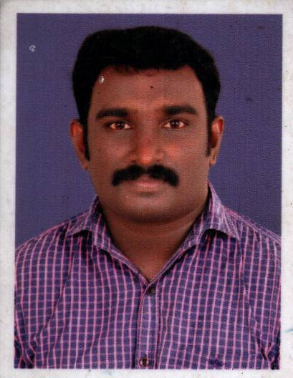**JOEL DANIEL**

DJ Villa

Mampra P.O.

Kodukulanji, Chengannur

Alappuzha (dist.)

Kerala – 689 508

Ph: 0479-2354731, 9497683141

Email:joeldaniel64@gmail.com

**---------------------------------------------------------------------------**

**CAREER OBJECTIVE**

To obtain An Manager level position in a reputed company and put to good use my abilities to achieve the organizations goals and there by my personal goals.

**CORE COMPETENCIES**

* Leadership Quality
* Good Adaptability
* Friendly character
* Team player

**EDUCATION QUALIFICATIONS**

|  |  |  |  |  |
| --- | --- | --- | --- | --- |
| **COURSE** | **UNIVERSITY** | **SCHOOL/COLLEGE** | **Specialization** | **YEAR OF PASSING** |
| MBA | M.G University | Micro Engg.& Computer Technology College, Pandalam. | Marketing & HRM | 2013 |
| B.Com | Kerala | Imperial College,Mavelikara | Co-Operation | 2006 |
| VHSE | Board of Vocational higher Secondary Examinations, Kerala | Mulakuzha Vocational higher Secondary School. | Office Secretary ship | 2001 |
| SSLC | Board of examination, Kerala | DB H.S. Cheriyanadu. | General | 1999. |

**WORK EXPERIENCE**

* Currently working with Nilkamal Pvt ltd as Accounts Cashier from May 2015
* Working as a Logistic Officer in Sabari Distribution Pvt Ltd from Nov2011 to May 2015
* One year experience as a Accounts Assistance Cum Office Assistance in Harikumar & Company, Chartered Accountants Tax Practitioners Mavelikara.

**MAJOR PROJECT**

* Company **FLOORA TEX**

Duration 7th April 2006 - 8th May 2006

Designation Management Trainee (Marketing)

Project Title Customer Satisfaction.

* **A knowledge oriented industrial visit on EASTERN COMPANY**

**COMPUTER PROFICIENCY**

* Computer Knowledge : M.S. Word, Excel, Power Point, Tally 9.0
* Typing Speed : 40 words per minute

**HOBBIES AND INTEREST**

* Making friends
* Listening to music

**PERSONAL DETAILS**

* Date of birth 23/04/1984.
* Name of father Daniel Joseph.
* Nationality Indian.
* Gender Male
* Marital status married
* Languages known English, Hindi, and Malayalam.

**PASSPORT DETAILS**

Passport No : H 5047030

Place of Issue : Cochin

Date of Issue : 30-09-2009

Date of Expiry : 29-09-2019

**REFERENCES**

* **Principal**, Raveendran MA, MA, PhD. Micro Engg. And Computer Technology, Pandalam.

**Declaration**

I Joel Daniel here by declares that above information given by me is true to best of my knowledge and belief.

**Place: Cheriyanadu**

**Date:**

**Joel Daniel**