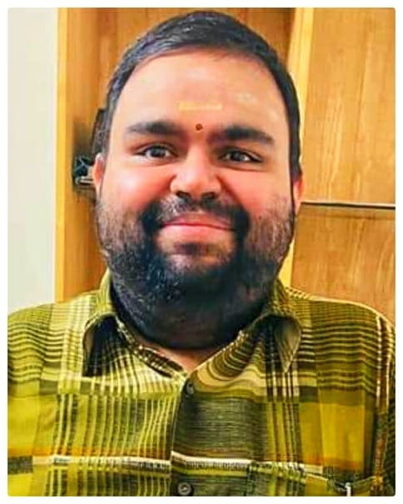**KALYAN SANKAR.S**

**Address :TC 38/353,Door No: 198**

**‘KALYAN’**

**Valiachalai Street.**

**Trivandrum-695036**

**E-mail:skalyansankar@gmail.com**

**Mobile: 9400400913, 0471-2573712**

## Career Objective

**To get associated with prestigious and progressive organization that gives scope to apply my knowledge and skill. To be a part of team that dynamically works towards growth of the organization and to use the opportunity as a platform in my Career**.

* Personal Profile
* Belief in team work, initiative, hard work, sincerity and the will to carry out the assignment in the specified time limit.
* Have ability to do any nature of work and can handle any department as required by the management.
* Have analytical and problem solved capacity and a creative mindset.
* Responsible and self-motivated person
* Ability to learn, adapts well to the new technology.
* Ability to achieve objectives or task as independently or as a team member.
* Highly optimistic and dedicated smart worker with a highly adaptable nature
* Have more than twelve years of experience for smooth functioning of an organization.
* **Educational Qualification**
* **B.Com** : Accounts & Commerce from University of Kerala.
* **Technical Qualification**

* **DCA :** Diploma in computer Applications from LBS Trivandrum**.**
* **‘O’ LEVEL :** Business Professional Programmer from DOEACC**.**
* **Computer Skills**

1. MS Word, Access, Excel, Power point
2. SQL
3. Visual Basic
4. Epfo, Esic, E-filing- Income tax
5. Tally
6. FoxPro & Visual FoxPro
7. DBMS

* **Work Experience**

|  |  |  |
| --- | --- | --- |
| **Company** | **Position held - From - To** | **Nature of Work** |
| Jothydev’s Diabetes Research Centre & Hospitals Pvt.ltd | Accountant   * June 2020 | * Preparation of accounts work in tally, administration activities & correspondences * GST data extraction, TDS remittance & payments. |
| APJ Abdul Kalam Technological University | Assistant on contract   * April 2018 to June 2020 | Assistant to Registrar (Administration Section) |
| * Managed the day to day office operations. |
| * Assist in all administrative tasks and administration of Office |
| * Coordinated all meetings |
| * Handled Visitors, inwards and outwards letter/mails. |
| * Performs any other work as assigned from time to time by the Registrar |
| Finance & Accounts Section |
| * Prepared monthly Accounts in excel & tally |
| * Provided salary to employees and other things related to pay arrear and increments |
| * Supported and coordinated establishment activities. |
| * Maintaining of Fixed deposits with bank for renewal and closure on due dates. |
| * Online transfer of payments to third parties through online banking. |
| The Central Scientific Supplies Co. Ltd | Branch Manager Trainee (Contract)   * December 2016 November 2017 | * Managed the day to day office operations and correspondences. * Performs the tasks of maintained administrative records of the organization. * Assist in all administrative tasks and administration of office and preparation of accounts work in tally. * Provided Establishment expenses and salary. * Meeting the customers for orders and promotion of sales. * Cash Receipts, payments and Co-ordination. * Verification accounts and vouchers. * Sending of reminder letter to customers for amount due from them and collected Cash/Cheque. * Executed all clerical work and liaison work. |
| Assistant Manager (Contract)   * January 2012 to December 2012 |
| Office Assistant/Computer Assistant (trainee)   * May 2007 July 2009 |
|  |
| University of Kerala | DEO (Section Assistant on contract)   * September 2013 November 2016 | * Monitor and coordinate all meetings, recording of minutes and follow up actions. * Informing committee member, giving intimations, circulars and coordinates all the activities for smooth conduct of meetings. * Handled correspondence letter, Secretarial work, and reply to (RTI if required) and same nature of work as mentioned above. |
| Tata Capital Financial Services Ltd | CRE(Customer Relationship Executive)/Sales Coordinator   * February 2013 August 2013 | * Cash Receipts and payments. * Cash collections from the customers. * Sales support & assisted walk in customers to sales executives for promotion of sales. * Logins and disbursement of application, for auto loans by customers, checked the status through LOS and replay to queries by Credit Mangers * Initiated FI,RCU and Collected reports from them and same nature of work as mentioned above. |
| Kerala Gandhi Smarak Nidhi | Internal Auditor/ Audit Assistant (Contract)   * September 2010 December 2011 | * Verification of Vouchers with cashbook and ledgers. * Verification of bills of sales depots with cashbook and ledgers. * Prepared trial balance, reconciliation of accounts. * Coordinates with Audit Superintendent for Accounts finalization, making consolidated statements and Audit Report. * Assists with the Audit Superintendent for various accounts and finance activities. |
| CA Firm | Audit Assistant   * August 2009 August 2010 | * Coordinates and assist with Audit Head for Accounts finalization, making consolidated statements and Audit Report. Assists with the Audit Head for various accounts and finance activities. |

* **Personal Data**
* **Date of Birth** :05/07/1986**.**
* **Name of Parents** :S.Subba Iyer, K. Brahan Nayaki**.**
* **Marital Status** : Single
* **Nationality** : Indian
* Languages Known

1. English (Write – Read - Speak)
2. Hindi (Write – Read - Speak)
3. Malayalam (Write – Read - Speak)
4. Tamil (Speak only)

* **Reference**

1. Smt.Bindu.R , Assistant Registrar, University of Kerala, Palayam, Thiruvananthapuram, Mobile:09847900986.
2. Sri.S.Hari Kumar, Assistant Registrar University of Kerala, Palayam, Thiruvananthapuram, Mobile:09447869988
3. Siju D.G,Sales Manager,Tata Capital Financial Services Ltd,Thiruvananthapuram

Mobile:09037000449, 08089040978.

### Declaration

I hereby declare that the information furnished above is true to the best of my knowledge and belief.

Place : Trivandrum

Date : 03/12/2020

**Kalyan Sankar. S**