**KANNAN P.K. 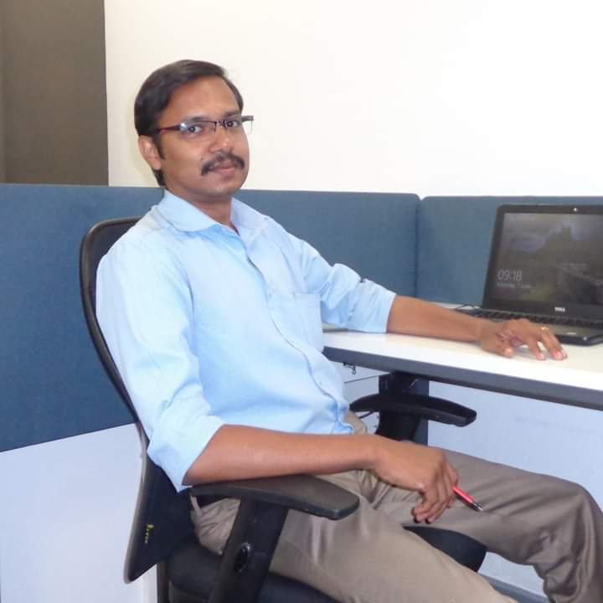**

Ph: 09809174291

1. mail: [kannantvpm84@gmail.com](mailto:kannantvpm84@gmail.com" \t "_blank)

CAREER OBJECTIVE

# Seeking a challenging position professionally where I can utilize my extensive experience and significantly contribute to the growth of the organization. I am open to face challenges and also solve them efficiently in a progressive & friendly environment.

PROFESSIONAL SKILL SET

Recruitment, Leave Management, Payroll Management, Administrative & Organizational Skill, Performance Appraisal

Leave Management, Exit Formalities, Interview Co-ordination, On boarding& Induction, Data Management

EDUCATIONAL QUALIFICATIONS

* Bachelor in Law (LLB) University of Kerala, Kerala Law Academy Law College,

Trivandrum, Kerala State India 2010-13

* Master of Business Administration. (MBA) Periyar University,

Avs College of Arts and Science, Salem Tamil Nadu State, India 2008-2010

COMPUTER MANAGEMENT

* ERP, Tally 9.
* Windows MS-Office (MS Excel, Word &, PowerPoint).

EMPLOYMENT HISTORY

1. **Senior HR Executive**

Company: BigdataInt Engineers Private Limited. Infopark, Kochi

From April 2018 till date.

1. **HR Executive**

Company: Oalva,Inc.

From March 2017 till March 2018.

1. **MIS Executive, Center Manager and State Head**

Company: Coffee Day Global Limited.

DDU GKY Project (Residence) From December 2015 till February 2017.

1. **Senior HR Executive**

Company: Kites Training Academy – Kollam and Ernakulam

Since Feb 2015 till Dec, 2015.

1. **Admin & HR Executive**

(Handling Accounts, HR Activities & Administration)

APOLLO CLINIC, Mogappair Branch, Chennai since Feb 2014 till Feb 2015 (1.2 years)

1. **Admin Executive**

Company: Kites Training Academy Kollam

Since May, 2013 till Feb, 2014.

1. **ACCOUNTS TRAINEE.**

M/s ISSAC & SUDHAKAR, Chartered Accountants • Since April, 2007 till March, 2008.

1. **ACCOUNTS EXECUTIVE.**

TAXATION CONSULTANCY CENTER • Since March, 2006 till April, 2007.