MOODLIGHT

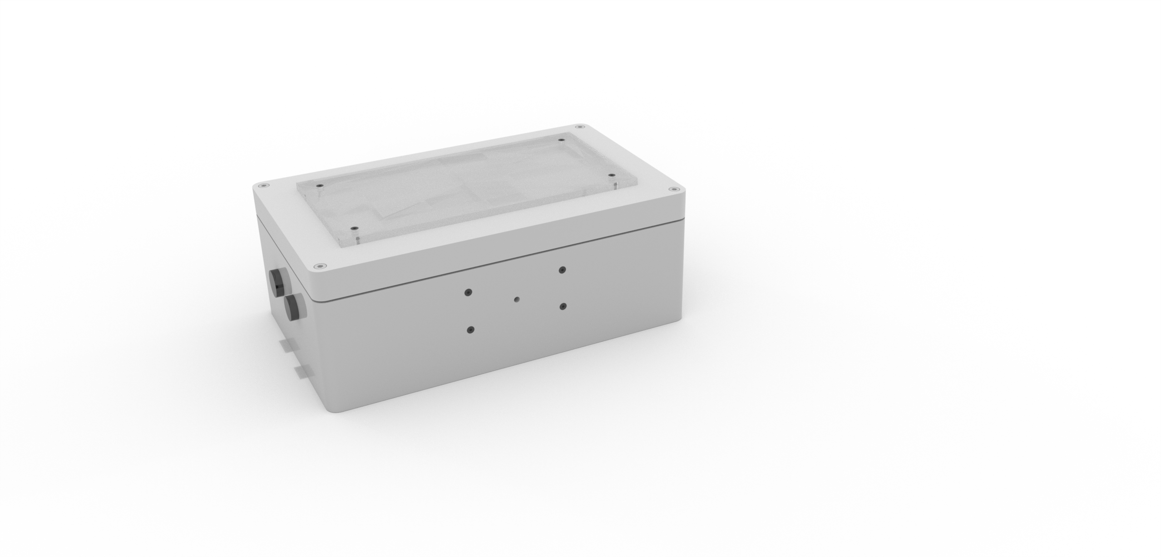

FUNCTIONALITY OVERVIEW

The Moodlight has five different modes, which can be selected on the app.

RGBW-Mode

Displays the colour which is selected on the colour circle.

Slider-Mode

Displays the colour which is adjusted with the sliders.

Temperature-Mode

The colour spectrum is determined by the ambient temperature. The higher the temperature, the greater the red portion. The lower the temperature, the greater the blue portion.

Fade-Mode

The Moodlight continuously runs through the individual colour portions.

Strobo-Mode

The Moodlight generates random colour combinations every second.

Illumination Settings

The brightness of the Moodlight is proportional by the ambient light. This functionality can be inverted. This means the brighter the ambient light, the darker the Moodlight.

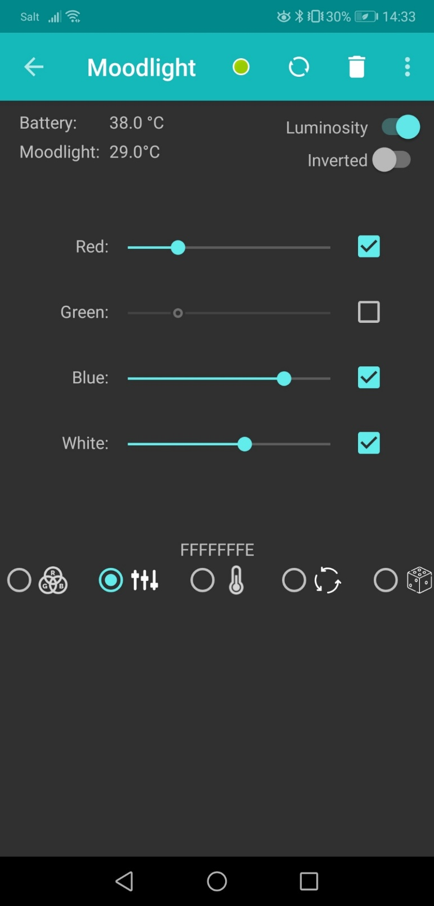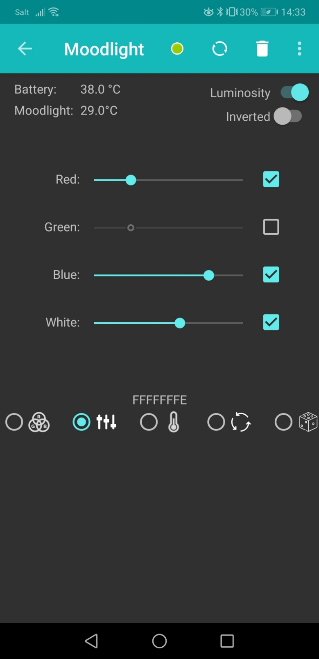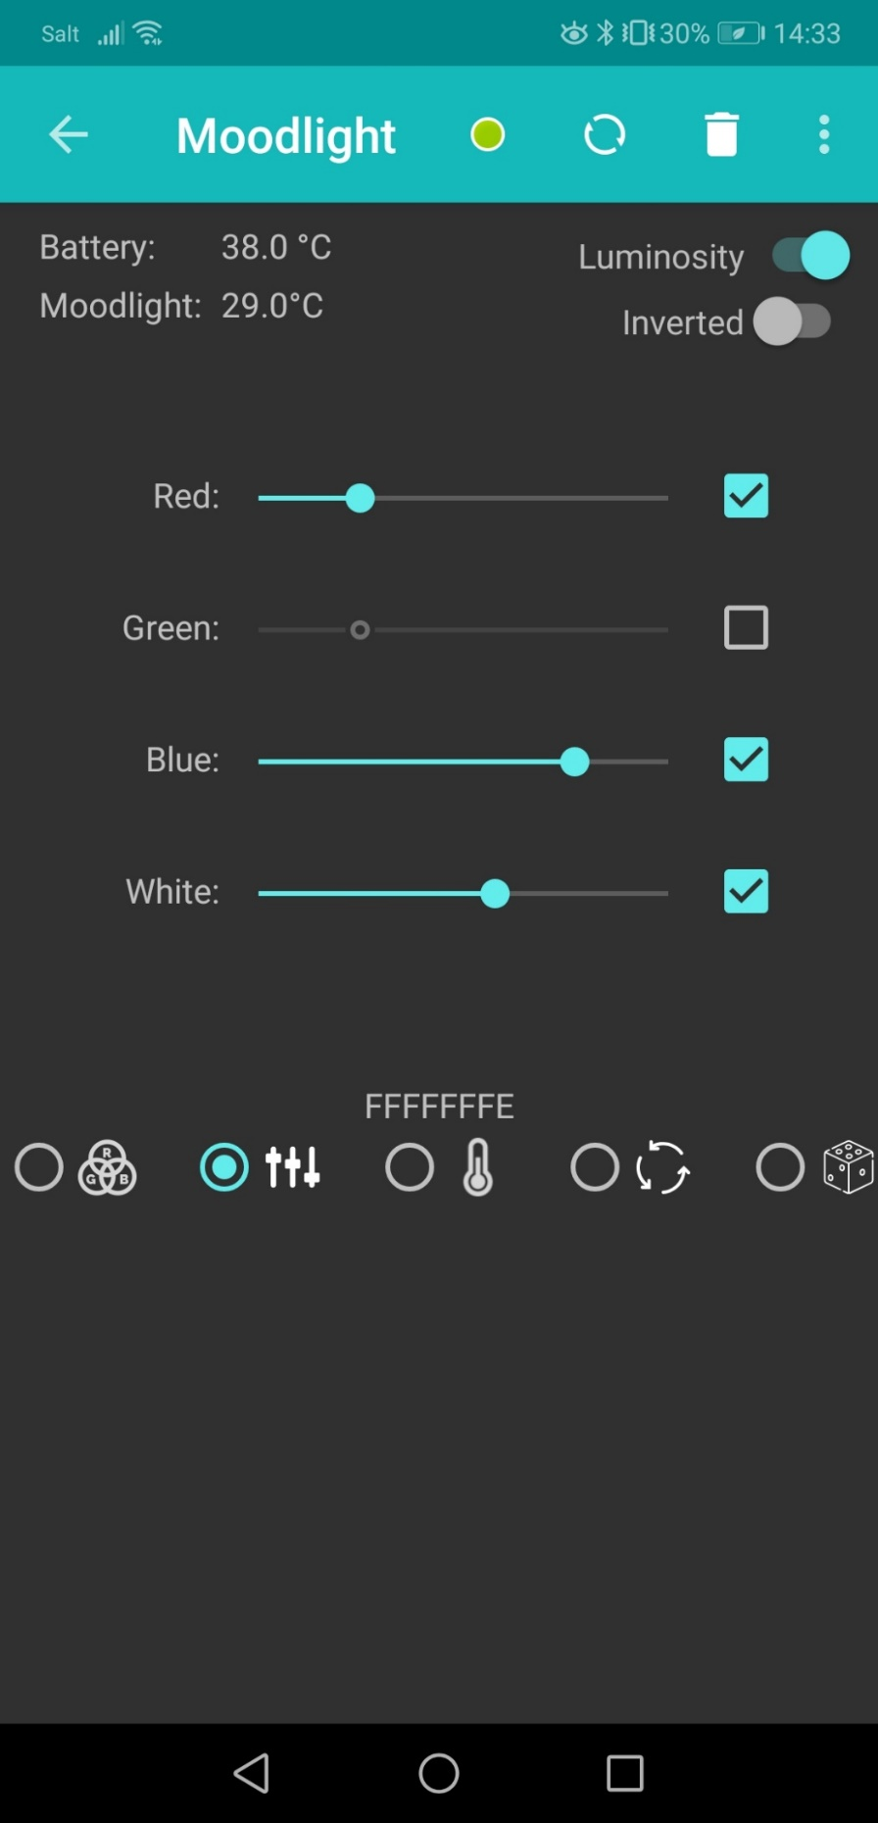

GETTING STARTED

Installing the Moodlight

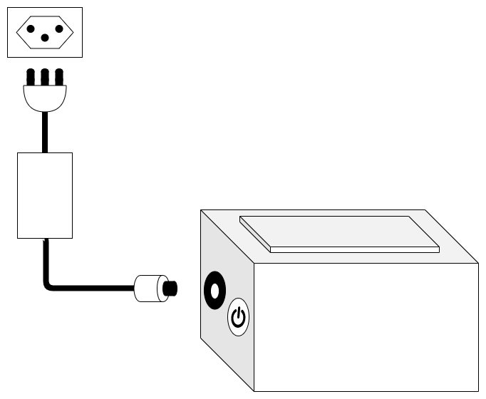

Connect the power cable to the power outlet

2

Connect included power cable to the Moodlight

1

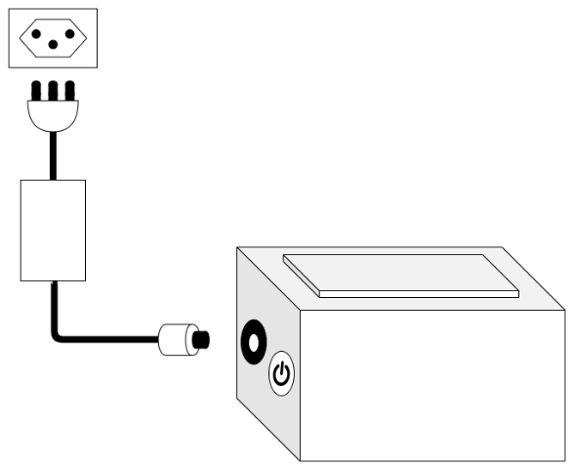

Turn the switch on to power the Moodlight

3

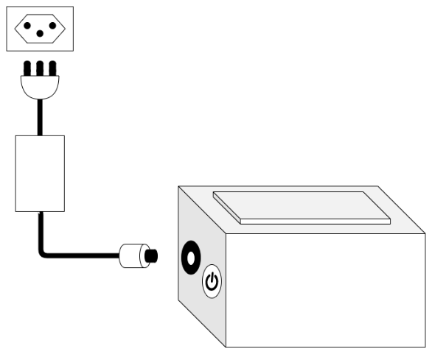

Connect your device

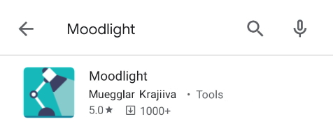

Download the Moodlight-App from the Google Play Store

1

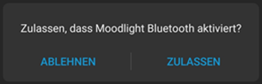

Start the Moodlight-App and allow to activate Bluetooth

2

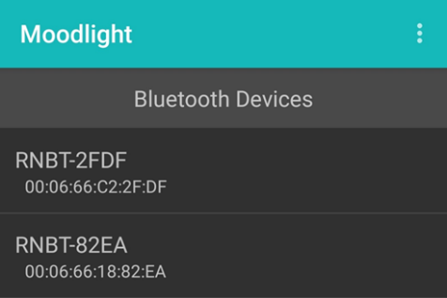

Select your Moodlight device

3

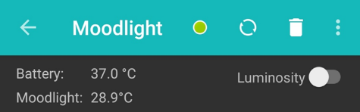

The Moodlight is ready when the dot lights up green.

4



Using the Moodlight app

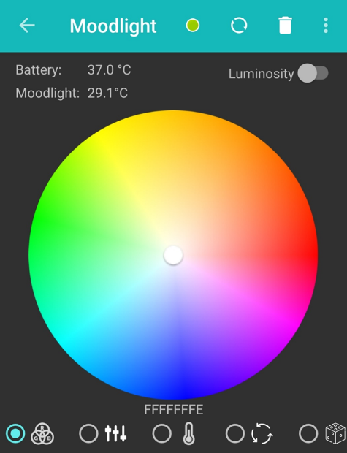

Temperature of the Moodlight and the smartphone battery

Buttons for mode selection

Colour circle to adjust the Moodlight colour

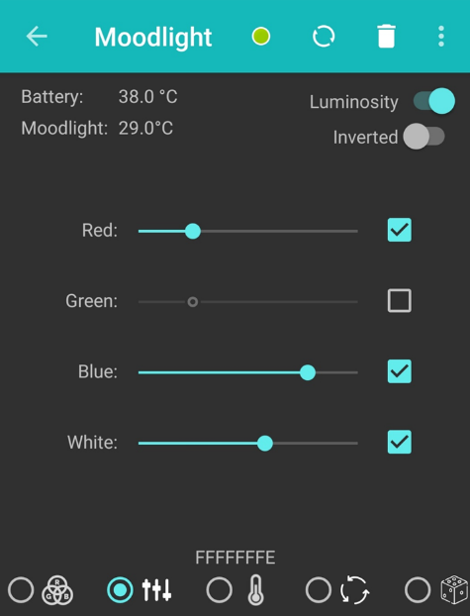

Switches to enable/disable the illumination function and to invert/not invert the logic of this functionality

Sliders to adjust the colour of the Moodlight

Checkboxes to enable/disable the individual colour portions

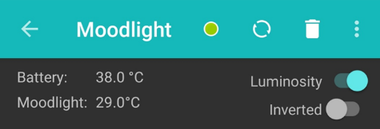

Connection status

* Connected
* Not connected

Reconnect

Delete transmission history

Open settings

Ein Bild, das Screenshot, Gerät, Zeichnung enthält.

Using the Moodlight app

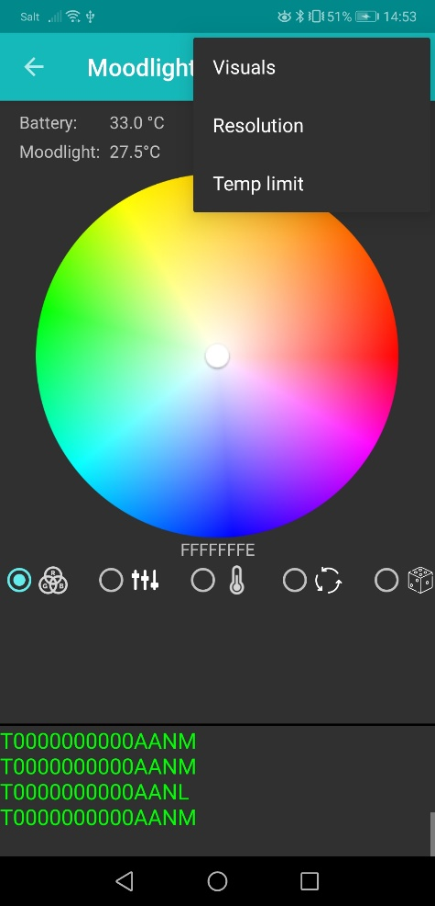

Settings:

* Visuals:
  + Show/Hide the incoming temperature in transmission history
  + Show/Hide the transmission history
* Resolution:
  + Select the sensitivity of the illumination function
* Temp limit:
  + Select the operation range of the temperature mode

Transmission history

SUPPORT & FAQ

FAQ

* What should I do if I can't connect to the Moodlight?

Press the Restart-Button in the App. If it still doesn’t work restart the Moodlight by unplugging it. Wait for 10 seconds and then start it again.

* Is it normal for my Moodlight to get warm?

The Moodlight has an overtemperature monitoring, which allows temperature up to 50°C. If it reaches this limit, the Moodlight turns off until the temperature falls under 45°C. During overtemperature the device can’t be use used.

Support

If you have any questions, please contact us via e-mail or visit our website:

* support@moodlight.ch
* www.moodlight.ch/support