|  |
| --- |
|  |
| Hardware Report Moodlight |
|  |

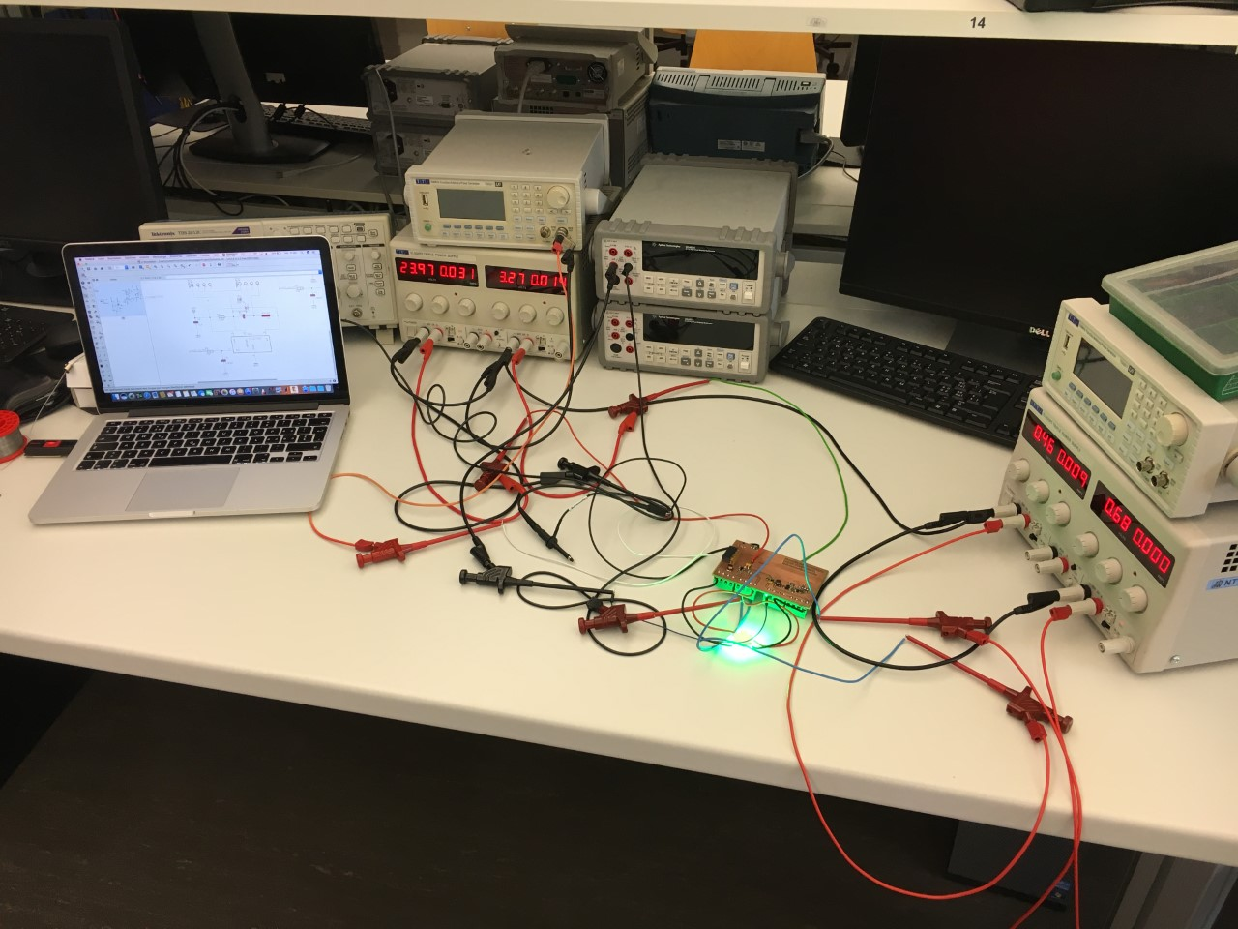

**Date** 06 November 2017

**Major** electrical engineering

**Subject** electronic project 1

autumn semester 2017

**Lecturer** Andreas Ehrensperger

**Students** Alen Kamenjas

Roman Frick

Table of contents

1 Abstract 2

1.1 Motivation 2

1.2 Problem statement 2

1.3 Approach 2

1.4 Results 2

1.5 Conclusion 2

2 Requirements 3

3 Evaluation of Solutions 4

3.1 Solution one 4

3.2 Solution three 4

3.3 Power and controller connections 5

4 Test results 6

4.1 Test results of “solution one” 6

4.2 Test results of “solution three” 7

5 Conclusion 8

6 Appendix 9

6.1 Improvements 9

6.2 Bill of material 9

6.3 PCB Layout 9

6.4 Tools 9

6.5 Datasheet 9

6.6 Gantt Diagram 9

# Abstract

## Motivation

While participating in the module “electrical engineering project”, we develop a light with different colours, which is named “moodlight”. We designed and built the whole hardware, carried out a lot of tests and will later write a program, which runs on an evaluation board of SiLabs called “Geko”. The schematic and the pcb will be designed on our own.

## Problem statement

One of the biggest problems is that we have to use a low cost power supply. This power supply isn’t able to provide a high current, so we have to manage the consumption of the current in the whole circuit. The moodlight is powered by a 24 V and 400 mA DC-supply. Due to the limitation of the current, we need to regulate the LED with current. It’s not possible to use some linear converters or LEDs with a high series resistance.

## Approach

First of all, we had to decide on the solutions that we wanted to use for our project. As soon as we had selected them, we started to draw the schematics and the PCB by using EAGLE. After that, while the print was in production, we had time to calculate the values of capacitors and resistors and carry out some simulations with LT-Spice. The next step was to hard-face the pcb and bring it into service. After some small improvements had been made, the hardware passed all our tests and runs now correctly.

## Results

This part contains only a short conclusion of the test results. For more details, please read the chapter “test results”.

With an adjust-voltage between 0.17 and 1.2 V at solution one, we can control the current through the led up to 312 mA. The integrated circuit has a switching-frequency of about 311 kHz.

In solution three, we measured a current about 322 mA with an adjust-voltage of 0.5 V. The flip-flop will be set with a frequency of 200 kHz.

## Conclusion

We presented our project in time, every requirement could be complied. During the whole development process, we recognized some ideas for improvements, which we plan to implement in the next project. These ideas are described in the appendix “improvements”.

# Requirements

The following picture visualizes a block-schematic of the moodlight project. The software runs on the evaluation board called “Geko” from SiLabs. The microcontroller is powered by a battery or the USB-power from the computer. The self-designed moodlight pcb is connected to the evaluation board by using a 20 pin connector. It is powered by the 24 V power supply. The pcb is armed with two adapters to connect the power-leds.

The following figure 1 visualizes a block-schematic of the moodlight project.

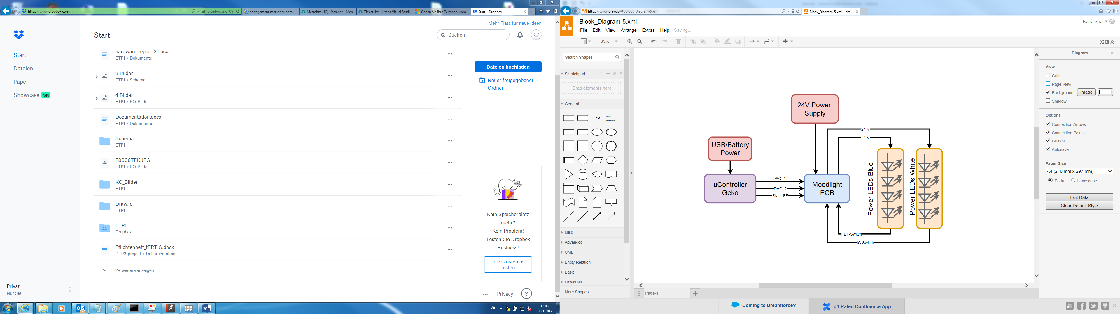

Figure Block-Schematic

# Evaluation of Solutions

We decided to choose two completely different solutions. Solution one doesn’t use a lot of components and looks easy to implement whereas solution three is a bit more complicated and reflects a higher technical background. That’s why we decided to use these two different solutions.

## Solution one

Solution one uses the integrated circuit ZXLD1350. The IC is the power switch, which controls the current through the induction and the led. The value of the current depends on the “adjust-voltage” at pin 3. Is there a higher voltage, the IC controls a higher current through the leds. The voltage will later be generated by the DAC from the microcontroller. Which range of adjust-voltage we can use without damaging the led will be measured later in chapter “test-results”.

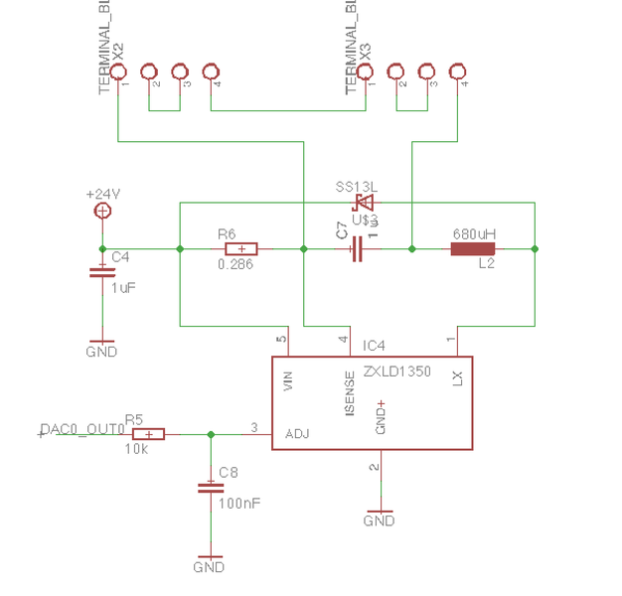

Figure 2 schematic solution one

## Solution three

In comparison with solution one, solution three is a bit more elaborately. We compare with an OPAMP the voltage over the shunt resistor with a control voltage form a DAC of the microcontroller. Is the voltage higher, the OPAMP resets the flip-flop which opens the FET. The flip-flop will be set over an IO Pin form the microcontroller with a constant frequency ranging between 150 and 300 kHz. The optimal frequency will be set after the test measurement. To limit the current through the led to 600 mA, we use a diode which is connected to the input pin of the OPAMP.

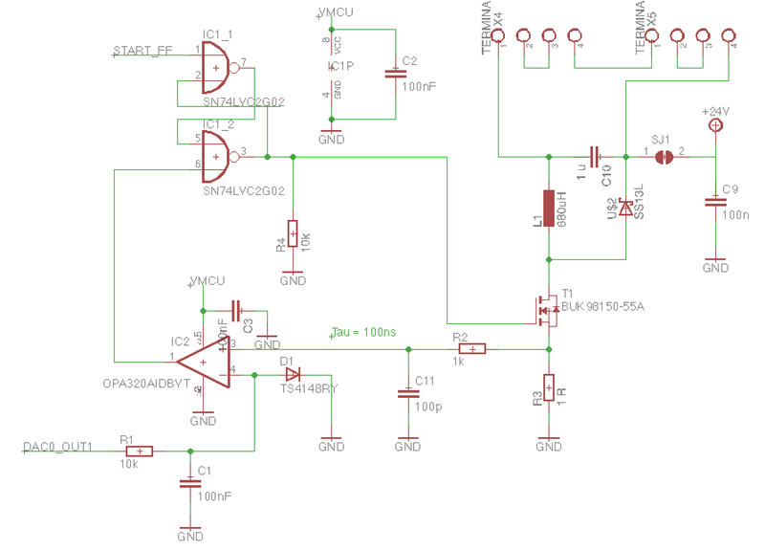

Figure : schematic solution three

## Power and controller connections

Of the hardware moodlight, there also exist the connections to the evaluation board GEKO as well as the jack of the power supply as pictured in the following figure.

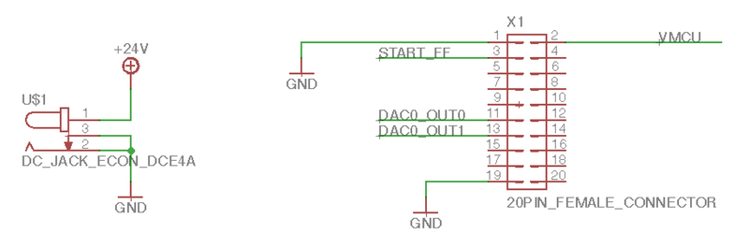

Figure 4: schematic power and controller connections

# Test results

To test the project, we do not use the final 24 V-power supply. It is the better way to use dc-sources what makes it possible to limit the current. For solution three, we use 3 different power-sources and a signal generator to set the flip-flop. To measure and visualize the behaviour of our circuit, we use an oscilloscope.

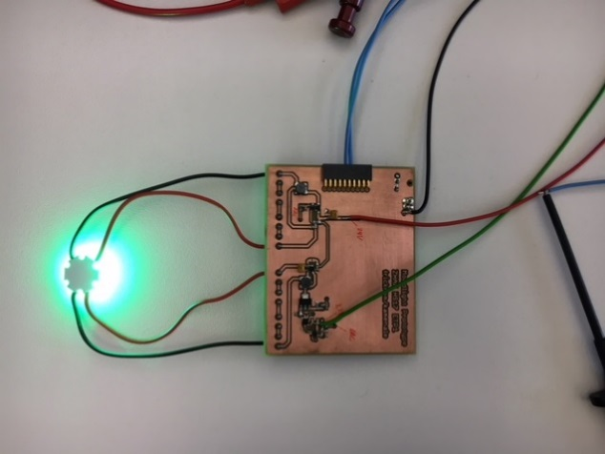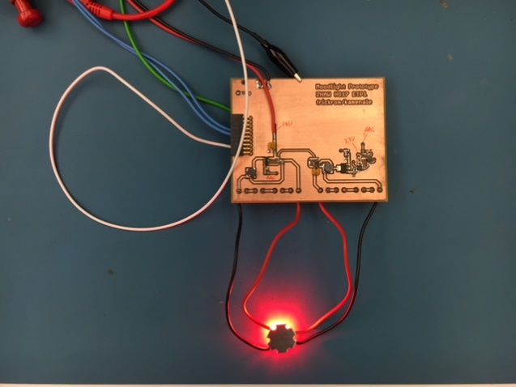This chapter explains the results of the two already mentioned solutions. Table 1 lists the required instruments for the functional test.

Figure 5 testing the hardware

|  |  |  |
| --- | --- | --- |
| **manufacturer** | **serial number** | **remark** |
| EL302RT Triple | NT12.72 | Power Supply for 24V, 3.3V and simulation of the DAC |
| Agilent Technologies U3402A | NT12.48 | voltmeter |
| Agilent Technologies U3402A | NT12.44 | ampere meter |
| Techtronix TDS2012C | NT16.66 | Scope |
| Waveform generator TG5011 | NT12.11 |  |

Table 1: test equipment

## Test results of “solution one”

Figure 6 shows the test arrangement to understand how solution one will be tested. For the functional test, a+24 V power is needed, which is connected to the connector X2 Pin 1. The 24 V is only needed for the power led driver and for the power led. The other power supply simulates the DAC output of the microcontroller. The range must be between 0 V and 2.5 V.

With this test arrangement, the whole function of the first solution can be tested. If the DAC voltage gets higher, the power led must be brighter. If the DAC voltage falls short of an ordained voltage, the power led must turn off.

The current through the led should not be higher than 350 mA. We raised the adjust-voltage slowly, until we got this maximum current. We reached 312 mA at a voltage of 1.2 V. This means, we should not exceed 1.2 V to secure the led.

Decreasing the adjust voltage leads to a lower brightness of the led. As soon as we go lower than 0.17 V, the IC turns off the led completely.

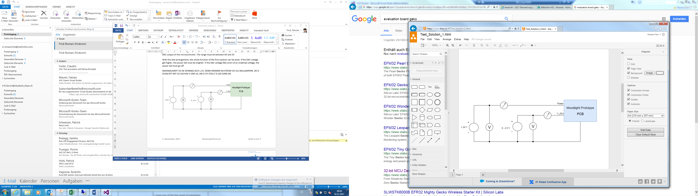

Figure 6: test arrangement solution one

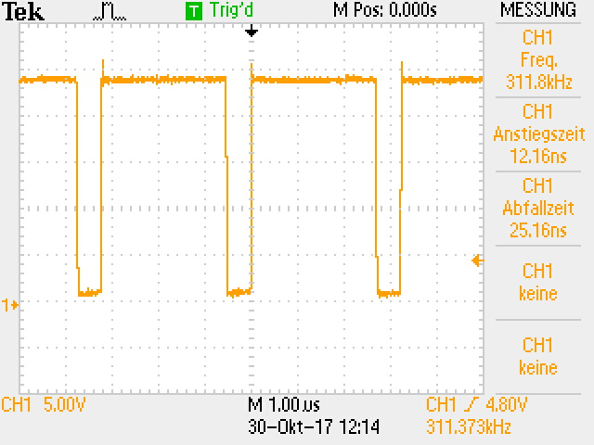

The test results point out that the first solution is working correctly. The higher the simulated DAC voltage, the higher the current consumption of the PCB and the higher the brightness of the power led. If the simulated DAC voltage goes below 0.17 V, the power led goes off. These results confirm the function of the first solution. The integrated circuit is switching at a frequency of about 311 kHz, what can be seen in Figure 5.

Figure 7: switching frequency

The following Table 2 shows the measurement results of solution one.

|  |  |  |  |
| --- | --- | --- | --- |
| **Power Supply [V]** | **LED current consumption[mA]** | **DAC Simulation [V]** | **DAC Simulation [mA]** |
| 24 | 312 | 1.2 | 0.1 |
| 24 | 290 | 1.0 | 0.1 |
| 24 | 166 | 0.5 | 0.1 |
| 24 | 100 | 0.2 | 0.0 |
| 24 | 0 | 0.17 | 0.0 |

Table 2: measurement results of solution one

## Test results of “solution three”

For this test we use 3 different power supplies; 24 V power, Power_MCU which is about 3.3 V and the reference-voltage which defines the brightness of the led. Additionally, we use a frequency-generator which sets the flip-flop. Figure 8 pictures the test arrangement.

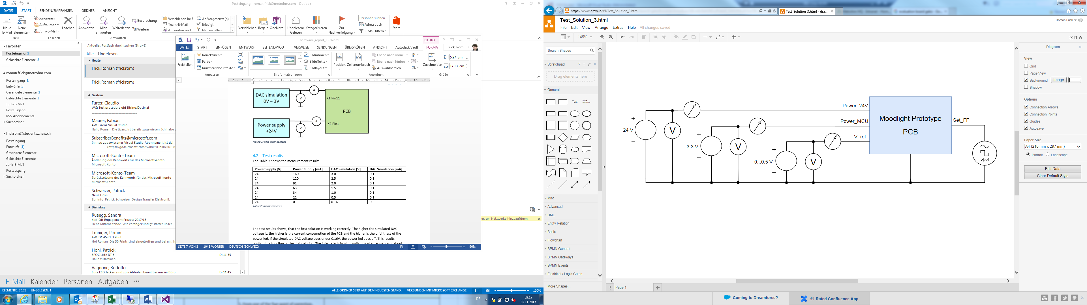

Figure 8: test arrangement solution three

We used a switching frequency of 200 kHz which sets the flip-flop. The voltage which defines how bright the led glows, we later use from the processor. The maximum value is 0.5 V, at this voltage, the current is 322 mA.

The two pictures below show the behaviour of the switching-regulator. Figure 10 visualizes the voltage over the shunt-resistor, Figure 9 visualizes the smoothed signal after the RC-filter.

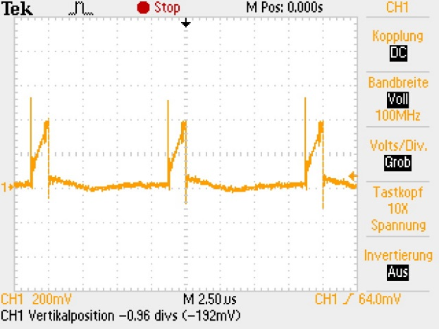 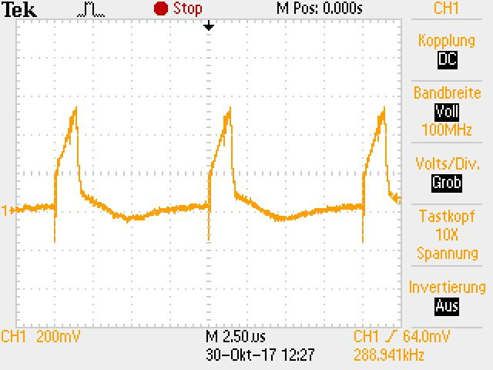

Figure 9: smoothed signal RC filter Figure 10: voltage over the shunt

Solution three is also working correctly. The frequency which sets the flip-flop slightly influenced the current through the led. Trying different frequencies has shown that the optimal behaviour of the circuit is reached at 200 kHz.

|  |  |  |  |
| --- | --- | --- | --- |
| **Power Supply [V]** | **Power_MCU [V]** | **DAC Simulation [V]** | **LED current consumption[mA]** |
| 24 | 3.3 | 0.0 | 0 |
| 24 | 3.3 | 0.1 | 53 |
| 24 | 3.3 | 0.2 | 112 |
| 24 | 3.3 | 0.3 | 175 |
| 24 | 3.3 | 0.4 | 280 |
| 24 | 3.3 | 0.5 | 322 |

Table 3: measurement results of solution three

# Conclusion

Our prototype is working correctly by using the two solutions. In a next step, we will develop the software for our moodlight. At the end of the prototype project, the moodlight will only work with the 24 V power supply. After that, we will design a new PCB, which can drive a minimum of 4 different LEDs. At the end, the moodlight will be controlled by an app via Bluetooth.

# Appendix

## Improvements

During the whole project, we recognized that not every issue is solved perfectly. The most important ideas for improvement are:

* Using some test points
* Using more “brazing-bridges” what eases the debugging
* Using bigger drill-wholes to implement the vias

The prototype is working and we are happy that everything works without any bigger problems. For the final type of the moodlight, we try to implement all of the ideas for improvement we recognized while working on the prototype. Then, the moodlight will be successful.

## Bill of material

|  |  |
| --- | --- |
| **Description** | **Value** |
| C1, C2, C3, C8, C9 | 100 nF |
| C4, C7, C10 | 1 uF |
| C11 | 100 pF |
| R1, R4, R5 | 10 kΩ |
| R2 | 100 kΩ |
| R3 | 1 Ω |
| R6 | 0.286 Ω |
| L1, L2 | 680 uH |
| D1 | TS4148RY |
| D2, D3 | SS13L |
| IC1 | SN74LVC2G02 |
| IC2 | OPA320A |
| IC4 | ZXLD1350 |
| T1 | BUK98150-55A |

## PCB Layout

The PCB-Layout will be handed in separately.

## Tools

|  |  |
| --- | --- |
| **Description** | **Version** |
| Autodesk Eagle | 8.3.2 |
| LT Spice | 4.23l |

## Datasheet

<http://www.ti.com/lit/ds/symlink/opa320.pdf> accessing date 02.11.2017

[https://www.diodes.com/assets/Datasheets/ZXLD1350.pdf](https://www.diodes.com/assets/Datasheets/ZXLD1350.pdf%20)  accessing date 02.11.2017

## Gantt Diagram

You can find the gantt diagram in the separate file Gantt_Diagram.xlsx.