**PCB manufacturing**



This document describes how to design PCBs (printed circuit boards) for the Electro-Technics Project.

If you are not a very experienced PCB layouter, we recommend using EAGLE.

If you are working with a different tool, you have to use analogous configurations. For Altium some links are provided in the chapter «Altium instead of Eagle» at the end of this document.

Finally, the PCBs are manufactured externally at Eurocircuits using the «STANDARD pool service default values».

**Checklist and systematic instruction**

1. Eagle tutorials and download 2

2. Eurocircuit design rules 2

3. Project-specific library 4

4. Create a new Eagle project 4

5. Create and draw the schematic 5

5.1. Recommended libraries 5

6. Create and layout the board 6

6.1. Forward/Backward annotation error 6

6.2. Components of one subcircuit in the same area 6

6.3. Increase sizes if desired 6

6.4. GND plates 7

6.5. Labels 7

7. Order the PCB 8

7.1. Last checks 8

7.2. Order the PCB 8

8. Altium instead of Eagle 8

© Hanspeter Hochreutener, [hhrt@zhaw.ch](mailto:hhrt@zhaw.ch), 1.1.2019

# Eagle tutorials and download

Download Eagle from <https://www.autodesk.com/products/eagle/free-download> and install it.

You can find a comprehensive Eagle documentation with manuals and tutorials in English and in German in the Eagle installation subfolder: C:\EAGLE x.x.x\doc .

Press the «F1» key to access context sensitive help from within EAGLE.

Tutorials in English which I recommend to start with are  
<https://learn.sparkfun.com/tutorials/how-to-install-and-setup-eagle> <https://learn.sparkfun.com/tutorials/using-eagle-schematic> <https://learn.sparkfun.com/tutorials/using-eagle-board-layout>

# Eurocircuit design rules

As the PCBs are manufactured at Eurocircuits it is important to comply with their design rules. The simplest way to guarantee this is to use the provided file as the default.

1. Start EAGLE and the «Control Panel» will show up.
2. Expand «Design Rules» as shown below  
   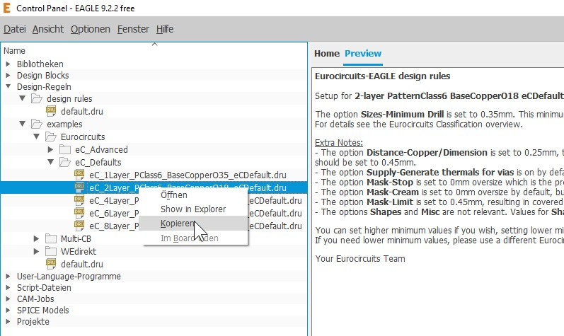
3. Right click on «**eC_2Layer_...**» and pick «Copy»  
   Click on «default.dru» und overwrite the file.  
   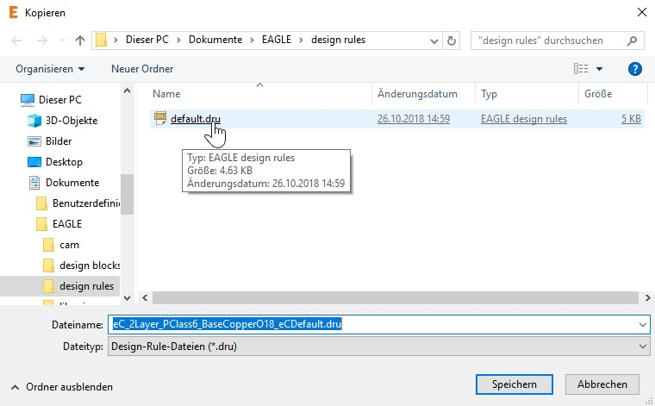
4. Check if this was successful by clicking on «default.dru». The description should say «Eurocircuits-EAGLE design rules».  
   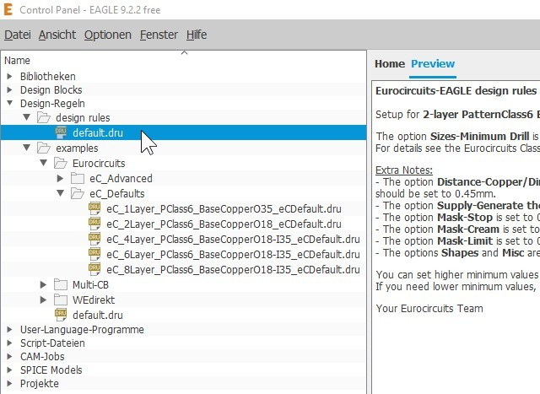
5. The values in the file «default.dru» are the minimum sizes that can be manufactured in the standard pool. However, in most cases it is better to use bigger sizes to make the PCB more robust and to reduce resistance of the conductor paths. This is especially true for paths where a significant current flows.

# Project-specific library

The lecturers provide a project specific EAGLE library. Copy it into your library path «C:\Users\xxxx\Documents\EAGLE\libraries»

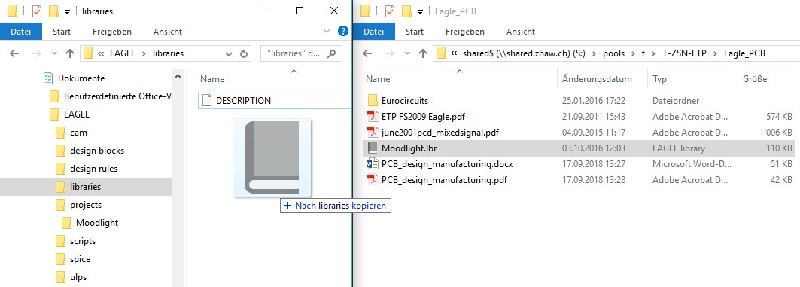

# Create a new Eagle project

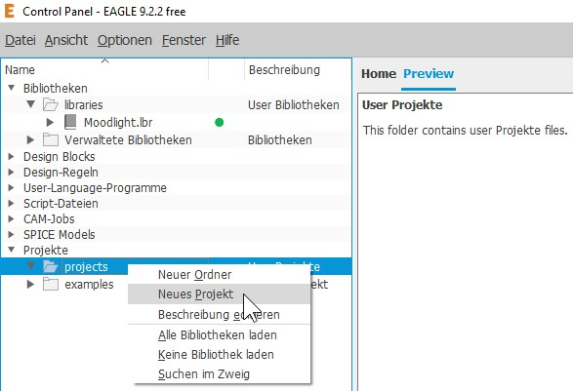  
The project is located in «C:\Users\xxxx\Documents\EAGLE\projects».

# Create and draw the schematic

Create a new schematic as follows:

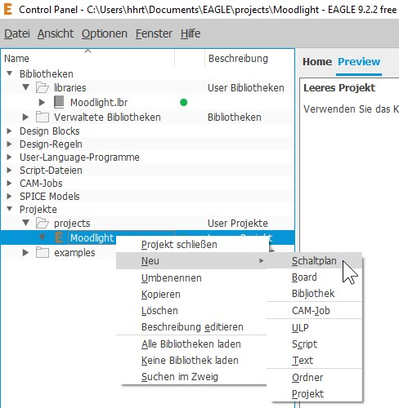

## Recommended libraries

In addition to the project specific EAGLE library mentioned above, the following libraries for standard components are useful.

* **GND and supply**: supply1, supply 2  
  Use the various ground and supply symbols for automatic wiring and keeping the schematic more readable.
* **Resistors, capacitors and inductors**: rcl  
  Resistors (values from the E12 series): rcl => R-EU_R0805  
  Capacitors (values from the E6 series): C-EUC0805 (up to 100nF), C-EUC1210 (for bigger Cs)  
  Electrolytic capacitors and inductors: check individual footprint
* **Jumpers**: jumper  
  Allow to disable subcircuits for testing
* **Testpoints**: testpad  
  Used for testing. Do not forget to put also some testpoints on GND to be able to connect the GNDs of your instruments and supplies!
* Place **ceramic block capacitors** (10nF – 100nF) close to the supplies of integrated circuits.

# Create and layout the board

Once the schematic has been drawn and the «**Electrical rule check**» is without errors and unapproved warnings, the board layout can be attacked.

Create the board from the schematic by clicking the «board» icon.  
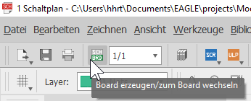

Remember to invoke the «**Design rule check**» from time to time. Before ordering the PCB it has to be without errors and unapproved warnings.

## Forward/Backward annotation error

Always keep both schematic and board open. Otherwise, you will get the following error message:   
  
Remember: It is very hard to recover those errors.

## Components of one subcircuit in the same area

As a rule, keep locally separate (in different PCB areas) **power circuits**, **digital circuits** and **analog circuits** to reduce crosstalk from the power and digital domain to analog signals.

## Increase sizes if desired

The values in the file «default.dru» are the minimum sizes that can be manufactured in the standard pool. However, in most cases it is better to use bigger sizes to make the PCB more robust and to reduce the resistance of the conductor paths.  
The sizes I prefer are around 24mils (= 0.6mm) for the path widths and for the via drill sizes as shown in the screenshot below. Just choose the convenient size before you draw the path.  
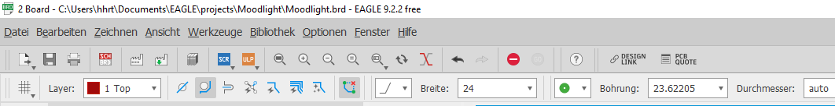  
Unit conversion: 1mil = 0.0254mm 1mm = 40mil

**Alternatively, you can change the minimum sizes in the «default.dru» file. In this case, the «autorouter» uses these values.**

The sizes, etc. can be changed later on.

Draw **wider paths where a substantial current flows**. See diagram at the end of <https://www.eurocircuits.de/pcb-design-guidelines/#trackwidthgraphic>

## GND plates

Low ohmic GND plates reduce greatly crosstalk and stability issues.  
Avoid long slits in the bottom GND plate and put vias to connect top and bottom GND plates.  
Proceed as follows:   
- Draw a polygon over the whole PCB (but keep a distance to the border) and name it «GND».  
- To avoid unwanted shorts to GND increase the «Isolate» property to about 16mil.  
- Execute the «Ratsnest» command to fill the ground plate or update the outline.  
- To make the ground plate invisible again use the «Ripup» command on the polygon.

## Labels

It is important to use the «**vector**» fonts because the size of the «proportional» font is not defined correctly and can lead to short circuits on the PCB.

As a PCB is always viewed from top to bottom:  
text on top layer => directly readable  
text on bottom => mirrored

1. Add an identifying text on each copper layer.  
   E.g. “ZHAW Moodlight” + your name  
   Text size ≥ 2mm
2. Use screen prints for **connectors, testpoints, etc.**choose text size ≥ 1mm  
   choose text line width ≥ 0.1mm  
   use tNames and bNames layers in Eagle

# Order the PCB

The PCBs are manufactured externally at Eurocircuits using the «STANDARD pool service default values» (= 2 layers, FR4 base material, 18um copper foil, with soldermask).

You will get the PCBs after about two weeks or earlier.  
If not specified differently each student will get two PCBs.

## Last checks

Before you order the PCB you should thoroughly check it. If you get a faulty PCB that you cannot correct easily, you would have to correct the PCB and order a new one, which will cause a delay of about three weeks!

1. «**Electrical rule check**» without errors and unapproved warnings.
2. «**Design rule check**» without errors and unapproved warnings.
3. Correct dimensions, meaningful labels (with «vector» font), testpoints included, ground plates ok
4. **Connectors accessible** and **mounting holes** in the corners
5. Check if it is possible to manufacture the PCB with this Online tool <https://www.eurocircuits.com/faq/how-can-i-check-that-my-data-is-correct-before-i-place-my-order/>

## Order the PCB

Send the **Eagle «.brd» file** by e-mail to [kern@zhaw.ch](mailto:kern@zhaw.ch)

If you did the PCB layout with a different tool, you have to send the «**Gerber X2**» files or the «**Gerber**» **and** «**Excellon**» files.

Make sure to meet the deadline for sending the files. Otherwise, you will have to put up with an additional delay of about a week.

# Altium instead of Eagle

The workflow is similar. Please follow the above-mentioned instructions and hints.

You can download the design files for Altium from <https://www.eurocircuits.com/Altium-Designer-templates-with-Eurocircuits-design-rules/>

To order the PCB choose «**Fabrication Outputs => Gerber X2**» to generate the «**Gerber X2**» file. Then you have to **zip** the file, before handing it in.

See also the following resources:

<https://www.altium.com/de/>

<https://www.eurocircuits.com/Altium-Designer-templates-with-Eurocircuits-design-rules/>

<https://www.eurocircuits.com/>

<https://www.eurocircuits.com/STANDARD-pool-service-default-values/>