**Installation of Simplicity Studio V4 for Windows**

eand 2.9.2019

1. Download Simplicity Studio from:  
   <http://www.silabs.com/products/mcu/Pages/simplicity-studio.aspx>

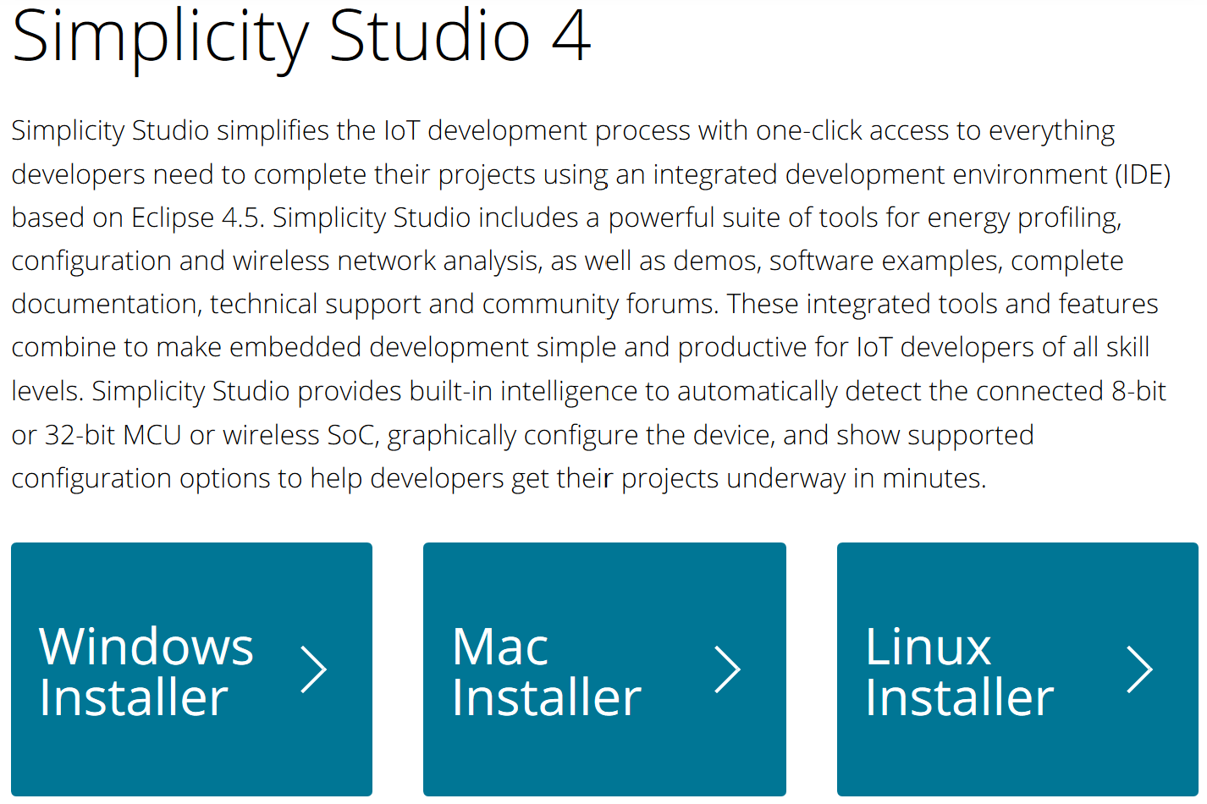

Notes:   
- This installation guide uses the Windows Installer for 64-bit computers (231MB).  
- You will be asked login an account at SILICON LABS or to create such a new account.

1. Run the installer program install-studio-v4_x64.exe as administrator.  
   - Accept the License Agreement  
   - Choose Destination Location (proposed default location recommended)  
   - Start installation (with Install button)
2. Simplicity Studio starts and a Logon Window pops up:  
   You may choose “Skip log in for now” …
3. Wait until the Installation Manager window appears. Select “Install by Device”.   
   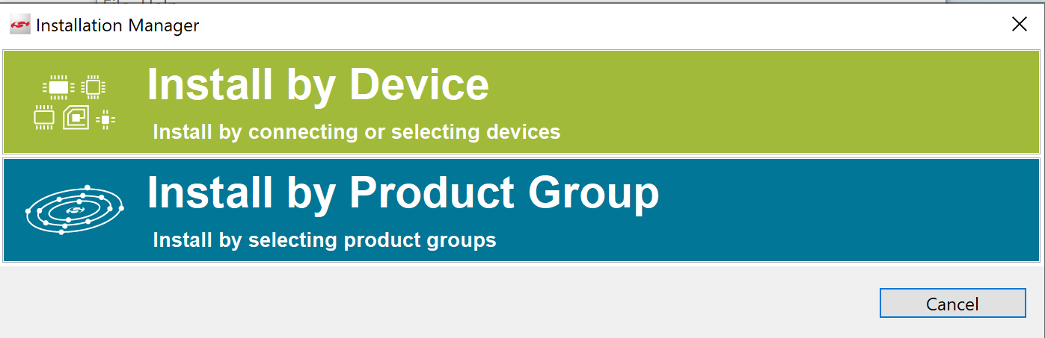
4. The following install wizard window appears:  
   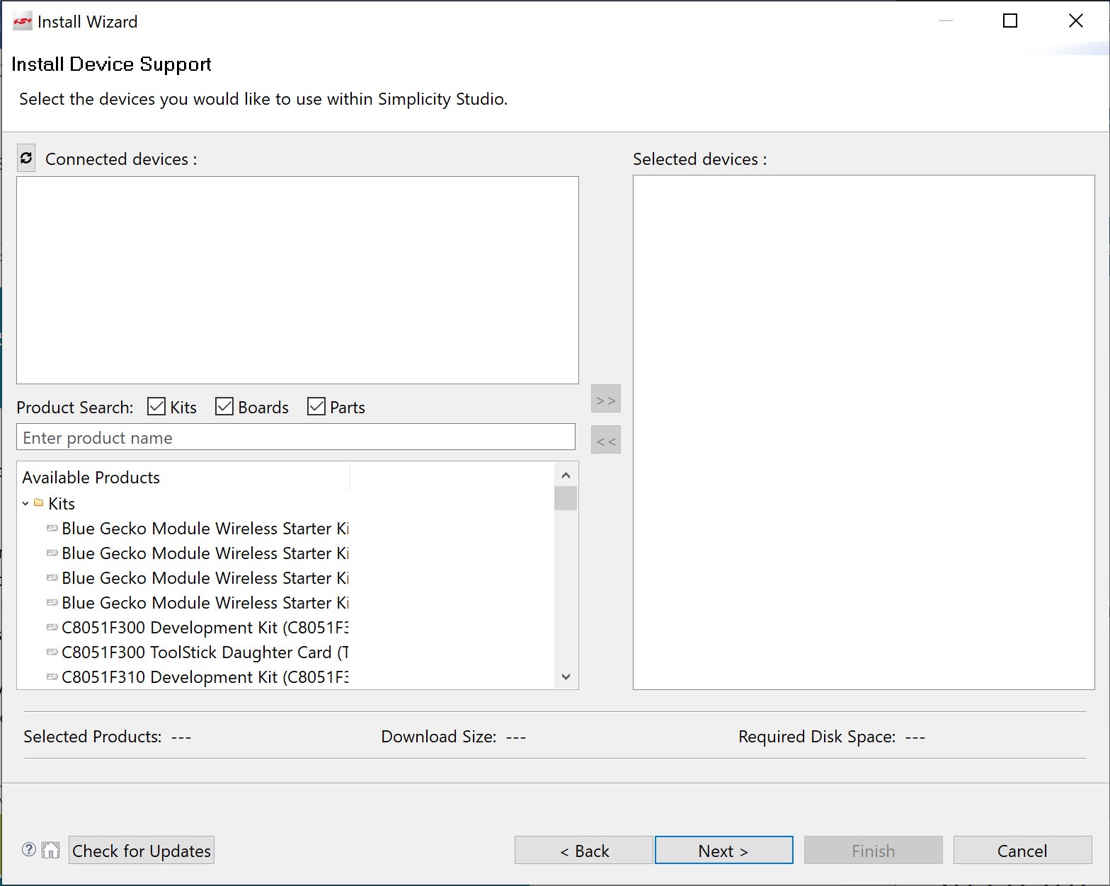
5. Now connect your Gecko Starter Kit via USB to the PC. When the following window pops up, answer with Yes:

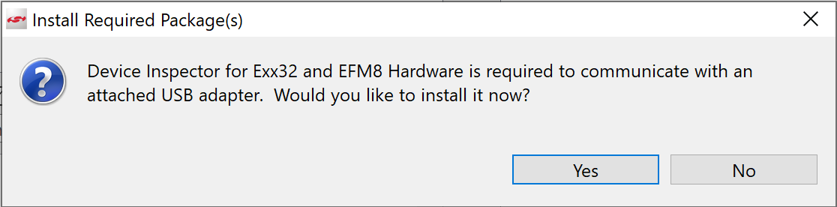

Note: If the above window does not appear, it might help to disconnect and re-connect the Gecko Starter Kit.

1. Wait until the connected device is found. The EFM32 Gecko Starter Kit (EFM32-G8xxSTK) should now be automatically detected and listed under “Connected devices”.   
   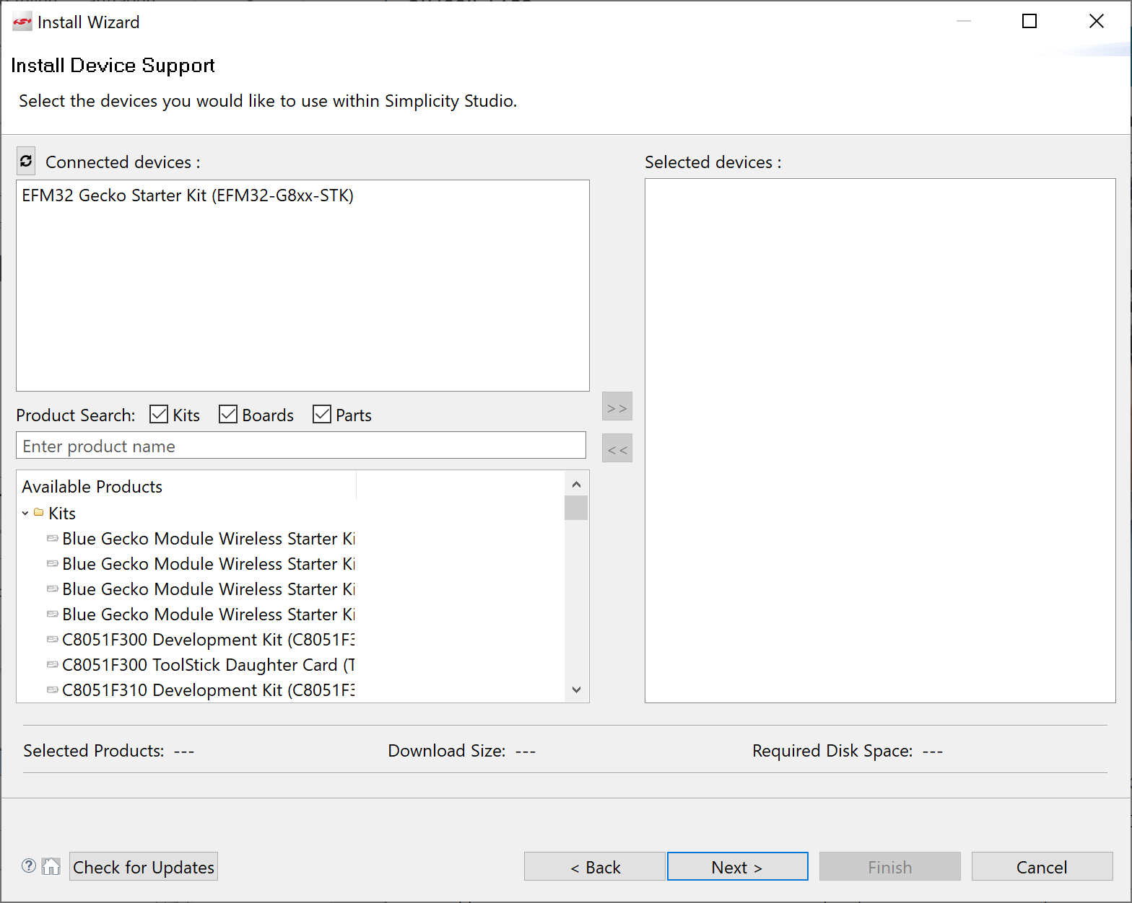  
   Double click EFM32 Gecko Starter Kit (EFM32-G8xxSTK) (such that it appears under “Selected devices”) and continue (click Next):
2. On the following screen “32 bit MCU” access must be granted on the following screen.   
   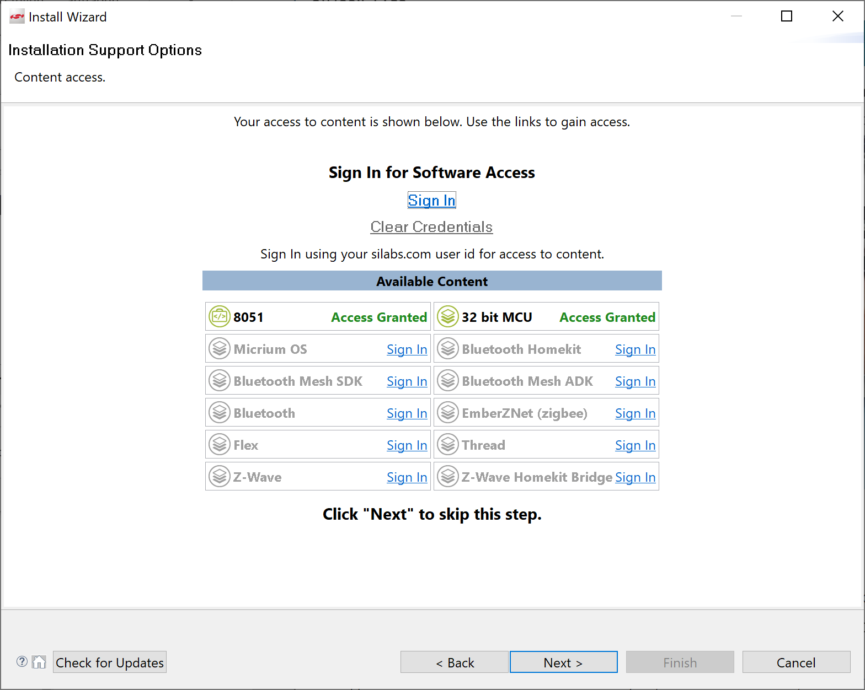  
   Click Next
3. Next screen shows the installation options. It is recommended to leave the settings unchanged.   
   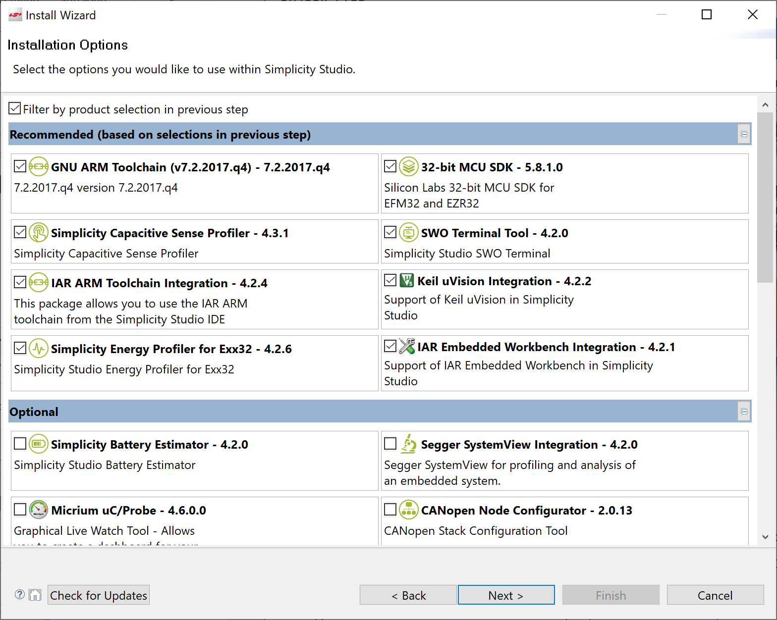  
   Click Next.
4. Accept the License Agreement, …

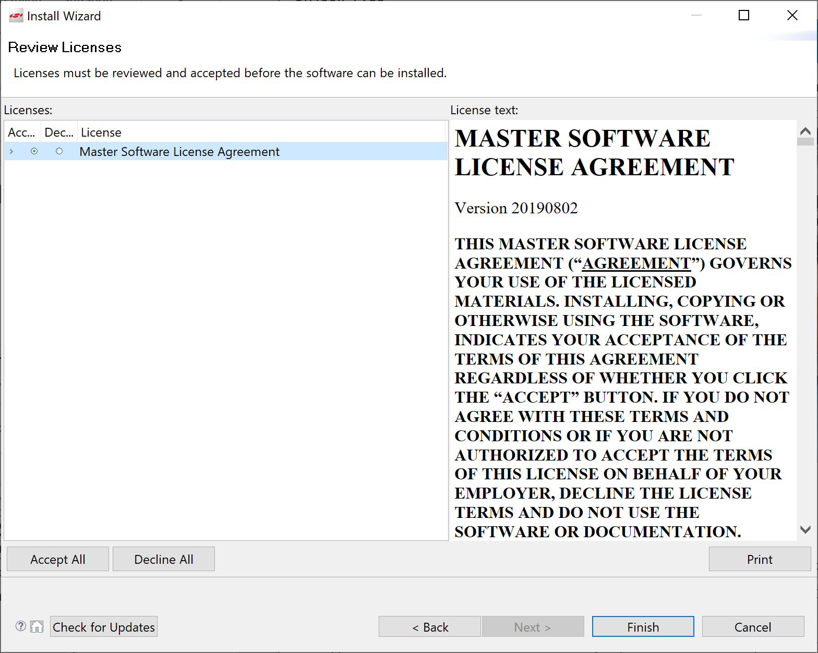  
… and click Finish.

1. The installation takes a several minutes

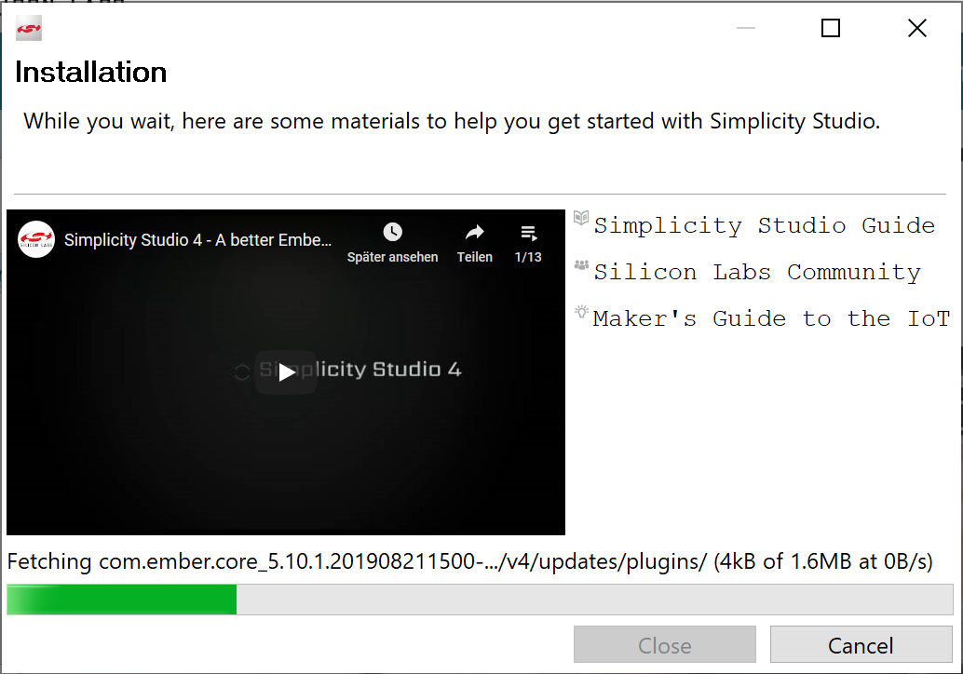

1. When the installation is finished, you are asked to restart Simplicity Studio.  
   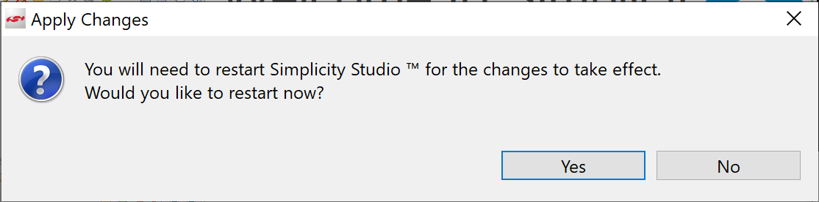  
   Click Yes.
2. Installation is now successfully completed.  
   After the restart you may first walk through a guided tour   
   or you may skip this step (with Exit tour)  
   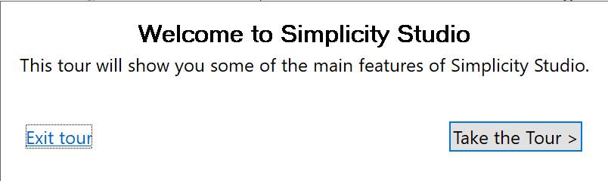
3. After the restart (while your Starter Kit is still connected) , Simplicity Studio shows the Launcher Tab which should look similar to the following:

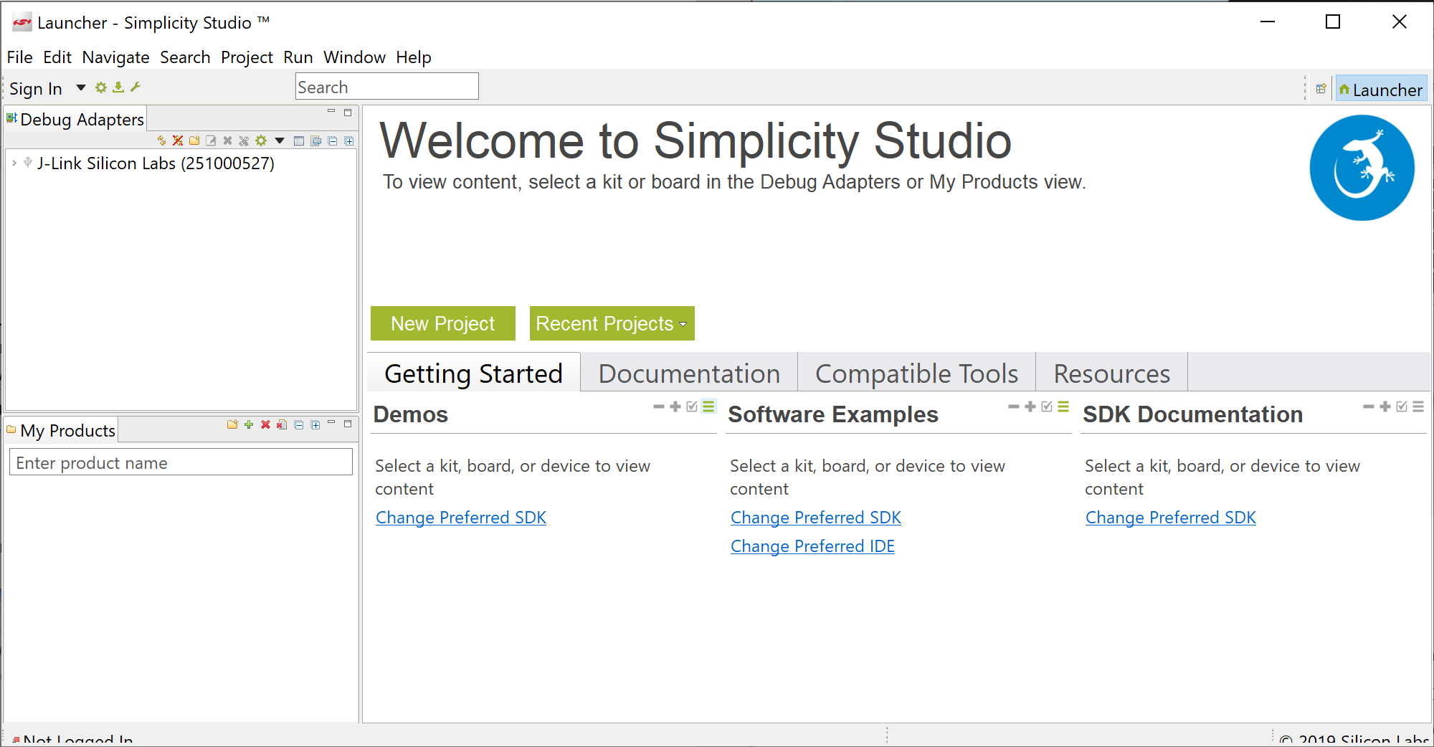

1. Select the (connected) EFM32 Gecko Starter Kit in the Device Tab (top left).   
   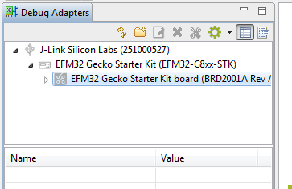

The displayed information should now look as follows (or similar).

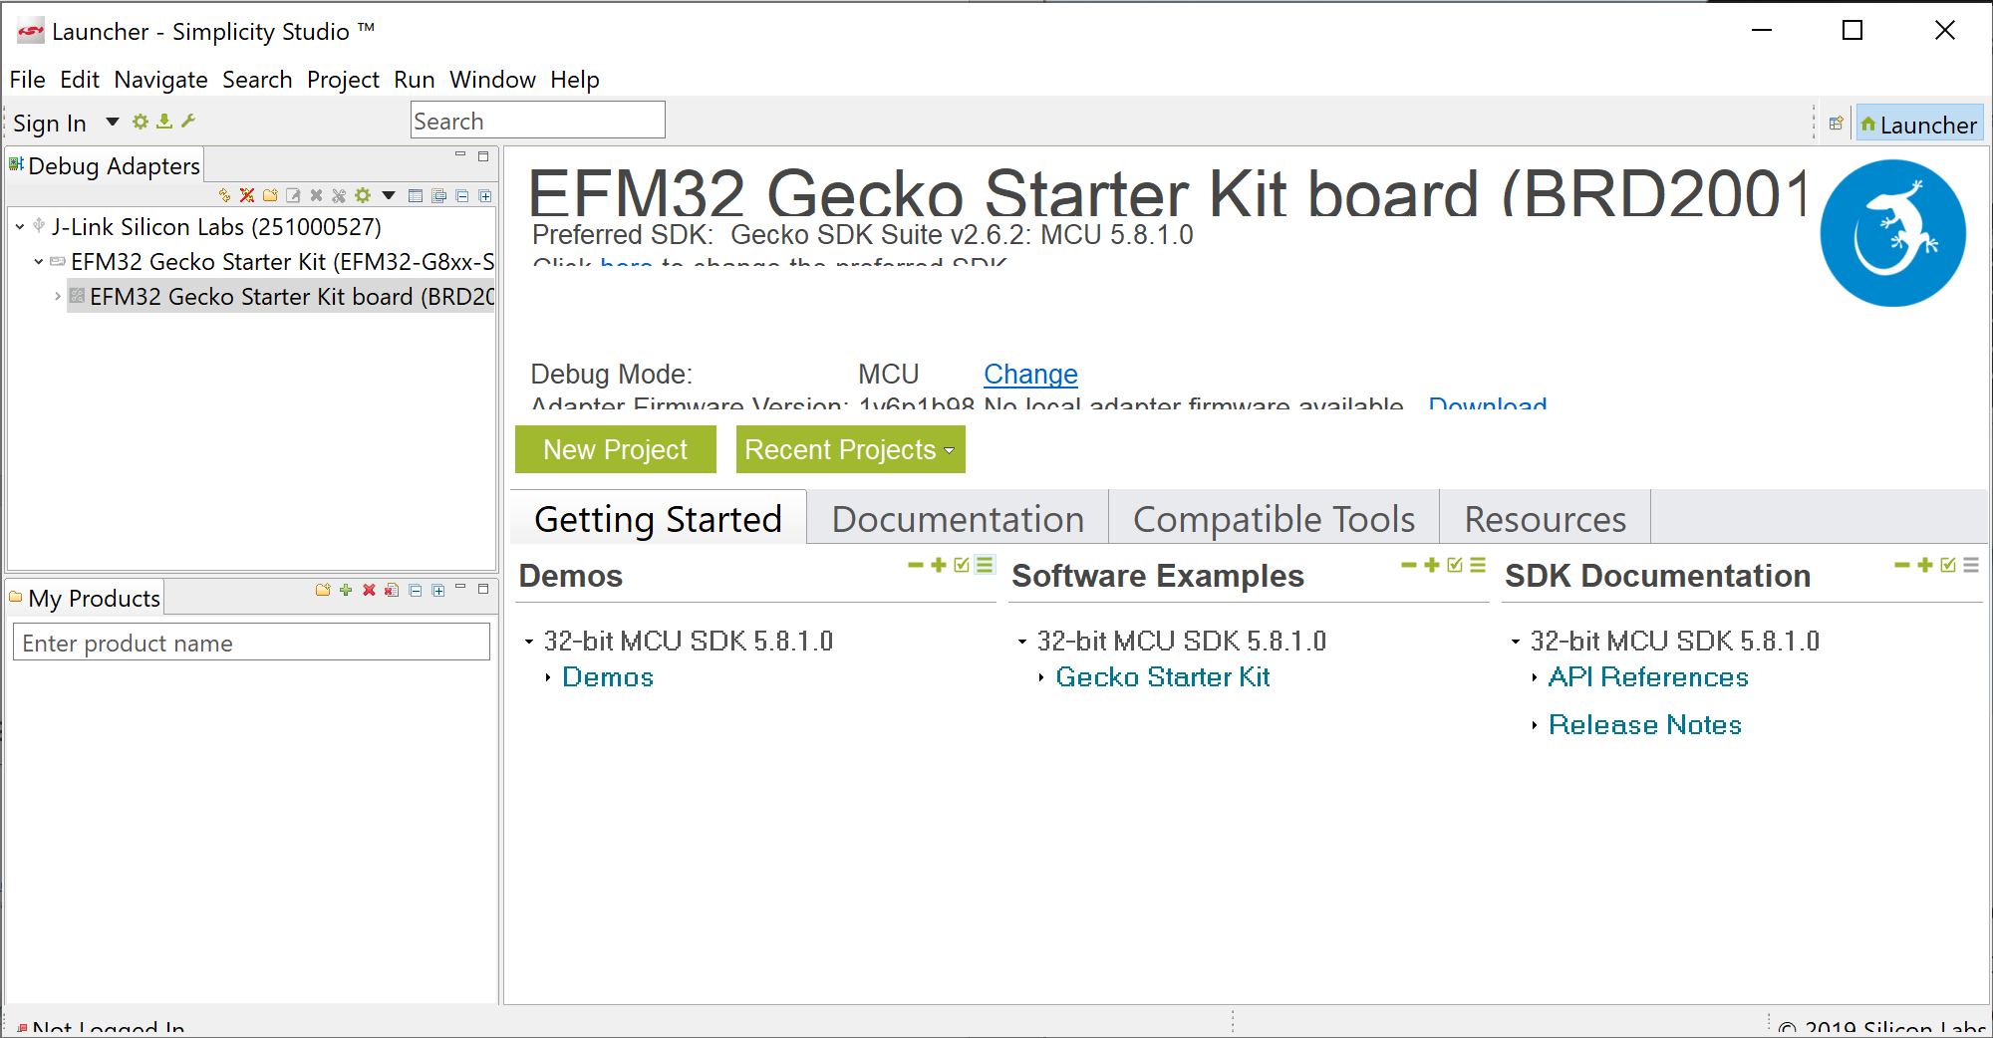

1. You may now proceed with loading some ready-to-use software example projects into your workspace which you may then explore build and run from the Simplicity Studio IDE.   
   Just click on one of the examples shown in the Getting Started tab under Software Examples🡪Gecko Starter Kit (e.g. STKXXX_blink).

