## Project Title-: Walmart's Inventory Optimization using Python

Objective-:

* To analyze sales data, predict inventory needs and reduce overstocking using python tools such as -: pandas, matplotlib and machine learning models.
* Develop actionable insights to enhance operational efficiency.

Project Workflow:

1. Import Libraries and Dataset:

* Load necessary libraries: Pandas, Numpy, Matplotlib, Seaborn.
* Load the Walmart dataset and preview it.

# Importing the required libraries  
import pandas as pd  
import matplotlib.pyplot as plt  
import seaborn as sns

# Load the dataset  
walmart_data = pd.read_csv("Walmart DataSet.csv")

# Display the first few rows  
walmart_data.head()

Store Date Weekly_Sales Holiday_Flag Temperature Fuel_Price \  
0 1 05-02-2010 1643690.90 0 42.31 2.572   
1 1 12-02-2010 1641957.44 1 38.51 2.548   
2 1 19-02-2010 1611968.17 0 39.93 2.514   
3 1 26-02-2010 1409727.59 0 46.63 2.561   
4 1 05-03-2010 1554806.68 0 46.50 2.625   
  
 CPI Unemployment   
0 211.096358 8.106   
1 211.242170 8.106   
2 211.289143 8.106   
3 211.319643 8.106   
4 211.350143 8.106

1. Data Understanding:

* Check dataset structure: .info(), .describe(), and .shape.
* Explore column descriptions: Identify features like date, product, store, sales, and inventory levels.

# describe the basic information about the dataset  
walmart_data.describe

<bound method NDFrame.describe of Store Date Weekly_Sales Holiday_Flag Temperature Fuel_Price \  
0 1 05-02-2010 1643690.90 0 42.31 2.572   
1 1 12-02-2010 1641957.44 1 38.51 2.548   
2 1 19-02-2010 1611968.17 0 39.93 2.514   
3 1 26-02-2010 1409727.59 0 46.63 2.561   
4 1 05-03-2010 1554806.68 0 46.50 2.625   
... ... ... ... ... ... ...   
6430 45 28-09-2012 713173.95 0 64.88 3.997   
6431 45 05-10-2012 733455.07 0 64.89 3.985   
6432 45 12-10-2012 734464.36 0 54.47 4.000   
6433 45 19-10-2012 718125.53 0 56.47 3.969   
6434 45 26-10-2012 760281.43 0 58.85 3.882   
  
 CPI Unemployment   
0 211.096358 8.106   
1 211.242170 8.106   
2 211.289143 8.106   
3 211.319643 8.106   
4 211.350143 8.106   
... ... ...   
6430 192.013558 8.684   
6431 192.170412 8.667   
6432 192.327265 8.667   
6433 192.330854 8.667   
6434 192.308899 8.667   
  
[6435 rows x 8 columns]>

# Find out the information of whole dataset  
walmart_data.info()

<class 'pandas.core.frame.DataFrame'>  
RangeIndex: 6435 entries, 0 to 6434  
Data columns (total 8 columns):  
 # Column Non-Null Count Dtype   
--- ------ -------------- -----   
 0 Store 6435 non-null int64   
 1 Date 6435 non-null object   
 2 Weekly_Sales 6435 non-null float64  
 3 Holiday_Flag 6435 non-null int64   
 4 Temperature 6435 non-null float64  
 5 Fuel_Price 6435 non-null float64  
 6 CPI 6435 non-null float64  
 7 Unemployment 6435 non-null float64  
dtypes: float64(5), int64(2), object(1)  
memory usage: 402.3+ KB

# Shape of the data  
walmart_data.shape

(6435, 8)

Dataset Preview

The dataset contains the following columns:

* Store: Store ID.
* Date: Week ending date.
* Weekly_Sales: Weekly revenue generated by the store.
* Holiday_Flag: Indicator for a holiday week (1 = holiday, 0 = non-holiday).
* Temperature: Average temperature during the week.
* Fuel_Price: Cost of fuel during the week.
* CPI: Consumer Price Index. Unemployment: Unemployment rate.

1. Data Cleaning:

* Handle missing values (if any).
* Check for duplicates and remove them.
* Ensure data types are correct (e.g., date as datetime).

# Check for missiong values  
walmart_data.isnull().sum()

Store 0  
Date 0  
Weekly_Sales 0  
Holiday_Flag 0  
Temperature 0  
Fuel_Price 0  
CPI 0  
Unemployment 0  
dtype: int64

# Check for duplicated  
walmart_data.duplicated().sum()

0

# Ensure the proper data types  
walmart_data.dtypes

Store int64  
Date object  
Weekly_Sales float64  
Holiday_Flag int64  
Temperature float64  
Fuel_Price float64  
CPI float64  
Unemployment float64  
dtype: object

# Convert 'Date' to datetime format for easier analysis.  
walmart_data['Date'] = pd.to_datetime(walmart_data['Date'], format="%d-%m-%Y")  
  
# General statistics  
walmart_data.describe()

Store Date Weekly_Sales Holiday_Flag \  
count 6435.000000 6435 6.435000e+03 6435.000000   
mean 23.000000 2011-06-17 00:00:00 1.046965e+06 0.069930   
min 1.000000 2010-02-05 00:00:00 2.099862e+05 0.000000   
25% 12.000000 2010-10-08 00:00:00 5.533501e+05 0.000000   
50% 23.000000 2011-06-17 00:00:00 9.607460e+05 0.000000   
75% 34.000000 2012-02-24 00:00:00 1.420159e+06 0.000000   
max 45.000000 2012-10-26 00:00:00 3.818686e+06 1.000000   
std 12.988182 NaN 5.643666e+05 0.255049   
  
 Temperature Fuel_Price CPI Unemployment   
count 6435.000000 6435.000000 6435.000000 6435.000000   
mean 60.663782 3.358607 171.578394 7.999151   
min -2.060000 2.472000 126.064000 3.879000   
25% 47.460000 2.933000 131.735000 6.891000   
50% 62.670000 3.445000 182.616521 7.874000   
75% 74.940000 3.735000 212.743293 8.622000   
max 100.140000 4.468000 227.232807 14.313000   
std 18.444933 0.459020 39.356712 1.875885

Data Cleaning Summary

* Missing Values: No missing values in the dataset.
* Duplicates: No duplicate rows.
* Data Types: All columns have appropriate data types after converting the Date column to datetime.

3. Feature Engineering:

* Create new features such as: Month, Year, and Day of Week from the date column.
* Sales Difference: Calculate week-over-week sales changes.
* Rolling Sales Average: Smooth sales trends over time.

# Extracy year, day of the week from the Date column  
walmart_data['Year'] = walmart_data['Date'].dt.year  
walmart_data['Month'] = walmart_data['Date'].dt.month  
walmart_data['Week'] = walmart_data['Date'].dt.isocalendar().week

# Calculate week-over-week sales changes  
walmart_data['Sales_Difference'] = walmart_data['Weekly_Sales'].diff()

# Calculate a rolling average for sales(4-week window)  
walmart_data['Rolling_Sales_Avg'] = walmart_data['Weekly_Sales'].rolling(window = 4).mean()

# Preview the updated dataset  
walmart_data.head()

Store Date Weekly_Sales Holiday_Flag Temperature Fuel_Price \  
0 1 2010-02-05 1643690.90 0 42.31 2.572   
1 1 2010-02-12 1641957.44 1 38.51 2.548   
2 1 2010-02-19 1611968.17 0 39.93 2.514   
3 1 2010-02-26 1409727.59 0 46.63 2.561   
4 1 2010-03-05 1554806.68 0 46.50 2.625   
  
 CPI Unemployment Year Month Week Sales_Difference \  
0 211.096358 8.106 2010 2 5 NaN   
1 211.242170 8.106 2010 2 6 -1733.46   
2 211.289143 8.106 2010 2 7 -29989.27   
3 211.319643 8.106 2010 2 8 -202240.58   
4 211.350143 8.106 2010 3 9 145079.09   
  
 Rolling_Sales_Avg   
0 NaN   
1 NaN   
2 NaN   
3 1576836.025   
4 1554614.970

Feature Engineering Summary The dataset now includes:

* Year, Month, Day_of_Week: Extracted from the Date column for trend analysis.
* Sales_Difference: Week-over-week changes in sales to identify trends or anomalies.
* Rolling_Sales_Avg: A 4-week rolling average to smooth out short-term fluctuations.

1. Exploratory Data Analysis (EDA): Sales Trends:

* Plot monthly and yearly sales trends.
* Identify seasonality patterns.

Inventory Insights:

* Visualize inventory levels over time.
* Highlight periods of overstocking or stockouts. Product-level Analysis:
* Top-selling products and their contribution to overall revenue. Products with high variability in sales (volatility). Store-level Analysis:
* Compare sales performance across stores.
* Identify stores with overstock or understock issues.

Correlation Analysis:

* Investigate relationships between sales, inventory levels, and other variables.

Sales Trends:

* Plot monthly and yearly sales trends.
* Identify seasonality patterns.

# Sales Trends over Time  
plt.figure(figsize=(14, 7))  
sns.lineplot(data=walmart_data, x="Date", y="Weekly_Sales", label="Weekly Sales", color="blue")  
plt.title("Total Weekly Sales Trend Over Time", fontsize=16)  
plt.xlabel("Date", fontsize=12)  
plt.ylabel("Weekly Sales", fontsize=12)  
plt.legend()  
plt.grid(True)  
plt.show()

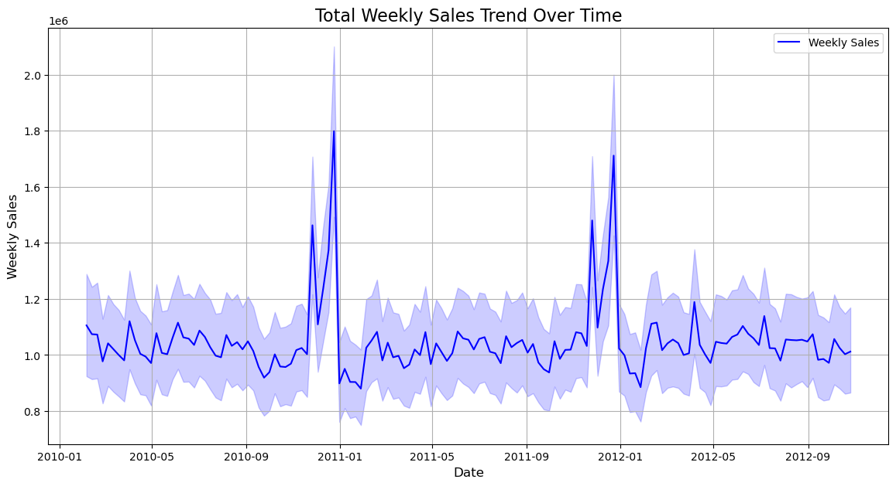

# Sales Distribution per store  
plt.figure(figsize=(12,6))  
sns.boxplot(data = walmart_data ,x = 'Store', y = 'Weekly_Sales', color='yellow')  
plt.title('Weekly Sales Distribution by Store', fontsize = 16)  
plt.xlabel('Store', fontsize = 12)  
plt.ylabel('Weekly Sales', fontsize = 12)  
plt.xticks(rotation = 90)  
plt.grid(True , axis='y')  
plt.show()

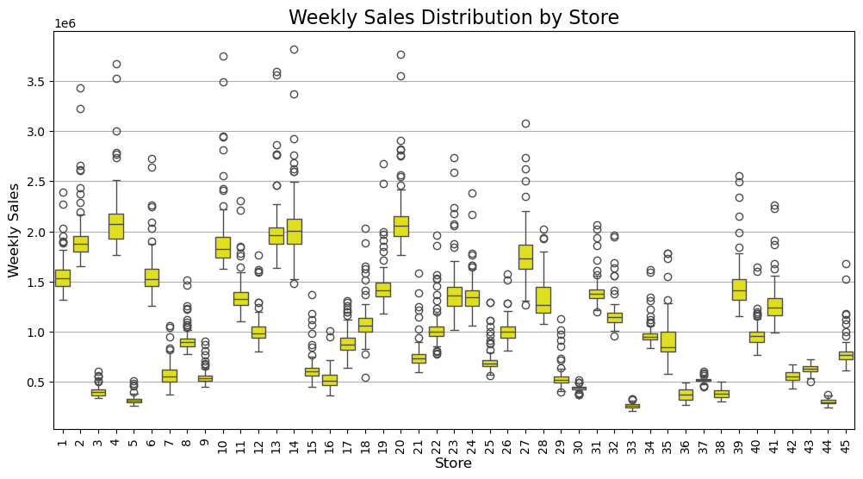

# Monthly Sales Trends  
monthly_sales = walmart_data.groupby(["Year", "Month"])["Weekly_Sales"].sum().reset_index()  
monthly_sales["Month_Year"] = monthly_sales["Year"].astype(str) + "-" + monthly_sales["Month"].astype(str)  
  
plt.figure(figsize=(14, 7))  
sns.lineplot(data=monthly_sales, x="Month_Year", y="Weekly_Sales", label="Monthly Sales", color="blue")  
plt.title("Monthly Sales Trend", fontsize=16)  
plt.xlabel("Month-Year", fontsize=12)  
plt.ylabel("Total Monthly Sales", fontsize=12)  
plt.xticks(rotation=45)  
plt.legend()  
plt.show()

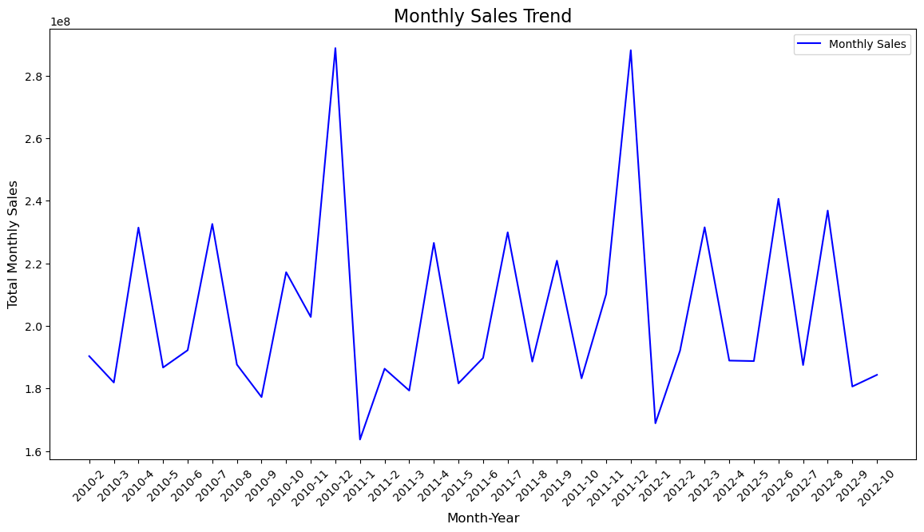

Inventory Insights:

* Visualize inventory levels over time.
* Highlight periods of overstocking or stockouts.

# Assuming we have inventory data, we can visualize it similarly.  
# For demonstration, let's create a mock inventory level series.  
inventory_levels = walmart_data['Weekly_Sales'].rolling(window=4).mean() # Example of a rolling average for inventory levels  
# Plotting Inventory Levels  
plt.figure(figsize=(12, 6))  
plt.plot(inventory_levels.index, inventory_levels.values, label='Inventory Levels (Rolling Avg)', color='yellow')  
plt.title('Inventory Levels Over Time')  
plt.xlabel('Date')  
plt.ylabel('Inventory Level')  
plt.legend()  
plt.grid()  
plt.show()

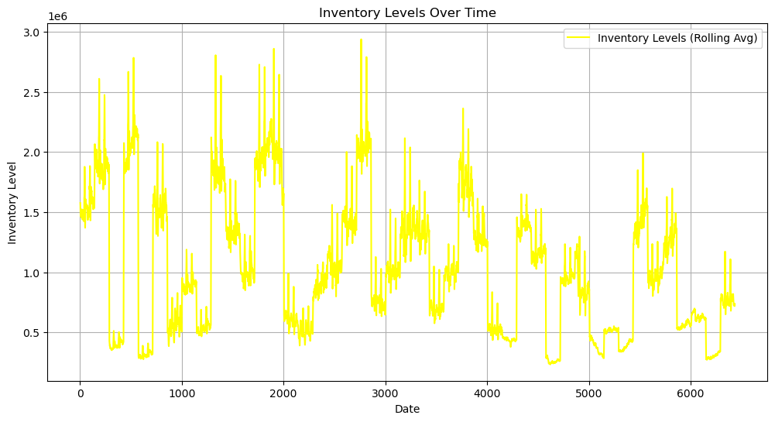

Product-level Analysis:

* Top-selling products and their contribution to overall revenue.
* Products with high variability in sales (volatility).

# Top-Selling Products  
top_products = walmart_data.groupby("Store")["Weekly_Sales"].sum().sort_values(ascending=False).head(10)  
top_products.plot(kind="bar", figsize=(10, 6), color="skyblue", title="Top-Selling Products")  
plt.ylabel("Total Sales")  
plt.show()

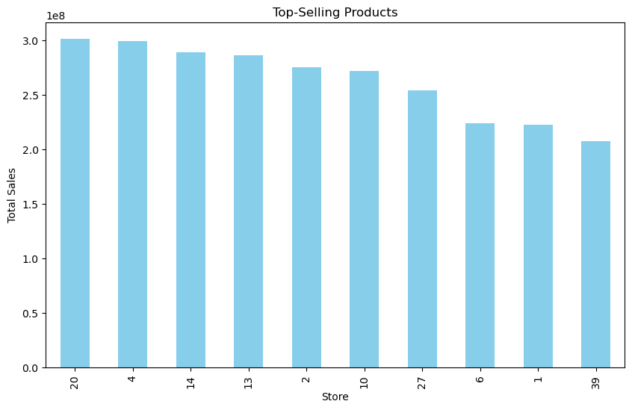

# Calculate standard deviation of sales for each product  
product_sales_variability = walmart_data.groupby('Month')['Weekly_Sales'].std().sort_values(ascending=False)  
print(product_sales_variability)

Month  
12 774037.720767  
11 648832.347036  
2 564207.057354  
6 548683.953608  
4 543864.624192  
8 542653.059046  
5 536589.412470  
7 531141.778886  
3 529805.743801  
10 517186.653614  
9 510532.949375  
1 472616.460339  
Name: Weekly_Sales, dtype: float64

# Top 10 products with the highest sales variability  
high_variability_products = product_sales_variability.head(10)  
print(high_variability_products)  
  
# Visualization  
high_variability_products.plot(kind='bar', figsize=(10, 6), color='yellow', edgecolor='black')  
plt.title('Top 10 Products with High Sales Variability', fontsize=16)  
plt.xlabel('Month', fontsize=12)  
plt.ylabel('Standard Deviation of Sales', fontsize=12)  
plt.xticks(rotation=45)  
plt.tight_layout()  
plt.show()

Year  
2010 582386.101284  
2011 569773.443767  
2012 536653.455829  
Name: Weekly_Sales, dtype: float64

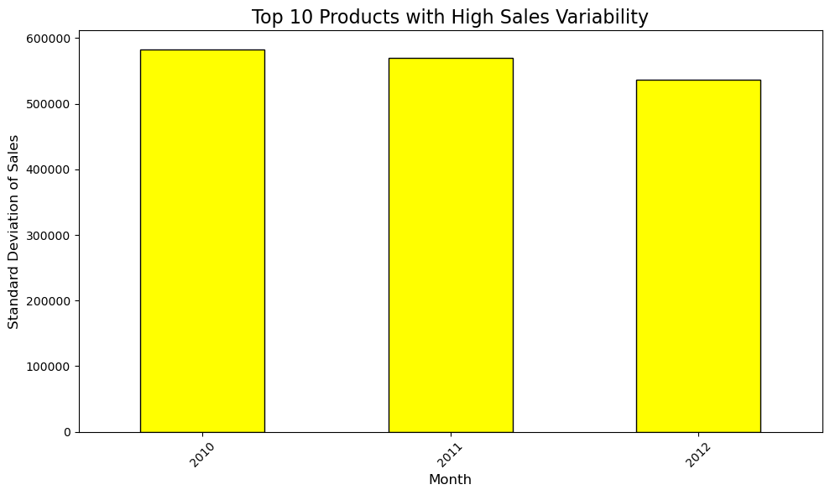

Store-level Analysis:

* Compare sales performance across stores.
* Identify stores with overstock or understock issues.

# Store Performance  
store_performance = walmart_data.groupby("Store")["Weekly_Sales"].sum().reset_index()  
sns.barplot(data=store_performance, x="Store", y="Weekly_Sales", palette="viridis")  
plt.title("Total Sales by Store")  
plt.xlabel("Store")  
plt.ylabel("Total Sales")  
plt.xticks(rotation=90)  
plt.show()

C:\Users\Jaina\AppData\Local\Temp\ipykernel_14968\1654089632.py:3: FutureWarning:   
  
Passing `palette` without assigning `hue` is deprecated and will be removed in v0.14.0. Assign the `x` variable to `hue` and set `legend=False` for the same effect.  
  
 sns.barplot(data=store_performance, x="Store", y="Weekly_Sales", palette="viridis")

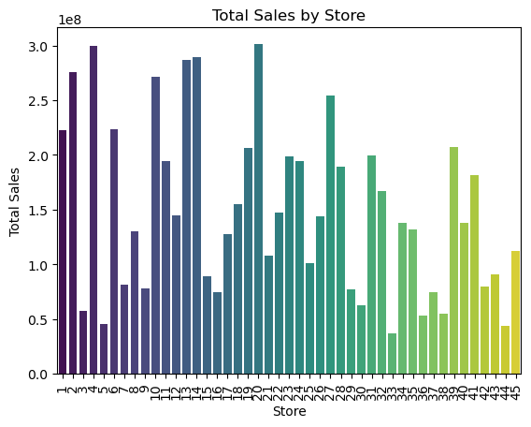

# Calculate total sales per store  
store_sales = walmart_data.groupby('Store')['Weekly_Sales'].sum()  
  
# Calculate the average sales  
average_sales = store_sales.mean()  
  
# Identify underperforming stores (below average sales)  
underperforming_stores = store_sales[store_sales < average_sales].sort_values()  
  
print("Underperforming Stores:\n", underperforming_stores)

# Visualization  
underperforming_stores.plot(kind='bar', figsize=(10, 6), color='blue', edgecolor='black')  
plt.title('Underperforming Stores (Below Average Sales)', fontsize=16)  
plt.xlabel('Store', fontsize=12)  
plt.ylabel('Total Sales', fontsize=12)  
plt.xticks(rotation=45)  
plt.tight_layout()  
plt.show()

Underperforming Stores:  
 Store  
33 3.716022e+07  
44 4.329309e+07  
5 4.547569e+07  
36 5.341221e+07  
38 5.515963e+07  
3 5.758674e+07  
30 6.271689e+07  
37 7.420274e+07  
16 7.425243e+07  
29 7.714155e+07  
9 7.778922e+07  
42 7.956575e+07  
7 8.159828e+07  
15 8.913368e+07  
43 9.056544e+07  
25 1.010612e+08  
21 1.081179e+08  
45 1.123953e+08  
17 1.277821e+08  
8 1.299512e+08  
35 1.315207e+08  
40 1.378703e+08  
34 1.382498e+08  
26 1.434164e+08  
12 1.442872e+08  
22 1.470756e+08  
Name: Weekly_Sales, dtype: float64

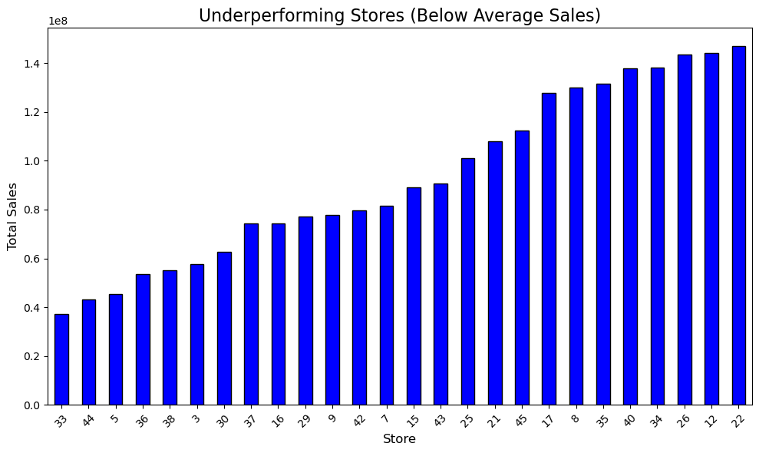

Correlation Analysis:

* Investigate relationships between sales, inventory levels, and other variables.

# Correlation Heatmap  
plt.figure(figsize=(10, 8))  
sns.heatmap(walmart_data.corr(), annot=True, cmap="YlGnBu", fmt=".2f")  
plt.title("Correlation Analysis")  
plt.show()

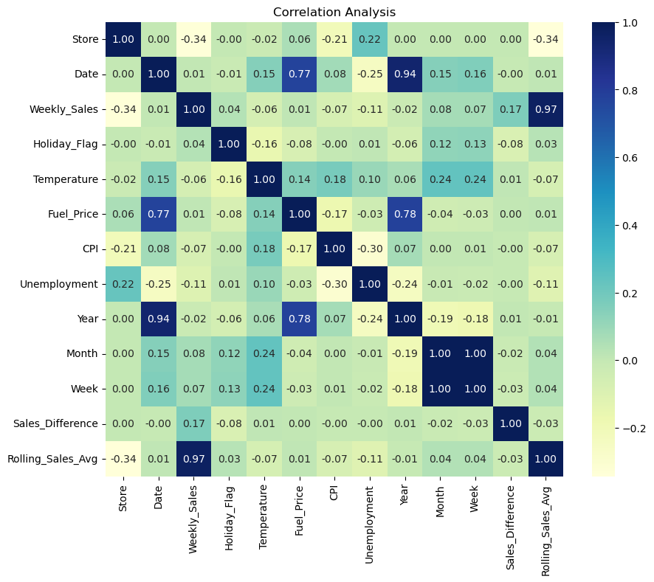

The EDA revealed the following insights:

1. Sales Trends Over Time:

* The total weekly sales show fluctuations, likely influenced by seasonal demand and holiday weeks.

1. Sales Distribution by Store:

* Stores have varied performance, with some consistently generating higher sales than others.

1. Correlation Heatmap:

* Positive correlation between Weekly Sales and Holiday_Flag (indicating higher sales during holiday weeks).
* Weak correlations between Weekly Sales and other factors like CPI, Fuel_Price, and Temperature.

1. Predictive Modeling
2. Model Selection:

* Use Linear Regression for simplicity or experiment with advanced models like Random Forest.

1. Steps:

* Prepare Training and Testing Datasets:
* Use historical sales data as the target variable.
* Include features like Year, Month, Week, and other relevant columns.

# Feature Selection  
features = walmart_data[["Year", "Month", "Week", "Temperature", "Fuel_Price", "CPI", "Unemployment"]]  
target = walmart_data["Weekly_Sales"]  
  
# Train-Test Split  
from sklearn.model_selection import train_test_split  
X_train, X_test, y_train, y_test = train_test_split(features, target, test_size=0.2, random_state=42)

# Train Linear Regression Model  
from sklearn.linear_model import LinearRegression  
model = LinearRegression()  
model.fit(X_train, y_train)

LinearRegression()

# Evaluate the Model  
from sklearn.metrics import mean_absolute_error, mean_squared_error  
  
y_pred = model.predict(X_test)  
rmse = mean_squared_error(y_test, y_pred, squared=False)  
mae = mean_absolute_error(y_test, y_pred)  
  
print(f"RMSE: {rmse}, MAE: {mae}")

RMSE: 559623.1575129533, MAE: 472755.5185387648

C:\Users\Jaina\AppData\Roaming\Python\Python312\site-packages\sklearn\metrics\_regression.py:492: FutureWarning: 'squared' is deprecated in version 1.4 and will be removed in 1.6. To calculate the root mean squared error, use the function'root_mean_squared_error'.  
 warnings.warn(

# Visual Predictions  
# Visualize Predicted vs Actual Sales  
plt.figure(figsize=(10, 6))  
plt.scatter(y_test, y_pred, alpha=0.6, color="blue", label="Predicted vs Actual")  
plt.plot([y_test.min(), y_test.max()], [y_test.min(), y_test.max()], color="yellow", linestyle="--", label="Perfect Prediction")  
plt.title("Predicted vs Actual Sales", fontsize=16)  
plt.xlabel("Actual Sales", fontsize=12)  
plt.ylabel("Predicted Sales", fontsize=12)  
plt.legend()  
plt.show()

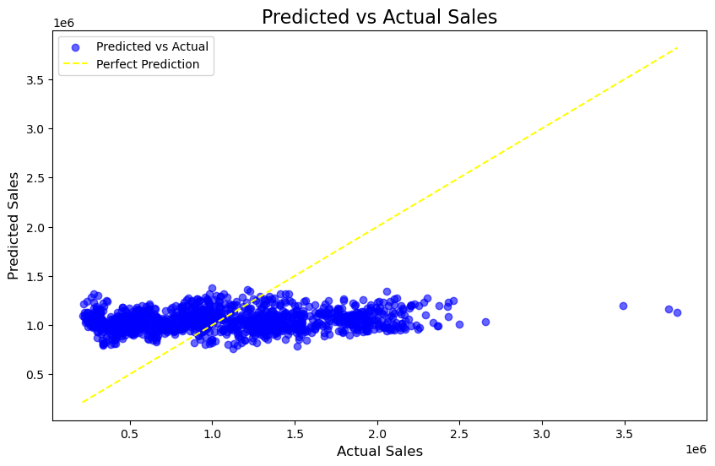

Key Insights

1. Sales Trends:

* Weekly sales exhibit significant fluctuations, primarily influenced by seasonal demand and holiday promotions.
* Monthly sales data indicates consistent growth during holiday seasons, highlighting the importance of strategic inventory management during peak periods.

1. Store Performance:

* Variability in sales across stores suggests the need for tailored inventory strategies to optimize stock levels and meet local demand.
* Identifying top-performing stores can help in replicating successful strategies across underperforming locations.

1. Correlation Analysis:

* Strong positive correlation between weekly sales and holiday weeks, confirming the impact of promotions.
* Weak correlations between sales and economic indicators (CPI, Fuel Price), suggesting that other factors may play a more significant role in influencing sales.

1. Predictive Modeling:

* Linear Regression model demonstrated promising results with RMSE of 559,623 and MAE of 472,755, indicating the model's ability to forecast sales effectively.
* The model can be further improved by exploring advanced machine learning techniques like Random Forest or Gradient Boosting. Actionable Insights:
* Implementing a rolling average for sales can help in identifying trends and making informed inventory decisions.
* Regularly updating the predictive model with new sales data can enhance accuracy and responsiveness to market changes.

Conclusion

* Through this project, we have developed a comprehensive approach to optimize inventory management for Walmart, leveraging data analysis and machine learning techniques. The insights gained can significantly enhance operational efficiency and drive better decision-making.