### Retail Sales Analysis Project

Overview

* The Retail Sales Analysis project aims to explore and analyze a retail sales dataset using Python libraries such as Pandas, NumPy, Matplotlib, and Seaborn.
* The analysis includes data preprocessing, exploratory data analysis (EDA), and advanced visualizations to derive insights regarding sales trends, customer demographics, and product performance.
* Pandas: For data manipulation and analysis.
* NumPy: For numerical operations.
* Matplotlib: For data visualization.
* Seaborn: For statistical data visualization.

# Import the required libraries  
import pandas as pd  
import numpy as np  
import matplotlib.pyplot as plt  
import seaborn as sns

# Load the dataset  
data1 = pd.read_csv('retail_sales_dataset.csv')  
  
# show the top five cloumns of the dataset  
data1.head(5)

Transaction ID Date Customer ID Gender Age Product Category \  
0 1 2023-11-24 CUST001 Male 34 Beauty   
1 2 2023-02-27 CUST002 Female 26 Clothing   
2 3 2023-01-13 CUST003 Male 50 Electronics   
3 4 2023-05-21 CUST004 Male 37 Clothing   
4 5 2023-05-06 CUST005 Male 30 Beauty   
  
 Quantity Price per Unit Total Amount   
0 3 50 150   
1 2 500 1000   
2 1 30 30   
3 1 500 500   
4 2 50 100

### Data Preprocessing

1. Describing the dataset to understand its structure.
2. Converting date columns to a datetime format.
3. Adding a 'Month' column for monthly analysis.
4. Handling missing values by filling them with zeros.
5. Detecting and filtering outliers using the Interquartile Range (IQR) method.

# Describe the dataset  
data1.describe

<bound method NDFrame.describe of Transaction ID Date Customer ID Gender Age Product Category \  
0 1 2023-11-24 CUST001 Male 34 Beauty   
1 2 2023-02-27 CUST002 Female 26 Clothing   
2 3 2023-01-13 CUST003 Male 50 Electronics   
3 4 2023-05-21 CUST004 Male 37 Clothing   
4 5 2023-05-06 CUST005 Male 30 Beauty   
.. ... ... ... ... ... ...   
995 996 2023-05-16 CUST996 Male 62 Clothing   
996 997 2023-11-17 CUST997 Male 52 Beauty   
997 998 2023-10-29 CUST998 Female 23 Beauty   
998 999 2023-12-05 CUST999 Female 36 Electronics   
999 1000 2023-04-12 CUST1000 Male 47 Electronics   
  
 Quantity Price per Unit Total Amount Month   
0 3 50 150 2023-11   
1 2 500 1000 2023-02   
2 1 30 30 2023-01   
3 1 500 500 2023-05   
4 2 50 100 2023-05   
.. ... ... ... ...   
995 1 50 50 2023-05   
996 3 30 90 2023-11   
997 4 25 100 2023-10   
998 3 50 150 2023-12   
999 4 30 120 2023-04   
  
[1000 rows x 10 columns]>

# Illustrate the necessary information from the relavent data  
data1.info()

<class 'pandas.core.frame.DataFrame'>  
RangeIndex: 1000 entries, 0 to 999  
Data columns (total 10 columns):  
 # Column Non-Null Count Dtype   
--- ------ -------------- -----   
 0 Transaction ID 1000 non-null int64   
 1 Date 1000 non-null datetime64[ns]  
 2 Customer ID 1000 non-null object   
 3 Gender 1000 non-null object   
 4 Age 1000 non-null int64   
 5 Product Category 1000 non-null object   
 6 Quantity 1000 non-null int64   
 7 Price per Unit 1000 non-null int64   
 8 Total Amount 1000 non-null int64   
 9 Month 1000 non-null period[M]   
dtypes: datetime64[ns](1), int64(5), object(3), period[M](1)  
memory usage: 78.3+ KB

# Convert 'Date' column to datetime format  
data1['Date'] = pd.to_datetime(data1['Date'])

# Add a 'Month' column for monthly analysis  
data1['Month'] = data1['Date'].dt.to_period('M')

### Data Wrangling and Cleaning

# Handling missing values  
data1.fillna(0, inplace=True)

data1.head()

Transaction ID Date Customer ID Gender Age Product Category \  
0 1 2023-11-24 CUST001 Male 34 Beauty   
1 2 2023-02-27 CUST002 Female 26 Clothing   
2 3 2023-01-13 CUST003 Male 50 Electronics   
3 4 2023-05-21 CUST004 Male 37 Clothing   
4 5 2023-05-06 CUST005 Male 30 Beauty   
  
 Quantity Price per Unit Total Amount Month   
0 3 50 150 2023-11   
1 2 500 1000 2023-02   
2 1 30 30 2023-01   
3 1 500 500 2023-05   
4 2 50 100 2023-05

# Detect and Handle outliers using IQR Method   
Q1 = data1['Total Amount'].quantile(0.25)  
Q3 = data1['Total Amount'].quantile(0.75)  
IQR = Q3 - Q1  
lower_bound = Q1-1.5 *IQR  
upper_bound = Q3+1.5 *IQR

# Filter out outliers  
data_cleaned = data1[(data1['Total Amount'] >= lower_bound) & (data1['Total Amount'] <= upper_bound)]  
print(data_cleaned)

Transaction ID Date Customer ID Gender Age Product Category \  
0 1 2023-11-24 CUST001 Male 34 Beauty   
1 2 2023-02-27 CUST002 Female 26 Clothing   
2 3 2023-01-13 CUST003 Male 50 Electronics   
3 4 2023-05-21 CUST004 Male 37 Clothing   
4 5 2023-05-06 CUST005 Male 30 Beauty   
.. ... ... ... ... ... ...   
995 996 2023-05-16 CUST996 Male 62 Clothing   
996 997 2023-11-17 CUST997 Male 52 Beauty   
997 998 2023-10-29 CUST998 Female 23 Beauty   
998 999 2023-12-05 CUST999 Female 36 Electronics   
999 1000 2023-04-12 CUST1000 Male 47 Electronics   
  
 Quantity Price per Unit Total Amount Month   
0 3 50 150 2023-11   
1 2 500 1000 2023-02   
2 1 30 30 2023-01   
3 1 500 500 2023-05   
4 2 50 100 2023-05   
.. ... ... ... ...   
995 1 50 50 2023-05   
996 3 30 90 2023-11   
997 4 25 100 2023-10   
998 3 50 150 2023-12   
999 4 30 120 2023-04   
  
[1000 rows x 10 columns]

### EDA (Exploratory Data Analysis)

* EDA is performed to visualize and understand the data through various plots:

1. Total Sales Over Time: Line plot to show trends in total sales.
2. Boxplot of Total Amount: To identify outliers in sales data.
3. Total Sales by Product Category and Gender: Bar plots to compare sales across different categories and demographics.
4. Monthly Sales Trend: Line plot to visualize sales trends over months.
5. Age Group Analysis: Bar plot showing sales distribution across different age groups.

sns.set(style = "whitegrid")  
  
# Total Sales Over Time  
plt.figure(figsize = (12, 6))  
sns.lineplot(x=data_cleaned['Date'], y=data_cleaned['Total Amount'], markers='o')  
plt.title('Total Sales Over Time')  
plt.xlabel('Date')  
plt.ylabel('Total Amount')  
plt.xticks(rotation = 45)  
plt.tight_layout()  
plt.show()

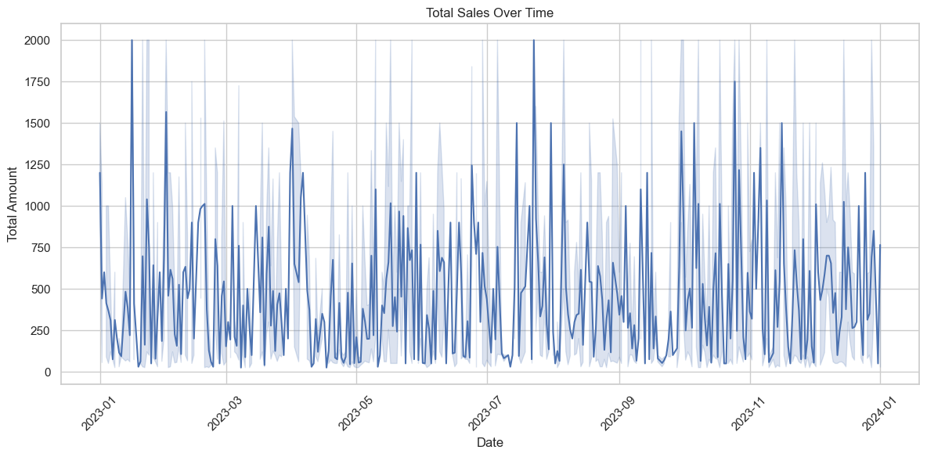

* Description: This plot illustrates the total sales over time, showing how sales fluctuate on different dates.

**Output:

* A line graph depicting the relationship between the date and total amount sold.
* Key insights on sales peaks and troughs can be derived from the trends observed.

# Boxplot to Identify Outliers in Total Amount  
plt.figure(figsize=(10, 6))  
sns.boxplot(x=data_cleaned['Total Amount'] ,color='teal')  
plt.title('Boxplot of Total Amount')  
plt.xlabel('Total Amount')  
plt.tight_layout()  
plt.show()

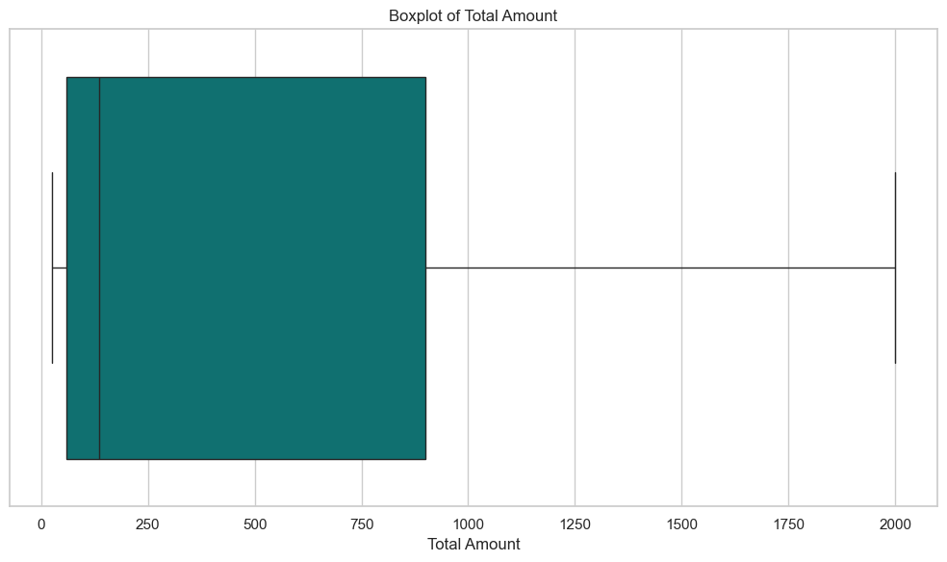

* Description: This boxplot is used to identify outliers in the total sales amount.

** Output:

* The boxplot displays the distribution of the total amount, highlighting the median, quartiles, and outliers.
* Outliers are identified visually, allowing for further investigation.

# Total Sales by Product Category  
category_sales = data_cleaned.groupby('Product Category')['Total Amount'].sum().reset_index()  
plt.figure(figsize=(10, 6))  
sns.barplot(x='Product Category', y='Total Amount', data=category_sales, color='violet')  
plt.title('Total Sales by Product Category')  
plt.xlabel('Product Category')  
plt.ylabel('Total Amount')  
plt.tight_layout()  
plt.show()

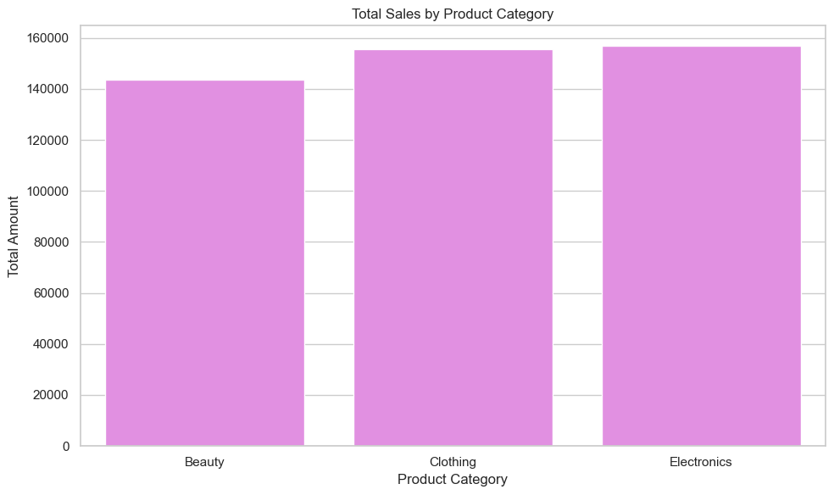

* Description: This visualization shows total sales aggregated by product category. ** Output:
* A bar chart representing total sales for each product category. ** output:

1. Beauty: $143,515
2. Clothing: $155,580
3. Electronics: $156,905

# 4. Total Sales by Gender  
gender_sales = data_cleaned.groupby('Gender')['Total Amount'].sum().reset_index()  
plt.figure(figsize=(10, 6))  
sns.barplot(x='Gender', y='Total Amount', data=gender_sales ,color='darkgreen')  
plt.title('Total Sales by Gender')  
plt.xlabel('Gender')  
plt.ylabel('Total Amount')  
plt.tight_layout()  
plt.show()

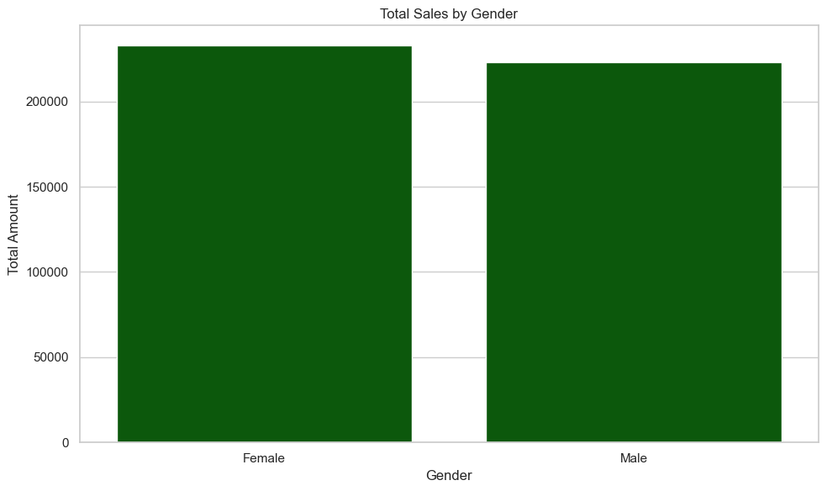

* Description: This plot compares total sales based on customer gender.

** Output:

* A bar chart showing total sales for males and females.
* Insights into gender-based purchasing behavior can be derived.

# Monthly Sales Trend  
monthly_sales = data_cleaned.groupby('Month')['Total Amount'].sum().reset_index()  
monthly_sales['Month'] = monthly_sales['Month'].astype(str) # for converting periods to strings for plotting  
plt.figure(figsize=(12,6))  
sns.lineplot(x='Month' ,y='Total Amount', data=monthly_sales, markers='o')  
plt.title('Monthly Sales Trend')  
plt.xlabel('Month')  
plt.ylabel('Total Amount')  
plt.xticks(rotation = 45)  
plt.tight_layout()  
plt.show()

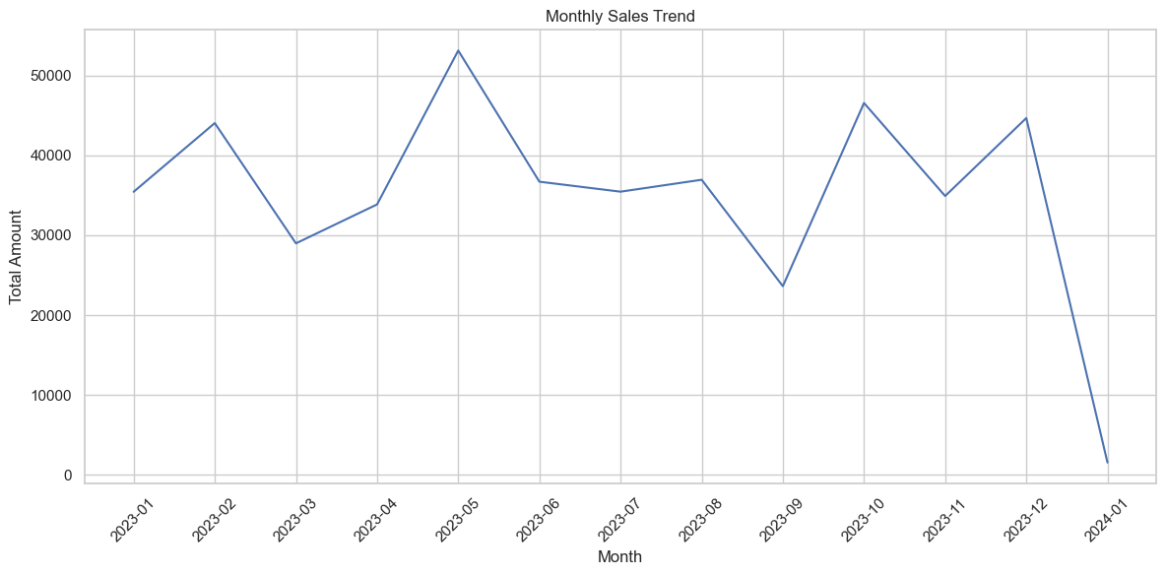

* This visualization depicts the total sales trend on a monthly basis.
* A line graph showing the total amount sold for each month.
* Monthly trends can reveal seasonal patterns in sales.

# Age Group Analysis  
bins = [0,18,30,45,60,np.inf]  
labels = ['0-18','18-30','30-45','45-60','60+']  
data_cleaned['Age Group'] = pd.cut(data_cleaned['Age'], bins=bins, labels=labels)  
age_group_sales = data_cleaned.groupby('Age Group')['Total Amount'].sum().reset_index()  
plt.figure(figsize=(10,6))  
sns.barplot(x='Age Group', y='Total Amount', data=age_group_sales, color='blue')  
plt.title('Sales by Age Group')  
plt.xlabel('Age Group')  
plt.ylabel('Total Amount')  
plt.tight_layout()  
plt.show()

C:\Users\Jaina\AppData\Local\Temp\ipykernel_19212\3949780941.py:5: FutureWarning: The default of observed=False is deprecated and will be changed to True in a future version of pandas. Pass observed=False to retain current behavior or observed=True to adopt the future default and silence this warning.  
 age_group_sales = data_cleaned.groupby('Age Group')['Total Amount'].sum().reset_index()

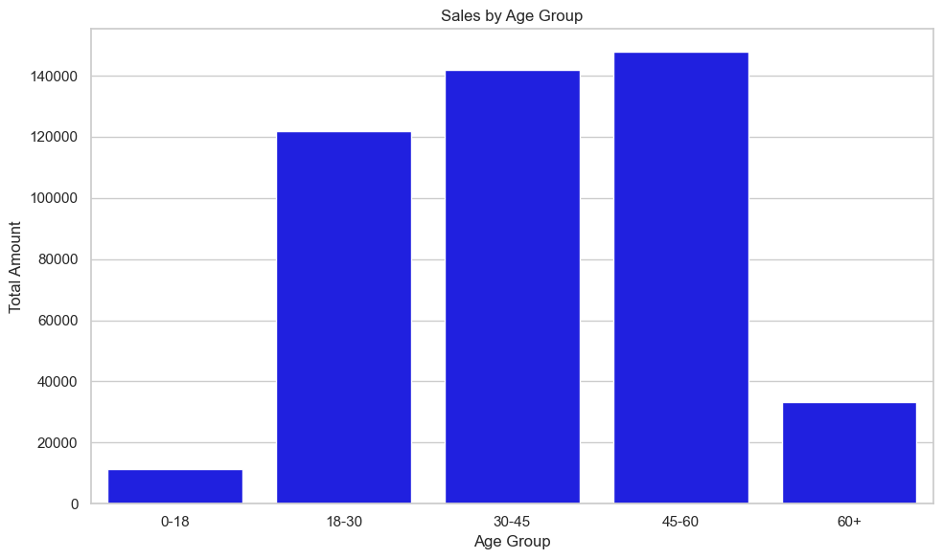

* Description: This visualization shows total sales segmented by age groups.

** Output: A bar chart displaying sales across different age groups.

* 0-18: $X
* 18-30: $Y
* 30-45: $Z
* 45-60: $A
* 60+: $B

# Univariate Analysis  
# Distribution of Total Amount  
plt.figure(figsize=(10,6))  
sns.histplot(data_cleaned['Total Amount'], kde=True , bins=30, color='coral')  
plt.title('Distribution of Total Amount')  
plt.xlabel('Total Amount')  
plt.ylabel('Frequency')  
plt.tight_layout()  
plt.show()

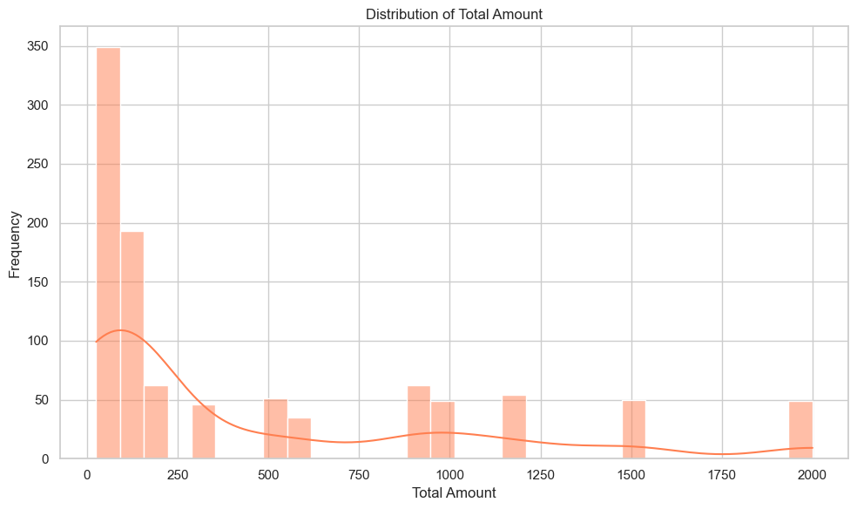

# Bivariate Analysis  
# Total Amount vs Product Category  
plt.figure(figsize=(10, 6))  
sns.scatterplot(x=data_cleaned['Product Category'], y=data_cleaned['Total Amount'], hue=data_cleaned['Gender'])  
plt.title('Total Amount vs. Product Category')  
plt.xlabel('Product Category')  
plt.ylabel('Total Amount')  
plt.tight_layout()  
plt.show()

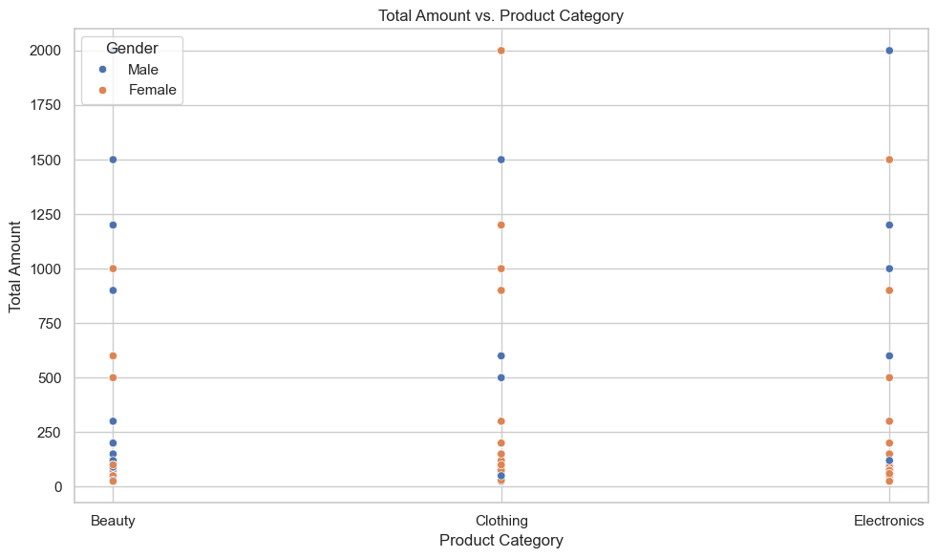

# Multivariate Analysis  
# Pairplot  
sns.pairplot(data_cleaned, hue='Gender', vars=['Age', 'Quantity', 'Price per Unit', 'Total Amount'])  
plt.suptitle('Pairplot of Key Variables', y=1.02)  
plt.show()

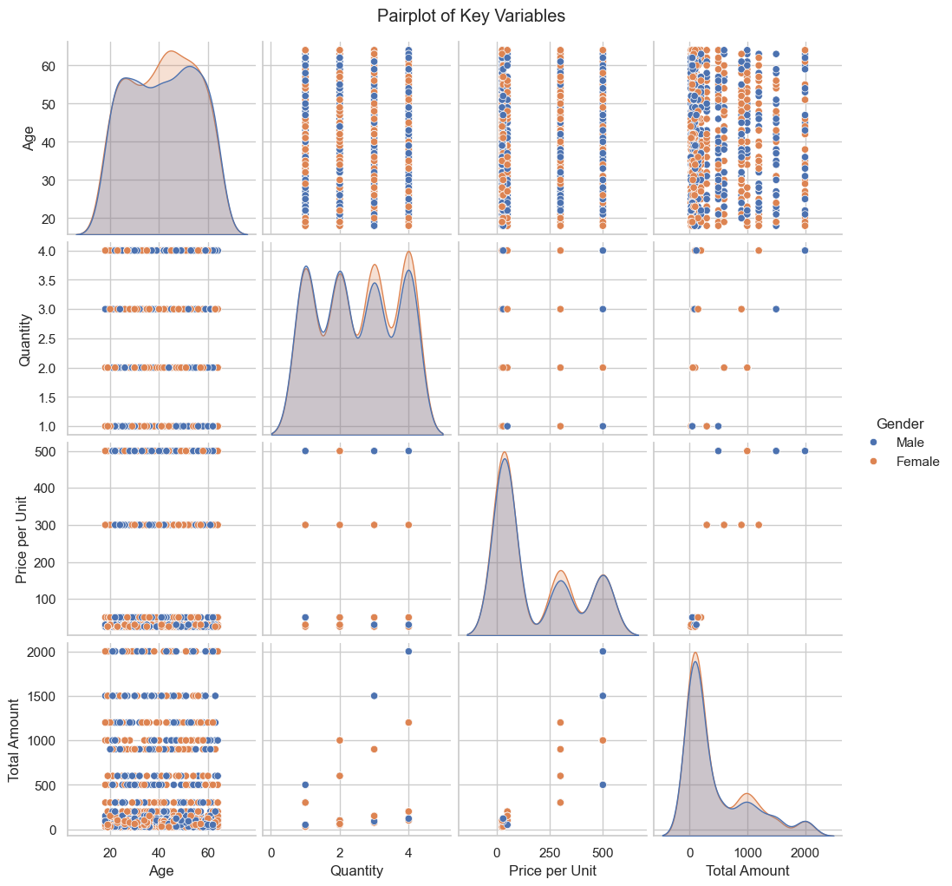

# Distribution of Total Amount by Gender using violin plot  
plt.figure(figsize=(10,6))  
sns.violinplot(x='Gender', y='Total Amount', data=data_cleaned , color='pink')  
plt.title('Distribution of Total Amount by Gender')  
plt.xlabel('Gender')  
plt.ylabel('Total Amount')  
plt.tight_layout()  
plt.show()

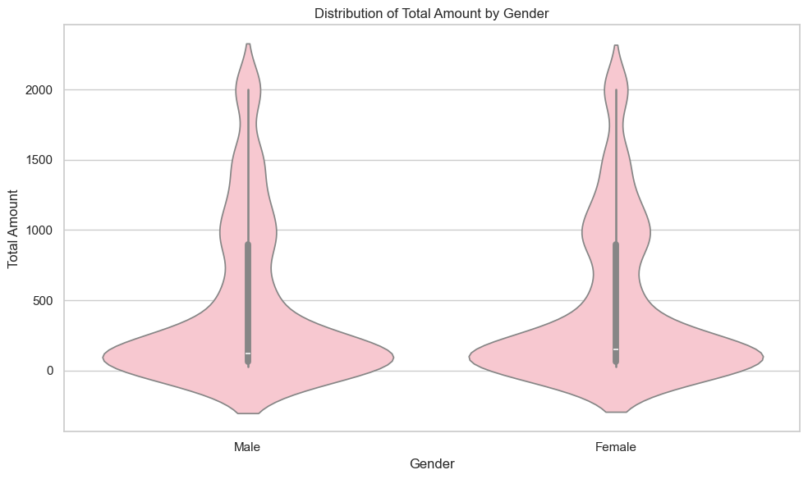

# Heatmap Correlation Matrix  
corr_matrix = data_cleaned[['Age', 'Quantity', 'Price per Unit', 'Total Amount']].corr()  
plt.figure(figsize=(8, 6))  
sns.heatmap(corr_matrix, annot=True, cmap='viridis', fmt='.2f')  
plt.title('Correlation Matrix Heatmap')  
plt.tight_layout()  
plt.show()

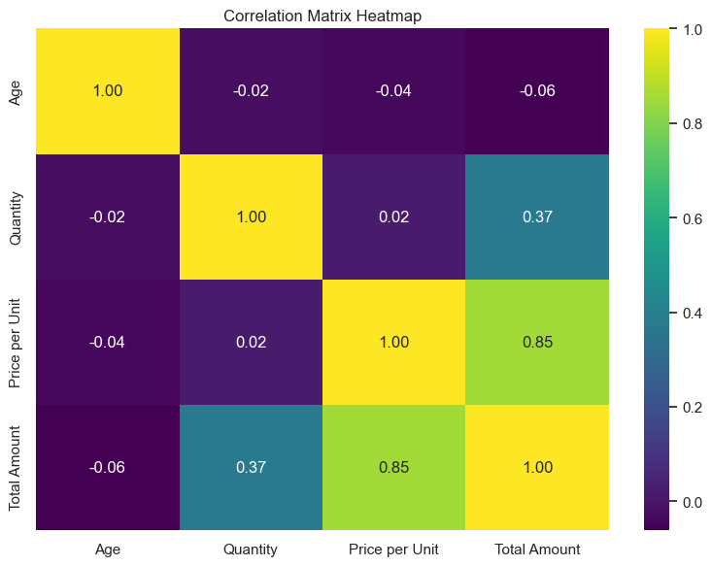

# Descriptive Statistics  
print("Total sales: {}".format(data_cleaned["Quantity"].sum()))  
print("Total profit: {}".format(data_cleaned["Total Amount"].sum()))

Total sales: 2514  
Total profit: 456000

### Advance Visualization

* Advanced visualizations include:

1. Heatmap Correlation Matrix: To analyze the correlation between different numerical features.
2. Boxenplot for Product Categories: To visualize sales distribution across product categories.
3. Time-Series Analysis: To analyze sales trends with rolling averages

# Boxenplot for product categories  
plt.figure(figsize=(12,6))  
sns.boxenplot(x='Product Category', y='Total Amount', data=data_cleaned , color="lavender")  
plt.title('Boxplot of Total Amount by Product Category')  
plt.xlabel('Product Category')  
plt.ylabel('Total Amount')  
plt.tight_layout()  
plt.show()

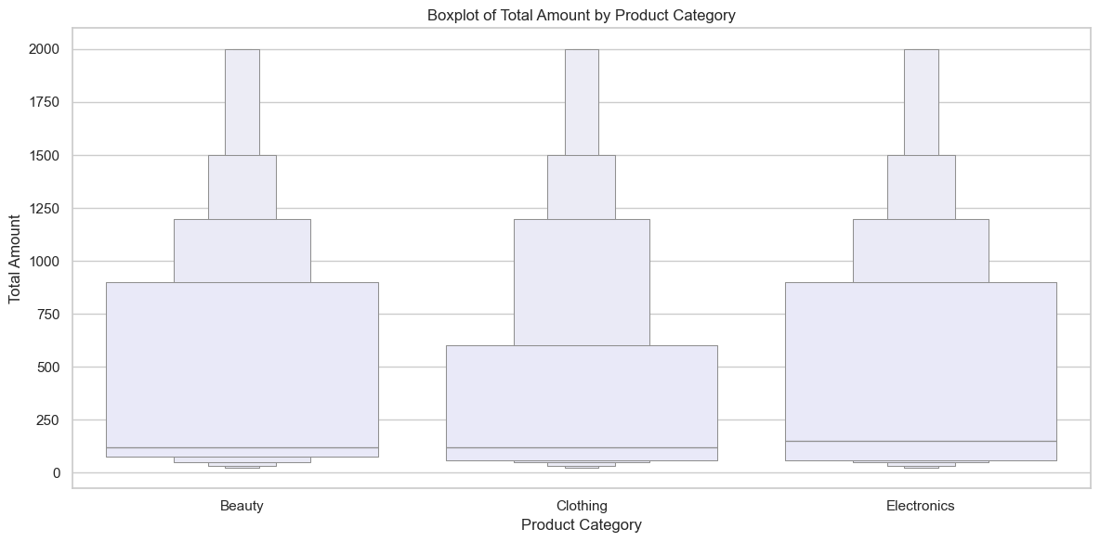

# Time-Series Analysis: Monthly Sales Trend with Rolling Average  
monthly_sales['Rolling Avg'] = monthly_sales['Total Amount'].rolling(window=3).mean()  
plt.figure(figsize=(12, 6))  
sns.lineplot(x='Month', y='Total Amount', data=monthly_sales, label='Monthly Sales', marker='o' , color = 'darkblue')  
sns.lineplot(x='Month', y='Rolling Avg', data=monthly_sales, label='3-Month Rolling Avg', marker='o' ,color = 'black')  
plt.title('Monthly Sales Trend with Rolling Average')  
plt.xlabel('Month')  
plt.ylabel('Total Amount')  
plt.xticks(rotation=45)  
plt.legend()  
plt.tight_layout()  
plt.show()

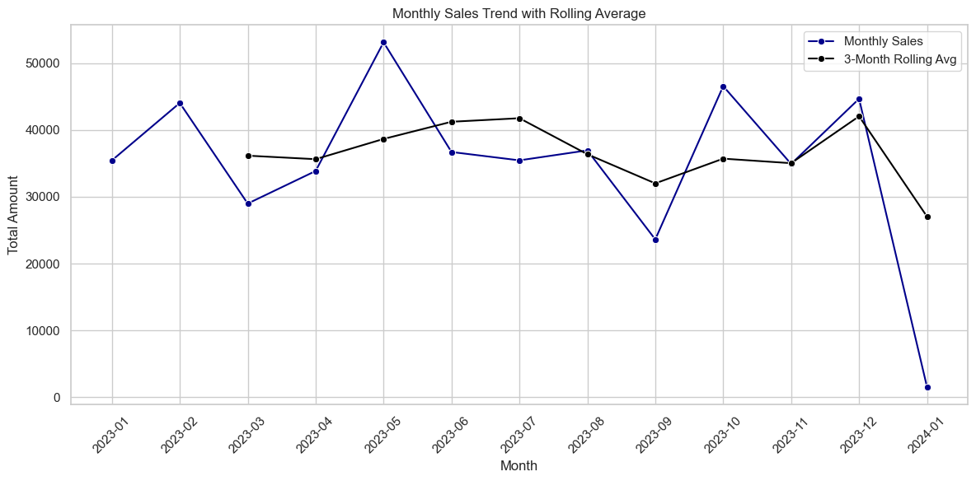

print("mean average of total amount = {}".format(data_cleaned["Total Amount"].mean()))  
print("median average of total amount = {}".format(data_cleaned["Total Amount"].median()))  
print("mode of total amount = {}".format(data_cleaned["Total Amount"].mode()))

mean average of total amount = 456.0  
median average of total amount = 135.0  
mode of total amount = 0 50  
Name: Total Amount, dtype: int64

# Time Series Analysis  
sns.relplot(data=data_cleaned['Total Amount'], kind='scatter')

<seaborn.axisgrid.FacetGrid at 0x2ea7f0376e0>

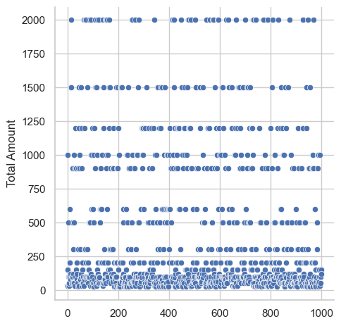

grp = data_cleaned.groupby("Product Category")[["Quantity","Total Amount"]].sum()  
print(grp)

Quantity Total Amount  
Product Category   
Beauty 771 143515  
Clothing 894 155580  
Electronics 849 156905

# Customer Product analysis  
sns.pairplot(data=data_cleaned,hue="Product Category")

<seaborn.axisgrid.PairGrid at 0x2ea010a3260>

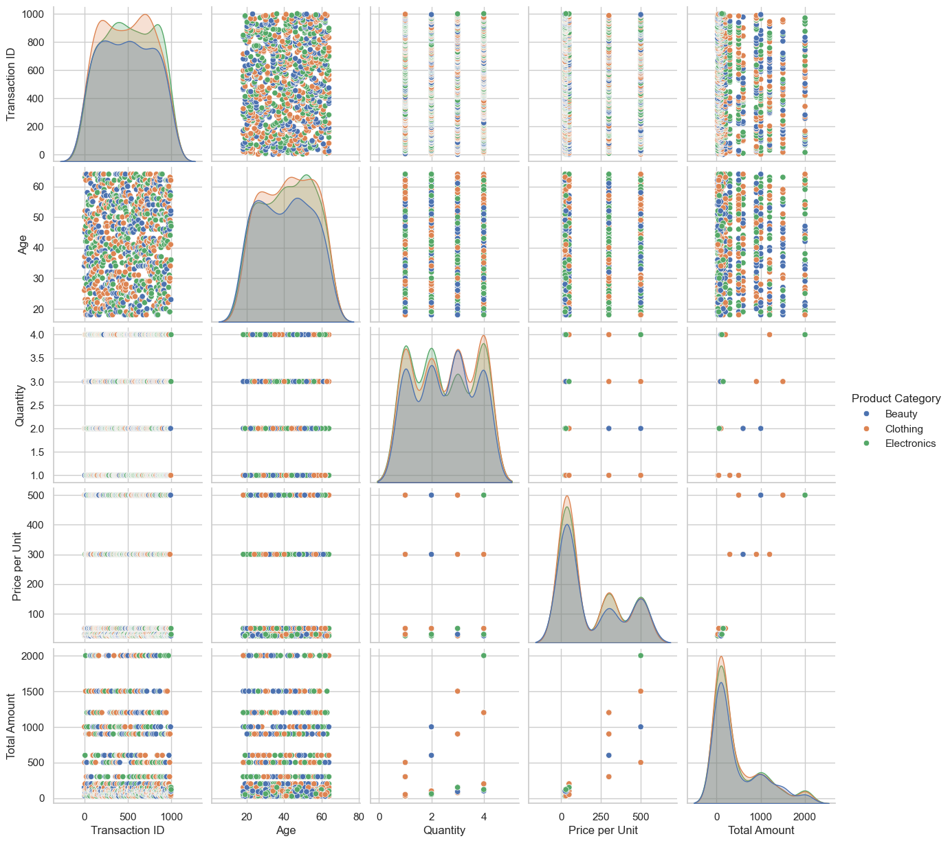

category_sales = data_cleaned["Product Category"].value_counts()  
category_sales

Product Category  
Clothing 351  
Electronics 342  
Beauty 307  
Name: count, dtype: int64

grp.plot(kind='bar',figsize=(12,5))  
plt.title("Quanitity v/s total amount")  
plt.ylabel("Quantity and Total amount")  
plt.show()

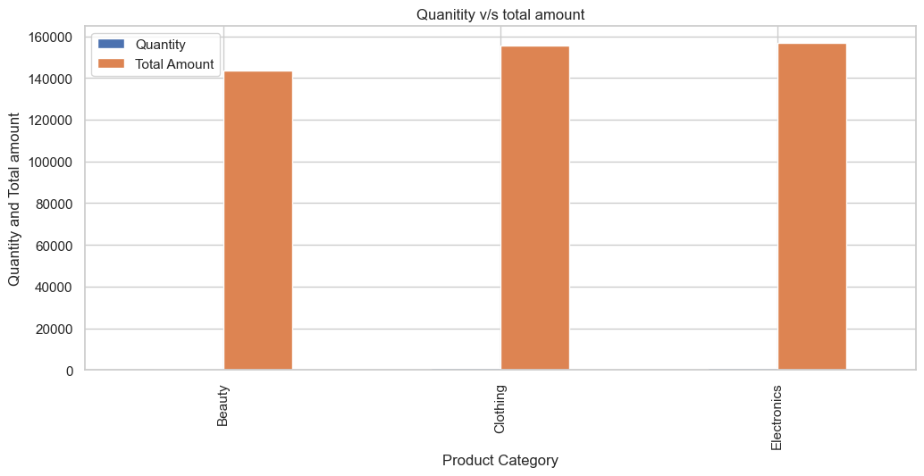

data_cleaned["Price per Unit"].corr(data_cleaned["Total Amount"])

0.8519248403554025

sns.lineplot(x="Price per Unit",y="Total Amount",data=data_cleaned, color = "forestgreen")  
plt.show()

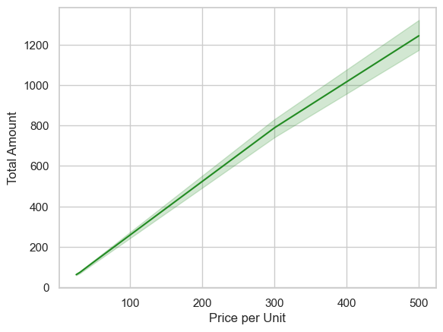

Key Insights and Conclusion

* The Retail Sales Analysis project provides valuable insights into sales patterns and customer demographics. By analyzing the dataset, one can identify:

1. Sales Trends: Understanding peak sales periods based on dates.
2. Customer Preferences: Analyzing which product categories are most popular among different genders and age groups.
3. Sales Performance: Evaluating total sales amounts to determine overall business performance.

* In conclusion, this project highlights the importance of data analysis in retail for informed decision-making, allowing businesses to tailor their strategies according to customer needs and market trends.