# Header 1

Text under header 1

## Header 2

Text under header 2

|  |  |  |
| --- | --- | --- |
| qwerty | asdfgh | zxcvbn |
| 123 | 456 | 789 |

## Contacts

Email: iwansam1996@gmail.com

## Pomeranian part

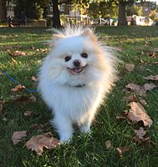

[This Photo](https://en.wikipedia.org/wiki/Pomeranian_(dog)) by Unknown Author is licensed under [CC BY-SA](https://creativecommons.org/licenses/by-sa/3.0/)