Final Assignment
by
Enrique Juan Gamboa
D23125488

INDEX:

Task II…………………………………………………………………………………….3

Task III……………………………………………………………………………………6

Task IV……………………………………………………………………………………8

Task V…………………………………………………………………………………….9

Task II

To accomplish the decryption of the test, we first must perform a frequency analysis on it to determine the most common letters in the text. For this, I will be using the code that was given to us in the second lab.
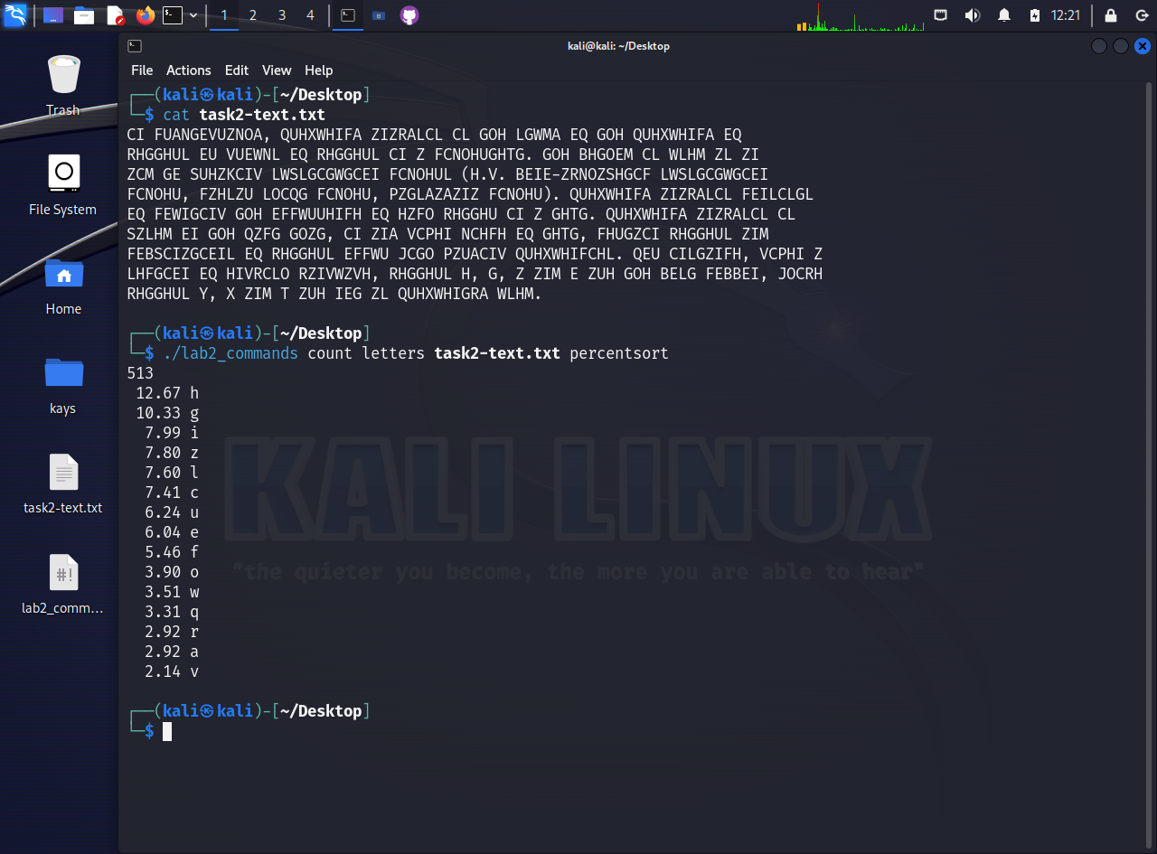
Here, I have created 2 files: one with the text called “task2-text.txt”, which we will be using throughout the task, and “lab2_commands”, which I have given executable permissions. This way I can run the command shown, and determine the most common letters.
With these letters, we can start by creating a couple of tables which will switch the common letters in the text with the most common letters in the English language.

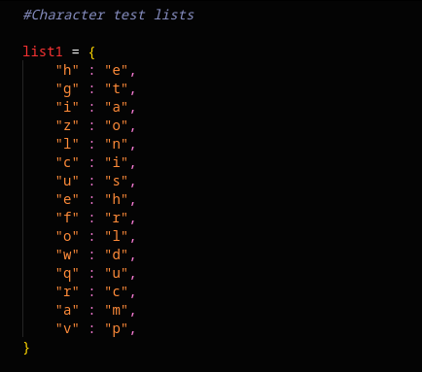
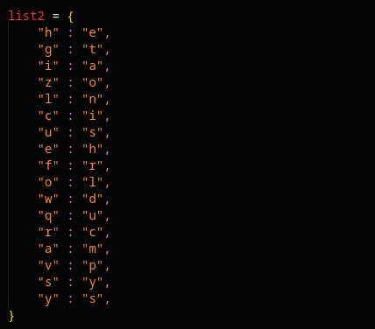
With these lists, we can use the code I have written (“task2-code.py”) to switch the letters:
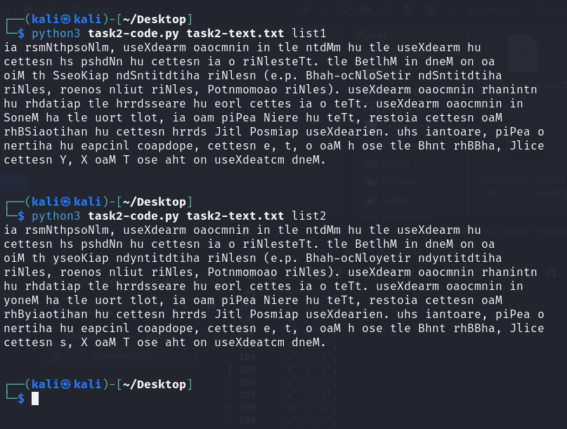
With these results we can determine a couple of repetitions: “tle” will most probably be “the”, and the first word will probably be “in”.
With a couple of trials, errors and more logical substitutions, I reached conclusions such as “oaM” being “and” due to it being a three-letter word at the end of various commas (meaning an enumeration), or “p” being “g” due to the use of parenthesis and two punctuated letters that usually indicate an example (“e.g.”). This helped to guess a lot of switches. These were compiled to the list 5 shown below, that gives us a potential solution (shown beside the list):
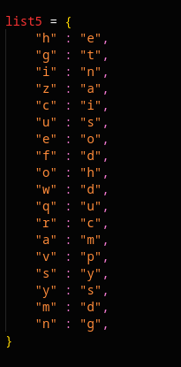
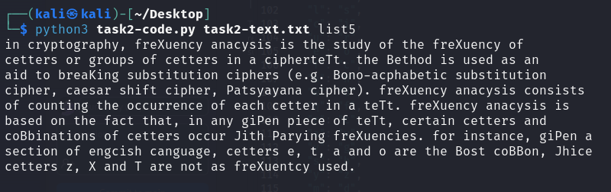

With this, I created a final list with the remaining replacements done. The best example is the word “text”, where I was able to figure “T” was “x” thanks to the program making the switches lowercase. Shown below, the final list and the decrypted message:
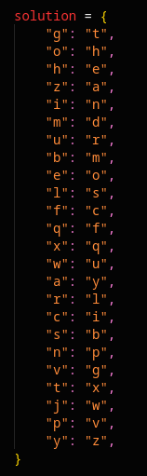
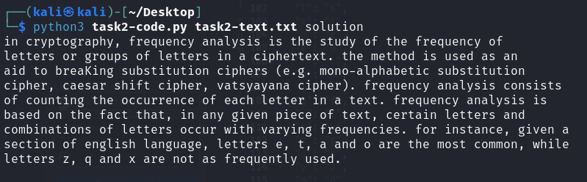

The file “task2-code.py” is sent alongside this document. It includes the method used to switch the letters, most of the lists used and the boot code that allows to choose between lists. This code reads a .txt file as its first argument, and the list to be used must be named as the second argument.

Task III

If the purpose is to securely send and receive messages using the Internet, we will have to start with the use the RSA (Rivest-Shamir-Adleman) encryption algorithm. This algorithm is based upon the use of two different keys: the receiver's public key, used by the sender, to encrypt the message; and the receiver’s private key, which is used by the receiver to decrypt it.
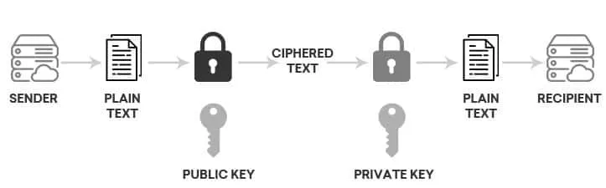
Here’s a simplified schematic of how it works:

