ASSIGNMENT II
by
Enrique Juan Gamboa
D23125488

INDEX

Part A . . . . . . . . . . . . . . . . . . . . . . . . . . . . . . . . . . . . . . . . . . . . . . . . . . 3

Part B . . . . . . . . . . . . . . . . . . . . . . . . . . . . . . . . . . . . . . . . . . . . . . . . . . 4
1. TUD Computer Science page Report
1.1. Manual Evaluation . . . . . . . . . . . . . . . . . . . . . . . . . . . . . . . . . . . . . . 4
1.2. Tool-Assisted Evaluation . . . . . . . . . . . . . . . . . . . . . . . . . . . . . . . . . .6
1.3. Manual vs. Tool-Assisted comparison . . . . . . . . . . . . . . . . . . . . . . 7
1.4. Remedial Actions . . . . . . . . . . . . . . . . . . . . . . . . . . . . . . . . . . . . . . . . 8
2. UCD Computer Science page Report
2.1. Manual Evaluation . . . . . . . . . . . . . . . . . . . . . . . . . . . . . . . . . . . . . 10
2.2. Tool-Assisted Evaluation . . . . . . . . . . . . . . . . . . . . . . . . . . . . . . . . 12
2.3. Manual vs. Tool-Assisted comparison . . . . . . . . . . . . . . . . . . . . . 13
2.4. Remedial Actions . . . . . . . . . . . . . . . . . . . . . . . . . . . . . . . . . . . . . . . 15

Part C . . . . . . . . . . . . . . . . . . . . . . . . . . . . . . . . . . . . . . . . . . . . . . . . . 17

Part A

The EU Web Accessibility Directive (WAD) is a big legal effort to make sure everyone, including those with disabilities, can easily access and make use of the digital world. The European Union wants to make sure that government websites and apps are easy to use for everyone, no matter their abilities.
The main points of the directive, which all EU countries must follow, are:
- Making Websites and Apps Accessible: Government websites and apps need to follow rules called the Web Content Accessibility Guidelines (WCAG) 2.1 at the AA level. These rules make the use of webs and apps easier for people with disabilities.
- Telling People About Accessibility: Governments have to say how well they follow the accessibility rules. They need to tell if there's anything on their sites or apps that's hard for people to use because of disabilities, and how people can get easier-to-use versions.
- Checking and Reporting: Countries have to keep an eye on whether their websites and apps follow the rules. They also need to report on how accessible these sites and apps are and what they're doing to make them easier to use if necessary.
The effects of the EU Web Accessibility Directive are different for each country. I have gone into a bit more depth on its effects both on Ireland and Spain, and uncovered that there’s a lot of work to do in both countries.
In Ireland’s case, they will have to vastly redesign most of their webpages and apps as they are usually not compliant. This is specially tough as there will have to be a lot of cooperation between different governmental bodies.
Spain on the other hand has usually had much more accessible webpages, even though they tend to be outdated. The problem is that the current push for electronic services in the country is leaving a lot to be desired, so a lot of resource allocation has to be done to fix this problem.

Part B

1. TUD Computer Science page Report

1.1. Manual Evaluation:

In this report, I am going to manually analyze the accessibility of TUDublin's Computer Science main page with respect to the WCAG 2.1 guidelines. TUDublin, an institution that prides itself on its accessibility, works very hard to ensure that its digital platforms are inclusive and accessible to all users, including those with disabilities. I will aim to identify areas where improvements can be made to improve accessibility and usability for individuals with disabilities, and commend those areas where it excels.
I have divided this evaluation in the segments indicated by the WCAG 2.1 checkpoints to more easily understand where the webpage excels and where it lacks compliance.
- Perceivable:
Issue: The website lacks alternative text for images in the starting carousel, which is essential for users who rely on screen readers.
Issue: The website lacks clear contrast in various buttons and relies on simple text as buttons.
Commend: The segments on the website are visually different between each other, making clear delimitations between them.
Commend: nearly all essential elements on the website have proper alternative text which describes accurately the purpose of what is being selected.

- Operable:
Issue: Keyboard navigation is not consistently implemented across all interactive elements, specially when tabulating from menu to menu.
Issue: When navigating between buttons, half of the time the selection isn’t clearly visible.
Commend: The use of pop-up menus on some buttons don’t hinder navigation: selection of the parent button can be made and the user is lead to another page where all pop-up selections are easily selectable.
Commend: large buttons are heavily used, which gives a greater margin of error for people with lower motor skills.

- Understandable:
Issue: Some sections of the website lack clear headings and structure, making it difficult for users to navigate and understand the content.
Issue: The website is confusing in it’s organisation, as confusing menus and conceptually unrelated topics are grouped together.
Issue: The language used is often vague in it’s meaning, leading to confusion while navigating.
- Robust:
Issue: The website relies heavily on JavaScript for functionality, potentially causing compatibility issues for users with assistive technologies that do not support JavaScript.
Issue: the website is very heavy on resources, taking long times to load all the elements on it.

In conclusion, while TUDublin's Computer Science main page shows commendable efforts in accessibility, several areas require improvement to meet WCAG 2.1 guidelines fully. Addressing issues related to perceivability, operability, understandability, and robustness will enhance the website's inclusivity and usability for all users, aligning with TUDublin's commitment to accessibility in digital platforms.

1.2. Tool-Assisted Evaluation:
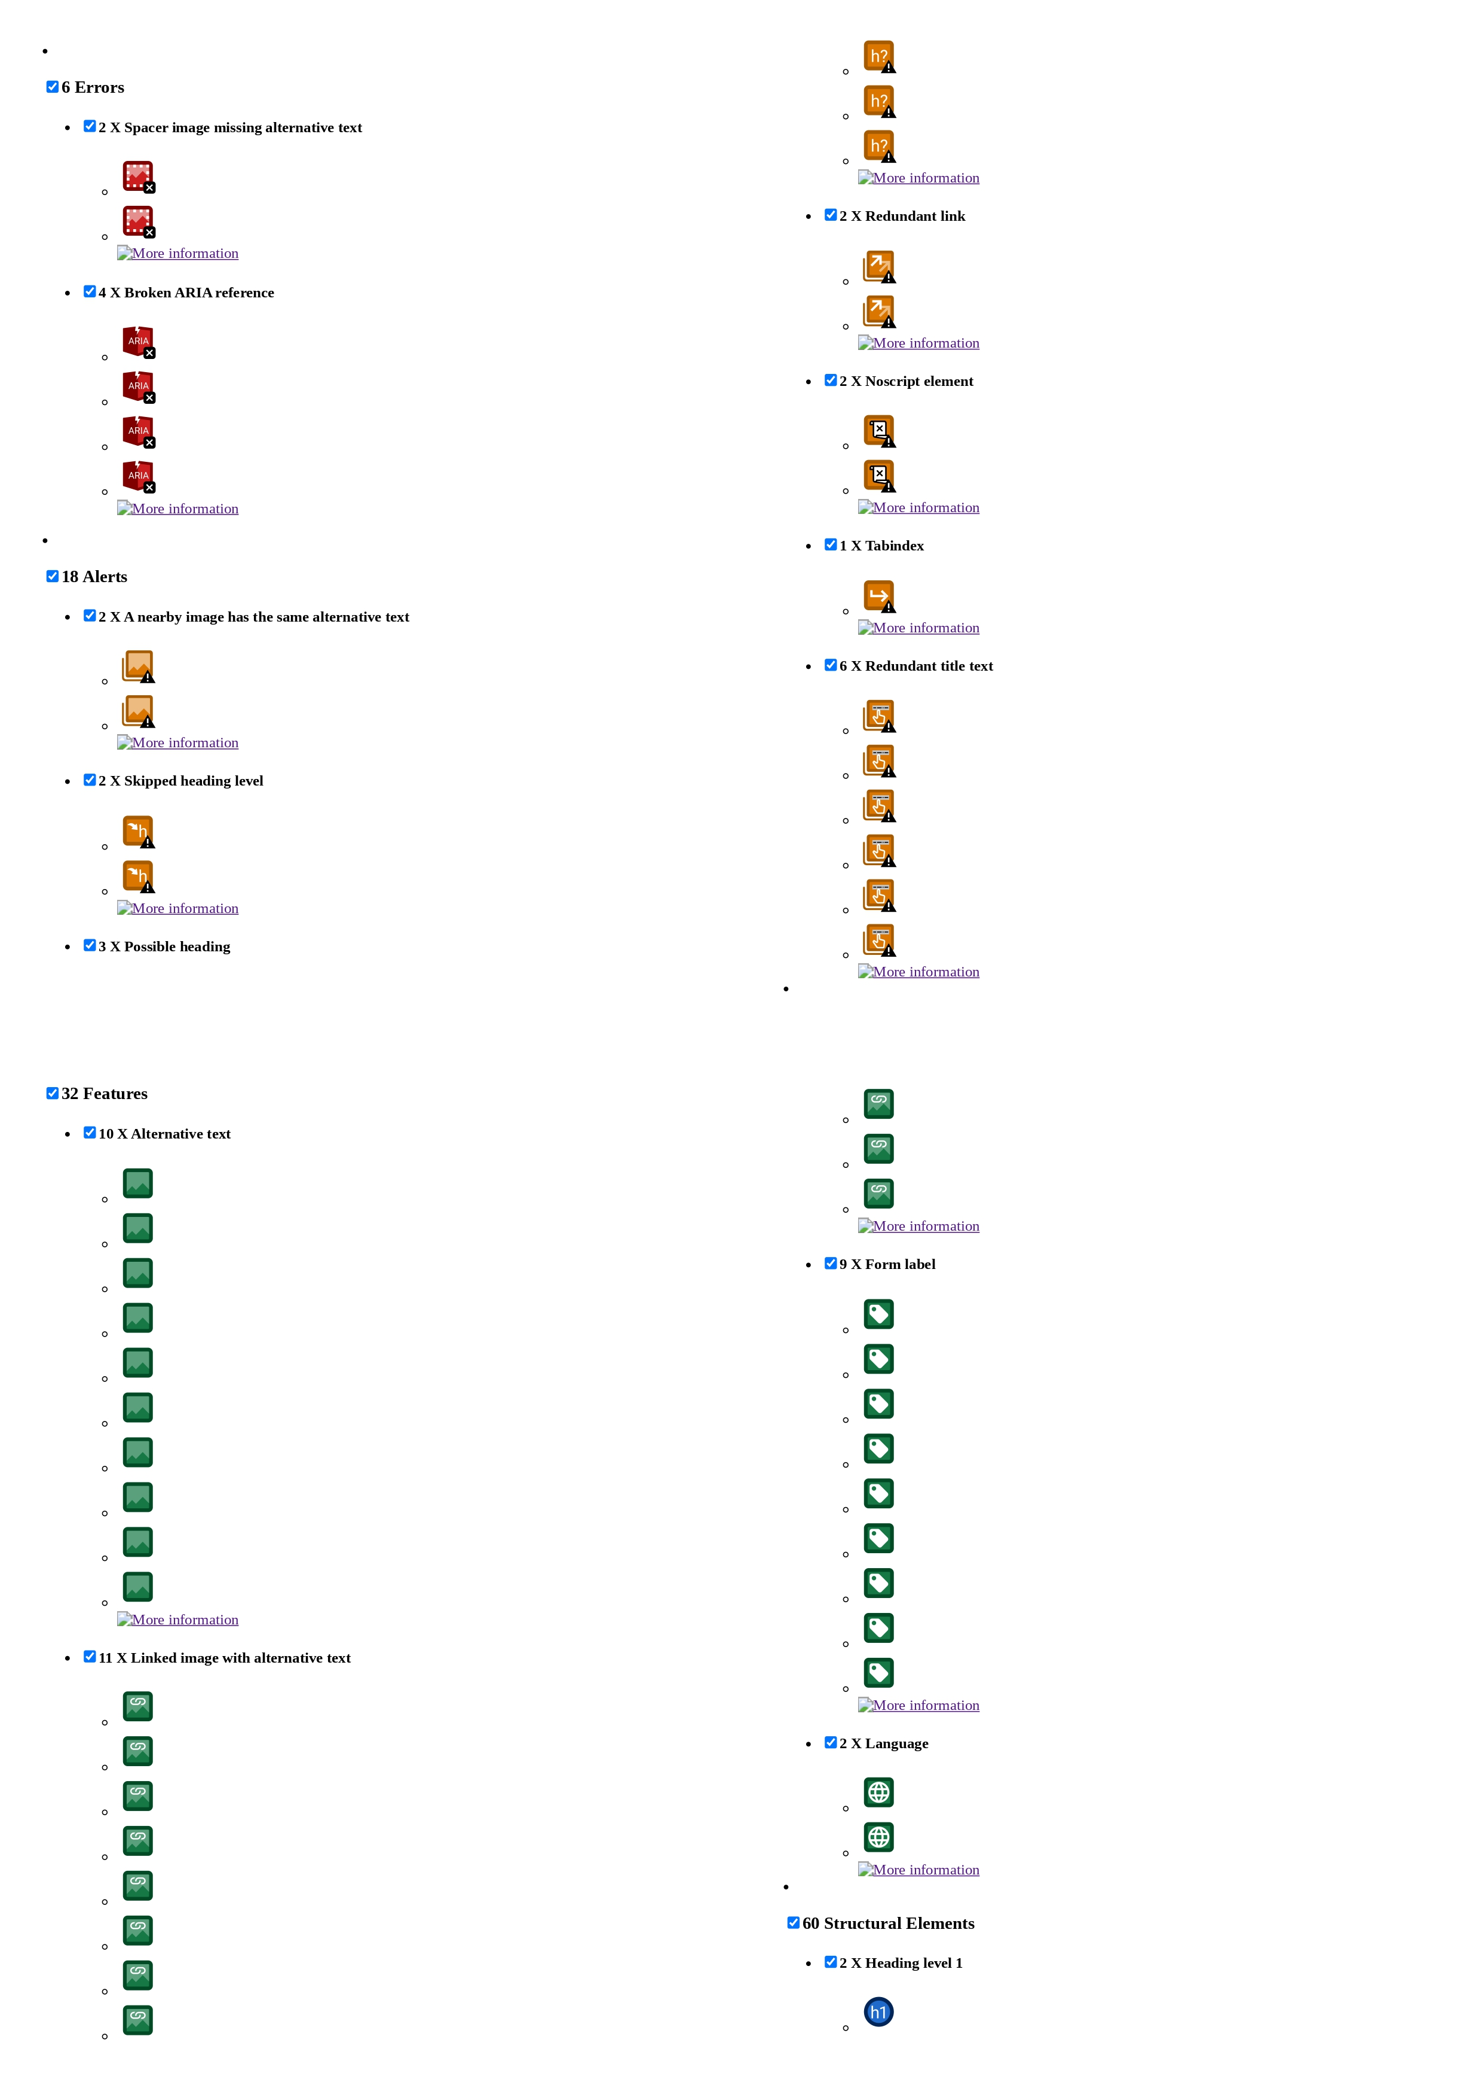
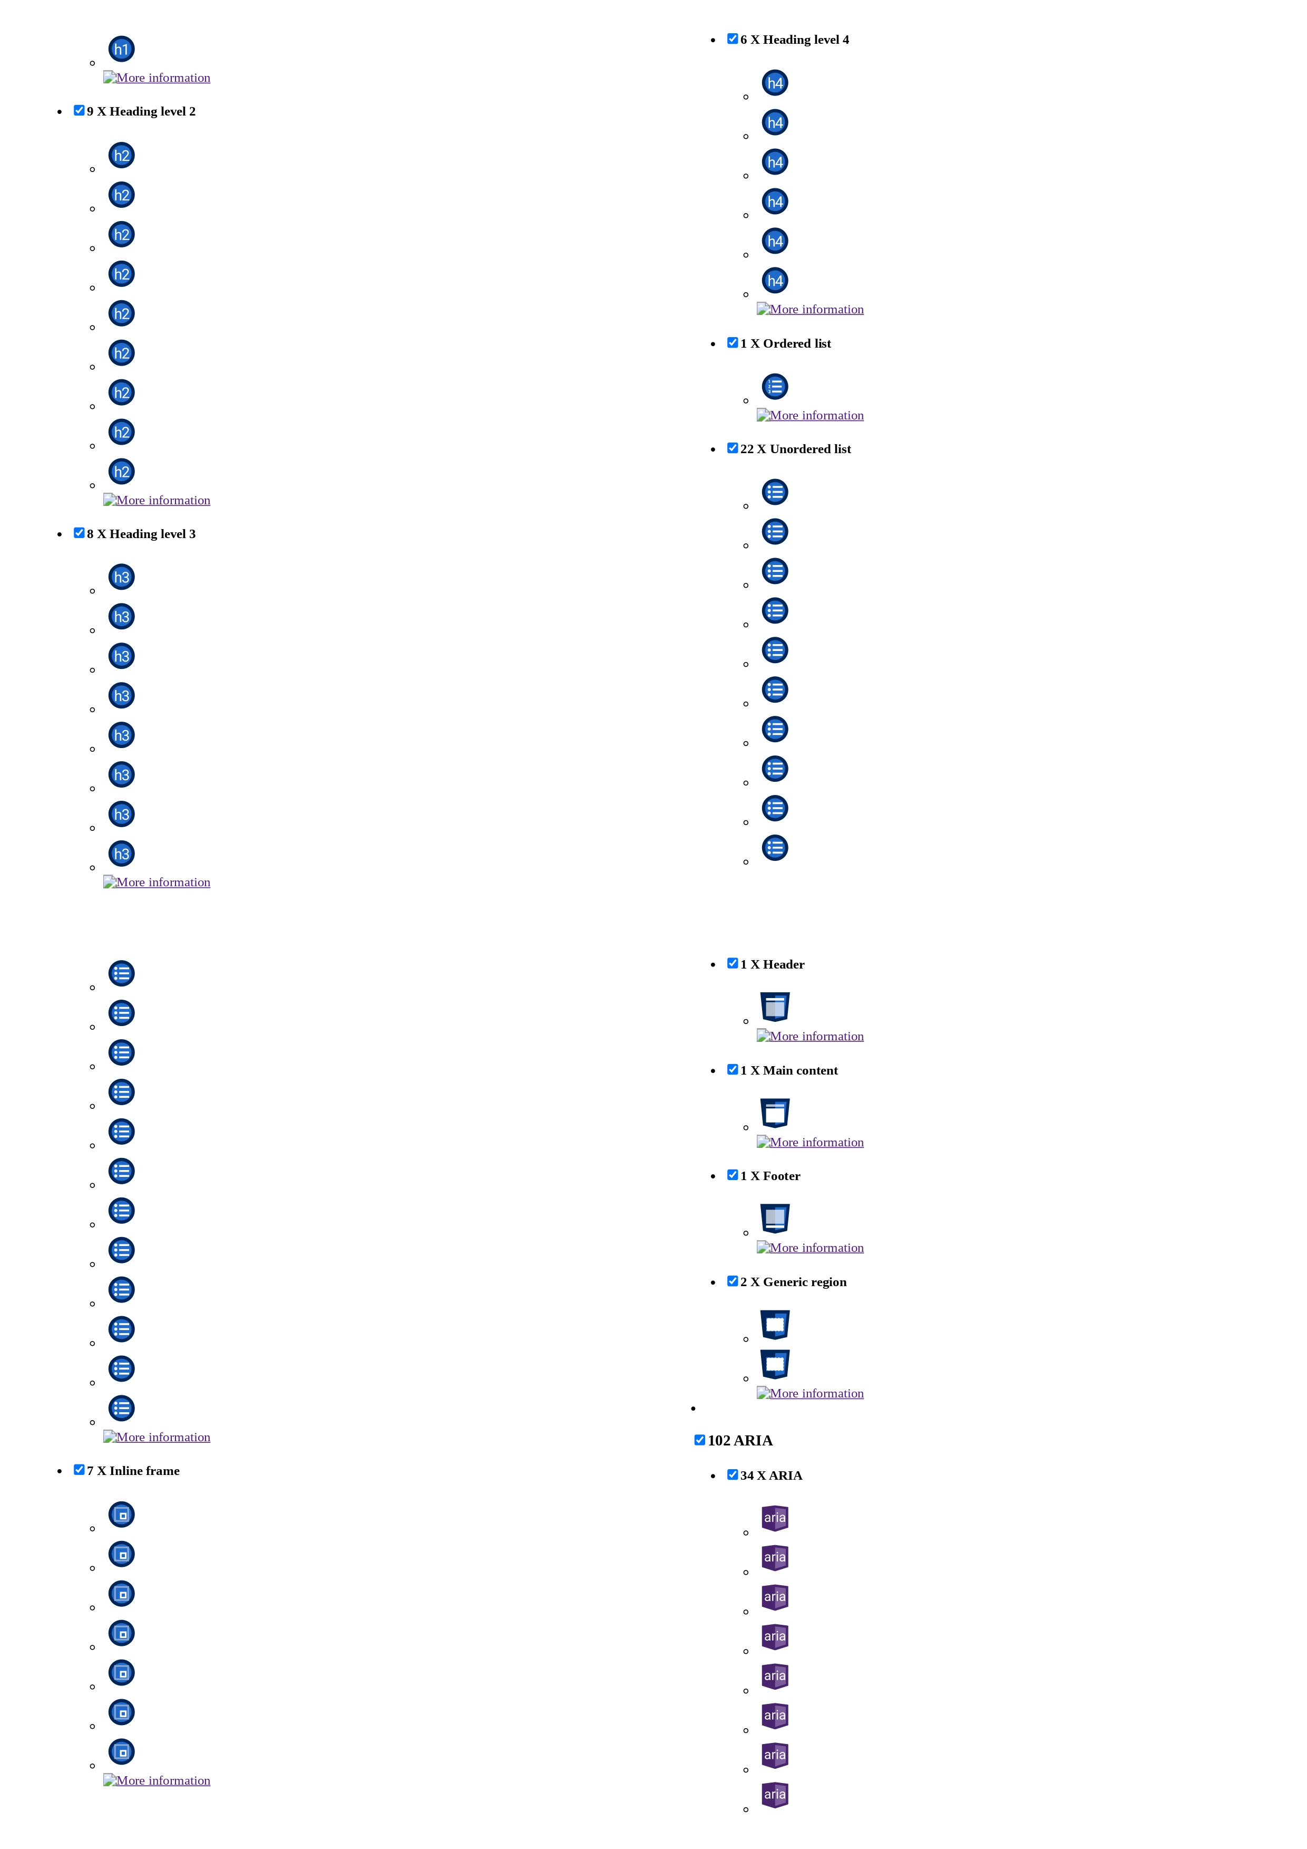
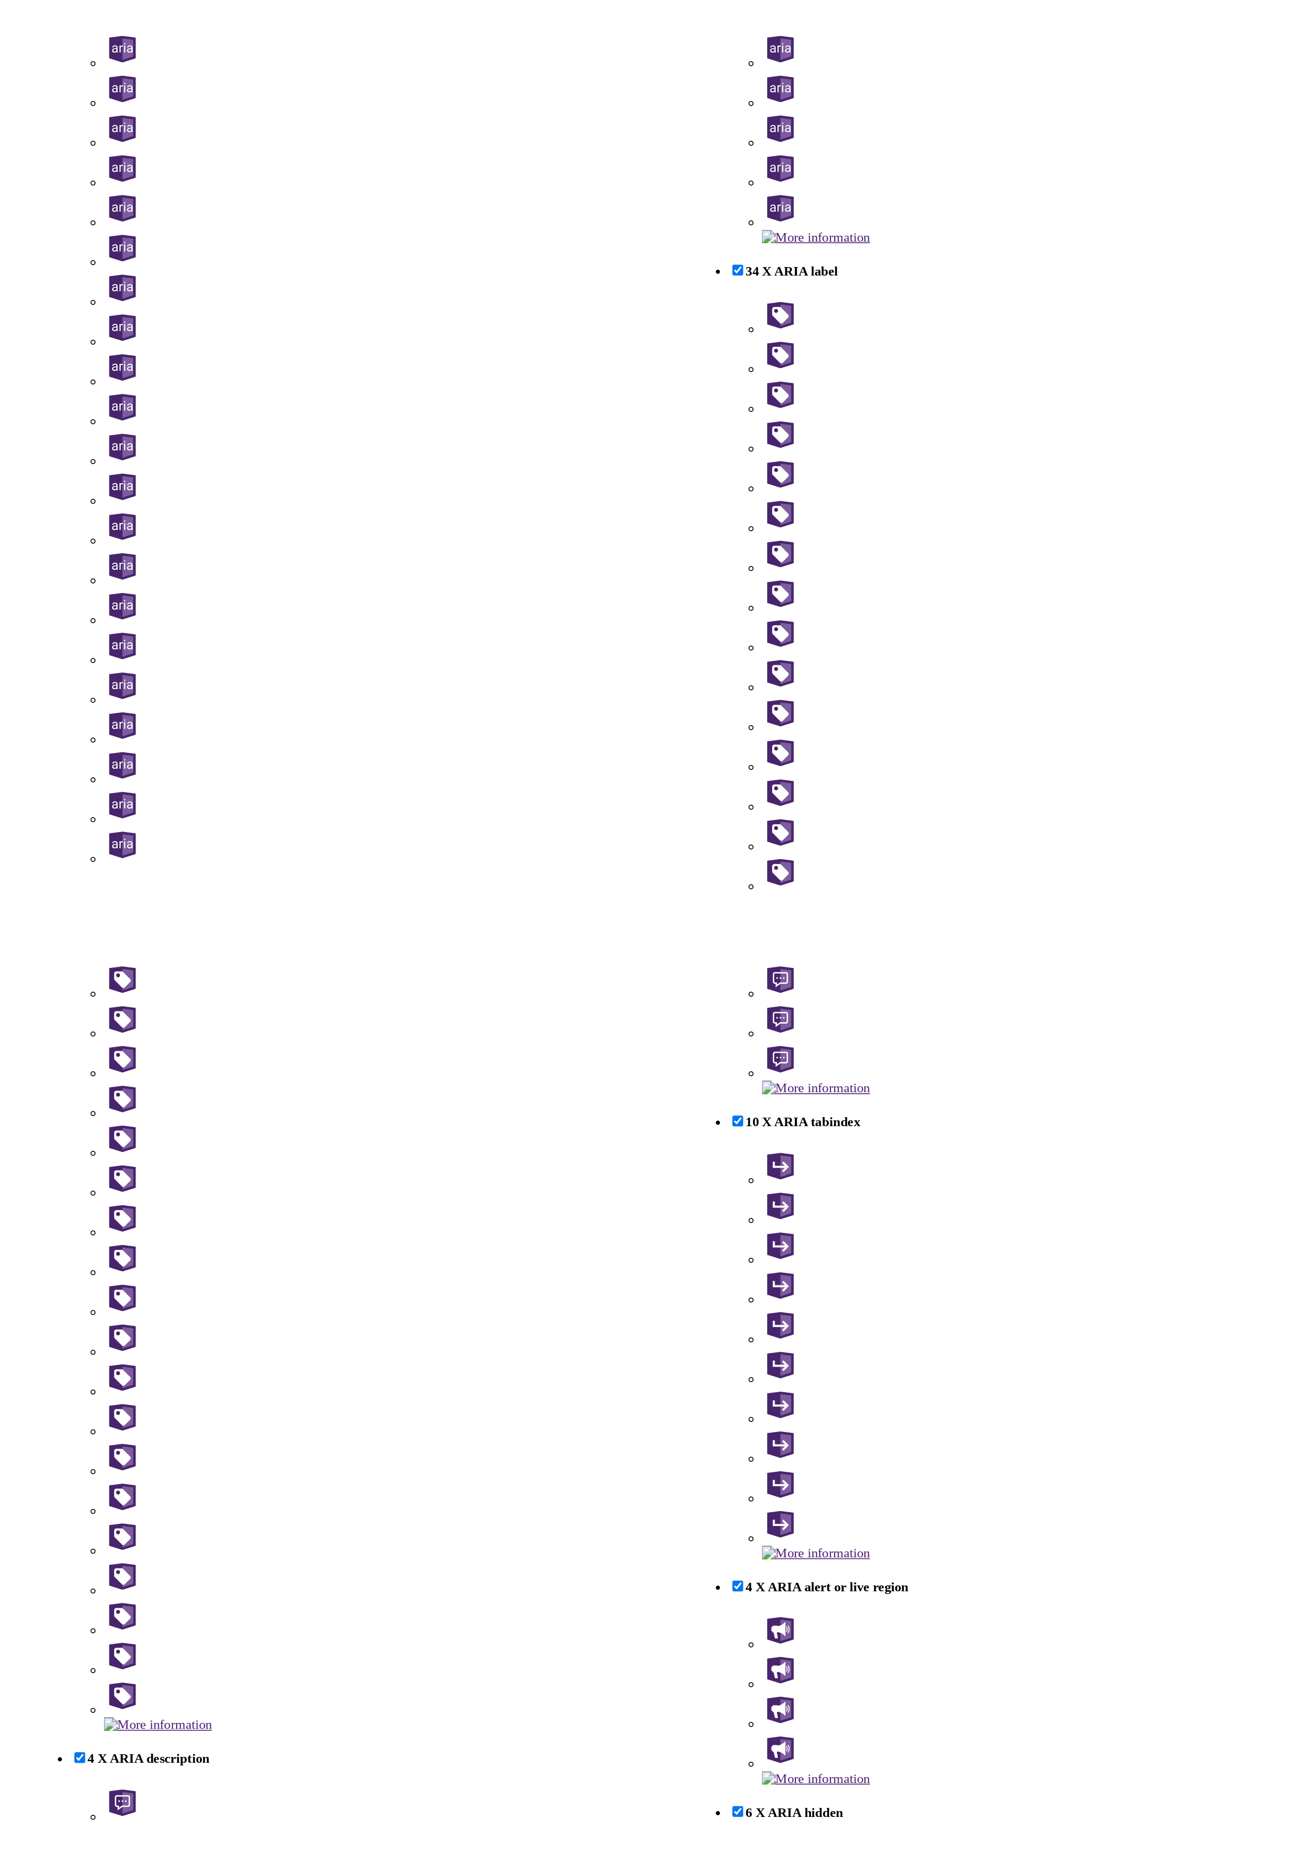
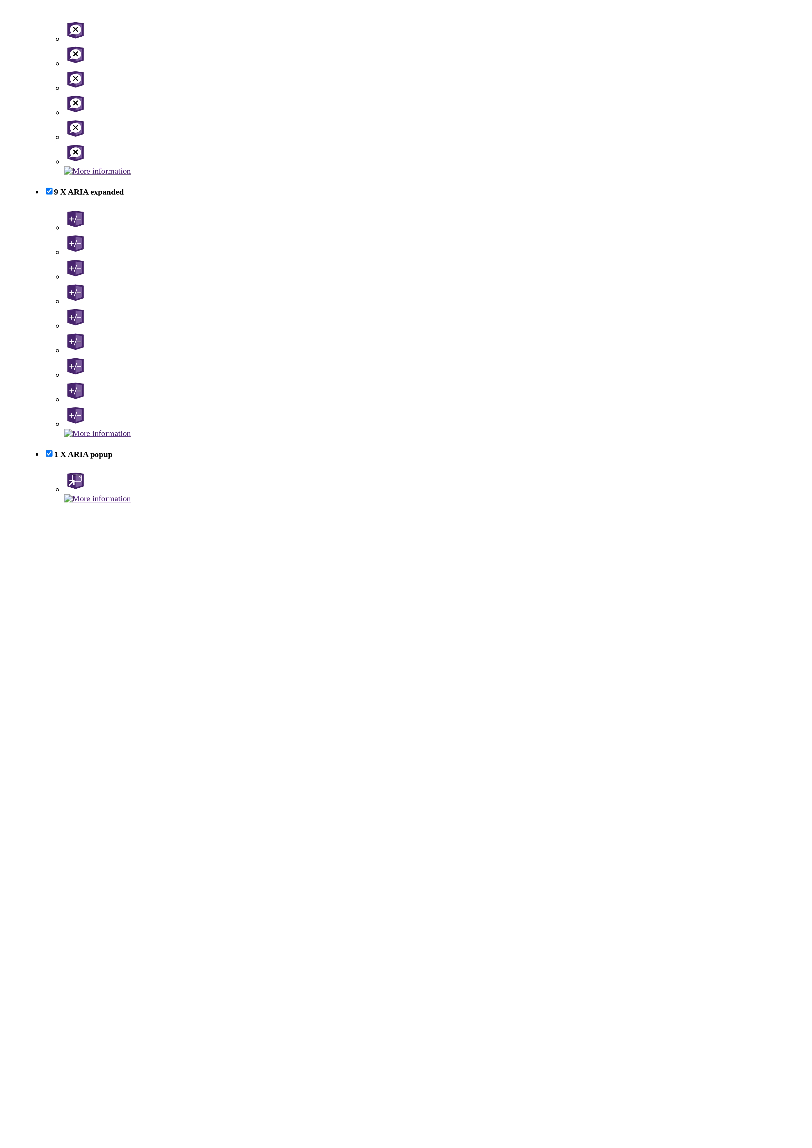

1.3. Manual vs Tool-Assisted Comparison

The previous analysis highlight the significance of both automated scans and manual analysis in evaluating the accessibility of TUDublin's Computer Science main page.
Automated scans, as mentioned, provide valuable initial insights by identifying errors, alerts, and features that may impact accessibility. They efficiently flag common issues like missing alternative text and broken ARIA references. These automated tools serve as a foundational step in the evaluation process, offering a broad overview of potential accessibility concerns.

On the other hand, manual analysis offers a deeper understanding of some of the specific issues identified by automated scans. It provides context and actionable insights by delving into the nuances of WCAG 2.1 guidelines and considering the practical implications of accessibility barriers for users. By examining the impact of identified issues on perceivability, operability, understandability, and robustness, manual analysis uncovers hidden complexities and offers tailored recommendations for improvement.

While automated scans efficiently highlight common accessibility issues, manual analysis complements this by providing a more comprehensive evaluation. It uncovers deeper insights into the specific challenges faced by users and offers nuanced recommendations for enhancing accessibility. The manual analysis is essential for understanding the real-world implications of accessibility barriers and prioritizing improvements accordingly.

In conclusion, while each method of analysis—automated scans and manual analysis—brings unique advantages to the evaluation process, neither alone provides a complete picture. A combination of both automated scans and manual analysis offers the most effective approach to evaluating accessibility. This hybrid approach harnesses the efficiency of automated tools and the depth of manual inspection, ensuring a thorough assessment and tailored recommendations for enhancing accessibility.

1.4. Remedial Actions

1. Perceivable:
Issue 1: Lack of alternative text for images in the starting carousel.
Remediation: Ensure all images have descriptive alternative text that accurately conveys their content and purpose for users relying on screen readers.
Issue 2: Insufficient contrast in various buttons; reliance on simple text as buttons.
Remediation: Increase contrast ratio to meet WCAG 2.1 requirements; consider using recognizable button graphics or styling to improve visual distinction.

2. Operable:
Issue 1: Inconsistent keyboard navigation, especially when tabulating between menus.
Remediation: Ensure all interactive elements are keyboard accessible and follow a logical tab order, facilitating seamless navigation for keyboard users.
Issue 2: Unclear visibility when navigating between buttons.
Remediation: Implement clear focus indicators or visual feedback to indicate button selection, enhancing usability for all users, particularly those with visual impairments.

3. Understandable:
Issue 1: Lack of clear headings and structure in some sections.
Remediation: Ensure consistent use of headings to organize content hierarchically, facilitating easier navigation and comprehension.
Issue 2: Confusing organization of menus and conceptually unrelated topics.
Remediation: Review and reorganize website structure to improve logical flow and grouping of related content.
Issue 3: Vague language leading to confusion.
Remediation: Use clear and concise language to convey information, avoiding ambiguity and improving comprehension for all users.

4. Robust:
Issue 1: Heavy reliance on JavaScript for functionality.
Remediation: Ensure essential functionality is accessible without JavaScript; provide fallback options or alternative methods for users with assistive technologies that do not support JavaScript.
Issue 2: Website is resource-intensive, leading to slow loading times.
Remediation: Optimize website performance by reducing unnecessary elements, compressing images, and implementing caching strategies to improve loading times and overall user experience.

Contextual Considerations:
Errors: Address six identified errors, including missing alternative text for spacer images and broken ARIA references, to ensure all elements are properly labeled and functional.
Alerts: Resolve 18 alerts, including issues with redundant links, skipped heading levels, and redundant title text, to improve clarity and navigation consistency across the website.
Integration: Integrate remedial actions for errors and alerts with the broader accessibility improvement plan, ensuring a comprehensive approach to enhancing TUDublin's Computer Science main page accessibility.
Testing: Conduct thorough testing, including both manual evaluation and tool-assisted analysis, to verify the effectiveness of implemented remedial actions and identify any remaining accessibility barriers.
Training: Provide training to web developers and content creators on best practices for accessibility, including proper labeling of elements and adherence to WCAG 2.1 guidelines, to promote ongoing compliance and maintenance.

2. UCD Computer Science page Report

2.1. Manual Evaluation:

In this report, I am going to manually analyse the accessibility of the UCD (University College Dublin) Computer Science homepage with respect to the WCAG 2.1 guidelines. Compared to TUD, I cannot really speak to the efforts that UCD might have done to address accessibility as I have never assisted any of their faculties or know about their goals. I will aim to identify areas where improvements can be made to enhance accessibility and usability for individuals with disabilities, while also acknowledging areas where the webpage excels.

I have divided this evaluation into segments indicated by the WCAG 2.1 checkpoints to provide clarity on where the webpage demonstrates compliance and where it falls short.

1. Perceivable:
Issue: The website lacks any meaningful alternative text for images (if it has any at all).
Issue: Visual differentiation between segments on the website is very unclear.
Issue: Twitter implementation at the end of the page isn’t mentioned when it starts, may lead to confusion.

2. Operable:
Issue: Keyboard navigation is inconsistently implemented across interactive elements, particularly when tabulating from menu to menu. Also, there are navigation loops that make no sense when navigating.
Issue: Clear visibility of button selection is lacking during navigation, causing confusion.
Commend: The use of large buttons improves accessibility for users with lower motor skills, reducing the margin of error.

3. Understandable:
Issue: Most sections of the website lack clear headings and structure, making it challenging for users to navigate and comprehend the content.
Issue: The website's organization is confusing, with menus grouping conceptually unrelated topics together.
Issue: The implementation of Twitter is confusing due to the use of the same design language and no contrasting colours.

4. Robust:
Issue: The website heavily relies on JavaScript for functionality, potentially causing compatibility issues for users with assistive technologies that do not support JavaScript.
Commendation: Surprisingly, the website is very quick when loading.

In conclusion, the UCD's Computer Science homepage demonstrates lackluster efforts in accessibility: most areas require improvement to even attempt to comply with WCAG 2.1 guidelines. Addressing issues related to perceivability, operability and understandability will enhance the website's inclusivity and usability for all users, aligning with UCD's need to comply with the WCAG 2.1 guidelines.

2.2. Tool-Assisted Evaluation

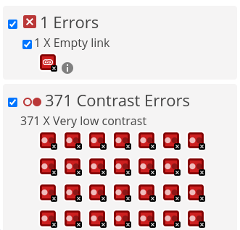
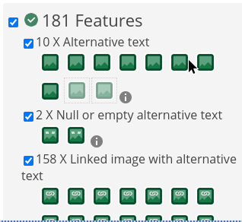
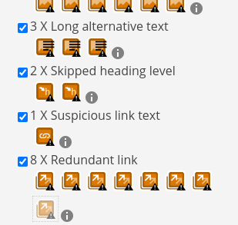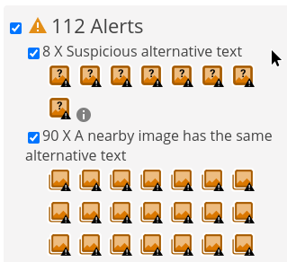

2.3. Manual vs Tool-Assisted Comparison

To start off with a different comparison, it seems like the UCD Computer Science homepage faces significant challenges in meeting accessibility standards compared to TUD. While both evaluations highlight areas for improvement, the UCD site has a lot more work to be done.

To start with the actual comparison:
Automated scans swiftly identify a range of issues, including errors, alerts, and specific features affecting accessibility. These scans efficiently flag common issues such as missing alternative text, suspicious link text, and redundant links. They provide a foundational overview, highlighting potential concerns and initiating the evaluation process.
On the other hand, manual analysis offers a more detailed examination of the issues surfaced by automated scans. It delves into the specifics, providing context and actionable insights based on WCAG 2.1 guidelines. For instance, it identifies perceivability issues like the lack of meaningful alternative text for images and unclear visual differentiation between segments on the website. It also analyses operability concerns, such as inconsistent keyboard navigation and unclear button selection visibility. Moreover, manual analysis uncovers understandability challenges, such as the absence of clear headings and confusing website organization. It also evaluates robustness issues, such as heavy reliance on JavaScript for functionality.
While automated scans efficiently detect common accessibility problems, manual analysis offers a deeper understanding of their implications and provides tailored recommendations for improvement. It examines the practical impact of accessibility barriers on users and suggests specific measures to enhance inclusivity and usability. So, combining both approaches ensures an in-depth evaluation and facilitates targeted improvements to enhance the website's accessibility for all users.

1.4. Remedial Actions

1. Perceivable:
Issue 1: Lack of alternative text for images.
Remediation: Ensure all images have descriptive alternative text that accurately conveys their content and purpose for users relying on screen readers.
Issue 2: Visual differentiation between segments on the website is very unclear.
Remediation: Improve visual differentiation by incorporating distinct borders, color contrast, or headings between segments on the website.
Issue 3: Twitter implementation at the end of the page isn’t mentioned when it starts, may lead to confusion.
Remediation: Clearly introduce and label the Twitter feed section to inform users about its purpose and relevance.
2. Operable:
Issue 1: Keyboard navigation is inconsistently implemented across interactive elements, particularly when tabulating from menu to menu. Also, there are navigation loops that make no sense when navigating.
Remediation: Ensure all interactive elements are keyboard accessible and follow a logical tab order, facilitating seamless navigation for keyboard users.
Issue 2: Clear visibility of button selection is lacking during navigation, causing confusion.
Remediation: Implement clear focus indicators or visual feedback to indicate button selection, enhancing usability for all users, particularly those with visual impairments.

3. Understandable:
Issue 1: Most sections of the website lack clear headings and structure, making it challenging for users to navigate and comprehend the content.
Remediation: Ensure consistent use of headings to organize content hierarchically, facilitating easier navigation and comprehension.
Issue 2: The website's organization is confusing, with menus grouping conceptually unrelated topics together.
Remediation: Review and reorganize website structure to improve logical flow and grouping of related content.
Issue 3: The implementation of Twitter is confusing due to the use of the same design language and no contrasting colours.
Remediation: Clearly differentiate the Twitter feed section.

4. Robust:
Issue 1: The website heavily relies on JavaScript for functionality, potentially causing compatibility issues.
Remediation: Ensure essential functionality is accessible without JavaScript.

Contextual Considerations:
Errors: Address identified errors, including missing alternative text for spacer images and broken ARIA references, to ensure all elements are properly labeled and functional.
Alerts: Resolve issues with suspicious alternative text, nearby images having the same alternative text, skipped heading levels, suspicious link text, and redundant links to improve clarity and navigation consistency across the website.
Integration: Integrate remedial actions for errors and alerts with the broader accessibility improvement plan, ensuring a comprehensive approach to enhancing UCD's Computer Science homepage accessibility.
Testing: Conduct thorough testing, including both manual evaluation and tool-assisted analysis, to verify the effectiveness of implemented remedial actions and identify any remaining accessibility barriers.
Training: Provide training to web developers and content creators on best practices for accessibility, including proper labeling of elements and adherence to WCAG 2.1 guidelines, to promote ongoing compliance.

Part C

In recent years, artificial intelligence (A.I.) has deeply influenced our daily lives. From aiding in COVID-19 research to paving the way for self-driving cars, its impact is undeniable. Yet there still lies a crucial frontier: accessibility for individuals with disabilities.
Currently, ensuring digital accessibility is challenging. While standards like the Web Content Accessibility Guidelines (WCAG) exist, many businesses lack resources for thorough compliance testing. Automated tools offer a solution, but they have limitations. They often miss nuanced issues and sometimes flag irrelevant ones.
However, the future holds promise. Advances in machine learning could empower A.I. to mimic human-like understanding, enhancing its ability to identify and fix accessibility barriers autonomously. Yet, challenges persist. Some A.I. tools produce inaccurate or biased results, posing risks for users with disabilities and misrepresenting a wide range of people.
Researchers are actively addressing these concerns, striving to ensure A.I. benefits all users equitably. They aim to refine A.I. systems to deliver accurate and unbiased information, fostering a more inclusive digital landscape. While progress is ongoing, the pursuit of accessible A.I. remains essential for creating digital inclusivity.

References:
https://www.boia.org/blog/will-artificial-intelligence-help-accessibility
https://www.washington.edu/news/2023/11/02/ai-accessibility-chatgpt-midjourney-ableist/

