Bug Report lab7

Exercise 3

This code had a couple of important bugs. For starters, it wouldn’t recurse upon itself so it would create a list with the basic items of the inputted list, ignoring nested lists and any type of variable that wasn’t str.

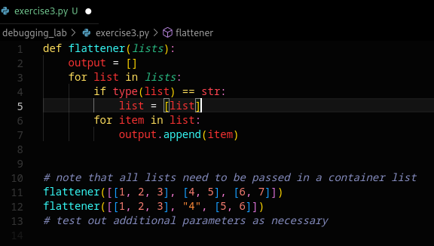
After adding recursion in the most basic form possible (an else statement that would append a flattener call, and a return statement at the end of said function) the lists created would be direct clones of the ones inputted. This is due to the append function of the list class, which adds to a list “in bulk”, as a single element.

After cleaning up the code and changing the append function for the extend function (which adds to a list each element of another at a time instead of grouped together), we arrive at a proper solution:
