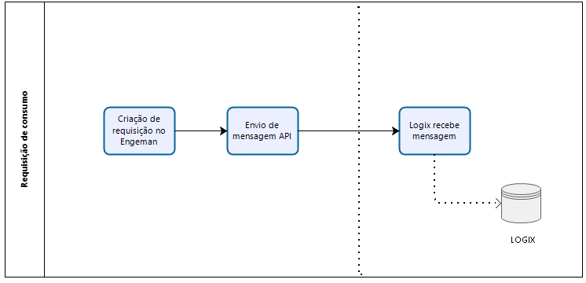 SUP5740 SUP50004

man10021

sup0710

- MANUAL