**TinyURLCreator POC**

User inputs will be provided at the command line level.

The actions available are listed below:

1. create: create tinyurl
2. delete: delete tinyurl
3. getLong: get long url
4. getStats: get TinyURL statistics
5. visit: visit tinyUrl
6. help: list actions
7. exit: exit the program

*actions are not case sensitive at the command line*

Sample Create Request:

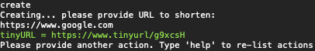

**Please ensure that URLs provided are of acceptable format.**

In the example above, we use “<https://www.google.com>” as the URL to shorten

The “https://” is required for valid URL formatting.

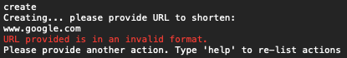

In the example above, we use “[www.google.com](http://www.google.com)” and get the invalid format error.

Visit Count

This console application is simply a POC, so real URL redirection is NOT configured, in order to visit the URL in this scenario we use the “visit” action.

Please see the sample visit request below:

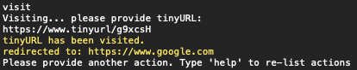

You can see that the visit count is updated by using the “getstats” action.

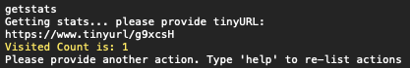

**General Code Overview**

1. TinyURLService
   1. Helper service to manage tinyURLs
      1. Storage/Mappings
         1. tinyURLs are stored in a dictionary of type:
            1. Dictionary<string tinyURL,(string longURL, int visitedCount)>

tinyURL is the key

A pair of longURL and visitedCount is the value

* + - 1. This Dictionary is stored in memory so the URL data is lost when the application stops running.
    1. Creation/Deletion
       1. tinyURLs are inserted into the Dictionary when created
       2. tinyURL tokens are stored in a list upon tinyURL creation
          1. List<string> tokens
          2. This list is only utilized to ensure tokens created are unique
    2. Stat Tracking/Updating

1. Program.cs
   1. Application Logic
   2. Utilizes TinyURLService calls
2. Unit Tests
   1. Unit Tests for the POC sit in the tinyURLTests project
      1. Tests each method in the TinyURLService

