Communication Document

First airbenders

Stefan Teeuwen, ivaylo ivanov, valentin vasilev, ahmad Alzarkaoui

2020

# Preface

Working in a team during a pandemic is not easy for both teachers and students. Setting up meetings and dividing tasks were more difficult than normal as we were far separated from each other. This also caused difficulties with available resources, as most parts were separated among team members. Working together with other teams was dreadful, as most teams were disintegrated and disorganized, which deteriorated communication capabilities. These issues are further explained in the following document:



The current means of communication and the teamwork is described in the following sections.

Table of Contents

Preface 1

Ways of communicating 2

Meetings 2

Scrum board 2

Reviewing 4

Schedule 4

Communication with other groups 4

Conclusion 5

# Ways of communicating

There are a number of things that are necessary to be able to fully cooperate, which will be discussed in this document. The main means of communication are: Microsoft Teams, WhatsApp, Discord, GitLab (scrum board) and Outlook. Each mean has its own pros and cons, which will be visualized in the following table.

*Table containing means of communications and corresponding pros and cons*

|  |  |  |
| --- | --- | --- |
| **Mean of communication** | **Pros** | **Cons** |
| Microsoft Teams | Great for elaborate group discussions and reviewing | Time consuming to set up and less accessible than other means |
| WhatsApp | Great for announcements, updates and small discussions. Very accessible | Virtually no options for reviewing and difficult to use for elaborate meetings |
| Discord | Great for  contact between individual team members or group discussions. Good for reviewing and reasonably accessible | Generally less accessible than WhatsApp, as WhatsApp is always active if connected to internet. Discord is only active if logged in. |
| GitLab (scrum board) | Outstanding in tracking tasks, updates, files (applications) and releases | It doesn't give clear notifications on updates |
| Outlook | Great in scheduling and keeping track of meetings | Not suitable for quick contact between teammates |

# Meetings

Meetings are held weekly, mostly on Monday and Friday, but occasionally on Wednesday as well to discuss progress, to give feedback and to assign unfinished tasks to those available. Every Monday there is a sprint demo to demonstrate last week's progression. After this sprint demo there is a meeting that is scheduled in advance. Other meetings are also discussed and planned in advance. Meetings are always held through Microsoft Teams.

# Scrum board

The scrum board contains the tasks that have to be done, the tasks that are currently being done and the finished tasks. Each finished task has to be reviewed by one or multiple team members in order to deliver the optimal result. The scrum board contains labels to show the current status of each task.

*Table containing prioritized labels and description used in the scrum board*

|  |  |
| --- | --- |
| **Prioritized labels** | **Description** |
| Doing | The part that is now being done |
| To Do | The part that has yet to be done |
| Closed | The part that is finished |
| Needs review | This part has yet to be approved (can already be reviewed and therefore needs to be improved and reviewed again) |
| Reviewed | The part that has already been reviewed (can be reviewed again if changes are made) |

*Table containing other labels and description used in the scrum board*

|  |  |
| --- | --- |
| **Other labels** | **Description** |
| Back-end | The part of the application which is responsible for storing and manipulating data |
| Documentation | The process of classifying and annotating texts |
| Front-end | The part in which the user interacts with the application |
| Merging | This is the part where all components have to be assembled in order to finalize the project. |

Each task is created during the meetings or on the basis of consultation via the WhatsApp group. During the meetings each task in the scrum board is discussed and as a result reopened, postponed or closed.

*Picture visualizing the tasks and labels used in the scrum board*

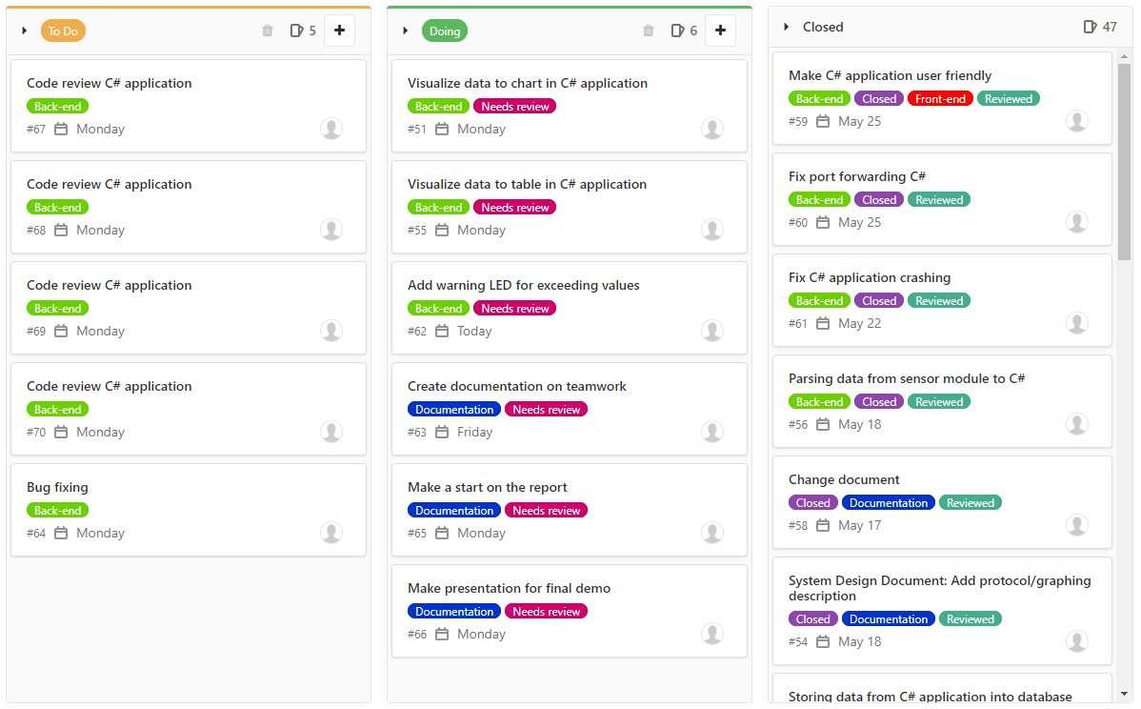

# Reviewing

As previously mentioned, another team member will review a task once it has been finished or if a team member gets stuck. This can be requested during meetings, via WhatsApp or via Discord. This ensures the optimal result, as this leaves no rooms for (major) bugs or other flaws. Each task in the scrum board contains information about its current status: reviewed, not reviewed or both. The latter might be confusing, but this simply means that a task has been reviewed and needs to be improved and reviewed once again.

# Schedule

The date and time for the next meeting is discussed during meetings or via WhatsApp. When everyone has agreed on a time and date, the meeting is scheduled in everyone's calendar. This is done by sending an invitation for the next meeting via Outlook to get a clear view of all upcoming meetings. The scrum master also has a clear view of all participants, as those who attend accept the meeting via Outlook.

# Communication with other groups

The method of communication between the sensor module and the application is discussed with other groups. This also includes agreement on the protocol. The scrum master discusses with the scrum masters/group leaders from other groups about the current situation, that which has to be discussed, method of communication and the time and date for the meeting. Next, all participants receive an invitation to the meeting, which also contains all the previously mentioned points.

Everything that is discussed is recorded and processed by one or more team members to avoid ambiguity.

# Components used

The project group unexpectedly had to use different components than initially planned, which is further explained in the aforementioned document. The components used in this project can be reviewed in the following document:



# Conclusion

Although teamwork was tricky in the beginning, the project group eventually found ways to work together smoothly. We have to thank current technologies for possibilities to work over long distances. Without it this project wouldn’t be possible during the current situation. In the end, the current situation makes us better professionals, as we learn to co-operate with each other during difficult times.