SYSTEM DESIGN

Group name

Arcade Brigade

Project name

INDUSTRY PROJECT

*GAME CONSOLE*

|  |  |  |  |
| --- | --- | --- | --- |
| Name | Student number | Email | Role |
| Stefan Teeuwen | 3654900 | 415849@student.fontys.nl | Scrum Master/Project Leader |
| Ivaylo Ivanov | 3853764 | 432022@student.fontys.nl | Co-ordinator |
| Valentin Vasilev | 3860140 | 432543@student.fontys.nl | Specialist |
| Ivo Belitts | 3797422 | 427265@student.fontys.nl | Process Consultant |
| Vladimir Vladinov |  | 432274@student.fontys.nl | Programmer |

Table of Contents

Hardware 3

Wiring diagram 4

System design 5

System context diagram 5

System architecture diagram 5

Communication and protocols 6

Control flow diagram 7

State diagrams 8

Central node 8

Controller 9

# Hardware

The game console consists of multiple parts: a central node and one or multiple controllers. Both the central node and the controller(s) use an ESP32 microcontroller. Furthermore, the controller(s) use an TFT LCD touch screen/display and a Qwiic joystick.

The components are listed as follows:

1. ESP32 microcontroller.
2. TFT LCD touch screen/display.
3. Qwiic joystick.

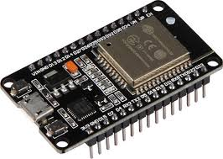

*Picture 1: ESP32 microcontroller*

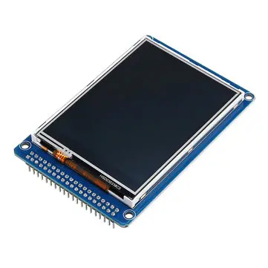

*Picture 2: TFT LCD display*

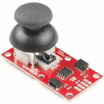

*Picture 3: Qwiic joystick*

# Wiring diagram

*Diagram 1: wiring diagram*

# System design

## System context diagram

*Diagram 2: system context diagram*

## System architecture diagram

*Diagram 3: system architecture diagram*

# Communication and protocols

The central node and controller(s) are wirelessly connected through the HTTP and TCP/IP protocol.

IP (Internet Protocol) is the part that obtains the address to which data is sent. TCP (Transmission Control Protocol) is responsible for data delivery once that IP address has been found. TCP tells the receiver which application should receive the data. However, TCP loses speed due to its reliability in the data transmitted. TCP uses a technique known as positive acknowledgement with retransmission, requiring the receiving end of transmission to give a response as to what data has been received to ensure that the data is sent properly. Then, the sender knows to send a new data packet or to resend the previously sent data packet.

HTTP (Hypertext Transfer Protocol) allows the fetching of resources which are initiated by the recipient. Servers and client communicate by exchanging individual messages. The messages which are sent by the client are called requests and the messages sent by the server as an answer are called responses. HTTP is an application layer protocol that is sent over TCP or any other reliable transport protocol.

The controller(s) and the Qwiic joystick(s) communicate over I2C. Furthermore, the controller(s) and the TFT LCD touch screen/display(s) also use I2C. I2C is a multi-master bus, which means that multiple chips can be connected to the same bus and each one can act as a master by initialising a data transfer.

# Control flow diagram

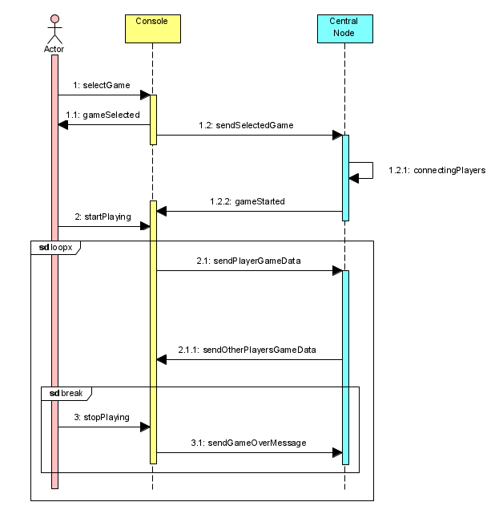

*Diagram 4: control flow diagram*

# State diagrams

## Central node

*Diagram 5: state diagram of central node*

## Controller

*Diagram 6: state diagram of controller*