MedicEdge Documentation

MedicEdge is a modern web-based appointment and patient records management system designed to streamline healthcare operations. This documentation aims to provide you with a comprehensive overview of the system's architecture, features, and setup instructions.
MedicEdge is built using PHP for the web application and utilizes a MySQL/MariaDB database to store and manage data. The database, named medicedge_db, includes various tables for managing users, their roles, and sessions. The system supports different user roles, including administrators, healthcare providers, receptionists, and patients, each with role-specific functionalities. User authentication is secured using Argon2id hashing for passwords.
MedicEdge is designed to revolutionize healthcare administration by providing a centralized platform for managing appointments, patient records, and user access. By streamlining these critical processes, MedicEdge reduces administrative overhead, minimizes errors, and improves the overall efficiency of healthcare facilities. The system empowers healthcare providers to focus on patient care by providing quick and easy access to patient information, while also enabling receptionists to efficiently manage appointment scheduling and patient flow. Furthermore, MedicEdge enhances the patient experience by offering a user-friendly interface for accessing medical records, scheduling appointments, and communicating with healthcare providers. With its robust security features and role-based access control, MedicEdge ensures the confidentiality and integrity of sensitive patient data, fostering trust and confidence in the healthcare system.
Setting up in your Local computer
Take note that you can also setup this system in an organization network or intranet, or to the internet. But for now, let’s just focus on running this in a local computer.

1. Download the MedicEdge’s software dependencies.
For easy results, I’m using XAMPP, since Apache (Web Server), MySQL/MariaDB (Database), and PHP (Server-side Scripting) is already bundled in XAMPP, along with couple of other tools.
Download Link: https://www.apachefriends.org/
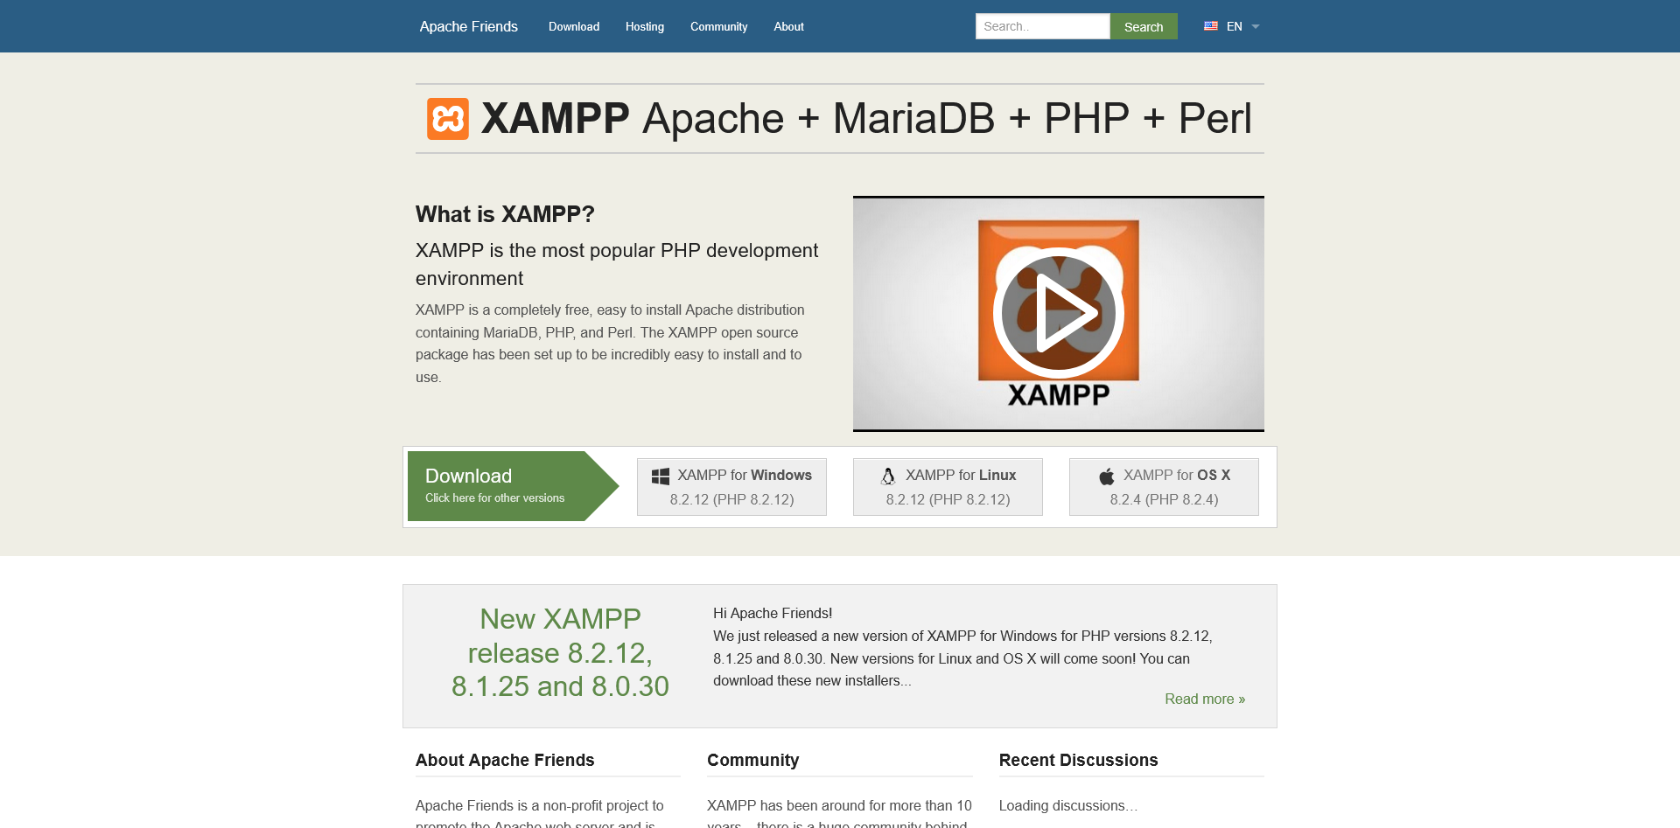

2. Install XAMPP
Install XAMPP. Follow the on-screen instructions.

Here are some notes during installation:
a. Be sure to install all components in XAMPP for best results, especially MedicEdge’s dependencies stated earlier, MySQL and PHP.
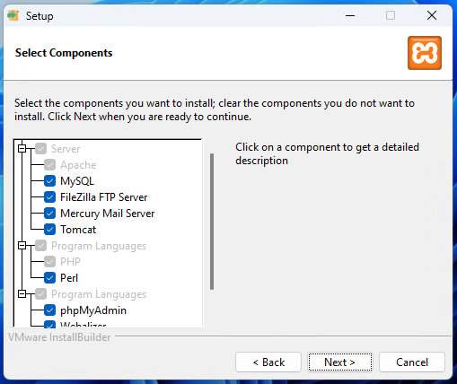

2.

