Expert System Merl1n
version 2.1

Copyright (C) 1999-2002 Ivo Vondrak

Contents

About Merl1n 3
Installation 4
Definition of Knowledge Base 5
Variables 5
Rules 5
Inference Engine 7
Expert System Architecture 8
ES Shell (Expert System Shell) 9
Basic Commands 10
Consulting 10
Merl1n Web Client 12
Contacts 13

About Merl1n

Expert system Merl1n is the application that defines knowledge based on rules and employs the inference engine with forward chaining. The main idea is that it is possible to define and check knowledge base (consisting of modules loaded based on actual demand) from Merl1n's expert system shell. Afterward the executable code is generated and distributed to the user in form of Java applet. The only requirement is to use Web browser with installed Java Plug-in version 1.4. In this way your company Guru can change knowledge and data on everyday basis and make news available to anybody connected to the Internet.

Installation

- Install Java Runtime Environment (JRE) 1.4.0 and higher (http://java.sun.com).
- Execute setup.exe. Select JRE's virtual machine from a list box as a default virtual machine.
- In case of internationalization of the Merl1n copy font.properties.xx to the lib directory of JRE. Czech version of font.properties.cs is available in the Merl1n directory.

Installation consists of one stand-alone application that is Merl1n shell. There is also a .html document that demonstrates how to use Merl1n’s runtime module in form of Java applets.

Definition of Knowledge Base

Knowledge base consists of one or more modules and each module consists of the variable and rule definitions.

Variables
Variable types employed by Merl1n are following: text, integer, real and boolean. All of them except boolean can be declared as enumerative. It means that only specific values of the given type from a finite set can be assigned to them.

Example:
integer value
integer enumValue (1,3,7,9) /* declaration of the enumerative integer */

There is also a possibility to assign initial value to variable when it is declared. In case that the variable is enumerative then the initial value has to be one of declared values from enumerative set.

Example:
boolean tired := true
text disease (“flu”, “pneumonia”) := “flu”

A variable that has to be assigned by an user uses keyword ask followed by associated text in its definition. This identification moves the variable and its description into the dialog box that is displayed to the user before the rules of the module are evaluated. Only variables from the active module (being evaluated) are displayed. Variables from the other module are displayed when this module is loaded and it is about to evaluated. Based on that user is not pushed to assigned all variables at the beginning but only when appropriate module is required.

Example:
ask “Body Temperature” real temperature
ask “Are you tired?” boolean tiredness := false

Rules
Rules used by expert system Merl1n employ following pattern for their definition:

name:priority if condition then action end

Name identifies the rule, priority defines the order of the rule evaluation. It is an integer number. In case that priorities have the same values, rules are evaluated from up to down.

Condition part has to be evaluated to true or false. Expression in the condition part uses logical operators and, or, not and relational operators = (equal), != (not equal), < (less), <= (less or equal), > (more), >= (more or equal). Numerical expression uses standard operators +, -, *, / and %. Texts can be concatenated by +.

Action part of rule can do following:

- variable := value assigns value to a variable
- print “text” prints text on the output window
- nl creates new line in an output text
- image “description” at “url_ specification” creates link to image in the output text
- document “description” at “url_ specification” creates link to html document in the output text
- stop stops the evaluation of rules
- exec loads and executes another module.

Action part can have one or more above action commands separated by comma ( ,). Variables used by rules have to be defined before the rule definition. URL specification use standard pattern protocol://host:port/filename to locate images and .html documents. If there is no protocol and host:port specified then the file is searched in the directory relative to working directory of Merl1n’s shell or runtime only in case that the filename does not start with slash (/). In opposite case the file is searched from the root directory.

Example:
healthy:10
if
(temperature <= 37) and (tiredness = false)
then
print “You are healthy!”, /* Print output text */
nl, /* Insert new line */
image “Enjoy you life in Monte Carlo!” at “images/Monte_Carlo.jpg”, /* Insert link to image */
stop /* No need to continue */
end

flu: 5
if
(temperature > 38) and (tiredness = false)
then
disease := “flu”,
print “You have a “+disease, nl, /* Texts are concatenated */
document “What to do?” at “http://www.doctor.com/flu.html”, /* Link to html document */
exec “Treatment” /* Next module named Treatment is loaded */
end

Inference Engine

Inference engine is based on forward chaining. It means that all input data are defined by user at the beginning and after that rules are evaluated based on their priorities. If the action command stop is reached during this evaluation or all of the rules were used the inference engine is stopped. Rule cannot be evaluated twice during one run of the engine but it is possible to restart the inference engine and the whole process can be repeated as many times as needed by user. The expert system remembers the input data from the last run so the user can change only what is needed to be changed and it is not necessary to define all input data again.

Inferencing starts with the first (top most) module. When the inference engine hits action command exec appropriate module is loaded, user is asked to define input data for this module and its rules are evaluated. When all rules are evaluated inference engine returns back to the original module and continues with evaluation of its rules. In case that stop command is reached, no matter in what module, the inference engine is stopped. Of course, the loaded module can load again some additional module. Appropriate modularization of knowledge base can radically lower the number of input data that have to be defined by the user at a given moment.

Expert System Architecture

The expert system Merl1n consists of expert system shell that is a stand-alone Java application and a runtime module that is a Java applet. The shell is used to define and test knowledge base. When the knowledge base is defined it is saved in a form of the persistent object and published through Java applets on the Internet. This runtime module requires installed Java Plug-in 1.3 (and higher) or Web browser that supports Java2 platform. Figure 1 describes the whole situation:

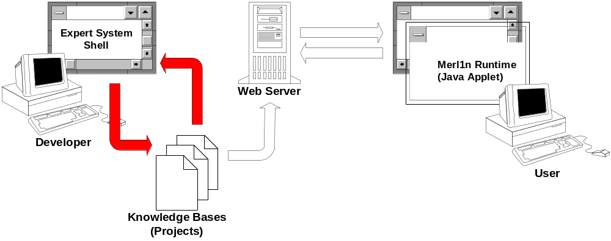
Fig. 1: Expert System Merl1n Architecture

ES Shell (Expert System Shell)

Expert system shell is a stand-alone application used for purposes of defining the knowledge base (project) and consulting with it. The life cycle of the project starts with the definition of modules, after that these modules are compiled what means that the project is built and ready for the consulting purposes. The order of module is important. If the variable is declared in one module and used in the second one then the first module has to be compiled first. Built project can be also published on the Internet and used by Merl1n clients implemented in form of Java applets.

Main window of ES Shell consists of three panels, a menubar and a toolbar with the most common commands represented by buttons (Fig. 2).
Menubar
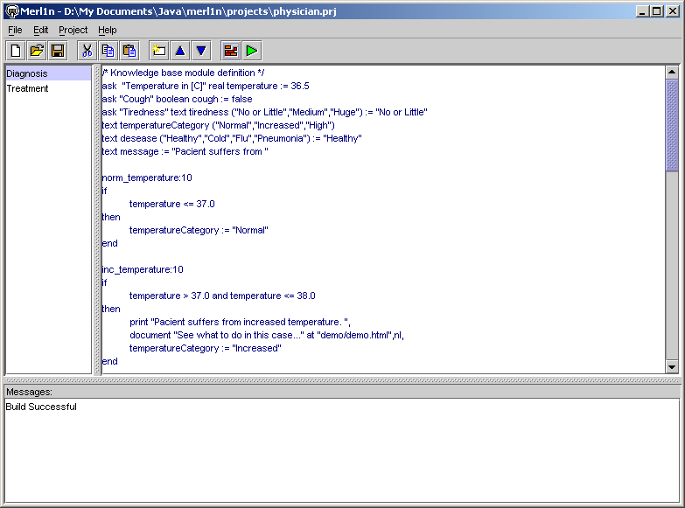
Toolbar
List of Modules
Edit Panel
Message Panel
Fig. 2: Expert System Merl1n Main Window

List of Modules shows what modules are used and what is the order of how they are compiled into the final project. There is also a possibility to import such modules from the externally defined text files (menu command File/External/Import Module...). On the other hand it possible to export module into the text file (menu command File/External/Export Module...) and use it in another project. The order of module can be changed by appropriate commands (Edit/Move Module Up or Edit/Move Module Down).

Edit Panel enables to edit content of module selected in the list of modules. When the project is built and the content of the module is changed it is necessary to build the whole project again. Edit panel implements all standard rules for editing common for all standard text editors.

Message Panel serves as the output device where system messages are shown to user. If the knowledge base module is not correctly defined error message is sent to this panel during the process of compilation. At the same time the line that contains syntax error is highlighted in the edit panel.

Basic Commands
Command | Description
 | New project command clears the shell environment and initializes new project with the empty knowledge base module Noname.
 | Open project command opens and loads already existing project from a file.
 | Save project command saves the actual project on a disk. If the project is not built then it cannot be used by Merl1n Runtime. This is possible only with the project that was successfully built before it was saved.
 | Cut text cuts highlighted text.
 | Copy text copies highlighted text..
 | Paste text pastes text from a clipboard to the edit panel.
 | Insert module command creates new knowledge base module and inserts it right after the selected one.
 | Move module up command moves selected module one step up.
 | Move module down command moves selected module one step down.
 | Build application command compiles all modules and builds application that enables to consult with the knowledge base.
 | Execute application command starts the consulting process with the knowledge base.

Consulting
Consulting with the expert system is enabled by inference engine that starts to evaluate rules of the first (in a list) module and asks user to enter all its input data. In case that additional module is loaded then a new dialog window is open and user is asked to enter new input data. The execution dialog window consists of two: input and output panels (Fig. 3,4).

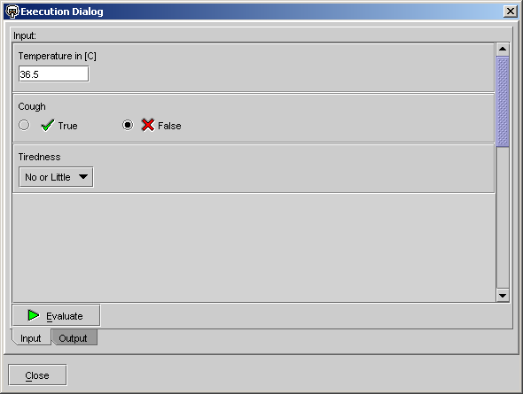
Simple data type input
Starts the inference engine
Output Panel
Close the dialog
Boolean data type input
Enumerative data type input
Message sent to user. Each cycle of inference engine (one push of Evaluate) is finished by “End of Evaluation” string.
Input Panel Active
Hyperlink to image

Fig. 3: Expert System Merl1n Main Window – Input Panel

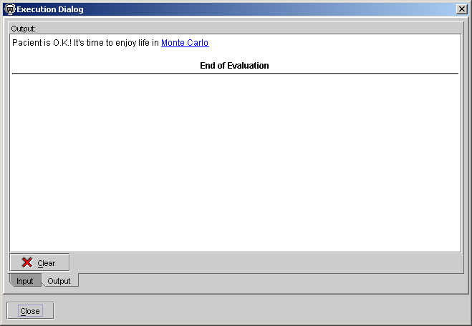
Clear output panel
Output Panel Active
Close the dialog
Message sent to user. Each cycle of inference engine (one push of Evaluate) is finished by “End of Evaluation” string.
Hyperlink to image

Fig. 4: Expert System Merl1n Main Window – Output Panel

Each new cycle of inference engine uses the values of data defined in a previous run. In case that there is a need to reset data to the initial values defined in a knowledge base it is necessary to build the project again.

Merl1n Web Client

The purpose of Merl1n web client implemented in form of Java applets is to make all projects available to people who need an advice. The code for this runtime module is implemented in package m1web.jar. To execute m1web.jar applet the following must be specified within an .html file:

<OBJECT
classid="clsid:8AD9C840-044E-11D1-B3E9-00805F499D93"
WIDTH = 350 HEIGHT = 30
codebase="http://java.sun.com/products/plugin/autodl/jinstall-1_4-win.cab#Version=1,4,0,0">
<PARAM NAME = CODE VALUE = merl1n.app.web.run >
<PARAM NAME = ARCHIVE VALUE = m1web.jar >
<PARAM NAME="type" VALUE="application/x-java-applet;version=1.4">
<PARAM NAME="scriptable" VALUE="false">
<PARAM NAME = "look&feel" VALUE ="-x">
<PARAM NAME = "label" VALUE = "Physician Example">
<PARAM NAME = "project" VALUE ="physician.prj">

<COMMENT>
<EMBED
type="application/x-java-applet;version=1.4"
CODE = merl1n.app.web.run
ARCHIVE = m1web.jar
WIDTH = 350
HEIGHT = 30
look&feel = "-x"
label = "Physician Example"
project = "physician.prj"
scriptable=false
pluginspage="http://java.sun.com/products/plugin/index.html#download">
<NOEMBED>
</NOEMBED>
</EMBED>
</COMMENT>
</OBJECT>

<!--
<APPLET CODE = merl1n.app.web.run ARCHIVE = m1web.jar WIDTH = 350 HEIGHT = 30>
<PARAM NAME = "look&feel" VALUE ="-x">
<PARAM NAME = "label" VALUE = "Physician Example">
<PARAM NAME = "project" VALUE ="physician.prj">
</APPLET>
-->
A parameter “look&feel” specifies how the application would look: -x means cross-platform, -s means look default to the platform where the applet is executed. Parameter “label” defines the title of the applet window and finally parameter “project” defines the name of the file that contains built project saved from Merl1n ES Shell. This file is downloaded from the web server to the applet through the network.

Contacts

Ivo Vondrak
Cs. exilu 537
708 00 Ostrava – Poruba
Czech Republic

E-mail: ivo.vondrak@vsb.cz
Phone: +420 69 693 2160
Mobile: +420 602 718 027

