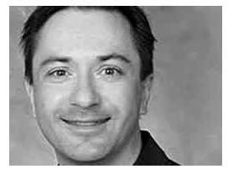
Richard G. Baraniuk is the Victor E. Cameron Professor of Electrical and Computer Engineering at Rice University. His research interests lie in new theory, algorithms, and hardware for sensing, signal processing, and machine learning. He is a Fellow of the IEEE and AAAS and has received national young investigator awards from the US NSF and ONR, the Rosenbaum Fellowship from the Isaac Newton Institute of Cambridge University, the ECE Young Alumni Achievement Award from the University of Illinois, and the Wavelet Pioneer and Compressive Sampling Pioneer Awards from SPIE. His work on the Rice single-pixel compressive camera has been widely reported in the popular press and was selected by MIT Technology Review as a TR10 Top 10 Emerging Technology for 2007. For his teaching and education projects, including Connexions (cnx.org), he has received the C. Holmes MacDonald National Outstanding Teaching Award from Eta Kappa Nu, Tech Museum of Innovation Laureate Award, the Internet Pioneer Award from the Berkman Center for Internet and Society at Harvard Law School, the World Technology Award for Education, the IEEE-SPS Education Award, and the WISE Education Award.

