**Graph Signal Processing**

José M. F. Moura

Carnegie Mellon University

[moura@ece.cmu.edu](mailto:moura@ece.cmu.edu), [www.ece.cmu.edu/~moura](http://www.ece.cmu.edu/~moura)

October 28, 2018

Asilomar Conference on Signals, Systems, and Computers

Asilomar Conference Grounds, Monterey CA

Signal Processing has traditionally dealt with time series, images, video where data is indexed by time ticks and pixels. The structure of the indexing set is taken for granted. In the last few years, new opportunities for signal and data processing have arisen, except data is now indexed by social agents, genes, customers of service providers, or by some other arbitrary enumeration suggested by the application. The tutorial will present *Graph* *Signal Processing* by revisiting the fundamentals of Signal Processing, developing for data (signals) arising from these various domains the essential concepts and methods of traditional Signal Processing—signal model, shift, filtering, convolution, spectral analysis, Fourier transform, filter frequency response, among others. We illustrate the concepts with datasets drawn from physical to social networks and applications from improving deep learning to uncovering graphs capturing dependencies among data

Work with Aliaksei Sandryhaila, Joya Deri, and Jonathan Mei.

Ack: NSF grants CCF-1513936

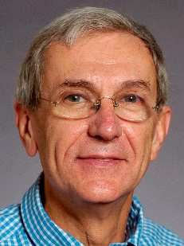**José M. F. Moura**, [www.ece.cmu.edu/~moura](http://www.ece.cmu.edu/~moura), is the Philip L. and Marsha Dowd University Professor at CMU, with interests in signal processing and data science. A detector he invented with Alek Kavcic is found in over 60% of the disk drives of all computers sold worldwide in the last 13 years (3 billion and counting)–leading to the largest settlement ever in the information technologies IP area, and 3rd largest overall, of US $750 Million between CMU and Marvell. He is (2018) IEEE President Elect, was President of the IEEE Signal Processing Society (SPS), and was Editor in Chief for the Transactions on SP. Moura received the IEEE SPS *Technical Achievement Award* and *Society Award*. He is Fellow of the IEEE, AAAS, and the US National Academy of Innovators, corresponding member of the Academy of Sciences of Portugal, and member of the US National Academy of Engineering. He received the Grã Cruz of the Ordem do Infante D. Henrique bestowed to him by the President of the Republic of Portugal.