**BankSystem**

A repository containing the Bank System Console Application for the Clean Code Course at FMI.

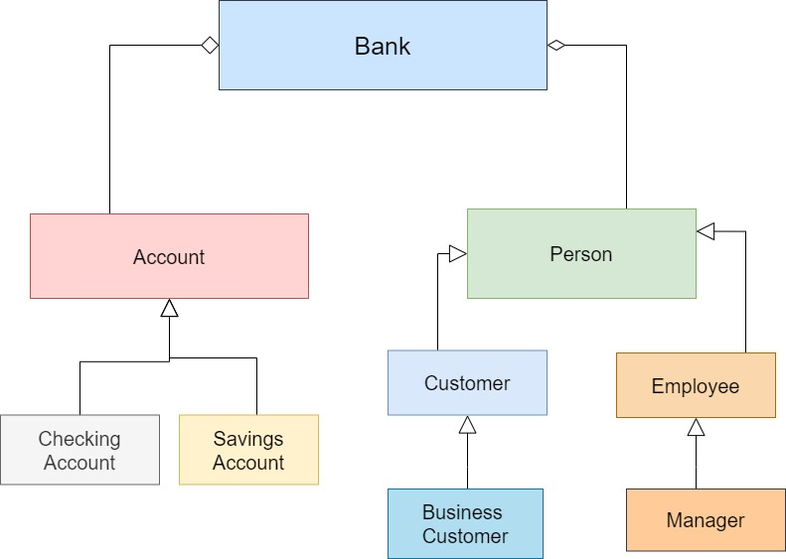

**Commands:**

Class Menu contains all functionalities of the BankSystem:

* **void listCustomers(Bank&);**
* **void addNewCustomer(Bank&);**
* **void addNewBusinessCustomer(Bank&);**
* **void deleteCustomer(Bank&);**
* **void listAllAccounts(Bank&);**
* **void listCustomerAccount(Bank&);**
* **void addNewCheckingAccount(Bank&);**
* **void addNewSavingAccount(Bank&);**
* **void deleteAccount(Bank&);**
* **void withdrawFromAccount(Bank&);**
* **void depositToAccount(Bank&);**
* **void transfer(Bank&);**
* **void getLoan(Bank&);**
* **void listEmployees(Bank&);**

**Classes and public methods:**

**Account**

* **Abstract class**
* **Account(std::string IBAN, std::string ownerID, double balance); -** constructor of class Account;
* **void deposit(double amount);** - deposit to an account. It accepts a double amount as an argument and returns void.
* **void withdraw(double amount); -** withdraw from an account. It accepts a double amount as an argument and returns void.
* **virtual void printInformation() = 0;** – pure virtual method that will be overwritten in the derivatives. It doesn’t accept any arguments and returns void.

**CheckingAccount**

* **CheckingAccount(std::string IBAN, std::string customerID, double balance); -** constructor of class CheckingAccount;
* **void printInformation() override;** – override printInformation() function from abstract class Account. It doesn’t accept any arguments and returns void. It prints information about CheckingAccount – IBAN, customer ID, account balance;

**SavingsAccount**

* **SavingsAccount(std::string IBAN, std::string customerID, double balance, double interestRate); -** constructor of class SavingsAccount;
* **void printInformation() override;** – override printInformation() function from abstract class Account. It doesn’t accept any arguments and returns void. It prints information about SavingsAccount– IBAN, customer ID, account balance, interest rate;

**Loan**

* **Loan(double amount, double loanRate, std::string ownerID); -** constructor of class Loan;

**Person**

* **Abstract class**
* **void validateAge(int age);** - check if age is between 18 and 100;
* **virtual void printInformation() = 0;** – pure virtual method that will be overwritten in the derivatives. It doesn’t accept any arguments and returns void.

**Customer**

* **Customer(std::string name, int age, std::string ID); -** constructor of class Customer;
* **void printInformation() override;** – override printInformation() function from abstract class Person. It doesn’t accept any arguments and returns void. It prints information about Customer – name, ID, age.

**BusinessCustomer**

* **BusinessCustomer(std::string name, int age, std::string ID, std::string businessType); -** constructor of class BusinessCustomer;
* **void printInformation() override;** – override printInformation() function from abstract class Person. It doesn’t accept any arguments and returns void. It prints information about BusinessCustomer – name, id, age, businessType;

**Employee**

* **Employee(std::string name, int age, std::string position, double salary);-** constructor of the class;
* **void printInformation() override;** – override printInformation() function from abstract class Person. It doesn’t accept any arguments and returns void. It prints information about Employee – name, position, salary;

**Manager**

* **Manager(std::string name, int age, std::vector<Employee*> employees, double salary); -** constructor of the class;
* **void addEmployee(std::string name, int age, std::string position, double salary); -** add an employee. It accepts string name, int age, string position and double salary as arguments and returns void.
* **void removeEmployee(int employeeID);** - delete an employee. It accepts an int employeeID and returns void.
* **int getNumberOfEmployees() const;** - returns the number of employees as an integer;
* **void listEmployees();** - prints information about employees and returns void;

**Bank**

* **Bank(std::string name, Manager* manager, std::map<std::string, Customer*> customers, std::map<std::string, Account*> accounts); -**constructor of the class;
* **Customer* getCurrentCustomer(std::**string **customerID) const; -** returns a Customer with given customerID as argument;
* **Account* getCurrentAccount(std::string IBAN) const; -** returns an Account with given IBAN number as argument;
* **void addCustomer(std::string name, int age, std::string customerID);** - add new customer. It accepts a string name, int age and string customer ID as arguments and returns void;
* **void addBusinessCustomer(std::string name, int age, std::string customerID, std::string businessType); -** add new business customer. It accepts a string name, int age and string customer ID as arguments and returns void;
* **void deleteCustomer(std::string customerID); -** delete a customer. It accepts a string customer ID as argument and returns void;
* **void listCustomers(); -** print information about all customers in the bank. It doesn’t accept any arguments and returns void.
* **void addCheckingAccount(std::string IBAN, std::string customerID, double balance); -** add a new checking account.It accepts a string IBAN, string customer ID and double balance as arguments and returns void.
* **void addSavingsAccount(std::string IBAN, std::string customerID, double balance, double interestRate); -** add a new savings account.It accepts a string IBAN, string customer ID, double balance and double interest rate as arguments and returns void.
* **void deleteAccount(std::string IBAN); -** delete an account.It accepts a string IBAN as argument and returns void.
* **void listCustomerAccount(std::string IBAN); -** print information about an account in the bank. It accepts a string IBAN and returns void.
* **void listAccounts(); -** print information about all accounts in the bank. It doesn’t accept any arguments and returns void.
* **void listEmployees(); -** print information about all employees in the bank. It doesn’t accept any arguments and returns void.
* **void getLoan(std::string customerID, double loanRate, double amount); -** add a new loan.It accepts a string customer ID, double loan rate, double amount as arguments and returns void.
* **void transfer(std::string fromIBAN, std::string toIBAN, double amount); -** transfer money from an account to an account.It accepts a string IBAN and double amount as arguments and returns void.
* **void deposit(std::string IBAN, double amount); -** deposit money to an account.It accepts a string IBAN and double amount as arguments and returns void.
* **void withdraw(std::string IBAN, double amount); -** withdraw money from an account.It accepts a string IBAN and double amount as arguments and returns void.
* **bool isValidTransaction(double amount, std::string IBAN);** - check if a transaction is valid.It accepts a string IBAN and double amount as arguments and returns bool.
* **bool IbanExists(std::string IBAN); -**  check if IBAN exists.It accepts a string IBAN as argument and returns bool.
* **bool isCustomerExist(std::string customerID); -** check if customer ID exists.It accepts a string customer ID as argument and returns bool.

**Menu**

**It includes all functionalities that can be chosen by the client of the BankSystem:**

* **void listCustomers(Bank&);**
* **void addNewCustomer(Bank&);**
* **void addNewBusinessCustomer(Bank&);**
* **void deleteCustomer(Bank&);**
* **void listAllAccounts(Bank&);**
* **void listCustomerAccount(Bank&);**
* **void addNewCheckingAccount(Bank&);**
* **void addNewSavingAccount(Bank&);**
* **void deleteAccount(Bank&);**
* **void withdrawFromAccount(Bank&);**
* **void depositToAccount(Bank&);**
* **void transfer(Bank&);**
* **void getLoan(Bank&);**
* **void listEmployees(Bank&);**