**Vehicle Power Management Setup**

Craig Beal, Bucknell University, Jan. 14, 2022

Small edits by Sean Brennan, Penn State University, Jan. 31st, 2022

**Summary:**

This document describes how to set up a power management system for a research vehicle to provide continuous power for research equipment when various sources of charging are intermittently available. These sources of charging include on-vehicle charging from an alternator or DC-DC stepdown converter as well as charging from “shore power” where energy flows from a set of AC mains, such as the outlet on a building, and is converted to DC by an onboard or offboard device. Shore power is particularly useful and common in mobile robotics, autonomous vehicles, and similar high-power mechatronic systems as it allows testing and debugging of the system without running down the battery. Indeed, the shore power system setup described below is designed to simultaneously provide power and to charge standby batteries on vehicles.

**Setup:**

The key element in this power management system is an EPIC PWRgate charge module from West Mountain Radio. The PWRgate module has four ports: BATTERY, OUT, POWER SUPPLY, and SOLAR PANEL. The last of these is slightly misleading, as many other power sources can be connected to the SOLAR PANEL port to provide charging to the system. The SOLAR PANEL represents an external power input that is intermittent – can be plugged in or unplugged. This is used in the setup to provide a power source external to the vehicle. The setup below also assumes that the vehicle has a high power, high-voltage DC power source (such as an EV battery pack) that is converted into lower, and saver, voltage via a DC to DC power converter.

The diagrams below illustrate the proper circuit arrangement for the PWRgate in an electric vehicle application (top) and in a vehicle with an internal combustion engine and alternator (bottom). Note that the only difference is the device producing onboard 12 V charging. Note also that, in both cases, the “shore power” supply does NOT provide power back into the EV battery pack or vehicle’s battery system.

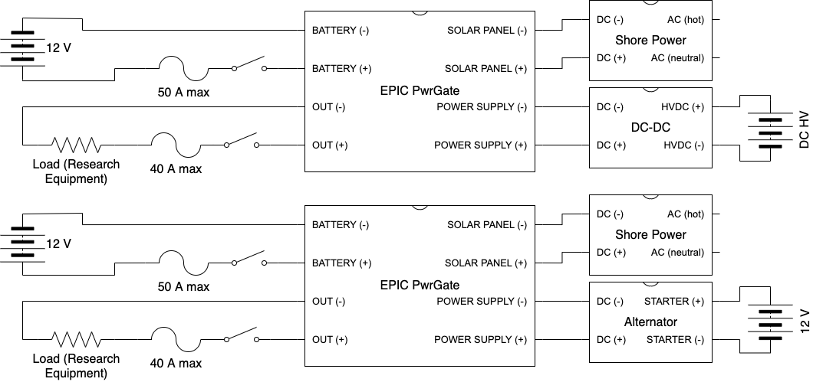

The BATTERY port of the PWRgate must be connected to the research equipment buffer battery. This is a separate battery from the vehicle starter battery, if one exists in the vehicle. Typically these buffer batteries are designed to allow a vehicle’s power system to operate even if the key is off, a very useful feature to avoid interrupting data collection during engine starts, gas station refueling, etc. A cutoff switch should be placed between the positive terminal of the buffer battery and the PWRgate to avoid a very slow current drain during periods of non-operation. The PWRgate has several LEDs and the milliamp current draw could drain the buffer battery over a long period without charging.

The OUT port of the PWRgate must be connected to the research equipment itself through another disconnect switch. This can be the same physical switch as the one disconnecting the battery (a DPST switch) or it can be two separate switches if it is desirable to be able to charge the battery without enabling power to the research equipment load. This connection should also be fused, either with an inline fuse or (more conveniently) on the DC IN port of a West Mountain Radio RigRunner or West Mountain Radio PWRguard module.

The POWER SUPPLY port of the PWRgate must be connected to the vehicle starter battery and alternator or DC-DC stepdown converter in the case of an electric vehicle. This input port will draw power when there is a voltage present over a programmable threshold. For an internal combustion vehicle with an alternator, this can be set to around 14 volts to prevent the PWRgate from drawing power from the vehicle’s battery when the vehicle engine is off. There is no need to include a disconnect switch for this connection as the unit is designed for such operation.

The SOLAR PANEL port of the PWRgate must be connected to the shore power module. The PWRgate will pull power from this source preferentially over the POWER SUPPLY port. In the context of the vehicle set up, this means that the shore power will be used whenever available, reducing load on the battery and the alternator or DC-DC stepdown converter. There is no need to include a disconnect switch for this connection.

**Modes of operation:**

The following modes of operation are enabled by the setup described in the previous section. Note that there are two problematic modes: both with the buffer battery connected (On) and both charging sources Inactive. In this situation, the load will draw from the buffer battery if it is connected (On) and the PWRgate will draw a small amount of power for its internal operation and LEDs. All other modes shut down the device completely or provide power to the battery and/or load in ways that are desirable.

|  |  |  |  |  |
| --- | --- | --- | --- | --- |
| **Battery** | **Out** | **Supply** | **Solar** | **Operation** |
| Off | Off | Inactive | Inactive | No power flow through PWRgate. |
| Off | Off | Inactive | Active | No power flow through PWRgate. |
| Off | Off | Active | Inactive | No power flow through PWRgate. |
| Off | Off | Active | Active | No power flow through PWRgate. |
| Off | On | Inactive | Inactive | No power flow through PWRgate. |
| Off | On | Inactive | Active | Research equipment runs off shore power?? |
| Off | On | Active | Inactive | Research equipment runs off vehicle charging?? |
| Off | On | Active | Active | Research equipment runs off shore power?? |
| On | Off | Inactive | Inactive | Milliamp draw from battery from LEDs may eventually run down buffer battery. |
| On | Off | Inactive | Active | Buffer battery charged from shore power |
| On | Off | Active | Inactive | Buffer battery charged from vehicle power |
| On | Off | Active | Active | Buffer battery charged from shore power |
| On | On | Inactive | Inactive | Research equipment runs off buffer battery. Mitigated by connecting research equipment through PWRguard Plus for low voltage shutoff but PWRgate LED load will remain. |
| On | On | Inactive | Active | Research equipment runs off shore power; excess power charges buffer battery. |
| On | On | Active | Inactive | Research equipment runs off vehicle charging power; excess power charges buffer battery. |
| On | On | Active | Active | Research equipment runs off shore power; excess power charges buffer battery. |

**Parallel circuitry:**

The EPIC PWRgate is limited to 40 amps of current draw from the output port, as mentioned previously. If additional load is anticipated, a second circuit can be added extending from the positive and negative terminals of the buffer battery. This circuit should not be connected to any other circuit connected to the PWRgate, as this may result in a ground fault loop and could destroy equipment unexpectedly. Additionally, since the PWRgate is limited to 10A charging current for the buffer battery, any parallel load beyond 10A will deplete the buffer battery even with a charging source active. Thus, the battery may be depleted even if the mode appears to be charging.