1. **Set up dev environment for Android.**
   1. ‘nodejs’, ‘npm’, ‘android sdk’ were installed

1.2 All paths were added to Environmental Variables.

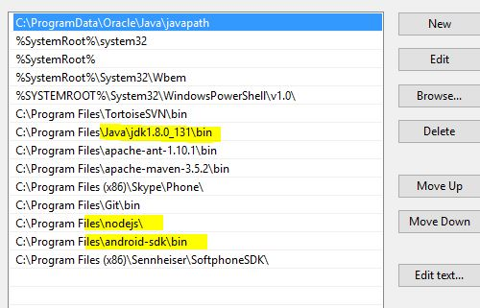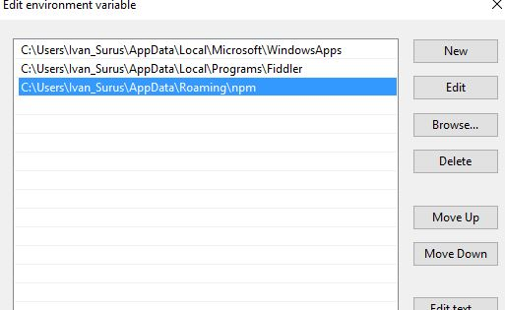

* 1. Appium was installed and invoked with commands:

*npm install –g appium*

*appium -a 127.0.0.1 -p 4723*

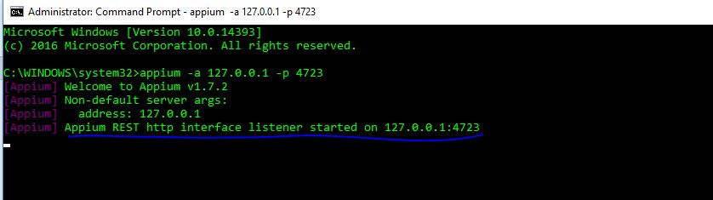

* 1. Got appium client with command:

*npm install wd*

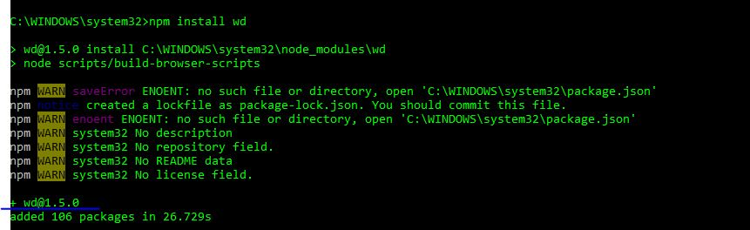

* 1. In order to check android dev environment appium-doctor was installed and ran with:

*npm install -g appium-doctor*

*appium-doctor –android*

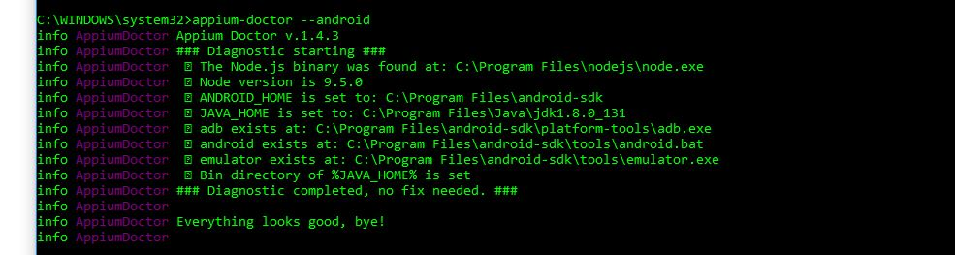

* 1. Andoid studio was installed, emulators were added to Android Virtual Device Manager

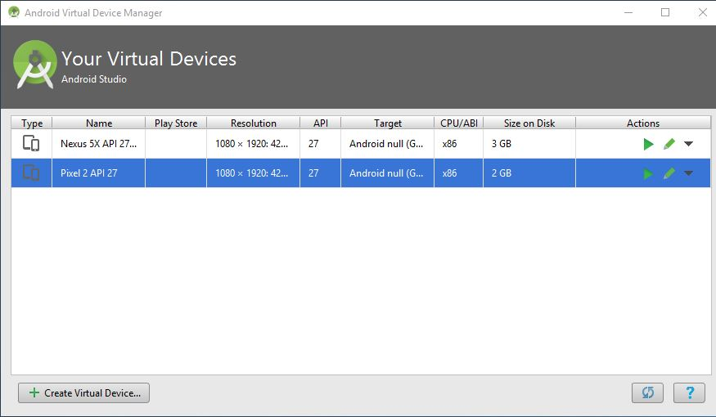

* 1. Emulators were started

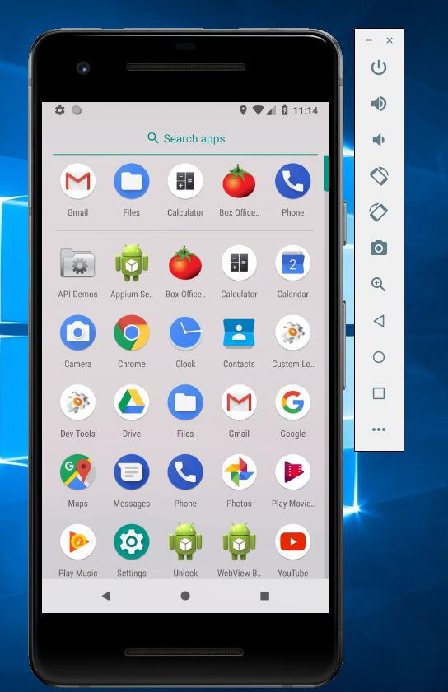

* 1. Checking emulators with ADB:

*Adb devices*

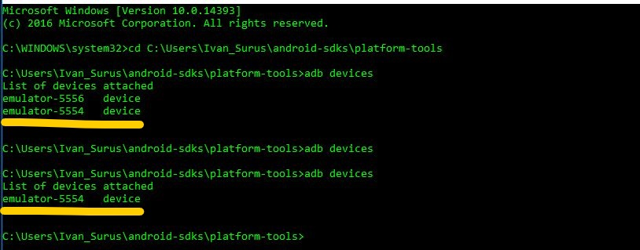

1. **Execute an existing test for any android app in repository**

**http://github.com/ivsurus/module12**

Existing test for ‘ApiDemos-debug.apk’ was executed in Eclipse

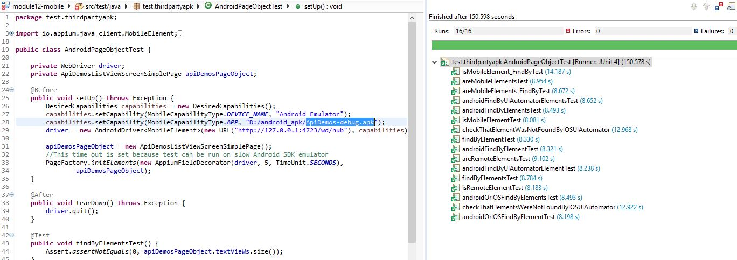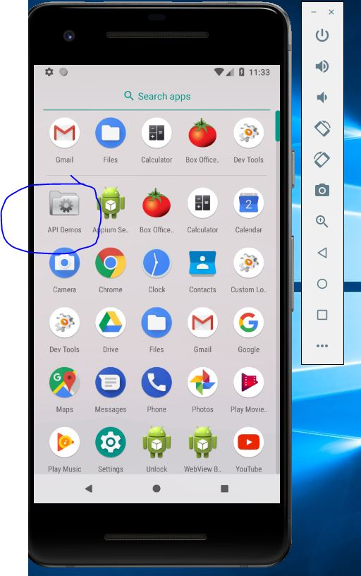

1. **Bonus**

**http://github.com/ivsurus/module12**

* 1. As a bonus task the test for native calculator was created and executed

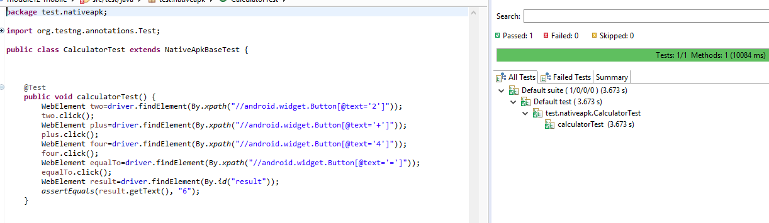

3.2 Lacators were found with uiautomatorviewer

