Самостійна робота 5
Ткачук Іван Васильович
Варіант 35

Завдання 1
Код 1
fun_model <- function(x, a) {
return(a[1] + a[2] * x)
}

fun_mnk <- function(a) {
s <- 0
for (i in 1:n) {
s <- s + (y[i] - fun_model(x[i], a))^2
}
return(s)
}

x <- c(0.5, 1.0, 1.5, 2.0, 2.5, 3.0)
y <- c(-4.2, -2.8, -2.2, -1.6, -1.3, -0.9)
n <- 6

a0 <- c(0, 0)

res <- optim(fn = fun_mnk, par = a0)

a1 <- res$par

ym <- fun_model(x, a1)

r <- y - ym
a <- 0.5
b <- 3.0
num <- 100
h <- (b - a) / (n - 1)
x1 <- c(1:n)
for (i in 1:n) {
x1[i] <- a + h * (i - 1)
}
y1m <- fun_model(x1, a1)

par(mfrow = c(1, 2))
plot(x, y, type = "p", col = "red")
lines(x1, y1m, col = "blue")
plot(x, r, type = "p")
lines(x1, r, col = "blue")
abline(h = 0)
abline(v = 0)

Результат 1
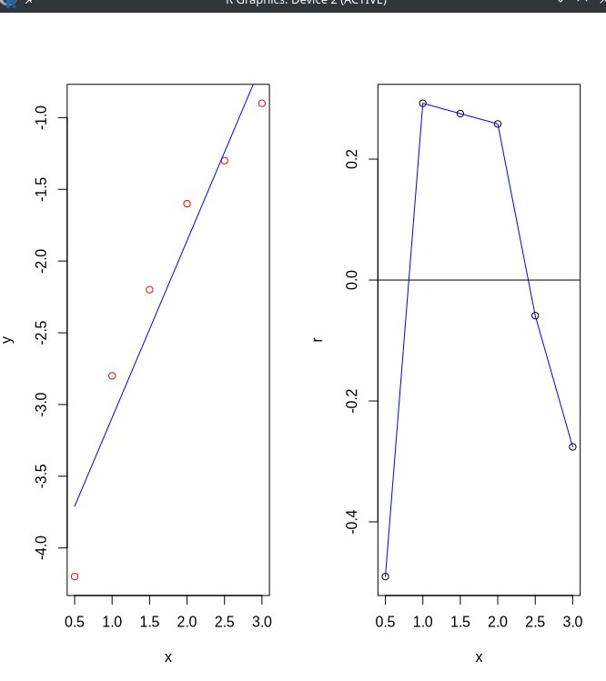
Код 2
# Варіант 35

x <- c(0.5, 1.0, 1.5, 2.0, 2.5, 3.0)
y <- c(-4.2, -2.8, -2.2, -1.6, -1.3, -0.9)
n <- 6

fun_model <- function(x, a) {
return(a[1] + a[2] * x + a[3] * x^2)
}

fun_mnk <- function(a) {
s <- 0
for (i in 1:n) {
s <- s + (y[i] - fun_model(x[i], a))^2
}
return(s)
}

a0 <- c(0, 0, 0)

res <- optim(fn = fun_mnk, par = a0)
a1 <- res$par

ym <- fun_model(x, a1)

r <- y - ym
a <- 0.5
b <- 3.0
num <- 100
h <- (b - a) / (n - 1)
x1 <- c(1:n)
for (i in 1:n) {
x1[i] <- a + h * (i - 1)
}
y1m <- fun_model(x1, a1)

par(mfrow = c(1, 2))
plot(x, y, type = "p", col = "red")
lines(x1, y1m, col = "blue")
plot(x, r, type = "p")
lines(x1, r, col = "blue")
abline(h = 0)
abline(v = 0)
Результат 2
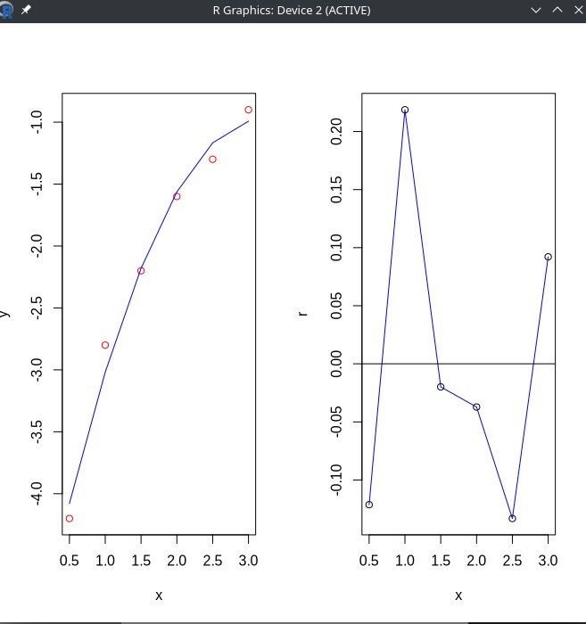
Код 3
# Варіант 35

x <- c(0.5, 1.0, 1.5, 2.0, 2.5, 3.0)
y <- c(-4.2, -2.8, -2.2, -1.6, -1.3, -0.9)
n <- 6

fun_model <- function(x, a) {
return(a[1] + a[2] * x + a[3] * x^2 + a[4] * x^3)
}

fun_mnk <- function(a) {
s <- 0
for (i in 1:n) {
s <- s + (y[i] - fun_model(x[i], a))^2
}
return(s)
}

a0 <- c(0, 0, 0, 0)

res <- optim(fn = fun_mnk, par = a0)
a1 <- res$par

ym <- fun_model(x, a1)

r <- y - ym
a <- 0.5
b <- 3.0
num <- 100
h <- (b - a) / (n - 1)
x1 <- c(1:n)
for (i in 1:n) {
x1[i] <- a + h * (i - 1)
}
y1m <- fun_model(x1, a1)

par(mfrow = c(1, 2))
plot(x, y, type = "p", col = "red")
lines(x1, y1m, col = "blue")
plot(x, r, type = "p")
lines(x1, r, col = "blue")
abline(h = 0)
abline(v = 0)
Результат 3
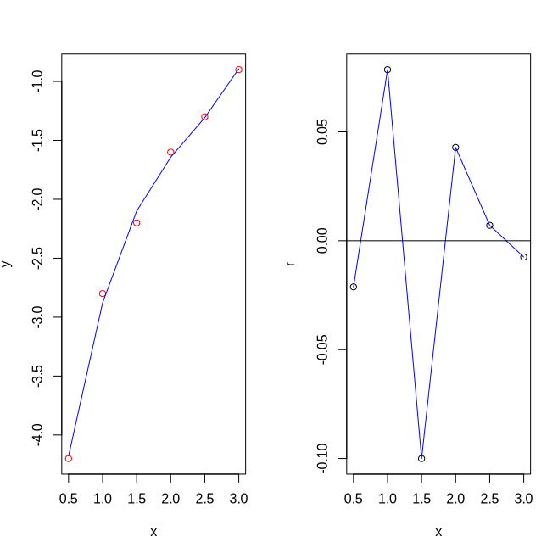

Завдання 2 Варіант 57
Код
x <- c(-2, -1, 0, 1, 2)
y <- c(-0.3, 0.5, 0.8, 1.8, 0.8)
n <- 5
k <- 3

fi <- function(x) {
return(c(1, x, x^2))
}

mnk_solve <- function(x, y, n, fi, k) {
fi_x <- matrix(nrow = n, ncol = k)
for (i in 1:n) {
fi_x[i, ] <- fi(x[i])
}
c <- matrix(nrow = k, ncol = k)
for (j in 1:k) {
for (m in 1:k) {
s <- 0
for (i in 1:n) {
s <- s + fi_x[i, j] * fi_x[i, m]
}
c[j, m] <- s
}
}
d <- c(1:k)
for (j in 1:k) {
s <- 0
for (i in 1:n) {
s <- s + y[i] * fi_x[i, j]
}
d[j] <- s
}
a <- solve(c, d)
return(a)
}

a1 <- mnk_solve(x, y, n, fi, k)
print(a1)

fun_model <- function(x, a) {
return(a[1] + a[2] * x + a[3] * x^2)
}

a <- -2
b <- 2
n <- 100
h <- (b - a) / (n - 1)
x1 <- c(1:n)
for (i in 1:n) {
x1[i] <- a + h * (i - 1)
}
y1m <- fun_model(x1, a1)

par(mfrow = c(1, 2))
plot(x, y, type = "p", col = "red")
lines(x1, y1m, col = "blue")

Результат
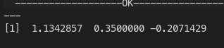
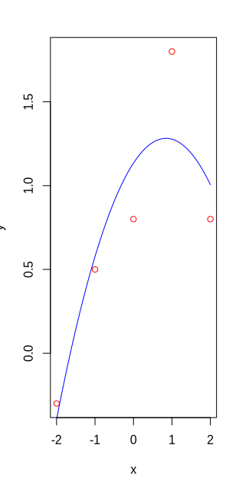
Код
x <- c(-2, -1, 0, 1, 2)
y <- c(-0.3, 0.5, 0.8, 1.8, 0.8)
n <- 5
k <- 4

mnk_solve_polinom <- function(x, y, n, k) {
c <- matrix(nrow = k, ncol = k)
for (j in 1:k) {
for (m in 1:k) {
s <- 0
for (i in 1:n) {
s <- s + x[i]^(m + j - 2)
}
c[j, m] <- s
}
}
d <- c(1:k)
for (j in 1:k) {
s <- 0
for (i in 1:n) {
s <- s + y[i] * x[i]^(j - 1)
}
d[j] <- s
}
a <- solve(c, d)
return(a)
}

fun_model <- function(x, a) {
return(a[1] + a[2] * x + a[3] * x^2 + a[4] * x^3)
}

a1 <- mnk_solve_polinom(x, y, n, k)
print(a1)

a <- -2
b <- 2
n <- 100
h <- (b - a) / (n - 1)
x1 <- c(1:n)
for (i in 1:n) {
x1[i] <- a + h * (i - 1)
}
y1m <- fun_model(x1, a1)

par(mfrow = c(1, 2))
plot(x, y, type = "p", col = "red")
lines(x1, y1m, col = "blue")

Результат
