Analyzing real world interfaces
Ivan M. Rodriguez Montilla

Exp & User Interfaces (UI & UX)

In this proyect I will be analyzing the user experience of Whatsapp. When we look at Whatsapp, one thing I always say is that it is different visually when you use it on IOS than on Android, not to say that it’s a big problem, but for people who are switching from Apple to Android, or vise versa, it can be a little tricky to navigate. One think I would definetly change is the menu. I think the menu would look better if they put it down on both systems, because on Apple it is down but on Android it is almost always up top.
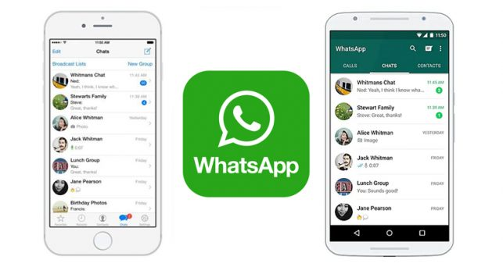

Another change is the pinned chats, when you pin a chat it doesn’t mark it as well as it should, because if you pin a chat its because it’s the most important for you, so changing a little bit the color or a label other than the pin, would be better visually. I think that they should make the gallery look more modern, maybe clear buttons, or clear overview. Another thing is when you look to attach a document or send a photo, the menu can be a little bit complicated especialy for older people. I think that they can put the options (camera, attach, location) above the keyboard so you don’t have to enter that menu.
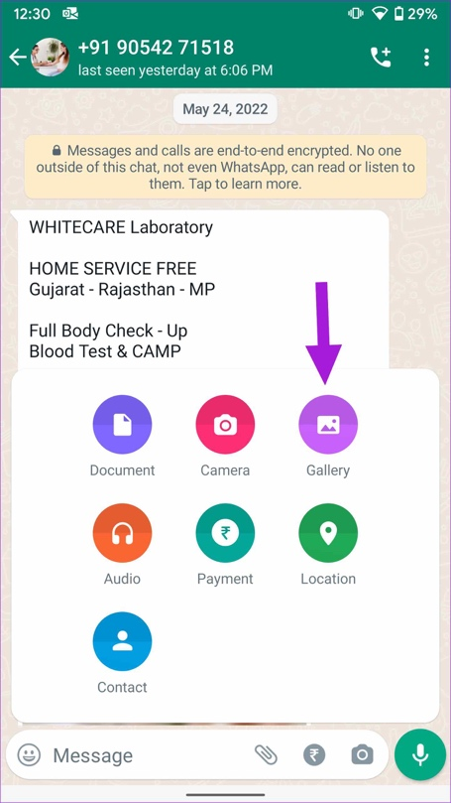

I think that they should let you put different sounds for different chats, so that you know which ones you should respond instantly and which ones you don’t need to answer as quick. And finally I think they should change the settings, there are a lot of settings that are hidden in the chats, I think they should change them all to the “Settings” tab and in there you can choose. For example, if you want to mute 3 chats, instead of going to each chat individually, you can go to the settings and mute the chats that you select. On the design side of things, it is widely aagreeded that Whatsapp does not have the most appealing looking app. Maybe they can use a darker green, adding a different color (mustard, or beige) and change the font of the buttons, nothing too fancy.
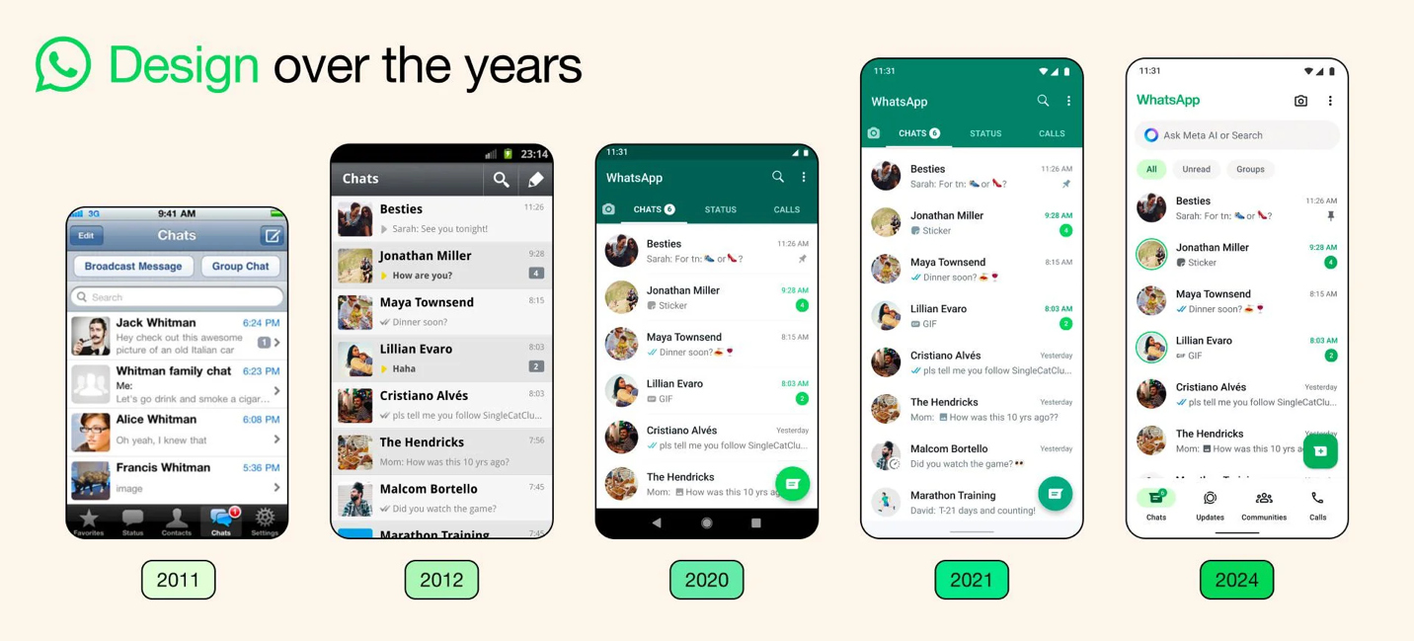

I interviewed my good friend Jadniel Rodriguez Viera and this is what he said “It’s a good app for sending text messages, but it’s missing features that I consider basic, like scheduled messages. The app’s options could be better thought out and less confusing.” “Also the synchronization of chats across multiple devices occasionally doesn’t work properly.”

In conclusion, Whatsapp is a very solid app but for me and my friend Jadniel, it is one of meta’s worst apps they have, and if they could work on the app, it could be better than Imessage.

