Name: Amoroso, Ivan Karl J. | Course: IT Elective 2
Section: 3.4 BSIT | Date: 10-24-26

Activity 1:
Code:
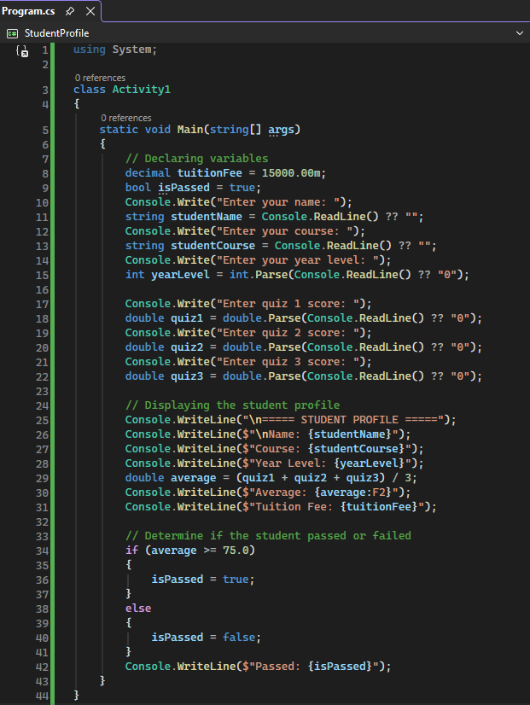
Output:


