Name: Amoroso, Ivan Karl J. | Course: IT-Elective 2
Section: 3.4 BSIT | Date: 10-28-26
Activity 2: Library Book Management
Code:
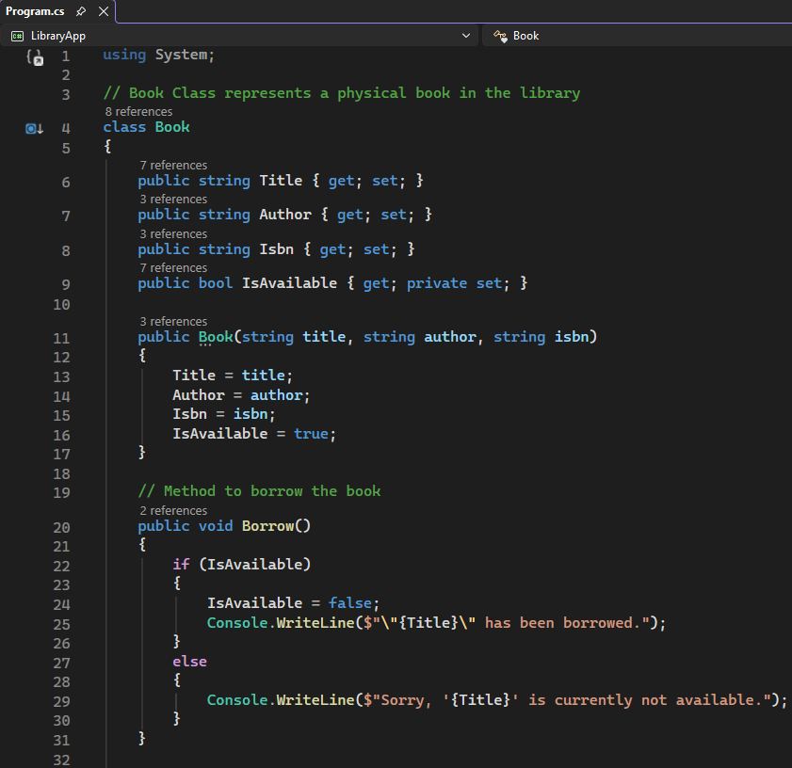
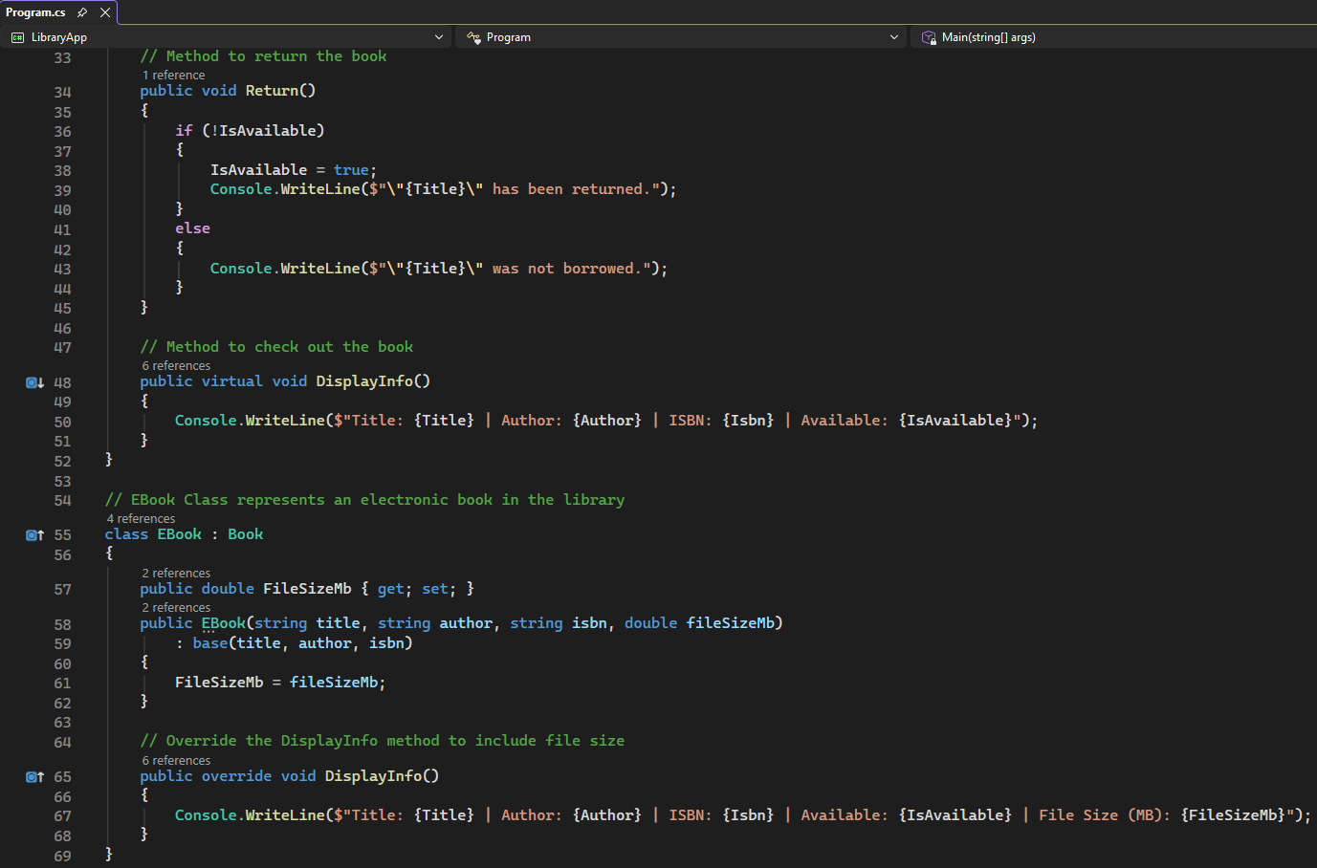
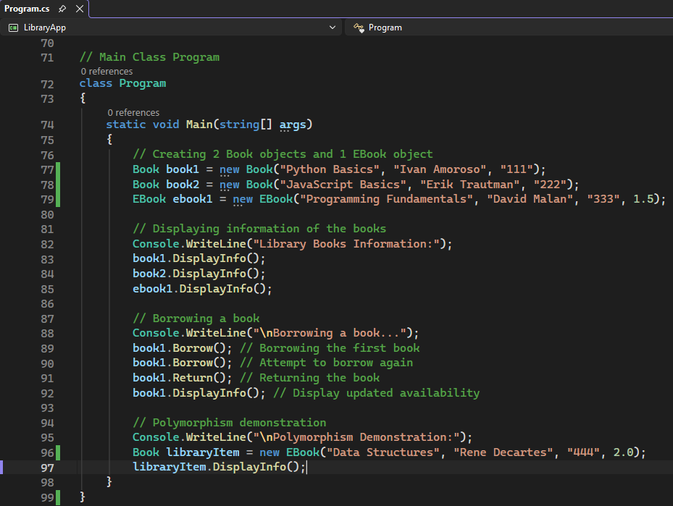
Output:


