Deep Learning models
for Sentiment Classification
Course: MH6812 Zhuang Xuyi Date: 11 Jan 2026
1 Introduction
This report looks at how different deep learning models perform in sentiment classification. First, we compare three optimizers to see differences in speed, stability, and generalization. Then we test Adam with different training epochs to observe overfitting. Finally, we evaluate several model architectures, including feed-forward networks, CNN, LSTM, and Bi-LSTM. The goal is to show the strengths and weaknesses of each approach and suggest directions for improvement.
2 Optimizers Comparison Analysis
We compared three optimizers (SGD, Adam, and Adagrad) on the sentiment classification task using a Vanilla RNN. The experimental results are summarized in Table 1.
Optimizer | Best Epoch | Test Accuracy | Test Loss | Convergence Speed | Stability
SGD | 20 | 55.03% | 0.68 | Slow | Stable (High Loss)
Adam | 12 | 72.08% | 0.55 | Fastest | Prone to Overfitting
Adagrad | 20 | 71.48% | 0.56 | Moderate | Most Stable
Table 1. Comparison of Optimizers
From Table 1, we can clearly see that Adam and Adagrad are much better than SGD. SGD performed poorly, with a test accuracy of only 55.03%. It seems SGD learns too slowly and didn't learn much in 20 epochs. Adam got the best test accuracy of 72.08% and the lowest loss of 0.55. It was the fastest optimizer, reaching its best performance at Epoch 12. Adagrad was also very good, with a test accuracy of 71.48%. It was very stable to reach its best compared other optimizers.
Table 2. Validation Accuracy Progression over Epochs
Optimizer | Epoch  5 | Epoch  10 | Epoch  15 | Epoch  20 | Trend Description
SGD | 53.69% | 54.02% | 55.29% | 55.76% | Improved very slowly, barely learning.
Adam | 66.46% | 70.86% | 75.29% | 63.05% | Fast convergence, then slight overfitting.
Adagrad | 65.90% | 70.26% | 71.01% | 71.76% | Consistent, steady improvement.
Table 2 shows how the model improved over time. SGD improved very little. It started at 53.69% in Epoch 5 and only reached 55.76% in Epoch 20. Adam learned very fast at the beginning. However, the accuracy dropped to 63.05% at Epoch 20. This big drop shows that Adam started to overfit in the later stages. Adagrad was the most steady one. It started at 65.90% and kept going up consistentl, which shows it is more stable for this task.
3 Epochs & Overfitting
We then investigate how the number of epochs influences the model's performance. We use the Adam optimizer and track the training loss versus validation loss to visualize the convergence behavior.
Table 3. Impact of Training Epochs on Model Generalization
Epoch | Train Loss | Val Loss | Val Acc (%) | Test Loss | Test Acc (%)
5 | 0.70 | 0.69 | 50.96 | 0.69 | 48.09
10 | 0.69 | 0.67 | 57.73 | 0.66 | 61.55
20 | 0.40 | 0.55 | 76.82 | 0.54 | 77.21
50 | 0.30 | 0.66 | 74.27 | 0.66 | 73.69
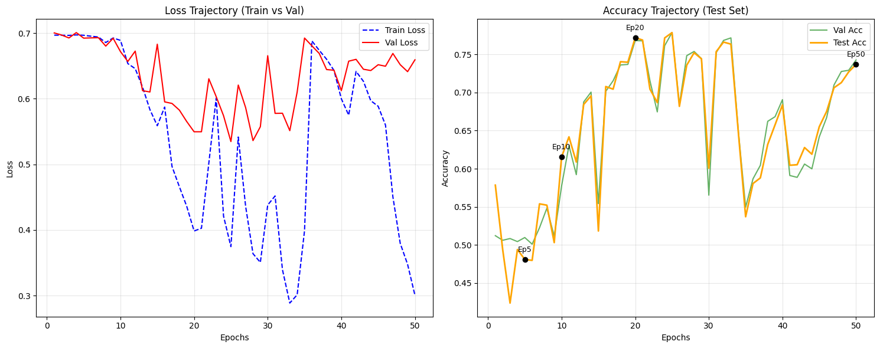
Figure 1. Trajectory of Loss and Accuracy over 50 Epochs
The results in Table 3 and Figure 1 clearly illustrate the trade-off between training time and model generalization. We observed three distinct stages during the training process:
- Underfitting (Epoch 5-10): The model exhibits high loss and low accuracy in the early stages, indicating that it has not yet learned the underlying patterns of the data.
- Optimal Balance (Epoch 20): The model reaches its peak performance at Epoch 20, achieving the highest test accuracy of 77.21% and lowest test loss of 0.54. This represents the optimal balance where the model generalizes best to unseen data without memorizing noise.
- Overfitting (Epoch 50): As training continues to Epoch 50, we observe a classic case of overfitting. Although the train loss keeps dropping to 0.30 (lowest), the test loss rebounds to 0.66. This divergence between training and testing performance is a clear sign of overfitting.
4 Model Architecture Comparison
In the final experiment, we compared six different deep learning architectures. Our goal was to investigate how different mechanisms impact the model's accuracy and efficiency.
Table 4. Performance Comparison of Deep Learning Models
Model | Parameters | Test Acc (%) | Avg Time (s) | Best Val Loss
FFNN_1L | 2551201 | 86.21 | 2.66 | 0.32
FFNN_2L | 2701301 | 85.40 | 2.72 | 0.32
FFNN_3L | 2761401 | 85.52 | 2.79 | 0.33
CNN | 2560801 | 88.19 | 12.37 | 0.28
LSTM | 2867049 | 88.75 | 8.73 | 0.29
Bi-LSTM | 3233897 | 89.23 | 14.91 | 0.28
4.1 Evaluation of FFNNs
The FFNN models had the lowest accuracy, staying around 85% to 86%. This confirms that simply adding depth does not help if the model ignores word order since FFNN uses averaged embeddings. The simple 1-layer model in fact worked slightly better than the 3-layer one, which suggests the deeper model might be overfitting a little.
4.2 Evaluation of CNN
The CNN model achieved a notable improvement with 88.19% accuracy. Unlike FFNNs, the CNN utilizes filters of varying sizes to capture local n-gram patterns. These local features are critical for detecting sentiment, explaining the performance boost over the baseline.
4.3 Evaluation of RNNs
Recurrent Neural Networks yielded the best results, validating the importance of modeling sequential dependencies. The LSTM reached 88.75% accuracy by handling long-range dependencies. The Bi-LSTM achieved the highest accuracy of 89.23% by processing text in both forward and backward directions, thereby capturing the complete context of the reviews.
4.4 Efficiency Trade-off
There is a clear trade-off between speed and accuracy here. Although Bi-LSTM is the most accurate, it is also the slowest to train, taking 14.9 seconds per epoch. The feed-forward networks are much faster, requiring only 2.7 seconds per epoch, but they are less accurate. The CNN is a good medium choice as it trains much faster than the Bi-LSTM while still giving very good results.
5 Conclusion
In this assignment, we studied how optimizers, training time, and model design affect sentiment analysis. We found that adaptive optimizers and careful tuning improve stability, while model structure matters more than depth. Architectures that capture context, such as Bi-LSTM and CNN, outperform simple feed-forward networks. Overall, good performance requires balancing efficiency with the ability to model language patterns.

