**RESEARCH PROPOSAL**

**ON**

**“DESIGN AND DEVELOPMENT OF TERRESTIAL CUM ARIAL FARM MONITORING SYSTEM”**



**Submitted by:**

**Ayush Srivastava and Pratyaksh Suri**

Students Btech, Department of Mechanical Engineering

**FACULTY OF ENGINEERING**

**DAYALBAGH EDUCATIONAL INSTITUTE**

**Dayalbagh, Agra, Uttar Pradesh - 282005**

**Part-A**

1. Board Subject: Farm Master
2. Area of specialization: Areal cum Terrestrial Monitoring System

Part-B

**Proposed research work**

1. **(i) Project Title: Design and development of phase change material based thermal storage.**

**(ii) Introduction:**

The project, titled "Earthly-Watch: A Comprehensive Real-time Arial and Terrestrial Farm Monitoring System," seeks to introduce a paradigm shift in contemporary agriculture by integrating advanced technologies and data-driven analytics. This IoT-based monitoring framework systematically acquires and manages critical Areal (Methane, AQI, Humidity, Areal Temperature) and Terrestrial (Nitrogen, Potassium, Phosphorus, pH, Humidity, Soil Temperature) data in real-time, affording agricultural practitioners an extensive understanding of their agricultural ecosystems.

The collected data is securely archived in a centralized database, facilitating historical analysis and informed decision-making. Leveraging artificial intelligence (AI) and machine learning (ML) algorithms, the system conducts in-depth data analysis, discerning recurring patterns, anomalies, and trends, thereby furnishing invaluable insights into crop health and environmental conditions.

An intuitively designed web application offers a graphical representation of the data, providing a lucid overview of the agricultural landscape. Moreover, the system empowers remote actuator control, granting farmers the capacity to optimize operations, such as irrigation and equipment management, in response to real-time sensor data.

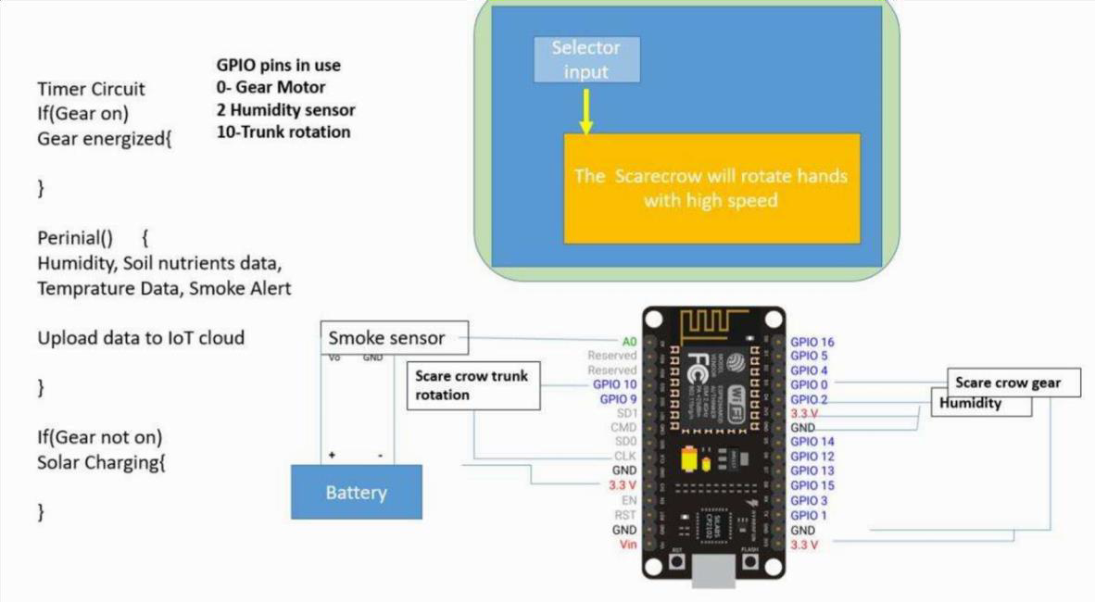

The project encompasses predictive models and crop-specific recommendations, optimizing agricultural productivity while minimizing resource utilization. The inclusion of alert mechanisms for critical events, robust data security protocols, scalability features, and integration with external data sources underscores the comprehensive, sustainable, and data-centric nature of this agricultural approach

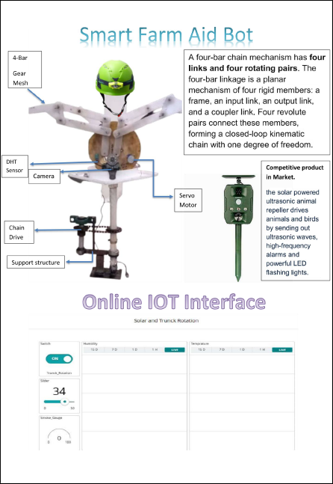

**(iii) Objectives**

• Develop IoT system for Areal and Terrestrial data.

• Secure data storage and real-time access.

• Utilize AI/ML for data analysis.

• Create user-friendly web app for data visualization.

• Enable remote actuator control.

• Provide forecasting models and crop-specific recommendations.

• Implement alerts for critical events.

1. Financial Assistance required

|  |  |  |  |  |
| --- | --- | --- | --- | --- |
| **S.No.** | **Items** | **Number** | **Rate Per Unit (Rs.)** | **Total Estimated Expenditure** |
| **(A) Non-Recurring** | | | | |
| **1** | **Camera**  **Long electric Cable**  **MQ Gas,Humidity,Temperature and NPK,**  **Gear and Drives**  **,**  **Motor**  **,**  **Battery**  **,**  **Digital Screen**  **,**  **Microcontroller**  **,**  **Shaft, members and Bearings**  **,**  **Surveillance balloon** | - | 12,000.00 | 11,000.00 |
|  | **Total (A)** |  |  | 11,000.00 |
| **(B) Recurring** | | | | |
| **1** | **Travel** | - | - | 3,000 |
| **3** | **Training and licencing** | - | - | 2,000 |
| **4** | **Others** | - | - | 3,000 |
|  | **Total(B)** | - | - | 8,000 |
| **Grand Total (A) +(B) 19,000** | | | | |

**Total: 19,000/- (Two lakhs thirty thousand only)**