BGGN 213 Class 05

Ivy Fernandes

January 25, 2019

Class 05 graphics and plots with R

## Class 05 graphics and plots with R  
  
# Section 2a: line plot  
weight<- read.table("bimm143_05_rstats/weight_chart.txt", header=TRUE)  
plot(weight$Age,weight$Weight,type="b",   
 pch=15,  
 cex=1.5,  
 lwd=2,  
 ylim=c(2,10),  
 xlab= "Age (Months)",  
 ylab="Weight (kg)",  
 main="Weight Trends by Age")

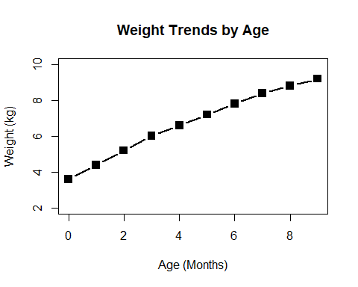

#b results in both "l"ine and "p"oints   
  
# Section 2b: bar plot  
feat<-read.table("bimm143_05_rstats/feature_counts.txt",header=TRUE,sep="\t")  
 #importing this file was different than the first one, because there are   
 #inconsistensies in how many words there are for a single feature  
 #use sep (field separator character) to encode a tab (\t) instead of a space  
barplot(feat$Count,   
 width=2,  
 names.arg=feat$Feature,  
 las=2,  
 horiz=TRUE,  
 xlim=c(0, 90000),  
 main="Numbers of Features in the Mouse GRCm38 Gene"  
 )

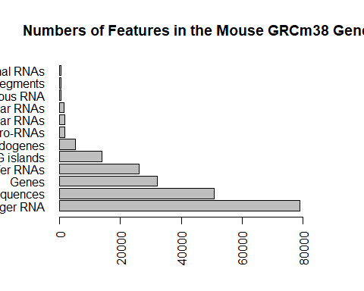

#height - needs to corelate to count  
 #las helps to reorient the labels so that they all fit and are readable  
 #reorient entire bar plot using the horiz argument   
  
par(mar=c(5,12,4,2))  
 #want to set the margins so that we can read the entire feature name   
 #must recall the plot because it runs it sequentially  
barplot(feat$Count,  
 names.arg=feat$Feature,  
 las=2,  
 horiz=TRUE,  
 xlim=c(0, 90000),  
 main="Numbers of Features in the Mouse GRCm38 Gene"  
)

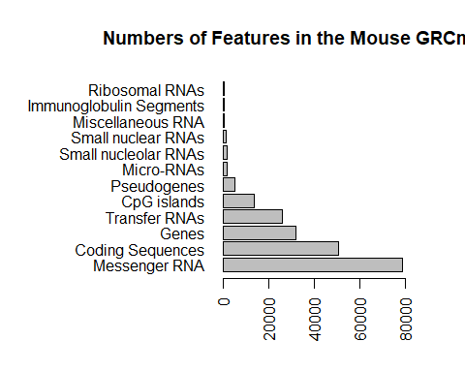

# Section 3a: providing color vectors   
mf<-read.table("bimm143_05_rstats/male_female_counts.txt", header=TRUE,sep="\t")  
mfc<- read.delim("bimm143_05_rstats/male_female_counts.txt")   
 #sets it to match a common file format so that you do not have to fill in the arguments  
barplot(mf$Count,  
 names.arg=mf$Sample,  
 xlab= "Names",  
 las=2,  
 ylab="Count",  
 col=rainbow(nrow(mf))  
 )

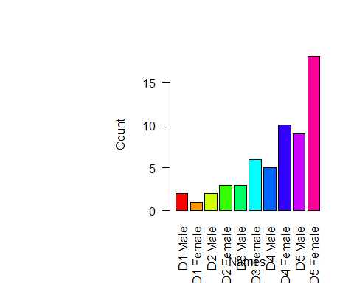

#different colors for males and females - only works out because the data is already sorted  
 # male, female, male, female etc however if you wanted to specifically color males and females  
 # to specific colors we would need to sort data differently  
barplot(mf$Count,  
 names.arg=mf$Sample,  
 xlab= "Names",  
 las=2,  
 ylab="Count",  
 col=c("pink","purple"))

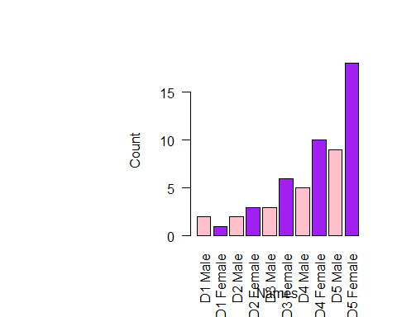

#using new color schemes that are pre-loaded   
barplot(mf$Count,  
 names.arg=mf$Sample,  
 xlab= "Names",  
 las=2,  
 ylab="Count",  
 col=topo.colors(nrow(mf)))

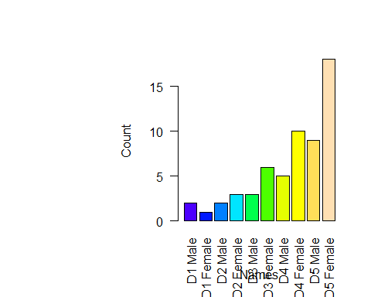

#using new color schemes that are from > install.packages("colorspace")  
# barplot(mf$Count,  
# names.arg=mf$Sample,  
# xlab= "Names",  
# las=2,  
# ylab="Count",  
# col=sequential_hcl(nrow(mf)))  
  
# Section 3b: coloring by value  
genes<-read.delim("bimm143_05_rstats/up_down_expression.txt")  
table(genes$State)

##   
## down unchanging up   
## 72 4997 127

palette(c("blue","gray","red"))  
plot(genes$Condition1,genes$Condition2, col=genes$State)

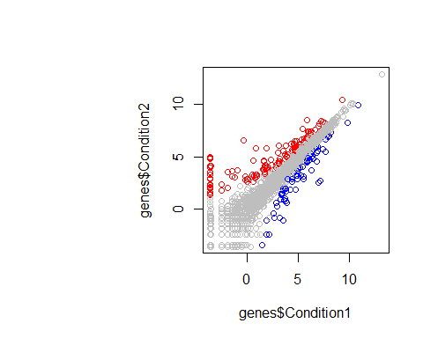

# > palette() <- this was used before setting the palette above to see what colors are default  
 # [1] "black" "red" "green3" "blue" "cyan" "magenta" "yellow" "gray"   
 # > levels(genes$State) <- this was used to see what colors coressponded to which state  
 # [1] "down" "unchanging" "up"   
  
# Section 3c: coloring by point density  
meth<-read.delim("bimm143_05_rstats/expression_methylation.txt")  
nrow(meth$X)

## NULL

plot(meth$gene.meth,meth$expression)

