Question 4: Creating the WAN Connection
The screenshot shows the serial link between Router0 and Router1.
Router | Interface | IP Address
Router0 | Serial0/1/0 | 10.10.10.1
Router1 | Serial0/1/0 | 10.10.10.2

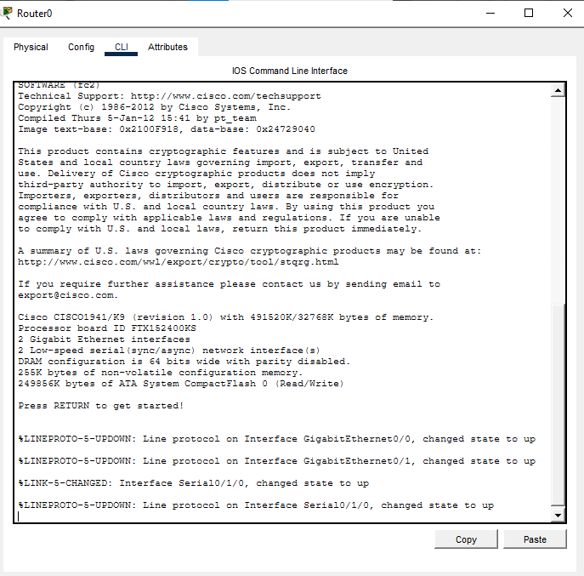

Figure 6: Router0 Serial and Static Routing Configuration

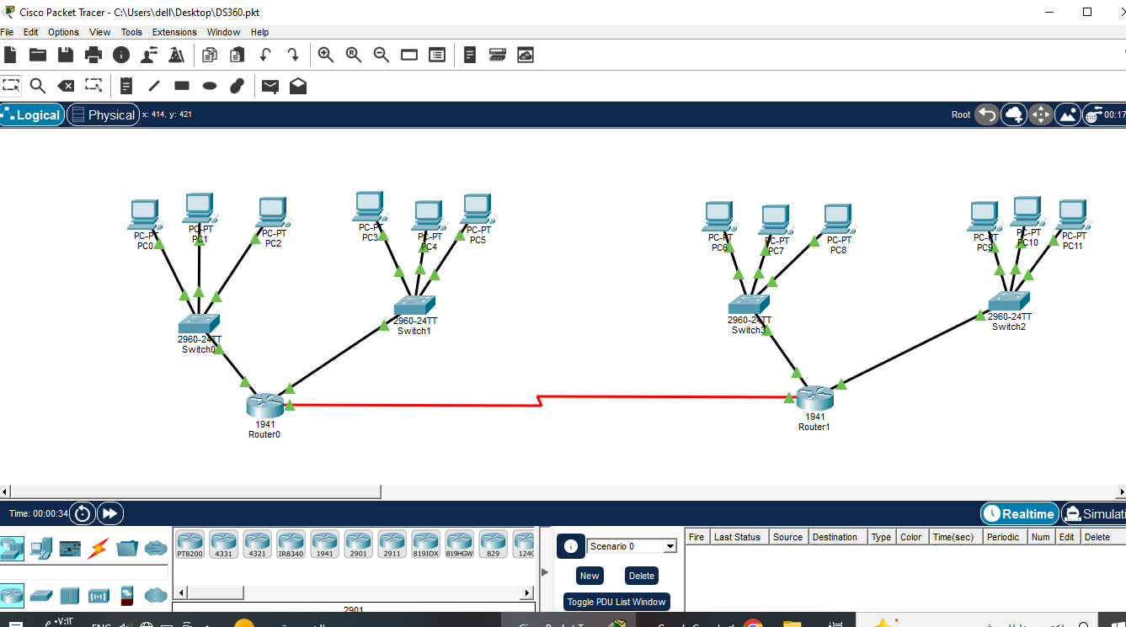

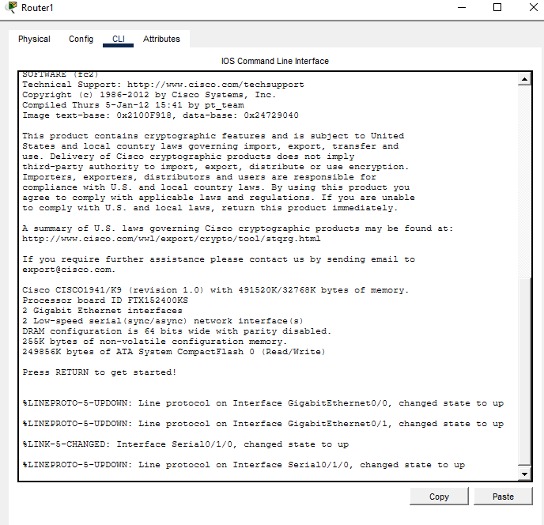

Figure 8: Router0 Serial and Static Routing Configuration

Question 5: Successful Data Transmission
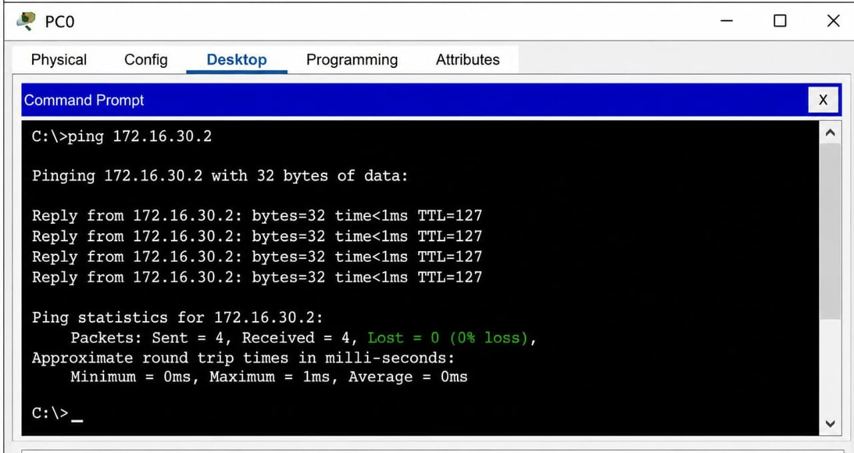
Figure 9: Successful Ping Test Results

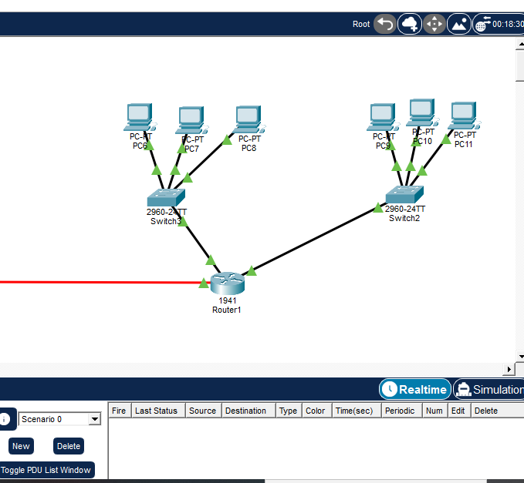

Figure 10: Successful Ping from WAN 2 to WAN 1 (0% Packet Loss)

