GURU99 LIVE MOBILE TESTING PROJECT

=====================================================================================

Below are the pre-requisites need to install before executing the project

**Java 1.7 or above**

* Download java from [here](http://www.oracle.com/technetwork/java/javase/downloads/index.html) and install jdk and jre
* Once installation completed set PATH and CLASSPATH for java

**Appium GUI for windows**

* Download and install Appium for windows from [here](http://appium.io/downloads.html)
* Once installation completed, launch the Appium click on the setting button
* Change the server address to 0.0.0.0, port number to 4723 and click on start button

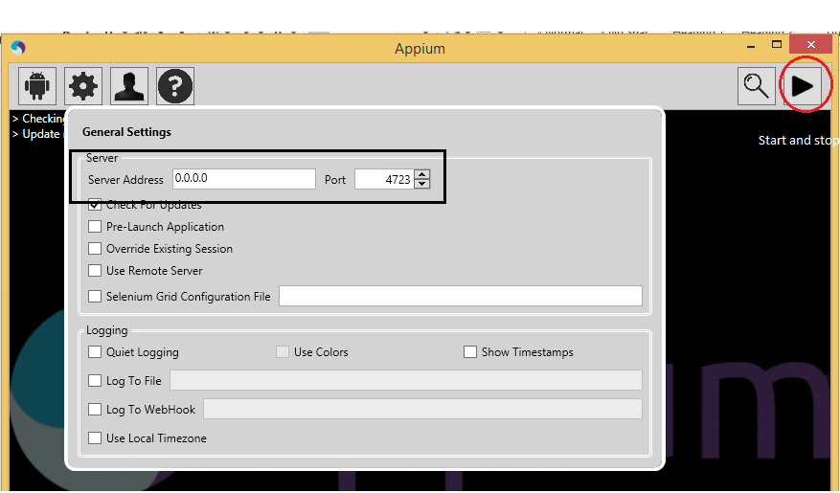

* Once clicked started after few seconds if you see the following message means Appium server started in your machine

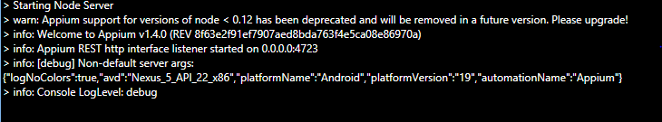

**Android SDK**

* Download and install android sdk from [here](https://developer.android.com/sdk/index.html)
* Create a system variable ANDROID_HOME with value “C:\Users\<username>\AppData\Local\Android\sdk”
* Add adb(android device bridge) location to PATH variable after installing android studio (<C:\Users\username\AppData\Local\Android\sdk\platform-tools>)
* Once set the path launch command prompt and type **adb** and press enter you’ll see a bunch of commands are displayed that means ADB is working fine in your machine

**Android real device with api level >17**

**Android simulator with api level > 17**

**Windows drivers to the android device**

**Eclipse**

* Download and install eclipse from [here](https://eclipse.org/downloads/)

**Checkpoints before starting execution:**

1. Make sure Appium server is started (Very common mistake)
2. Check ADB is working
3. Verify your testing device has api level > 17