MIDTERM - DL Challenge: AI-Powered Database Pipeline
Name: Ivy Lo
Deployed App on Digital Ocean: https://congestion-tracker-ltyfg.ondigitalocean.app/
GitHub Repository: https://github.com/ivyklo/SYSEN5381-dsai/tree/main/05_hackathon/congestion_tracker
- API, dashboard, AI integration codes
- Codebook
- Readme
- database schema
- Process Diagram
Test demonstration examples (pulling data from 3 test datasets):
Test A
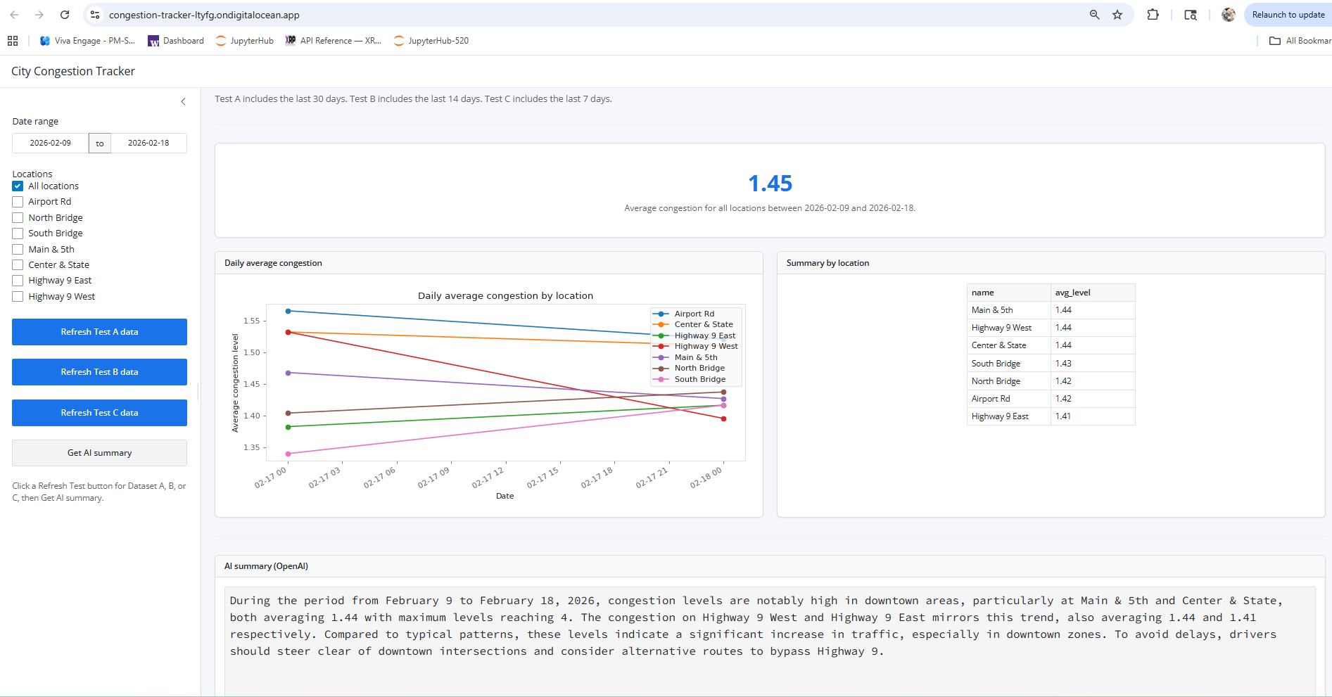

Test B
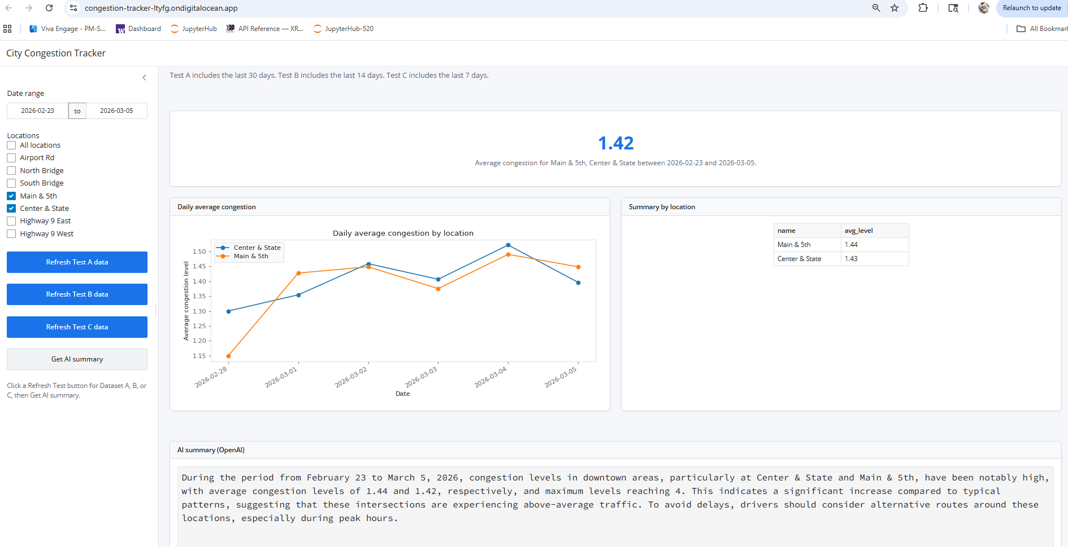
Test C
