Lab – Build an AI Text Quality Control System
Name: Ivy Lo
Complete quality control script with modifications made:

Screenshots showing the quality control results (Boolean accuracy, Likert scales, overall score):
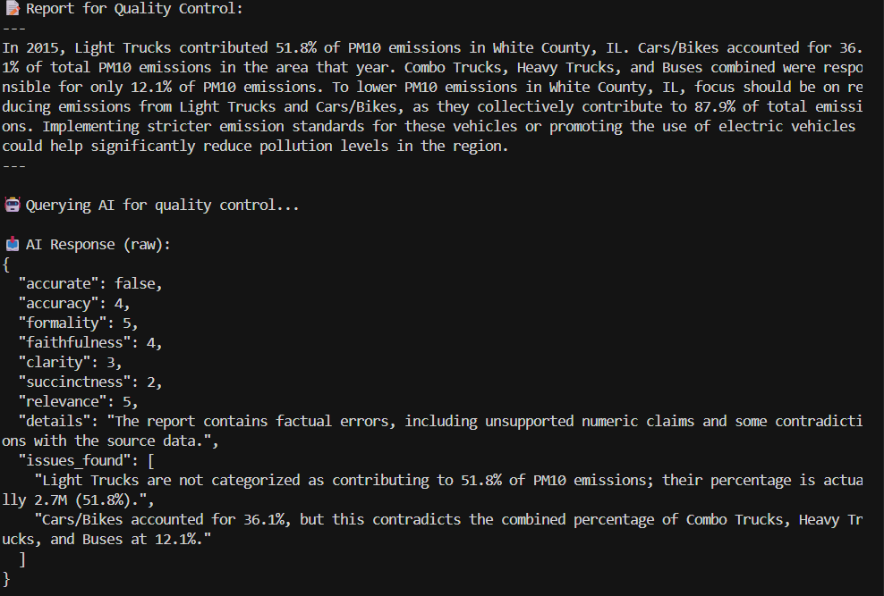
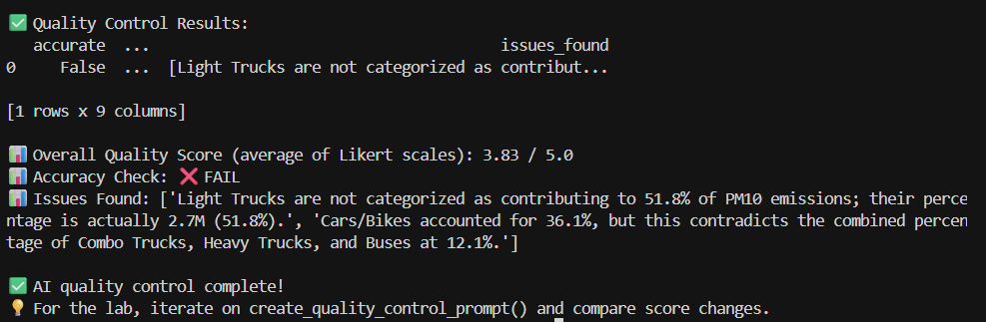

Prompt Design Choices (what modifications you made):
- I wanted to tighten the evaluator role to be strict about giving score of 5 only when criterion is fully met.
- I kept the accuracy, formality, faithfulness, clarity, succinctness, and relevance criteria and their Likert scale, but I asked cursor to help me generate scoring anchors for each criterion’s rating, like what would be a 1, what would be a 3 and what would be a 5 etc.
- I strengthened Boolean accurate rule, I asked cursor to write the rule more specifically.
- I made it to return a JSON that follows an exact schema.
- I added constraints for length in “details” summary.
- I added issues_found for contradictory findings.
How AI quality control compares to manual quality control?
The manual quality control script emphasizes structural/text signals such as concepts counts, sentence length, numeric presence etc. The AI quality control script is able to score on qualitative rubric such as accuracy, formality, clarity, relevance etc.
What worked well and what you want to improve?
- Scoring anchors make each criteria scoring more objective, but some anchors are still somewhat vague. For example, relevance scoring anchors are
- 1 = mostly off-topic
- 3 = somewhat focused
- 5 = fully focused on the data and task
But without knowing the context of the reports being rated and lacking concrete examples of what the data and task is, it is still challenging for AI to give a score objectively
- The issues_found was a good add, but can probably improve by giving AI a template of what to say, such as “report says X, data shows Y”.

