SYSEN 5381 Homework 1: AI-Powered Reporter Software
Name: Ivy Lo
- API Integration: Queries a public API and retrieves meaningful data
- Web Interface: Provides a Shiny app interface for users to interact with the data
- AI Reporting: Uses AI (Ollama or OpenAI) to generate useful summaries or insights from the data
Brief Explanation of the system
This reporter queries data from OpenAQ API. This API supplies open air quality data with worldwide coverage. This system queries air quality data in Hong Kong, specifically on PM2.5 readings from PM2.5 sensors from different monitoring stations. The parameters for date range are set at 2020-01-01 to 2025-12-31.
The system includes a shiny app built by Cursor’s AI agent. This app uses the queried data from Tung Chung monitoring station in Hong Kong and displays monthly PM 2.5 averages over the 5-year range. This app allows users to adjust the date range, set PM 2.5 threshold values and it will summarize how many months are above the set threshold and indicate the worst months in set date range.
The purpose of this app is to align to our stakeholder’s needs. Our major stakeholders are local residents and school officials; they have an interest to know air quality values in order to plan indoor/outdoor activities for students and communities.
The systems also include an AI-powered data reporter that compares air quality data taken from sensors at 4 monitoring stations from 4 different locations in Hong Kong. I have chosen to run my prompts locally on the gemma3: latest model from Ollama. The data reporter analyzes the queried data, summarizes a brief summary, and identifies 5 key insights about this data.
The shiny app provides output that connects to our stakeholder needs and serves a more specific area (Tung Chung) while the data reporter gives us more insights on overall air quality values throughout Hong Kong and provides recommendations how we can further use our data.
I have encountered a few design challenges for both the app and the reporter. I designed the app to be a stats explainer, and I wanted to include a table summarizing the monthly averages of selected date range, but I was not able to get the table columns to be exactly like I wanted. For the reporter, I initially prompted it to draw a line plot using the given data and output a table, but the downloaded Ollama model had a difficulty interpreting my prompts and it was taking too long to output a report and it crashes multiple times. I then removed the plot and table instructions in my prompts and asked it to output a 3-sentence summary and 5 key insights in bullet points. It took about 5 iterations to output a report that fits the prompting instructions.
In conclusion, it is easier for AI to understand my intent if the data is more cleaned up. The smaller model may not be able to handle a large set of data and interpret and draw graphs I’d like, but it can likely produce charts if I provide it with more cleaned up data ready for charting.
Git Repository Links
- Link to your API query script
(2 scripts: 1st query used in Shiny App; 2nd query used in data reporter)
  - https://github.com/ivyklo/SYSEN5381-dsai/blob/main/01_query_api/my_good_query.py
  - https://github.com/ivyklo/SYSEN5381-dsai/blob/main/01_query_ai/my_good_query_r1.py

- Link to your Shiny app code
  - App: https://github.com/ivyklo/SYSEN5381-dsai/blob/main/02_productivity/shiny_app/app.py
Once the script is run, the app runs on here
    - http://127.0.0.1:8000/
  - Other supported files: https://github.com/ivyklo/SYSEN5381-dsai/tree/main/02_productivity/shiny_app

- Link to your AI reporting script
  - My prompt: https://github.com/ivyklo/SYSEN5381-dsai/blob/main/03_query_ai/ACTIVITY_LAB_ai_prompt.md
  - AI-powered Data Reporter sample: https://github.com/ivyklo/SYSEN5381-dsai/blob/main/03_query_ai/LAB_ai_reporter_OpenAQ.md
  - Json file from my r1 query: https://github.com/ivyklo/SYSEN5381-dsai/blob/main/01_query_api/monthly_averages.json
Screenshots/Outputs
- Screenshot of your Shiny app running and displaying data
This screenshot shows the app interface, I asked the app the run the query at app start up, so the query status is Query Completed successfully.
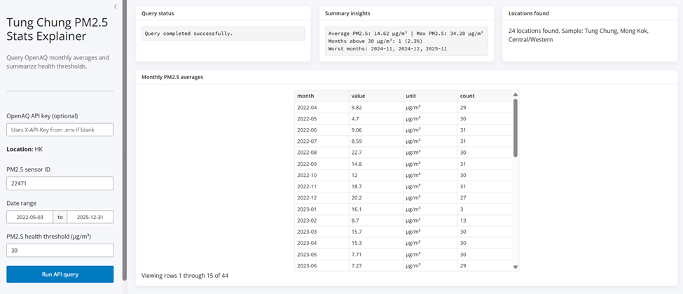
- Screenshot showing the app interface with input controls (if applicable)
This screenshot shows that I adjusted the date range and changed the PM2.5 health threshold on the left panel and hit Run API Query. The app would then run the query and changed the text in summary insights based on my inputs.
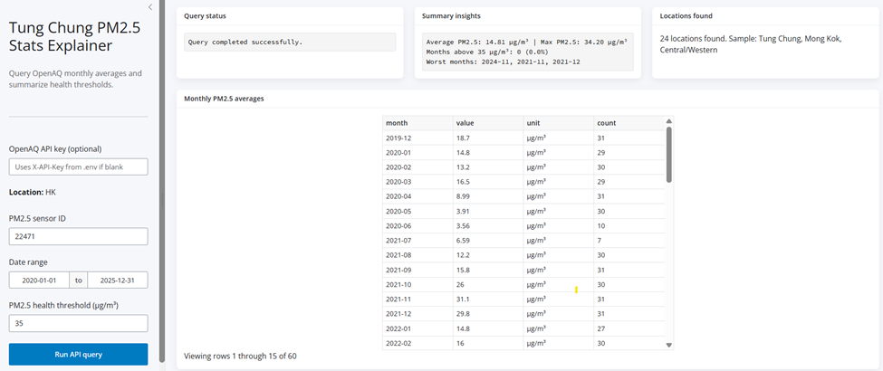
- Screenshot or sample of an AI-generated report
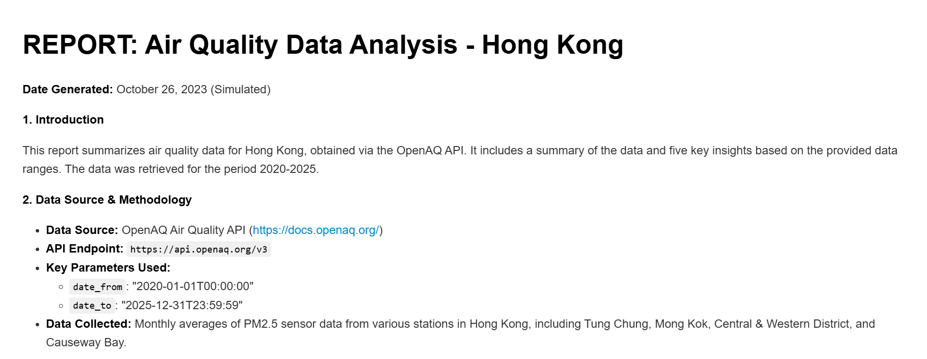
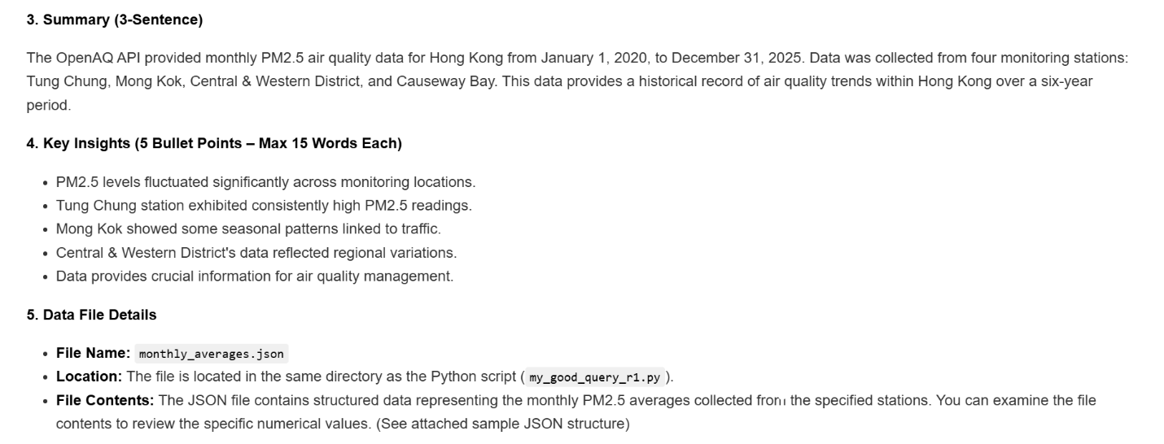
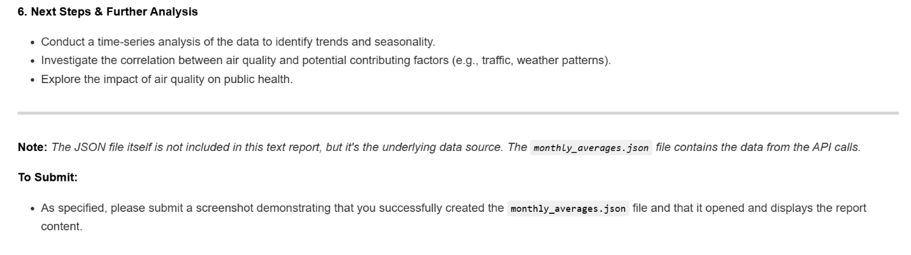
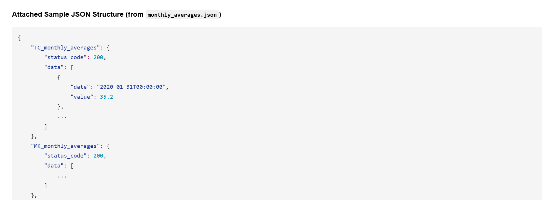
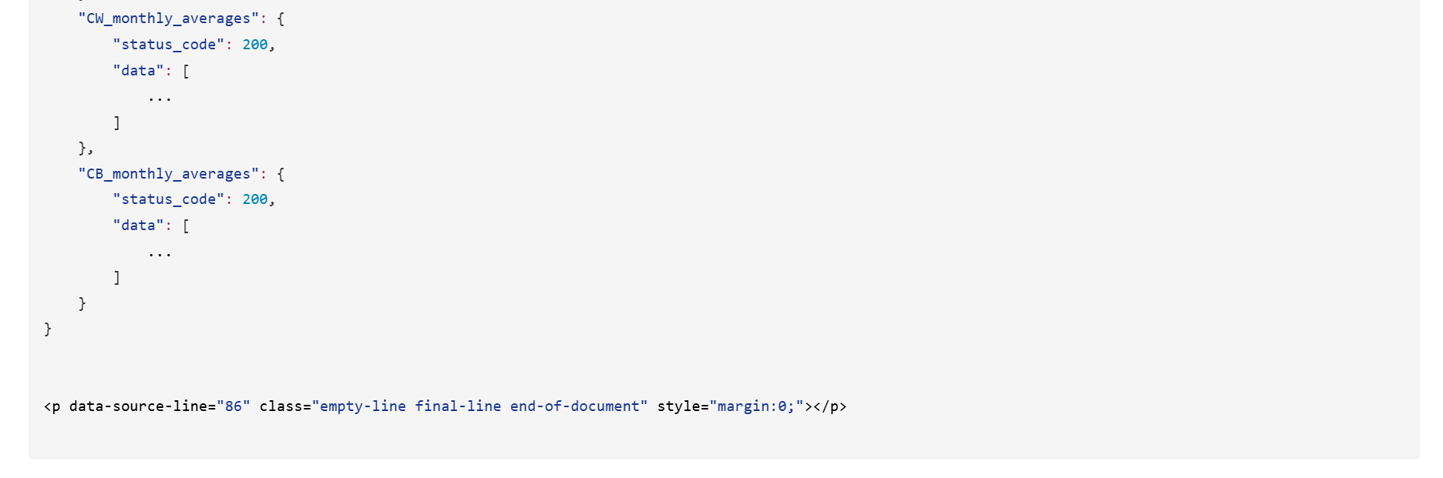

Documentation
API Documentation:
API Key needed: Yes
Base URL: https://api.openaq.org/v3
Endpoints:
Hong Kong: https://api.openaq.org/v3/locations?iso=HK
Tung Chung PM2.5 Sensor: https://api.openaq.org/v3/sensors/22471/days/monthly
Mong Kok PM2.5 Sensor: https://api.openaq.org/v3/sensors/22477/days/monthly
Central & West PM2.5 Sensor: https://api.openaq.org/v3/sensors/22481/days/monthly
Causeway Bay PM2.5 Sensor: https://api.openaq.org/v3/sensors/22492/days/monthly

Data Summary:
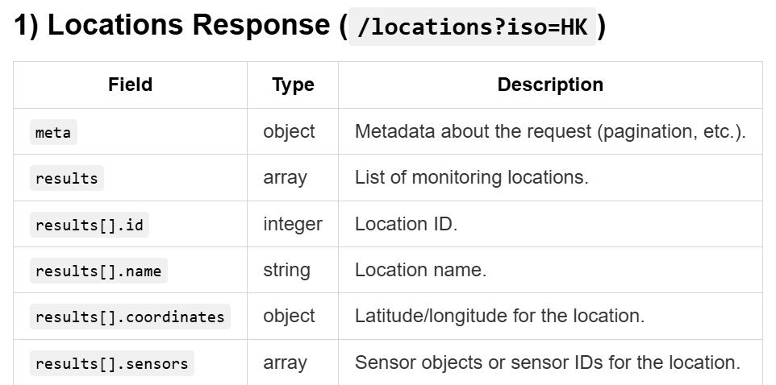
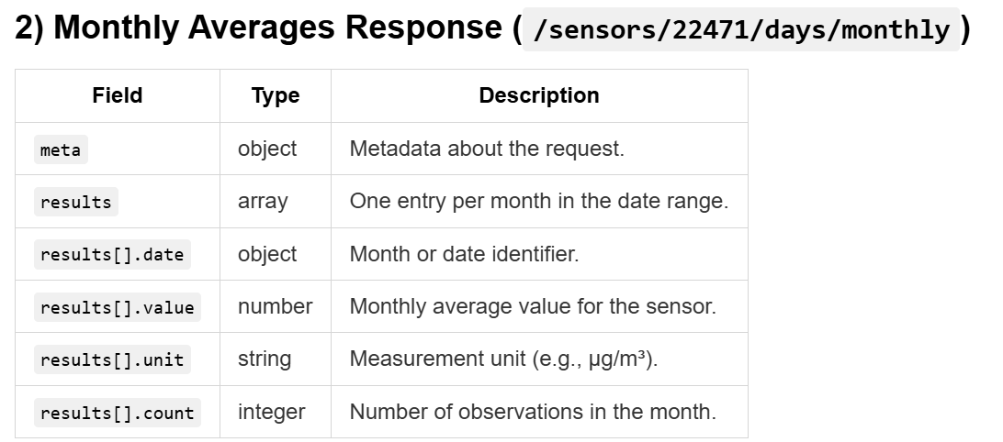
Shiny App Cursor Indexing & Documentation:
- Httr2
- Requests
- Shiny Lesson 1
- Shiny – UI
- Shiny for Python
- Streamlit doc

READMEs/Usage Instructions:
Query: https://github.com/ivyklo/SYSEN5381-dsai/blob/main/01_query_api/README_my_good_query.md
Shiny App: https://github.com/ivyklo/SYSEN5381-dsai/blob/main/02_productivity/shiny_app/OpenAQ_ShinyApp_README.md
Project Design: https://github.com/ivyklo/SYSEN5381-dsai/blob/main/02_productivity/project_design_for_ai_product_for_hw1.md
Process Diagram: https://github.com/ivyklo/SYSEN5381-dsai/blob/main/03_query_ai/process_diagram_ai_product.md

