MIDTERM - DL Challenge: AI-Powered Database Pipeline
Deployed App on Digital Ocean: https://congestion-tracker-ltyfg.ondigitalocean.app/
GitHub Repository (database schema, Readme, API, dashboard, AI integration, Codebook): https://github.com/ivyklo/SYSEN5381-dsai/tree/main/05_hackathon/congestion_tracker
Test demonstration examples (pulling data from 3 test datasets):
Test A
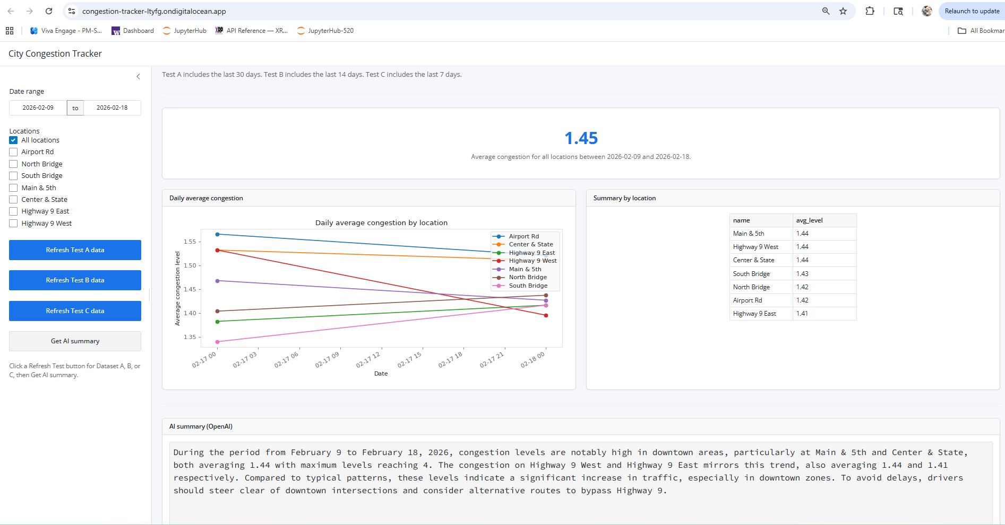

Test B
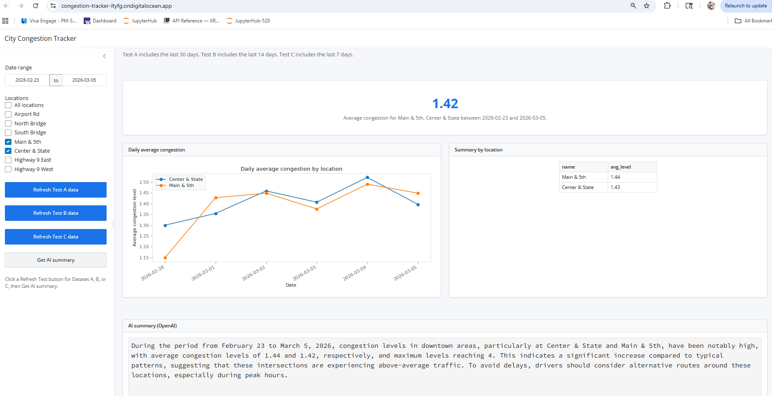
Test C
