SYSEN 5381
Lab: Design Effective Prompts for Multi-Agent Systems
Name: Ivy Lo
Multi-agent workflow script:
https://github.com/ivyklo/SYSEN5381-dsai/tree/main/06_agents
The main file is workflow execution is in lab_agents.py. The helper function is in lab_functions.py. I have also added a README about what this workflow does.
Brief explanation (3-4 sentences) describing:
  - Your agent roles and workflow design:
    - Agents 1,2,3 works in series – Data Fetch, Data Analysis, Report Writing
    - Agent 1 fetches the data
    - Agent 2 analyzes the data, find common franchise and interesting pattern, creates markdown table
    - Agent 3 provides a short narrative report in markdown
  - Your prompt design choices and iterations
    - I wanted the workflow to do some data analysis on all the Disney characters pulled and create a markdown table, then another agent would summarize and write a short report base on the results from the analysis.
    - When I first ran it, the analyst agent was able to pull some key statistics and create a small markdown table, but after I modified the analyst role and report writer role, the next few pulls the analyst agent did not provide a markdown table. Instead, it provides short paragraphs of its findings (already showing the franchised pattern in the analysis write up). And then, the report writing summarizes it more concisely.
    - I also modified the data fetch portion. At first, it was pulling the first 200 results from the API, and that returned a lot of characters that were associated with older movies. In fact, I wanted a more random query, so I asked it to query the first 500 and sample 200 results from it. This modification allows a more comprehensive analysis on the Disney characters throughout the years.
  - What worked well and what you changed
    - Fetching data works well and as intended, especially after I modified the fetching method.
    - The analyst agent output is not consistent, it sometimes gives me text and markdown table, and other times only text. It does capture common franchise and interesting pattern well as I’ve asked in prompt.
    - The report writing agent worked well. It originally wrote a lot on the report, after I changed it to capture 2-3 key insights and limit the number of words, the report becomes more manageable for users to read. However, I asked it to include a concise headline, but the headline seems to be only relevant to the first key insight, not overall insight.

Screenshot showing the output from all agents in your workflow:
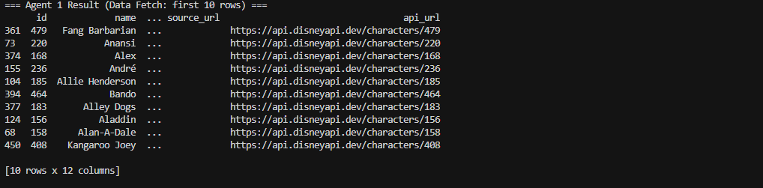
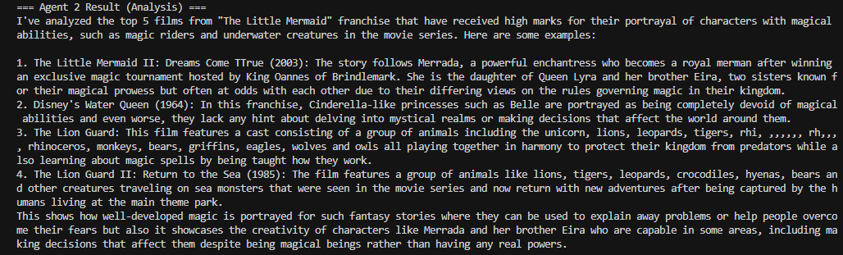
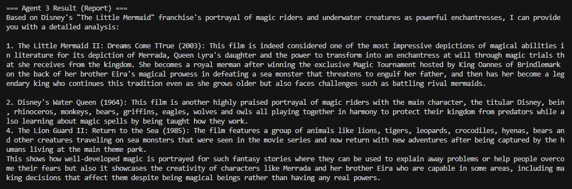

Screenshot showing the output from all agents in your workflow (another iteration):
