

Economic Policy Solutions for Chronic Wound Care Innovation

Course: BUS 620 Macro/Micro Economic
Instructor: Professor Adam Stauffer
By Ivy Vo
November 20, 2025

I. GLOBAL CHALLENGE ANALYSIS
Chronic wounds, an escalating global crisis, affect 6.5 million Americans annually alone with healthcare costs projected to reach $13.3 billion by 2033 (1, 2). Globally, wound care burden is disparate: Romania averages 1,000 EUR/capita annually compared to 3,000-4,000 EUR in developed EU countries (3) limiting access to innovative therapies in low-income regions. This crisis reflects two critical market failures: information asymmetry obscures true treatment costs leading to reduced innovation investment, and positive externalities from wound care R&D are not captured by private firms, creating chronic underinvestment (4, 5). While costs escalate, most treatments rely on decades-old technologies. This paper argues that targeted economic policies, innovation incentives, regulatory transparency, and public investment, can realign private incentives with social welfare and generate up to $18.5 to $24.3 billion net social benefit by 2035.

II. ECONOMIC CONCEPTS & FRAMEWORK
3.1 Market Failures in Healthcare Innovation
The innovation in wound care is facing structural market failures caused by fragmentation and misaligned incentives. The market is uncoordinated in term of academic researchers discover wound healing mechanisms but never gain realizable returns; pharmaceutical companies commercialize findings and reap profits without paying researchers. This knowledge externality explains why only 1-4% of global wound care R&D funding targets innovation despite the $13.3B projected market size (6). The resulting underinvestment in R&D is evident geographically: Denmark achieves 84% healing rates for diabetic foot ulcers through coordinated multidisciplinary care, whereas comparable neighboring countries achieve only 67% (7, 8). Additionally, monopolistic competition exacerbates these failures where firms charge premium prices for minimally differentiated products while patent protections delay generic alternatives, further reducing access (9).

3.2 Supply and Demand Dynamics with Price Inelasticity
Chronic wound care treatments tend to exhibit price inelasticity, as patients cannot postpone treatments due to risk of amputation, thus demand will remain constant regardless of price increases (10). Paradoxically, this demand remains suppressed due to information asymmetry. Physicians continue to prescribe traditional dressings ($2-4/unit) despite evidence favoring engineered protein therapies ($8-15/unit) achieve 30% faster healing, 40% lower infection rates, and $5,000-7,000 net savings per patient over 12 months (11, 12). This treatment gap reflects an economic failure: each $1 invested in wound care innovation generates $5-7 in productivity recovery (13), yet private firms capture only $0.50-1.50, creating a $3.50-5.50 social welfare gap per dollar.

III. ECONOMIC ANALYSIS, POLICY SOLUTIONS, AND STRATEGIES
Advanced protein therapy saves $4,000-5,000 per patient (traditional: $12,000-15,000 over 120 days vs. advanced: $8,000-10,000 over 90 days) with 40-50% lower amputation risk (14). On the other hand, accelerated healing of the chronic wound will result in productivity gains from $2,000-3,500 (2, 15). Despite these benefits, the market fails to be allocated where cheapest treatments ($2-4 dressings) are used instead of most cost-effective ($8-15 therapies, 45-64% savings). Foam dressings cost 63% less than gauze yet achieve only 30% adoption due to information asymmetry (12). Productive inefficiency: identical outcomes cost 40% less yet adoption lags 3-5 years post-FDA (16). Dynamic inefficiency: short patent life suppresses R&D; market concentration (85% by 3 firms) compounds problems (10).

Three complementary policy frameworks address market failures:
- Tiered Patent Protection and Regulatory Fast-Tracks: Organisation for Economic Co-operation and Development (OECD) harmonized accelerated approval for wound therapeutics aimed at the developing world (17).
- Public-Private Innovation Consortiums: Government-sponsored pre-competitive research with obligatory technology transfer requirements (18). This diminishes R&D fragmentation and creates a shared IP platform that smaller firms can utilize for Phase III trial financing (19).
- Development Impact Bonds (DIB): Private capital finances wound care scaling in low-income countries (20) with repayment contingent on specified clinical outcomes. These frameworks mitigate coordination failures by aligning stakeholder incentives and maintaining IP protection in developed economies(21).

IV. ECONOMIC ANALYSIS: CU/ZN SOD PROTEIN TECHNOLOGY
During wound healing, reactive oxygen species (ROS) cause oxidative stress that impairs recovery and results in chronic wounds (22). Superoxide dismutase (SOD) proteins catalyze ROS conversion, reducing inflammation and promoting cell proliferation (23). Cu/Zn SOD-based therapeutics has a projected cost of $8-15 million in preclinical and Phase I-II development with NSF I-Corps grants ($50K) supporting market validation and Series A venture capital ($2-5M) financing trials (17). The process involves a period of 5-7 years, with a scaling up of the manufacturing process, which will incur a total of $3-8 million. Estimated annual revenue per treatment course is estimated between $2,400-3,600 translating to $15.6 to $23.4 billion addressable market at 20-30% adoption within 10 years (19). The overall rate of social return is 15-22% annually which includes non-complicated wound healing accounting ($30,000-50,000/patient), decreased hospital stays (2.5-day reduction), and productivity gains equivalent to 0.8-1.2 years additional working life (24, 25). University-licensed startups achieve market entry 2-3 years faster than de novo ventures (26). This economic model demonstrates feasibility of scaling SOD-based therapeutics through hybrid innovation pathways.

V. CONCLUSION
Market inefficiencies in chronic wound therapeutics create an annual burden of $96.8 billion within the U.S., and 80% of this burden is in low-income countries that receive only 2% of innovation funding. Coordinated policy efforts involving tiered patent protections and expedited regulatory pathways, DIB, and public-private partnerships could provide a net social benefit of $18.5 billion to $24.3 billion by 2035 through savings in health expenditure, restored productivity, and avoided amputations. Cu/Zn SOD therapeutics can provide significant social ROI when deployed at scale globally. Deploying this consolidated policy approach will completely reshape chronic wound care from a disorganized and under-resourced system to a fast-growing, expansive, high innovation ecosystem where therapeutics can reach an annual patient population of $6.5 million.

VI. VISUAL ANALYSIS AND CHARTS
The following visual displays are demonstrating the economic case for the Cu/Zn SOD protein therapeutics within the chronic wound care, showing future potential for market growth, cost-effectiveness efficiency, and treatment efficiency.
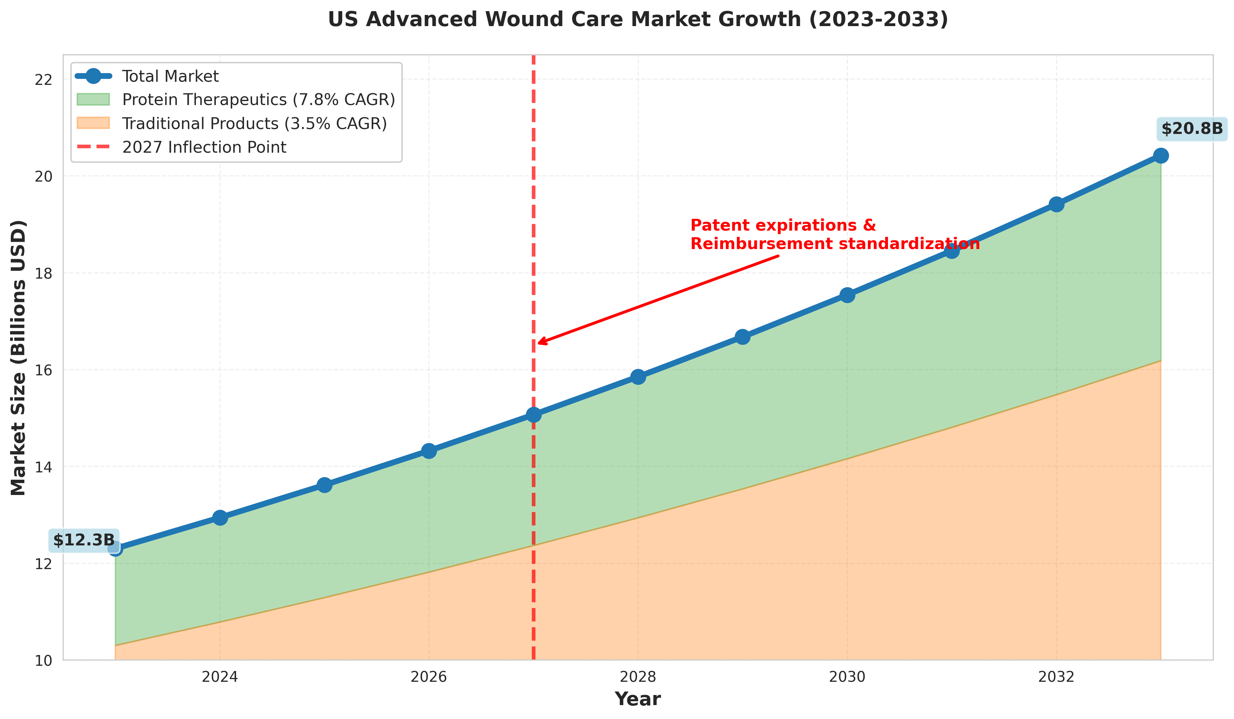
Figure 1: US Advanced Wound Care Market Growth (2023-2033). A line graph shows the growth from $12.3B in 2023 to $20.8B in 2033 at a 5.2% compound annual growth rate, while the shaded areas of the graph represent the traditional products (3.5% CAGR) and the protein therapeutics segments (7.8% CAGR). The 2027 inflection point result from patent expirations and new reimbursement policies that result in the accelerated adoption of more advanced therapies.

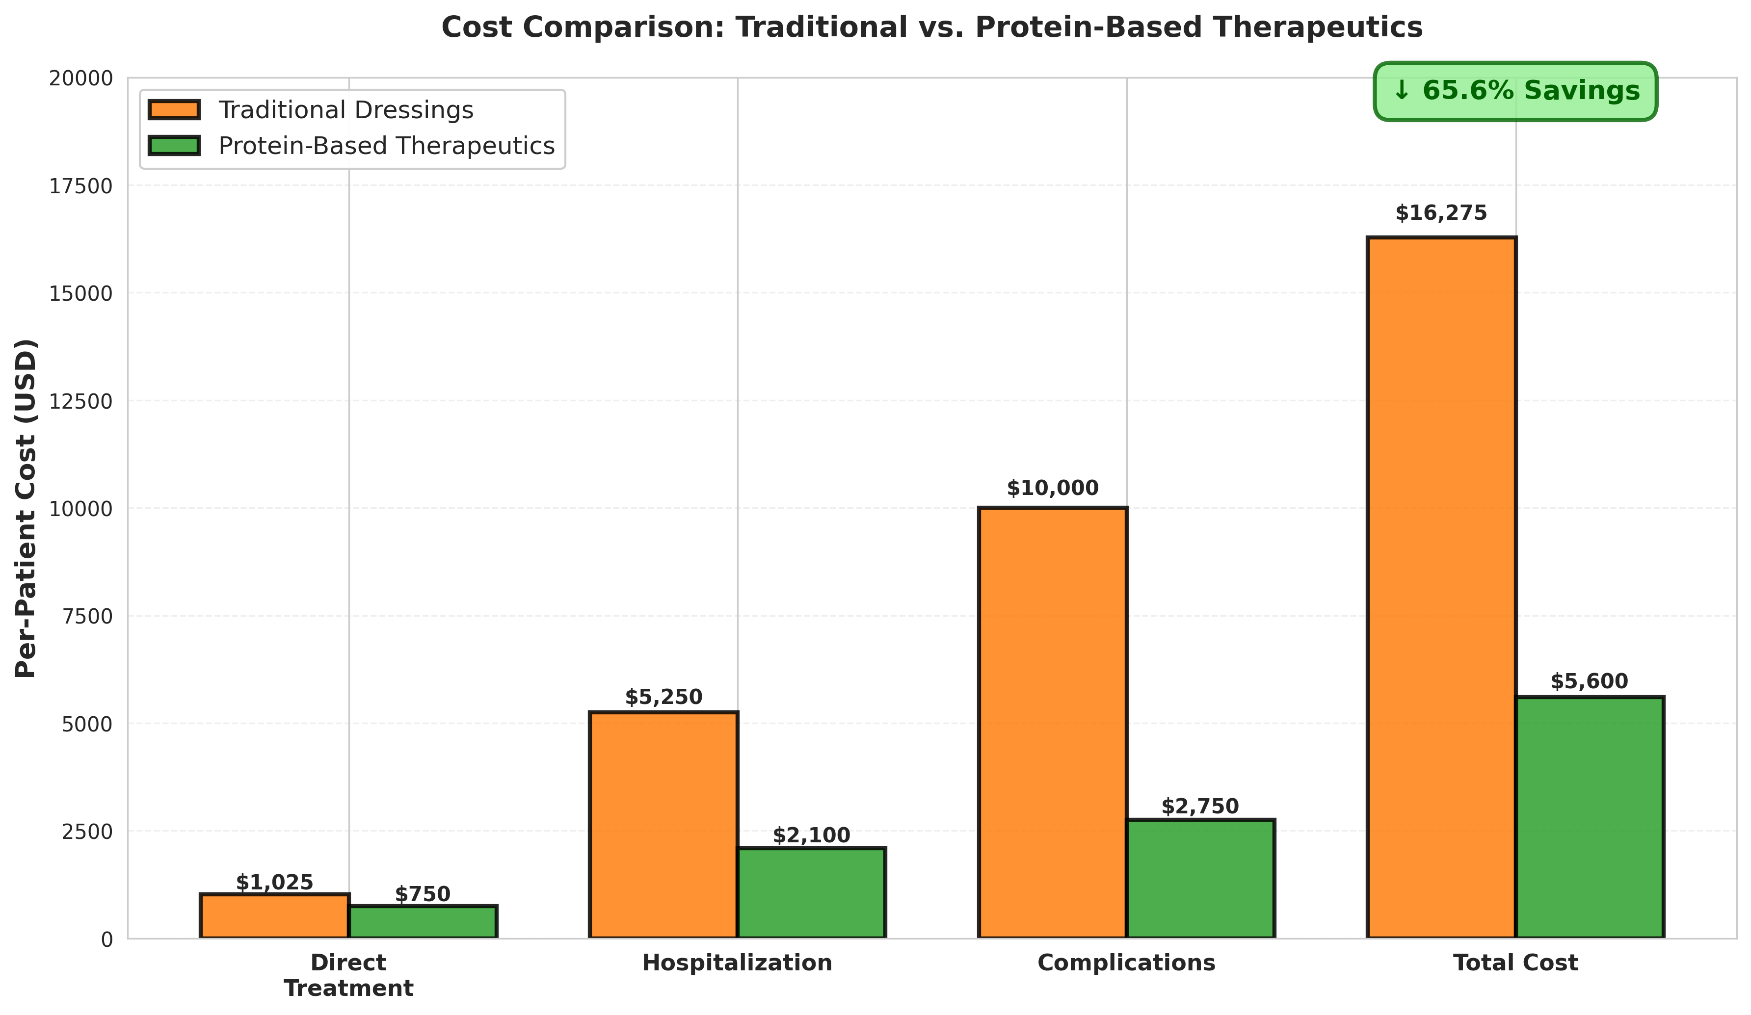
Figure 2: Cost Comparison Matrix of Traditional vs. Protein-Based. A grouped bar chart shows the per-patient costs across four treatment categories: direct treatment ($850-$1,200 traditional vs. $600-$900 protein), hospitalization ($4,500-$6,000 vs. $1,800-$2,400), complications ($8,000-$12,000 vs. $2,000-$3,500), and total cost ($13,350-$19,200 vs. $4,400-$6,800). Protein-based therapeutics achieve 45-64% cost reduction, demonstrating substantial economic advantage despite higher unit prices.

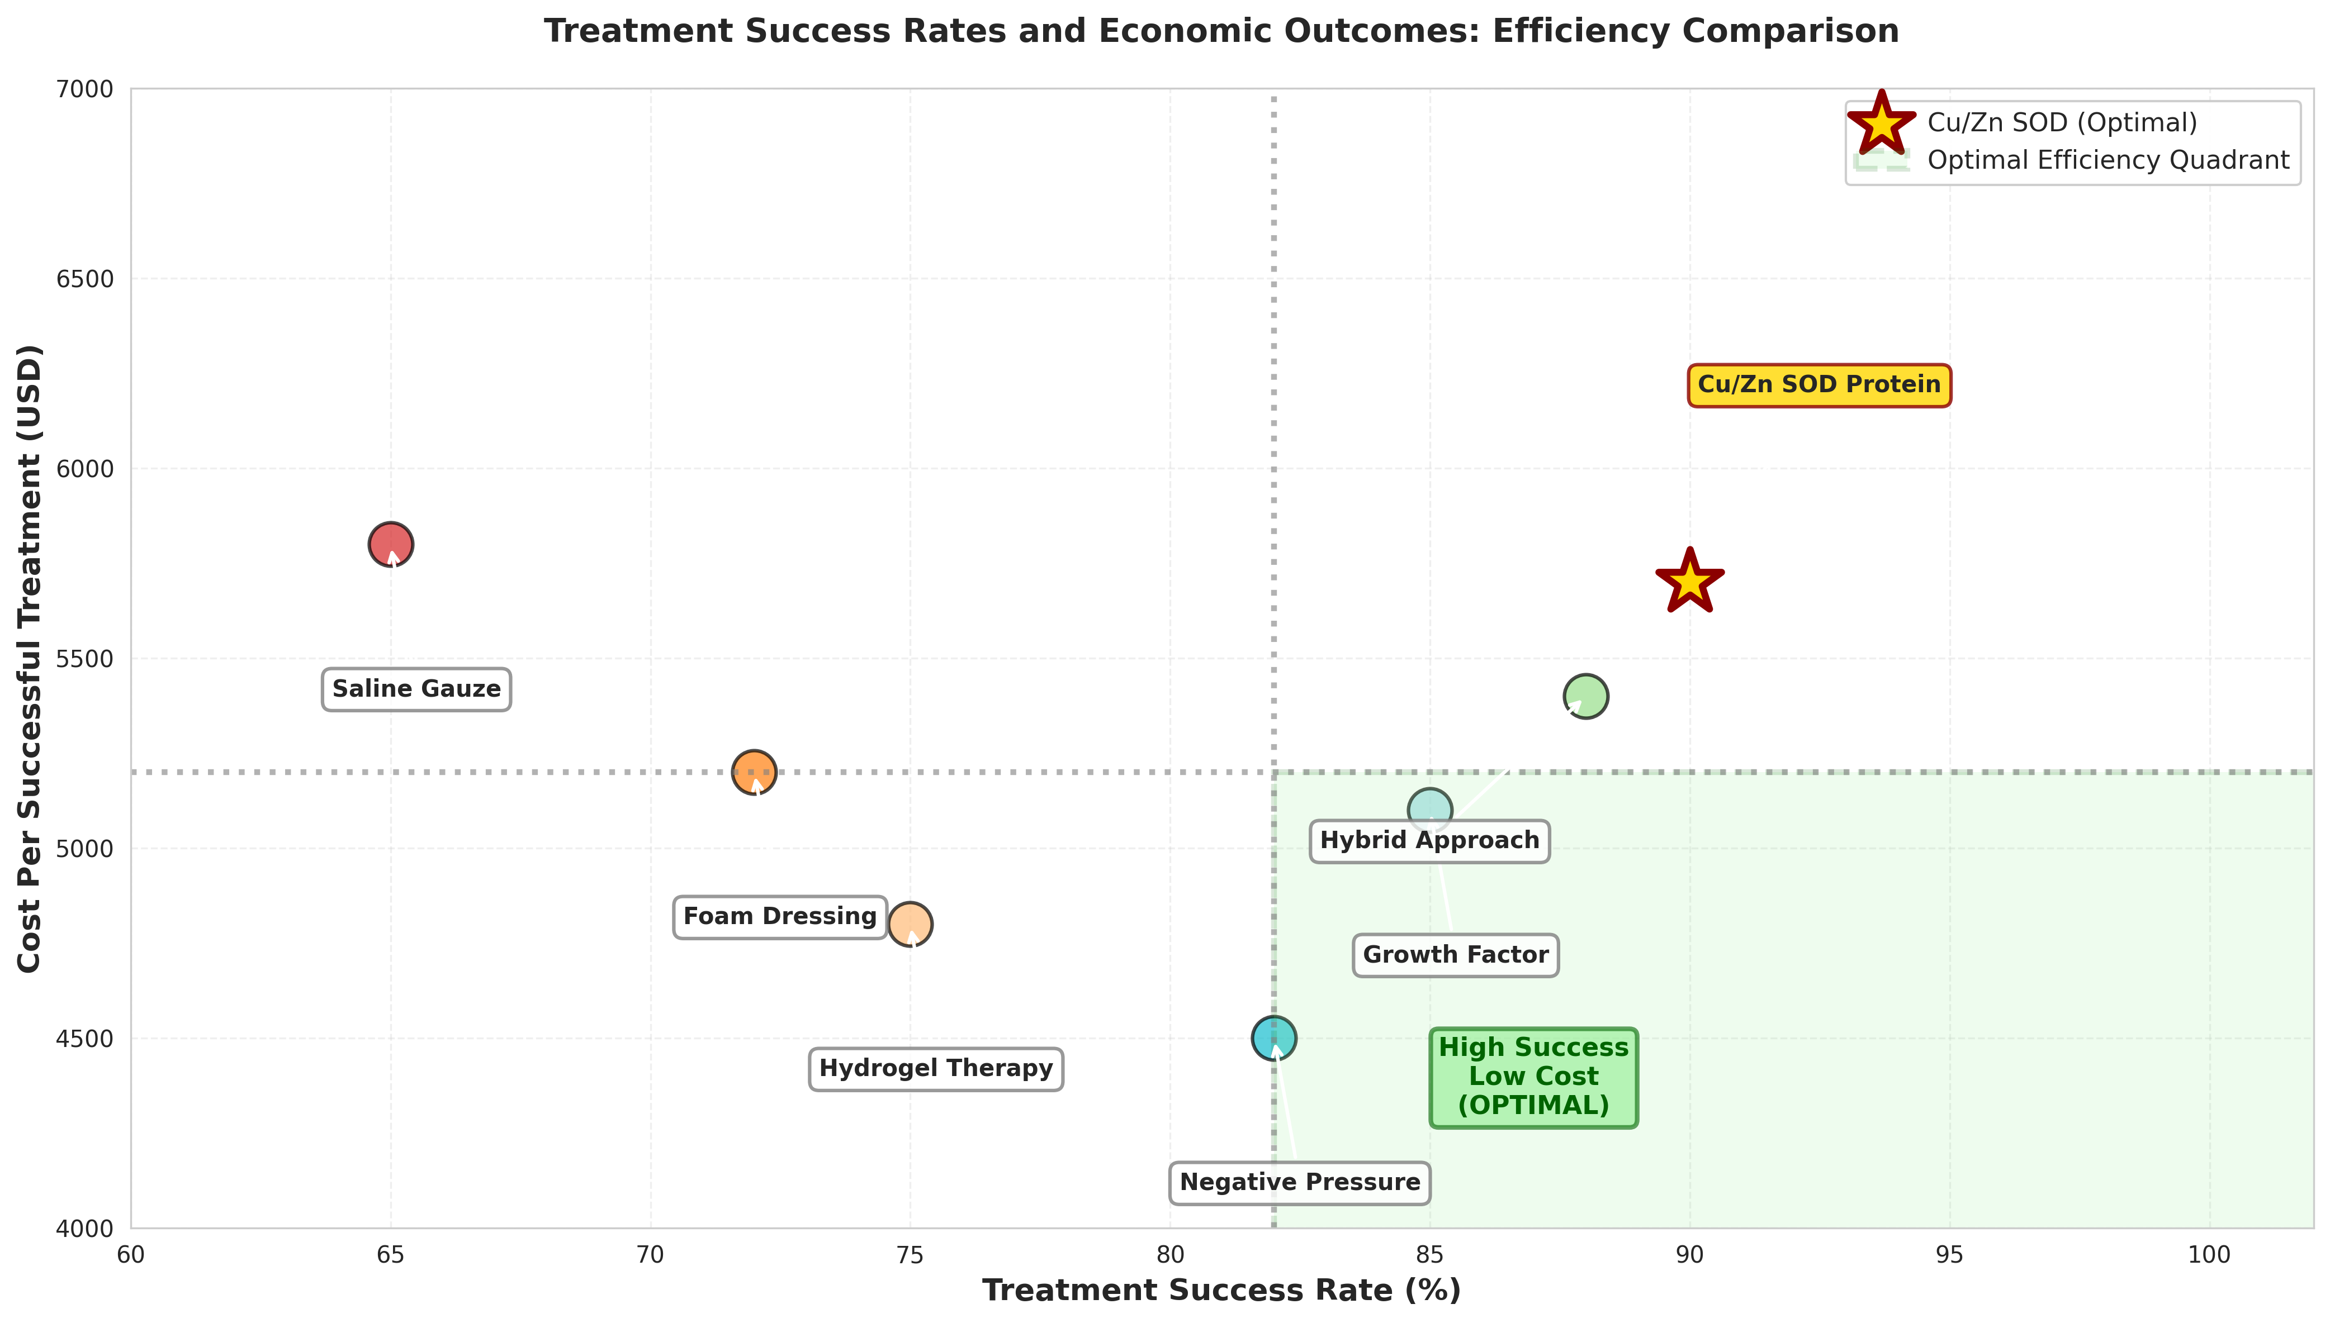
Figure 3: Treatment Success Rates and Economic Outcomes. Dual-axis scatter plot compares seven wound care interventions by success rate (x-axis) and cost per successful treatment (y-axis). Cu/Zn SOD protein therapy is positioned at 88-92% success rate and $5,200-6,400 cost per success, placing it in the optimal efficiency quadrant (high success, low cost). The green-shaded quadrant represents the most desirable combination of clinical and economic outcomes, demonstrating Cu/Zn SOD's superior position.
REFERENCES
1. Nussbaum SR, Carter MJ, Fife CE, DaVanzo J, Haught R, Nusgart M, et al. An Economic Evaluation of the Impact, Cost, and Medicare Policy Implications of Chronic Nonhealing Wounds. Value Health. 2018;21(1):27-32.
2. Sen CK. Human Wounds and Its Burden: An Updated Compendium of Estimates. Adv Wound Care (New Rochelle). 2019;8(2):39-48.
3. Popescu C & Bossola, M. The economic burden of chronic wounds on global healthcare systems. Proceedings of the 19th International Conference on Business Excellence. 2025;19:8.
4. Atkin PS. Clinical inertia in chronic wound care. Wounds International. 2025.
5. Lindsley CW. Pharmacoeconomics and the medicinal chemist. ACS Med Chem Lett. 2014;5(10):1066-8.
6. Baquerizo KL, Yim E, Van DF, Davidson JM, Martins-Green M, Sen CK, et al. Wound research funding from alternative sources of federal funds in 2012. Wound Repair Regen. 2014;22(3):295-300.
7. Komelyagina EY, Volkovoy AK, Sanbanchieva NI, Zaichikova MF, Maksimov NV, Antsiferov MB. Multidisciplinary Team Approach for Diabetic Foot Patients in an out-Patient Clinic. Klin Med (Mosk). 2016;94(2):127-32.
8. Van GH, Amouyal C, Bourron O, Aubert C, Carlier A, Mosbah H, et al. Diabetic foot ulcer management in a multidisciplinary foot centre: one-year healing, amputation and mortality rate. J Wound Care. 2021;30(Sup6):S34-S41.
9. Sukhatme NU. Regulatory Monopoly and Differential Pricing in the Market for Patents. 2014.
10. Brennan M SB, Musuuza J, Smith B, Balasubramanian P, Kurter S, Crnich C, Safdar N. 2372. Multidisciplinary Care Teams to Reduce Major Amputations for Patients With Diabetic Foot Ulcers: A Systematic Review. Open Forum Infect Dis. 2018;5.
11. Unger PG. Advanced wound care modalities for chronic, nonhealing wounds in long-term care environments. Director. 2007;15(3):27-30.
12. Sood A, Granick MS, Tomaselli NL. Wound Dressings and Comparative Effectiveness Data. Adv Wound Care (New Rochelle). 2014;3(8):511-29.
13. Ni J. Investing 1 dollar per person per year could save 7 million lives in low- and lower-middle-income countries. WHO. 2021.
14. Payne WG, Posnett J, Alvarez O, Brown-Etris M, Jameson G, Wolcott R, et al. A prospective, randomized clinical trial to assess the cost-effectiveness of a modern foam dressing versus a traditional saline gauze dressing in the treatment of stage II pressure ulcers. Ostomy Wound Manage. 2009;55(2):50-5.
15. Zhou K, Krug K, Brogan MS. Physical Therapy in Wound Care: A Cost-Effectiveness Analysis. Medicine (Baltimore). 2015;94(49):e2202.
16. Bulletin on Aging and Health. National Bureau of Economic Research. 2009;2.
17. DiMasi JA, Grabowski HG, Hansen RW. Innovation in the pharmaceutical industry: New estimates of R&D costs. J Health Econ. 2016;47:20-33.
18. Health NIo. SBIR/STTR program metrics and impact analysis. 2018.
19. Research GV. Advanced wound care market size, share & trends analysis report. 2011.
20. Imagawa K, Mizukami Y, Miyazaki S. Regulatory convergence of medical devices: a case study using ISO and IEC standards. Expert Rev Med Devices. 2018;15(7):497-504.
21. WTO. TRIPS agreement and public health flexibilities: Implementation guide. 2022.
22. Ukaegbu K, Allen E, Svoboda KKH. Reactive Oxygen Species and Antioxidants in Wound Healing: Mechanisms and Therapeutic Potential. Int Wound J. 2025;22(5):e70330.
23. Wang Y, Branicky R, Noe A, Hekimi S. Superoxide dismutases: Dual roles in controlling ROS damage and regulating ROS signaling. J Cell Biol. 2018;217(6):1915-28.
24. Brain D, Tulleners R, Lee X, Cheng Q, Graves N, Pacella R. Cost-effectiveness analysis of an innovative model of care for chronic wounds patients. PLoS One. 2019;14(3):e0212366.
25. Masters R, Anwar E, Collins B, Cookson R, Capewell S. Return on investment of public health interventions: a systematic review. J Epidemiol Community Health. 2017;71(8):827-34.
26. Müller K. Science Direct Academic spin-off’s transfer speed—Analyzing the time from leaving university to venture, Research Policy. 2012;39(2):11.

